Foreign Investment
Review Board

Annual Report
2008-09

© Commonwealth of Australia 2010
ISBN 978-0-642-74580-4

This work is copyright. Apart from any use as permitted under the Copyright Act 1968, no part may be reproduced by any process without prior written permission from the Commonwealth. Requests and inquiries concerning reproduction and rights should be addressed to:
Commonwealth Copyright Administration
Attorney-General’s Department
3-5 National Circuit
BARTON ACT 2600

Or posted at: www.ag.gov.au/cca

A copy of this document appears on the Foreign Investment Review Board website at www.firb.gov.au.

Printed by CanPrint Communications Pty Ltd.

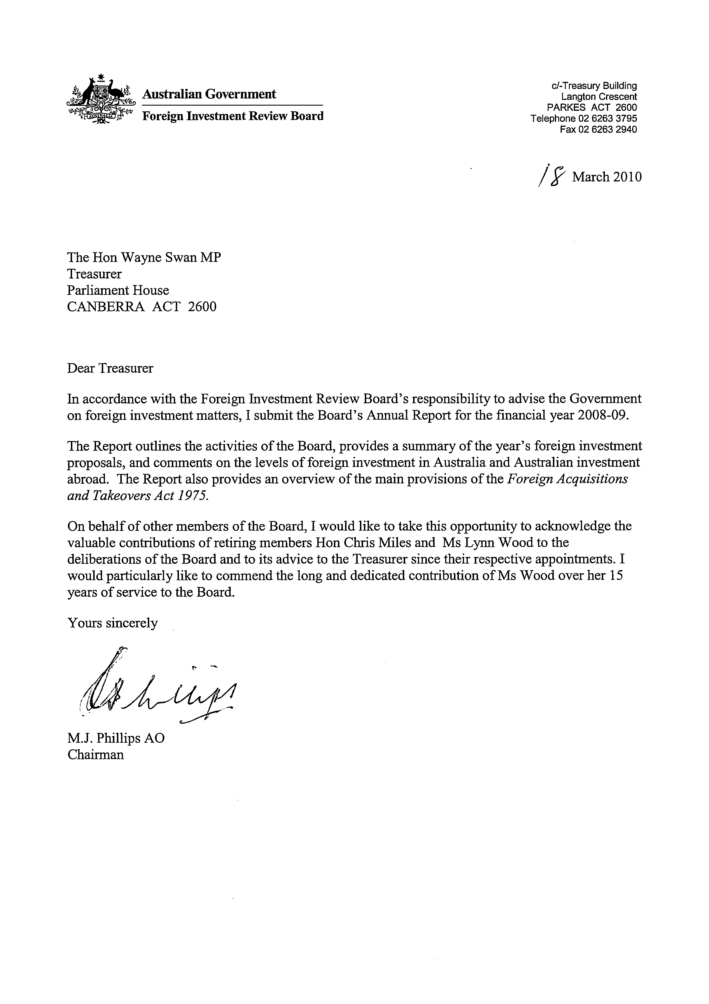

Contents
Acronyms and abbreviations ix
Glossary xi
Main points xv
Chapter 1: Foreign Investment Review Board 1
Functions of the Board 3
Board membership 4
Relationship of the Division to the Board 5
Administration of foreign investment policy 5
Information, advice and education 5
Consideration timeframe 6
Examination and approval process 6
Consultation arrangements 6
National interest 7
Handling of commercial-in-confidence and personal information 8
2008-09 outcomes 9
Cost of the Board’s operations 9
Consideration of proposals and enquiries 9
Changes to foreign investment policy — residential real estate 10
Monitoring and compliance activity 11
Chapter 2: Foreign investment proposals 13
Features of the FIRB statistics 15
Applications considered 18
Applications decided 20
Approvals by value 22
Approvals by sector 24
Agriculture, forestry and fishing 25
Finance and insurance 25
Manufacturing 26
Mineral exploration and development 27
Resource processing 27
Services 27
Tourism 28
Real estate 28
Approvals by country of investor 36
Chapter 3: Overview of the Foreign Acquisitions and Takeovers Act 1975 39
Introduction 41
Notification 42
The Treasurer’s powers 43
Foreign-to-foreign transactions 44
Prior approval for contractual arrangements 44
Foreign control 44
Enforcement provisions 45
Other aspects of foreign investment policy 45
Foreign portfolio shareholdings 45
Foreign government investment in Australia 46
Amendments to the Foreign Acquisitions and Takeovers Act 1975 46
Taxation 47
Chapter 4: Australia’s international investment position 49
Introduction 51
Australia’s international investment position 52
Foreign investment levels 52
Foreign direct investment levels by country 52
Foreign investment flows 54
Appendix A: Media releases and policy statements 57

Tables
Table 2.1: Applications considered: 2003-04 to 2008-09 (number of proposals) 19
Table 2.2: Applications decided: 2003-04 to 2008-09 (proposed investment) 20
Table 2.3: Total approvals by value and number 2005-06 to 2008-09 22
Table 2.4: Total approvals by industry sector in 2008-09 24
Table 2.5: Manufacturing sector approvals in 2008-09 26
Table 2.6: Mineral exploration and development sector approvals:
2007-08 to 2008-09 27
Table 2.7: Services (excluding Tourism) sector approvals in 2008-09 28
Table 2.8: Proposed foreign investment in the tourism sector
2004-05 to 2008-09 28
Table 2.9: Investment in residential real estate by type of expenditure and number of proposals approved in 2008-09 30
Table 2.10: Comparison of investment in residential real estate by expenditure and number of proposals approved in the period 1 July 2007 to 31 March 2008 and 1 July 2008 to 31 March 2009 32
Table 2.11: Investment in residential real estate by type of expenditure and number of proposals approved in the period 1 April to
30 June 2009 33
Table 2.12: Investment in commercial real estate by type of expenditure and number of proposals approved in 2008-09 35
Table 2.13: State distribution of proposed investment in real estate in 2008-09 35
Table 2.14: Approvals by country of investor in 2008-09 — industry sector 37
Table 4.1: Foreign investment flows 2004-05 to 2008-09 55

Charts
Chart 2.1: Applications decided 2003-04 to 2008-09 — number of proposals 21
Chart 2.2: Applications decided 2003-04 to 2008-09 — proposed investment 21
Chart 2.3: Total approvals by value 2005-06 to 2008-09 — number of proposals 23
Chart 2.4: Total approvals by value 2005-06 to 2008-09 — proposed investment 23
Chart 2.5: Total approvals by value by industry sector in 2008-09 — proposed investment 25
Chart 4.1: Level of foreign direct investment by country 53
Chart 4.2: Foreign investment flows 2004-05 to 2008-09 56

