REGULATOR PERFORMANCE FRAMEWORK

Administration of Australia’s  
Foreign Investment Framework

Report 2017–18

© Commonwealth of Australia 2019

ISBN 978-1-925504-96-5

This publication is available for your use under a [Creative Commons Attribution 3.0 Australia](http://creativecommons.org/licenses/by/3.0/au/deed.en) licence, with the exception of the Commonwealth Coat of Arms, the Treasury logo, photographs, images, signatures and where otherwise stated. The full licence terms are available from <http://creativecommons.org/licenses/by/3.0/au/legalcode>.

Creative Commons attribution licence 3.0 icon. 

Use of Treasury material under a [Creative Commons Attribution 3.0 Australia](http://creativecommons.org/licenses/by/3.0/au/deed.en) licence requires you to attribute the work (but not in any way that suggests that the Treasury endorses you or your use of the work).

*Treasury material used ‘as supplied’.*

Provided you have not modified or transformed Treasury material in any way including, for example, by changing the Treasury text; calculating percentage changes; graphing or charting data; or deriving new statistics from published Treasury statistics — then Treasury prefers the following attribution:

*Source: The Australian Government the Treasury.*

**Derivative** **material**

If you have modified or transformed Treasury material, or derived new material from those of the Treasury in any way, then Treasury prefers the following attribution:

*Based on The Australian Government the Treasury data*.

**Use of the Coat of Arms**

The terms under which the Coat of Arms can be used are set out on the Department of the Prime Minister and Cabinet website (see [www.pmc.gov.au/government/commonwealth-coat-arms](http://www.pmc.gov.au/government/commonwealth-coat-arms)).

**Other uses**

Enquiries regarding this licence and any other use of this document are welcome at:

Manager  
Media and Speeches Unit  
The Treasury  
Langton Crescent   
Parkes ACT 2600  
Email: [medialiaison@treasury.gov.au](mailto:medialiaison@treasury.gov.au)

Contents

Introduction to Australia’s foreign investment framework 1

The 2017–18 regulatory environment 2

The Regulator Performance Framework 5

Methodology 5

Assessing performance and consultation 5

Overall assessment 6

Self‑assessment against each Key Performance Indicator (KPI) 8

KPI 1 – Regulators do not unnecessarily impede the efficient operation of foreign investors 8

KPI 2 – Communication with foreign investors is clear, targeted and effective 10

KPI 3 – Actions undertaken by regulators are proportionate to the regulatory risk being managed 14

KPI 4 – Compliance and monitoring approaches are streamlined and coordinated 16

KPI 5 – Regulators are open and transparent in their dealings with foreign investors 18

KPI 6 – Regulators actively contribute to the continuous improvement of regulatory frameworks 20

Appendix A – Key Performance Measures 21

Appendix B – Stakeholder Survey Feedback 25

Appendix C – Quantitative Data 27

# Introduction to Australia’s foreign investment framework

In 2014, the Australian Government established the Regulator Performance Framework (the RPF) to encourage Commonwealth regulators to minimise any unnecessary impost associated with administering their regulation. The RPF comprises a set of six common key performance indicators (KPIs) against which to assess Commonwealth regulators’ performance (see Regulator Performance Framework).

This report presents a self-assessment of the administration of Australia’s foreign investment framework (the framework) against the RPF for 2017-18. The framework is underpinned by the *Foreign Acquisitions and Takeovers Act 1975* (the Act) and supporting legislation. Administering the framework involves the Government reviewing foreign investment applications against the national interest test on a case‑by‑case basis. Applications are generally approved as the Government aims to maximise investment flows, without compromising the national interest. However, when the Government reviews a proposal that raises national interest concerns, the Treasurer may take action. For example, the Treasurer may:

* apply conditions to the way a proposal is implemented to ensure it is not contrary to the national interest;
* block any proposal that is contrary to the national interest; or
* require a foreign person to dispose of real estate or share interests, or terminate an arrangement, if an unapproved transaction has already been completed and is contrary to the national interest.

Although responsibility for Australia’s foreign investment policy rests with the Treasurer, several government entities provide advice to inform government decisions under the framework. The Department of the Treasury (Treasury), the Australian Taxation Office (ATO) and the Foreign Investment Review Board (FIRB) have the primary responsibility to examine foreign investment applications and provide advice on associated national interest implications. Treasury and the ATO are collectively referred to in this report as ‘FIRB agencies’.[1]

The Treasury is primarily responsible for the day‑to‑day administration of the framework in relation to business, agricultural land and sensitive or complex commercial real estate investments.[2]

The ATO administers foreign investment into residential real estate, as well as non-sensitive commercial real estate (vacant and non‑vacant) and corporate reorganisations, and the development and maintenance of foreign ownership registers.[3] It is also responsible for the collection of all foreign investment application fees.

The FIRB serves as a non-statutory advisory body. Its role is to:

* examine proposed investments that are subject to the Act and supporting legislation, and to make recommendations to the Treasurer and other Treasury portfolio ministers on the national interest implications of these applications;
* provide advice on the operation of the framework and related matters;
* foster awareness and understanding, both in Australia and abroad, of Australia’s foreign investment policy;
* provide guidance to foreign persons and their representatives or agents on the operation of the framework; and
* monitor and ensure compliance with the framework.

For significant foreign investment applications, FIRB agencies consult with Australian Government departments, state and territory government departments, national security agencies and authorities with responsibilities relevant to the proposed investment. Advice and comments provided by these consultation partners are important in assessing the implications of proposed investments and in particular, in determining whether they raise any national interest issues. Sourcing such input, as well as any further information required from applicants to inform the assessment, may result in additional time being required for the application’s review in addition to the initial 30 day review period.[4]

FIRB agencies share a close working relationship to promote consistency in the administration of the framework, as well as working closely with consultation partners of which there are around 35 agencies. This self-assessment provides a holistic assessment of how the framework was administered in 2017-18.

## The 2017–18 regulatory environment

The evolving foreign investment landscape in recent years has prompted changes to the administration of the framework. While legislative changes have formally changed the scope of the regulatory system, changes to the types of transactions, technological advancements, and a heightened national security environment, have posed new challenges for the administration of the framework.

In 2017‑18, FIRB agencies considered over 12,300 applications and decided over 11,600 applications, including variation applications. Figure 1 provides an overview of the approvals given by industry sector. In addition, the ATO completed over 1,400 residential compliance investigations and Treasury completed 11 business audits relating to more than $25 billion of proposed investment.[5]

Figure 1: Foreign investment approvals and variations given in 2017‑18

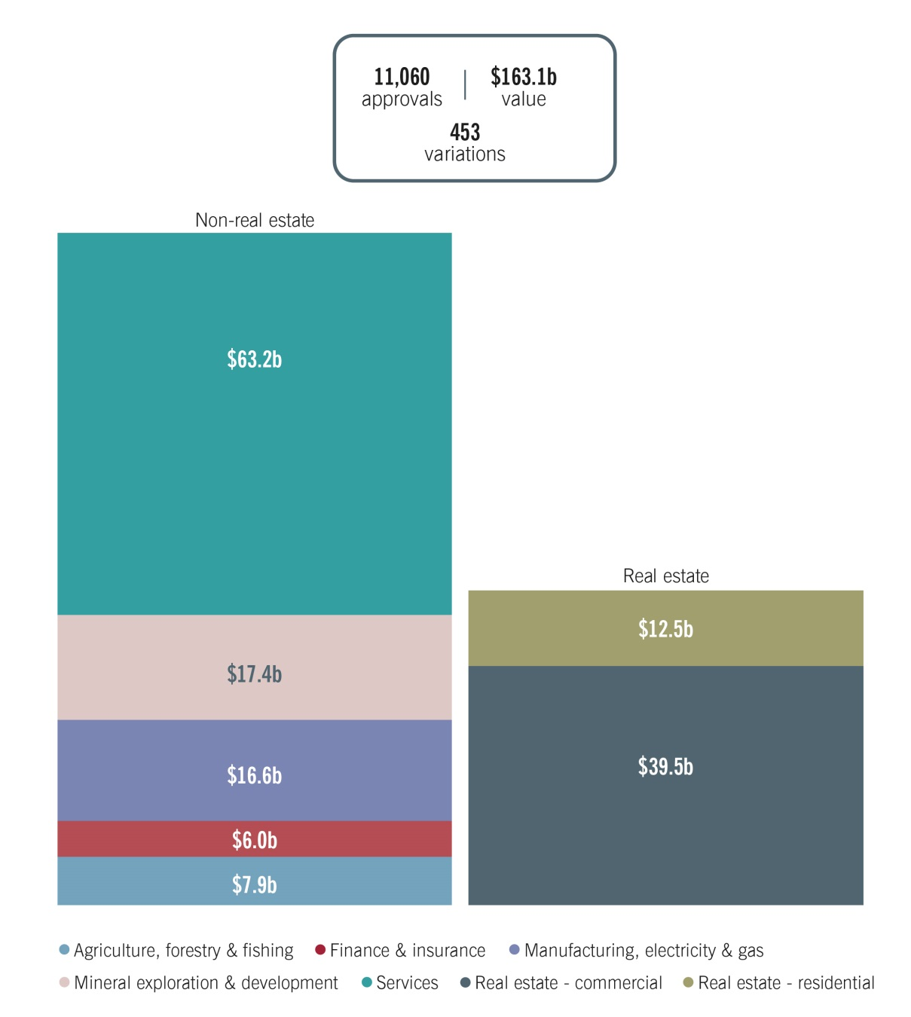

Note: In addition to the above, there were also 119 corporate reorganisation and 20 new business approvals.

Key areas of policy focus for FIRB agencies related to implementing the regulatory changes introduced in the 2017-18 Budget that included a number of streamlining measures that came into effect on 1 July 2017 such as the simplified fee framework for business; the introduction of a vacancy fee in respect of residential real estate; and February 2018 policy announcements concerning the acquisition of agricultural land and electricity assets. FIRB agencies worked closely with consultation partners, applicants and their advisers over the period to implement   
these changes.[6]

Compliance with the framework was a priority for the FIRB, including continuing to encourage voluntary compliance. Treasury conducted a pilot series of compliance audits on previous approvals given to businesses. Other work undertaken to strengthen assurance that foreign persons are meeting their obligations included education and stakeholder engagement, audits and investigations, and the imposition of penalties under the Act. Treasury also implemented enhanced compliance arrangements in relation to non-real estate investment, including a framework to bring together compliance activities undertaken by FIRB agencies. The ATO continued to actively use data matching as a trigger for investigations of residential real estate related breaches.

In addition to ongoing application system enhancements by FIRB agencies designed to improve the customer experience, Treasury continued work on a redesigned FIRB application portal for non‑residential applications.[7]

FIRB agencies also supported the implementation of the Critical Infrastructure Centre (CIC), which is now within the Department of Home Affairs, and the Australian National Audit Office’s (ANAO) review and report, *Management of compliance with foreign investment obligations for residential real estate.* The June 2018 ANAO report presented a comprehensive review of the arrangements the Government implemented in December 2015 to strengthen compliance with residential real estate rules. This included the transfer of administrative responsibility for residential real estate from Treasury to the ATO along with additional enforcement powers. The objective of the audit was to assess the effectiveness of the ATO and Treasury’s management of compliance with foreign investment obligations for residential real estate.[8]

# The Regulator Performance Framework

Commonwealth regulators that administer, monitor or enforce regulation must implement the Australian Government Regulator Performance Framework (RPF). Under this, regulators must undertake an annual self-assessment of their regulatory performance using the following six key performance indicators (KPIs).

1. Regulators do not unnecessarily impede the efficient operation of regulated entities.
2. Communication with regulated entities is clear, targeted and effective.
3. Actions undertaken by regulators are proportionate to the regulatory risk being managed.
4. Compliance and monitoring approaches are streamlined and coordinated.
5. Regulators are open and transparent in dealing with regulated entities.
6. Regulators actively contribute to the continuous improvement of regulatory frameworks.[9]

## Methodology

In 2015, FIRB agencies translated the six KPIs into operational objectives by developing a set of ‘measures of good regulatory performance’. These measures identified several positive actions and outcomes that FIRB agencies anticipated would lead to the achievement of the RPF KPIs. In turn, FIRB agencies agreed to assess the achievement of these measures using agreed ‘activity‑based evidence and metrics’. These metrics provide verifiable and often quantifiable measures of performance.[10]

The self-assessment methodology draws on a range of quantitative metrics[11] and annual survey feedback from key stakeholders[12], complemented by qualitative information to support evidence of actions taken during the reporting period.

This report focuses on assessing regulatory activities against the six KPIs and does not seek to address all aspects of regulatory performance.

## Assessing performance and consultation

This report is structured such that performance is considered against each of the six KPIs.

#### Stakeholder perceptions survey and follow-up discussions

In addition to ongoing feedback received during application review and stakeholder engagement and outreach activities, to inform the findings of this report, FIRB agencies invited feedback through a survey of key stakeholders (the survey) and targeted discussions with survey respondents.

Each quantitative question in the survey was assessed on a five point scale, centred on a neutral response. In addition, there were questions that offered respondents the opportunity to comment on aspects of FIRB agencies’ performance.

The survey was sent to 31 people from 24 organisations and there were six respondents. A summary of stakeholders’ survey responses is at **Appendix B**. The follow‑up targeted discussions with survey respondents also provided them with an opportunity to discuss other matters relating to their regulatory experience that were not covered or raised in their survey response. Some of the matters raised in these discussions have been included in this report. Survey respondents were consulted on the draft report prior to publication.

The activity-based evidence and metrics used in this self-assessment draw upon a range of quantitative metrics and qualitative information to evaluate FIRB and FIRB agencies’ performance against the KPIs. Many of the metrics appear in several measures and KPIs. To avoid repetition, metrics that appear multiple times are not addressed against every KPI.

#### Ministerial‑approved consultation body

The Foreign Investment Committee of the Law Council of Australia (the Committee) is the Ministerial‑approved consultation body for FIRB agencies for the purposes of the RPF and was consulted on this report.

Feedback received through various avenues, including from the Committee and other external stakeholders, informed the drafting of this report.

## Overall assessment

The overall assessment is that the KPIs were met during 2017‑18.

In the 2016-17 RPF self‑assessment, the following were noted as areas of focus for 2017‑18:

* improving the timeliness of advice and application processing times;
* progressing the redesign of the FIRB application portal to provide a more flexible, user friendly experience;
  + the new FIRB application portal, which went live on 2 July 2018, was redesigned with significant input from stakeholders during the design and testing process;
* continuing to encourage investors and their representatives to engage early with FIRB agencies;
* supporting the Critical Infrastructure Centre to provide investors with greater clarity about the types of critical infrastructure assets that will attract national security scrutiny and potential ownership restrictions and mitigations; and
* enhancing compliance capability and activities.

While progress was made in all of the above areas, continuing to improve the timeliness of advice and application processing times, encouraging early engagement with FIRB agencies, and enhancing compliance capability remain areas of focus for 2018‑19. Other areas of focus for 2018‑19 are:

* working with stakeholders to balance commercial deadlines against the robust review of applications under the framework;
* developing customer service standards for the handling of phone and written enquiries against which to assess our performance;
* liaising with consultation partners to improve their understanding of the framework and assist them in providing advice in a timely manner on applications relevant to their areas of responsibility and expertise; and
* continuous improvement of external client‑facing systems and forms.

# Self‑assessment against each Key Performance Indicator (KPI)

## KPI 1 – Regulators do not unnecessarily impede the efficient operation of foreign investors

|  |
| --- |
| **Measures of good regulatory performance** |
| Demonstrate an understanding of the operating environment of the industry or organisation, or the circumstances of individuals and the current and emerging issues that affect the sector |
| Minimise the potential for unintended negative impacts of regulatory activities on foreign investors |
| Implement continuous improvement strategies to reduce the costs of compliance for foreign investors |

#### Overview

In 2017-18, FIRB agencies took measures to minimise impediments to foreign investment, and to strengthen understanding of foreign applicants’ operating environments through improved industry engagement. FIRB agencies held more stakeholder engagements than in 2016-17, built commercial capabilities into application review teams and implemented strategies to respond to commercial sensitivities, such as the confidential information provided through applications.

While the areas of focus for 2018‑19 include elements that will enhance performance against this KPI, this KPI has been met.

#### Understanding the operating environment better through enhanced industry engagement

In 2017-18, Treasury’s Foreign Investment Division (the Division) had officers based in Canberra, Sydney and Perth, strengthening the Division’s ability to build links externally.

The Division held more than 400 stakeholder meetings in 2017-18. These meetings facilitated dialogue on the framework, and gave FIRB agencies the opportunity to seek stakeholders’ input on proposed legislative amendments and the redesign of the FIRB Application Portal (Portal).

On 10 April 2018, Treasury hosted a *Foreign Investments Insights Day* at which consultation partners discussed emerging issues affecting the framework and opportunities to improve the administration and operation of the framework.

The ATO undertook extensive stakeholder engagement and education activities in 2017-18. It held two webinars to provide information to stakeholders on the newly-established Register of foreign ownership of water entitlements. These targeted sessions provided irrigation infrastructure operators, water authorities, and water holders with information on the Register and advice on registration requirements, including for the initial five month ‘stocktake period’ that ran from 1 July to 30 November 2017 following the establishment of the register.

The ATO also held meetings with 22 legal practitioners and conveyancers providing intermediaries with information on the framework to help them assist their clients, including information on the new vacancy fee for residential property. Foreign investor reporting requirements for the annual vacancy fee were designed to minimise compliance costs, including by allowing for online reporting to the ATO.

In addition, the ATO held three meetings with business and industry representatives as part of the ATO’s Foreign Investment Reforms Working Group. It also conducted five presentations on the framework and its administration to other government agencies and industry representatives.

#### Incorporating stakeholders in the FIRB Application Portal redesign

The Portal is the channel through which foreign investors, or their agents, apply for approval for non-residential investments. During 2017-18, the Portal was redesigned to deliver a more flexible, user-friendly system for applicants and agents.

Enhancements to the Portal, developed in response to stakeholder feedback, include an enhanced fee calculator, the ability to lodge one application for multiple notifiable actions and the ability to lodge online a variation application in relation to an earlier approval. A number of external stakeholders made further contributions to the redesign through participation in user‑acceptance testing. While suggesting further refinements, most of which were able to be actioned prior to the roll-out, feedback was generally positive.

Following the roll-out on 2 July 2018, feedback was also sought from stakeholders on minor refinements and possible future enhancements. These have either been actioned or incorporated into future planning. Of the survey respondents who expressed a view on the redesign process and the implementation of the new Portal, the majority were either ‘very satisfied’ or ‘somewhat satisfied’.

#### Confidentiality

Foreign investment applicants have flagged the importance of protecting the confidentiality of material provided to government. This is an ongoing priority for FIRB agencies. In 2017-18, FIRB agencies identified several measures to achieve this end. Clearer privacy notices and user declarations for the new Portal were designed to minimise the potential for unintended impacts.

An additional new functionality in the Portal includes the requirement for potential users to acknowledge Terms and Conditions before an account can be registered and applications can be lodged. The Terms and Conditions include links to overarching Privacy Notices that clearly state how FIRB collects and uses the personal information disclosed in the application. The new application declarations have been designed to minimise the administrative burden on foreign investors by removing the requirement for additional mandatory forms to be completed and uploaded at the time the application is submitted, except in limited cases.

Some survey respondents provided feedback that government processes to protect confidential information do not take into account investor expectations that information can be shared with various arms of government under relevant legislation. FIRB agencies continue to work with consultation partners to explore ways to address this and ensure seamless sharing of information within regulatory parameters.

In 2017-18, FIRB agencies developed additional guidance and held training sessions to increase staff understanding of their privacy and protected information responsibilities and obligations. New materials included a division-specific record keeping policy to supplement department-wide recording keeping materials, and an updated protected information and data strategy.

## KPI 2 – Communication with foreign investors is clear, targeted and effective

|  |
| --- |
| Measures of good regulatory performance |
| Provide guidance and information that is up to date, clear, accessible and concise through media appropriate to the target audience |
| Consider the impact on foreign investors and engage with industry groups and representatives of the affected stakeholders before changing policies, practices or service standards |
| Provide decisions and advice in a timely manner, clearly articulating expectations |

#### Overview

In 2017-18, FIRB agencies used various public channels to communicate the requirements of the framework, provided updated guidance and continued to take steps to facilitate timely decision making in relation to foreign investment applications and better articulation of conditions of approvals.

While the areas of focus for 2018‑19 include elements that will enhance performance against this KPI, this KPI has been met.

#### Provision of information and guidance

Foreign investors, the regulated entities of FIRB and FIRB agencies, are geographically dispersed and operate in a wide range of sectors. The span and diversity of Australia’s foreign investor profile (by factors such as business practice, regulatory environments, culture and language) raises challenges for FIRB and FIRB agencies to engage effectively and efficiently with stakeholders.

FIRB agencies use various public channels to communicate the requirements of the framework, including the FIRB and ATO websites, the Australian Trade and Investment Commission (Austrade), Australian missions, Treasury Posts, Australia’s Foreign Investment Policy statement, guidance material, legislation and supporting materials, the FIRB Annual Report, stakeholder engagements, ministerial media releases, FIRB website subscriber updates, and consultation on specific matters such as proposed changes to the framework.

FIRB agencies updated guidance material throughout 2017-18, in line with announcements of policy and/or legislative changes, to provide further transparency and clarity.

**Figure 2: Top 15 countries by number of users accessing the   
FIRB website in 2017-18**

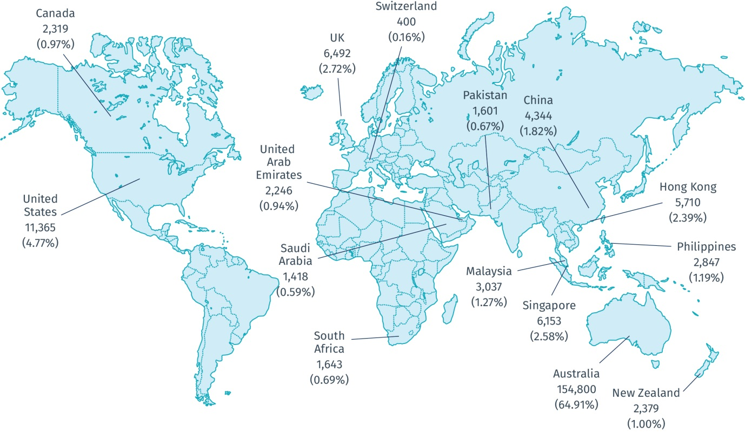

Notes:

This diagram shows the top 15 sources of website users by country based on known IP addresses and accounts for 89.60 per cent of total users.

A ‘user’ for the purposes of this diagram is a first time user during the period. There were 238,482 such users from over 170 countries during 2017‑18.

Location is allocated based on the recorded IP address. However, 0.44 per cent of IP locations were unknown (these have not been excluded from the above total user number).

China excludes Special Administrative Regions and Taiwan.

The FIRB website includes users who are subsequently directed to foreign investment specific content on the ATO website.

Countries with an average user session duration of 30 seconds or less have been excluded from the dataset due to the likelihood that the data for the country has been impacted by abnormal hit traffic or that users inadvertently came to the website.

During 2017‑18, interest in the FIRB website, which is managed by Treasury, was strong as over 238,000 users accessed the site from across the globe. Interest in foreign investment pages on the ATO website was also strong. In 2017-18 the ATO developed new content in support of the vacancy fee. In total, there were 76,408 unique user page views of ATO mainstream or in-language English content and 1,361 unique views of Chinese language pages. A direct correlation was observable between web hits and ATO promotional or compliance activities undertaken in 2017‑18.

##### Public speeches

During 2017-18, the Chair of the FIRB, Mr David Irvine AO, gave several speeches and interviews relating to the framework, including the systemic pressures that will influence the direction of foreign investment policy. This included the keynote address at the Committee for Economic Development of Australia conference *Agribusiness Outlook: Investment, Innovation and Growth* and an address to the International CEO Forum. Such speeches and interviews are available on the FIRB website.

##### Direct stakeholder contact

FIRB agencies use several mechanisms to field questions from the general public, foreign investors and advisers, such as an enquiries phone line and email. In 2017-18, the ATO handled over 18,700 calls on its foreign investment enquiry line and Treasury handled over 2,800 calls on its foreign investment enquiry line. The ATO responded to over 6,100 written enquiries and Treasury to over 340 enquiries.

The ATO screens more than 10,000 residential real estate and non-sensitive commercial applications for foreign investment approval each year. The ATO has training modules in place which are supported by documented policies and procedures for undertaking screening of residential real estate. Tailored screening processes and policies exist for ATO staff to follow when screening large commercial acquisitions of residential real estate. The ATO’s foreign investment enquiry line is manned by a dedicated group of ATO call centre representatives trained in the framework. Where necessary, enquires are escalated to the specialist area for a direct response.

The Treasury screens around 1,000 foreign investment applications per year. To support its application screening function, a training and seminar program was delivered during the period including framework‑specific and industry sector‑specific training. Treasury case officers manage the FIRB enquiries line. There are avenues available to officers to support them in responding to more complex or unusual enquiries.

The above channels and direct contacts are utilised for application-specific and sensitive materials. When applicants or their agents have an application specific matter, they can seek clarification from the case officer, including for post approval questions, for example, on conditions.

##### Maintaining guidance material

To assist foreign investors to comply with their obligations under the framework, FIRB agencies updated information on the FIRB website regularly to ensure it was clear, relevant and current.

Survey respondents were generally satisfied with:

* the clarity and effectiveness of guidance provided on the FIRB website and via other channels (such as stakeholder engagements and in response to phone or written enquiries);
* the transparency of decisions made in relation to investment applications;
* consultation on the process that informed the design of the new Portal; and
* FIRB agencies’ receptiveness to feedback on foreign investment matters.

Some respondents identified areas where they would prefer more targeted communication, including suggesting that FIRB should publish mark-ups showing changes to guidance material. Further effort has been made to ensure that FIRB subscribers receive notifications, via email alerts, when guidance material is updated. These alerts provide more information on the extent and reasons for the amendments.

A specific matter raised was the application in February 2018 of the requirement for an open and transparent sale process when assessing the national interest, to yet to be decided applications to acquire agricultural land. The national interest test in the Act is undefined (although Australia’s Foreign Investment Policy provides some guidance on this) and is applied on a case‑by‑case basis. Its application to particular proposed investments or industry sectors evolves based on broader circumstances and factors. In such situations, it is not necessary for a particular position or guidance to have been publicly announced prior to such action. Following the announcement, Treasury undertook consultations to ensure the effective implementation of the requirement for an open and transparent sale process.

Some respondents also noted the implementation of the annual vacancy fee. After the measure was passed into law in December 2017, the ATO conducted an awareness and education program, delivering 22 individual stakeholder visits, an email campaign with key intermediaries, and hosting three webinars that focussed on the legislative requirements and the systems to be used to report to the ATO. The ATO also developed a suite of web based guidance including translations of key material into Chinese traditional and simplified language, supported by alerts through the ATO’s various channels to professionals. After the announcement of the measure the ATO also included advice on the vacancy fee in all residential real estate approvals.

#### Incorporating stakeholders in the FIRB Application Portal redesign

In 2017-18, Treasury sought input on the operation and design of the new Portal, including inviting selected stakeholders to participate in User Acceptance Testing and to provide feedback on their experience and on draft support materials. Testing involved 12 participants from nine law firms and accounting bodies. Six responses were received to the post testing survey. The feedback was generally positive with the majority reporting they were either ‘somewhat satisfied’ or ‘very satisfied’ with the Portal. They also recorded a high level of satisfaction with the draft support materials and their feedback was considered in the final design of the Portal and support materials.

To support foreign investors’ transition to the new Portal on 2 July 2018, a communication strategy with accompanying materials was developed and delivered, including advising of a planned outage to occur when transitioning to the new Portal. Treasury officers also undertook training in the Portal prior to roll-out to test their ability to deliver support.

#### Application decision timeframes

Stakeholders provided FIRB agencies with feedback on the importance of applications being processed within anticipated time periods. In 2017-18, the average processing time varied depending on the application type and, for real estate applications, the type of land proposed to be acquired. For example, the average ATO processing time for residential applications was 13 days.

Sensitive or significant applications may still take significant time due to their complexity and the need for the process to be informed by expert input from consultation partners. However, FIRB agencies continue to work closely with consultation partners to foster mutual understanding of the framework and the interaction of consultation partners’ regimes with the framework.

General work on conditions imposed in emerging areas of foreign investment, such as health care and national security, has aided timelier finalisation of more complex applications.

Subject to receiving appropriate notice of commercial deadlines, FIRB agencies endeavour to meet such deadlines in all circumstances while balancing national interest concerns. They also liaise closely with relevant consultation partners where required to achieve this.

## KPI 3 – Actions undertaken by regulators are proportionate to the regulatory risk being managed

|  |
| --- |
| Measures of good regulatory performance |
| Apply a risk-based, proportionate approach to compliance obligations, engagement and regulatory enforcement actions. Recognise the compliance record of foreign investors |
| Consider all available and relevant data on compliance |

#### Overview

In 2017-18, FIRB agencies undertook significant work to enhance their compliance capability and activities, including work in relation to conditions imposed on approvals.

While the areas of focus for 2018‑19 include elements that will enhance performance against this KPI, this KPI has been met.

#### Applying conditions to foreign investment

The foreign investment landscape in Australia has changed considerably in recent years. The FIRB has continued to manage a range of complexities associated with large commercial investments in sectors critical to the Australian community and economy. This has led to a higher proportion of non‑real estate approvals being subject to conditions. FIRB agencies are conscious that the application of conditions, and the associated reporting requirements, should seek to minimise unnecessary regulatory imposts on the investor while balancing the need to manage national interest risks. In 2017‑18, FIRB agencies worked closely with foreign investors or their agents when finalising conditions, to assist foreign investors to meet their obligations under the framework, and ensure that regulatory action appropriately and proportionately addressed risk.

FIRB agencies consider each application case-by-case on its merit, assessing whether the proposed investment is contrary to the national interest. Depending on the type of case, consultations are held with relevant Australian federal, state and territory government departments and authorities as part of this risk assessment.

If specific risks to the national interest are identified, conditions may be recommended to the decision-maker and, in rare cases, a recommendation may be made to prohibit the action. Consultation partners are given an opportunity to identify risks and propose mitigation strategies to address the risks they have identified. These risks and strategies will inform the advice of FIRB agencies to the decision maker on whether to impose conditions, and what those conditions might be. FIRB agencies work closely with consultation partners to tailor conditions so that they are proportionate and can mitigate identified risks. Applicants and their agents are given an opportunity to comment on any conditions prior to them being recommended, unless they have already agreed to such potential conditions when applying.

FIRB stakeholders have been generally receptive towards strengthened enforcement activities and the application of conditions on applications, noting the importance of proper consultation on conditions before they are imposed.

#### Conditions for critical infrastructure

Embedding the CIC into applicable case reviews and the management of risks associated with critical infrastructure was a priority in 2017‑18.

The CIC has produced best-practice guidance for owners and operators of critical infrastructure on how to manage security risks. FIRB agencies have encouraged investors to seek guidance early where sensitive assets such as critical infrastructure are being purchased. FIRB agencies provide guidance to investors on which assets are likely to attract greater scrutiny, and how this may affect assessment timeframes.

FIRB agencies, the CIC and critical infrastructure owners and operators have worked together to improve the conditions that the Treasurer applies on some foreign investment acquisitions. This ensures that the conditions are proportionate to identified risks.

#### Compliance with conditions

As part of compliance audits, Treasury sought input from some foreign investors who had conditions imposed on their approvals. The purpose of the audit program is primarily compliance assurance. The audits indicated a high level of compliance on the part of foreign investors with their obligations under the framework.

FIRB agencies match data from various sources including taxation, immigration, banking and land titles. FIRB agencies also receive periodic and exception‑based reports from foreign investors on compliance with conditions, as well as information from third parties such as other regulators and the public. These reports are assessed by FIRB agencies and appropriate actions are taken.

The ATO has continued to develop clearer enforcement guidance, setting out the objectives, legislative framework, roles and responsibilities. It continues to refine its data-matching rules and compliance and enforcement strategy to ensure that its compliance approach is consistent and appropriate to the risk and level of non-compliance.

The ATO has continued to investigate non-compliance relating to residential real estate and impose appropriate remedies. In 2017-18, 1,404 investigations were completed. As a result of its investigations, there were 131 residential properties divested by foreign persons totalling nearly $134 million in sales. Penalties issued under infringement notices were applied to minor breaches.[13]

## KPI 4 – Compliance and monitoring approaches are streamlined and coordinated

|  |
| --- |
| Measures of good regulatory performance |
| Utilise existing information to limit the reliance on requests made to foreign investors and share the information among other regulators, where possible |
| Base monitoring and inspection approaches on risk and where possible, takes into account the circumstance and operational needs of foreign investors |

#### Overview

In 2017-18, the Government announced enhanced compliance arrangements to enhance assurance that foreign investors are meeting their obligations while minimising the regulatory burden.

Ensuring there is strong compliance with the framework is a priority for the Government. In 2017‑18 Treasury allocated additional resources to compliance, developed a revised compliance framework, commenced a rolling annual compliance audit program, and established a clearer enforcement policy. These arrangements are separate to the ATO’s delegated responsibilities for foreign investment, which focus largely on residential real estate.

While remaining an area of focus in 2018‑19, this KPI has been met in 2017‑18.

#### The pilot compliance audit program 2017‑18

The compliance audit process has generated information that will support improvements to foreign investment processes. This includes the use and development of conditions imposed on investors to mitigate risks to the national interest. Treasury has developed a risk-based audit selection methodology and compliance audit process which will be used as Treasury continues the audit program in 2018-19. The ATO, and other relevant agencies, were consulted in the development of the 2017-18 audit program. Research is underway to better understand the drivers of non‑compliance, and to make better use of system information and market intelligence options to improve monitoring of foreign investment compliance, while minimising costs on regulated entities.

#### Residential real estate compliance

##### The Australian National Audit Office (ANAO) report on residential real estate compliance

During 2017‑18, the ANAO completed its comprehensive review of the arrangements the Government implemented in December 2015 to strengthen compliance with residential real estate rules. As the December 2015 changes included the transfer of administrative responsibility for residential real estate from Treasury to the ATO, the review primarily focussed on the ATO. In June 2018, the ANAO table in Parliament its report *Management of compliance with foreign investment obligations for residential real estate*.

The ANAO report was largely positive about the arrangements implemented, finding that, overall, ATO processes for investigating compliance with the residential real estate rules are effective. It noted the significant work undertaken by the ATO to develop processes and systems to support the detection and investigation of non-compliance with foreign investment obligations for residential real estate.

The report made recommendations to improve how non‑compliance is detected and reported. The ATO has commenced work to implement these recommendations, including compiling an overarching compliance and enforcement strategy, and implementing outstanding data matching rules to aid the detection of key compliance risks.

While the report contained no specific recommendations for Treasury, the ANAO observed that the public guidance material could be simplified and Treasury is reviewing and updating its guidance material and the FIRB website.

##### ATO compliance activities

The ATO undertakes data matching to manage compliance with residential real estate obligations by foreign persons, including matching application details and land register data with third party information. As part of this, the ATO works with partner agencies including state and territory counterparts to share data, intelligence and expertise to increase the rate of detection of non‑compliance.

Most foreign persons who purchased a residential property after 9 May 2017 are required to lodge an annual vacancy fee return to the ATO disclosing whether their property was occupied or genuinely made available on the rental market. Vacancy fee returns are able to be lodged online. To assist foreign persons to comply, investors who have registered on the ATO’s Land and water register receive targeted reminders two weeks before their vacancy fee return is due. Non‑compliance is subject to enforcement action as appropriate, including deeming the property vacant if the foreign person fails to lodge a vacancy fee return.

Online guidance material providing details on the intention, administration and background of the vacancy fee, and separate instructions on how to lodge the return, have also been developed and scripting and training provided to ATO call centre staff who field enquiries.

The ATO will continue to monitor vacancy fee return lodgement rates to assess whether additional education tools and awareness activities are required.

#### Meetings to discuss compliance coordination

FIRB agencies meet regularly to ensure there is a coordinated approach to the review and processing of applications. FIRB agencies also hold regular meetings with consultation partners to ensure a cooperative approach to delivering efficient and effective compliance processes. They also hold Interdepartmental Committee meetings on particular investment applications and foreign investment matters (see Appendix C).

## KPI 5 – Regulators are open and transparent in their dealings with foreign investors

|  |
| --- |
| Measures of good regulatory performance |
| Ensure information on risk-based frameworks is publicly available in a format which is clear, understandable and accessible where possible |
| Be open and responsive to requests from foreign investors regarding the operation of the regulatory framework, and approaches implemented by regulators |
| Ensure performance measurement results are published to ensure accountability to the public |

#### Overview

While the areas of focus for 2018‑19 include elements that will enhance performance against this KPI, this KPI has been met.

#### The FIRB website

The FIRB website is the central access point for information on the framework. It has a broad range of information to support foreign investment applications made through FIRB agencies, including:

* general information on the FIRB, its role and the regulatory arrangements in which it operates;
* guidance and information for foreign investors and their advisers; and
* reports on past performance.

Subscriber alerts update interested parties on changes in the requirements and to the website.

Information on the FIRB website is supplemented in some instances by pages on the ATO website that include more detail relevant to aspects of the framework administered by the ATO.

Notwithstanding the breadth and complexity of the framework, feedback from stakeholders on the information contained on the FIRB website has been generally positive. Some survey respondents noted that while the guidance notes are helpful in explaining the framework, there is scope for them to be improved and their coverage to be expanded. FIRB agencies continue to work with stakeholders to improve information on the websites. Statistics on stakeholder engagements and phone enquiries are at Appendix C.

#### Publication of performance measurement results

This report is the mechanism for reporting on performance measurement results. The FIRB Annual Report is the mechanism for reporting on foreign investment applications, approvals and compliance.

As noted above under ‘Methodology’ and ‘Assessing Performance and Consultation’, FIRB agencies agreed to six KPIs as measures of good regulatory performance. FIRB agencies’ self‑assessment is informed by feedback from various sources, including a stakeholder survey[14] and consultation with the Foreign Investment Committee of the Law Council of Australia.

#### Openness and responsiveness to requests

As mentioned earlier, FIRB agencies regularly respond to requests from foreign investors and their advisers regarding the framework and its application.

FIRB agencies also aim to consider and respond to feedback received from stakeholders as it arises.

Figure 3: Foreign investment activities

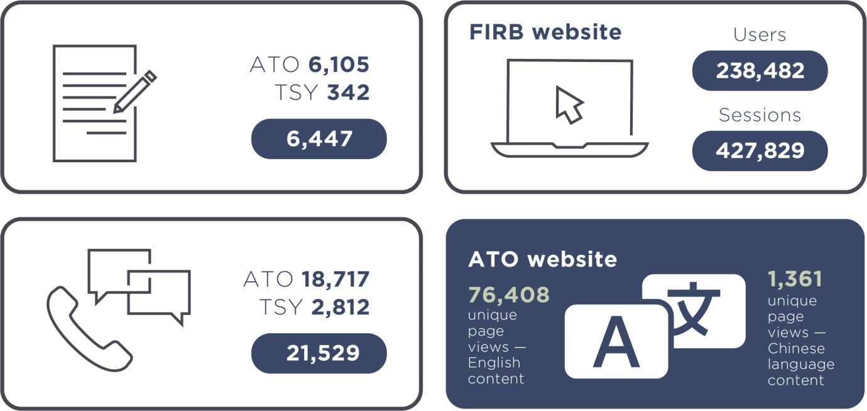

Notes:

For FIRB website statistics, a ‘user’ is a first time user during 2017‑18 and a session is a period of time that a user is on the site. If a user is inactive for 30 minutes or more, future activity is counted as a new session(s). Otherwise, ongoing activity by the same user is counted as one session.

A portion of FIRB website users will have been directed from the FIRB website to foreign investment specific content on the ATO website, for example, in relation to residential real estate.

## KPI 6 – Regulators actively contribute to the continuous improvement of regulatory frameworks

|  |
| --- |
| Measures of good regulatory performance |
| Establish cooperative and collaborative relationships with stakeholders to promote trust and improve the efficiency and effectiveness of the regulatory framework |
| Engage stakeholders in the development of options to reduce compliance costs |
| Regularly share feedback from stakeholders and performance information with policy departments or agencies and across the Division and other areas in Treasury to improve the operation of the regulatory framework and administrative processes |

#### Overview

While the areas of focus for 2018‑19 include elements that will enhance performance against this KPI, this KPI has been met.

#### Cooperative initiatives with stakeholders in 2017‑18

Given the breadth of industries and transactions that are subject to the foreign investment framework, FIRB agencies rely on building strong relationships with stakeholders and consultation partners. In 2017-18, FIRB agencies demonstrated their commitment to strengthening stakeholder relationships and information sharing, supporting discussions on improvements to the framework and on emerging issues.

* Treasury’s foreign investment team continued secondment programs with various consultation partners including the Australian Competition and Consumer Commission, the ATO, the CIC, and private law firms, to improve the implementation of the framework;
* Treasury’s 10 April 2018 *Foreign Investment Insights Day* built on existing collaborative relationships with consultation partners from federal, state and territory governments;
* FIRB agencies held frequent sessions with potential foreign investors and their representatives, foreign governments, industry peak bodies and consultation partners;
* Treasury supported the establishment of the CIC by various means; and
* Treasury initiated the Cross Agency Foreign Investment Compliance Forum to support strategic engagement across Australian Government agencies. This forum will enable ongoing improvements to the efficiency and effectiveness of compliance assurance and enforcement under the framework.

In 2017‑18 FIRB and FIRB agencies continued to encourage early engagement by stakeholders to help manage national interest issues early and effectively.

# Appendix A – Key Performance Measures

To avoid repetition, metrics that appear multiple times are not addressed against every KPI.

**KPI 1 – Regulators do not unnecessarily impede the efficient operation of foreign investors**

|  |  |
| --- | --- |
| **Measures of good regulatory performance** | **Activity-based evidence and metrics** |
| Demonstrate an understanding of the operating environment of the industry or organisation, or the circumstances of individuals and the current and emerging issues that affect the sector. | * Regular, ongoing consultations or engagement with stakeholders, including industry associations, on policies and processes. * Number of FIRB information sessions. * Number of meetings with industry associations. * Number of meetings with Government departments or agencies * Reporting will include a qualitative assessment of stakeholder satisfaction with these consultations. * Have in place processes and regularly monitor to ensure the confidentiality of information provided by applicants. |
| Minimise the potential for unintended negative impacts of regulatory activities on foreign investors. | * Incorporate feedback from stakeholders into our processes. * Seek feedback on processes from other Government departments or agencies and how this impacts on the FIRB processes. |
| Implement continuous improvement strategies to reduce the costs of compliance for foreign investors. | * A qualitative assessment on processes and appropriate changes made. * Ensure a consistent and commercially neutral approach to reviewing applications. * An internal manual is available to staff which provides guidance on reviewing applications consistently and on a commercially neutral basis. A qualitative review of staff use of the manual will be undertaken. |

**KPI 2 – Communication with foreign investors is clear, targeted and effective**

| Measures of good regulatory performance | Activity-based evidence and metrics |
| --- | --- |
| Provide guidance and information that is up to date, clear, accessible and concise through media appropriate to the target audience. | * Information on the website is clear, accessible and up to date. * Where possible, the FIRB website conforms to the Government’s accessibility guidelines and web content is aligned across ATO, FIRB and other relevant Government departments or agencies. * A qualitative assessment will be made on the clarity and timing of publications on the website. |
| Consider the impact on foreign investors and engage with industry groups and representatives of the affected stakeholders before changing policies, practices or service standards. | * In consultation with stakeholders, FIRB considers the possible impacts of potential policy changes when making recommendations to Government. * Number of FIRB information sessions. * Number of meetings with industry associations. * Number of meetings with Government departments or agencies. * A qualitative assessment of stakeholder satisfaction with the consultation process. |
| Provide decisions and advice in a timely manner, clearly articulating expectations. | * A qualitative assessment of stakeholder satisfaction on timeliness of general advice and awareness of commercial deadlines under which applicants are operating. * Notification on the decisions taken is provided as soon as possible after that decision has been reached. * Proportion of applications completed within the statutory period of 30 days. |

**KPI 3 – Actions undertaken by regulators are proportionate to the regulatory risk being managed**

|  |  |
| --- | --- |
| Measures of good regulatory performance | Activity-based evidence and metrics |
| Apply a risk-based, proportionate approach to compliance obligations, engagement and regulatory enforcement actions. Recognise the compliance record of foreign investors. | * FIRB ensures that there is sufficient and appropriate public information to aid stakeholders in complying. * FIRB website information is updated in a timely manner. * Reporting will be based on a qualitative assessment of the timeliness of web updates and, more generally, the comprehensiveness of information provided to assist stakeholders to comply. * Compliance action and scrutiny is risk-based (i.e. the level of scrutiny takes account of the compliance record and degree of risk). * Application of penalties takes account of factors such as the compliance record of the foreign investor. |
| Consider all available and relevant data on compliance. | * Compliance strategies utilise a range of information available, including information from third parties with a view to reducing the burden of compliance on the foreign investor. * Types of information sources used, such as information from other relevant Government departments or agencies. * A qualitative assessment on types of information sources used. |

**KPI 4 – Compliance and monitoring approaches are streamlined and coordinated**

| Measures of good regulatory performance | Activity-based evidence and metrics |
| --- | --- |
| Utilise existing information to limit the reliance on requests made to foreign investors and share the information among other regulators, where possible. | * Information is shared among Government departments or agencies. * Number of inter-departmental committee (IDCs) meetings. * Consult with relevant Government departments or agencies. * Draw on other Government departments’ or agencies’ information, data and systems (as appropriate) to reduce information requests to applicants where possible. * Draw on previous applications as appropriate and where possible. * Utilise public sources of information including information such as search engines and stock exchange filings. * A qualitative assessment on the effective sharing and use of existing information. |
| Base monitoring and inspection approaches on risk and where possible, takes into account the circumstance and operational needs of foreign investors. | * Regular review and assessment of agreed conditions and undertakings imposed on foreign investment proposals. * Number of reviews of conditions and undertakings in a year. |

**KPI 5 – Regulators are open and transparent in their dealings with foreign investors**

|  |  |
| --- | --- |
| Measures of good regulatory performance | Activity-based evidence and metrics |
| Ensure information on risk-based frameworks is publicly available in a format which is clear, understandable and accessible where possible. | * Clear information on the FIRB website, including for example policy documents, guidance notes and annual reports, which gives an overview of the framework, including the decision making process. * A qualitative assessment of the information on the website. |
| Be open and responsive to requests from foreign investors regarding the operation of the regulatory framework, and approaches implemented by regulators. | * Email and phone queries are adequately responded to: * Data on phone enquiries. * Number of stakeholder engagement events. |
| Ensure performance measurement results are published to ensure accountability to the public. | * Performance-related information published in annual reports in a timely manner. |

**KPI 6 – Regulators actively contribute to the continuous improvement of regulatory frameworks**

| Measures of good regulatory performance | Activity-based evidence and metrics |
| --- | --- |
| Establish cooperative and collaborative relationships with stakeholders to promote trust and improve the efficiency and effectiveness of the regulatory framework. | * A qualitative assessment of processes designed to allow active and regular engagement with stakeholders. * Number of stakeholder engagement events. |
| Engage stakeholders in the development of options to reduce compliance costs. | * Number of stakeholder events held to facilitate participation in the development and/or amendment of regulatory frameworks and a qualitative assessment of stakeholder satisfaction with those events. |
| Regularly share feedback from stakeholders and performance information with policy departments or agencies and across the Foreign Investment Division (the Division) and other areas in Treasury to improve the operation of the regulatory framework and administrative processes. | * Processes are in place to facilitate the flow of information between the regulator on policy and regulatory functions in the Division, other areas of Treasury and also other Government departments or agencies. * Number of IDC meetings held. * Number of stakeholder engagement events. * Processes in place to improve understanding of the foreign investment framework. * Attend external meetings and seminars. |

# Appendix B – Stakeholder Survey Feedback

The FIRB continues to actively engage with stakeholders and Australian businesses to provide information on the operation of the framework. Below is a summary of survey respondent feedback against each specific topic covered by the stakeholder survey. It is not meant to be a comprehensive summary of all responses received.

##### Application assessment and decision making

Most survey respondents were satisfied with the clarity and effectiveness of communication with FIRB agencies during the application assessment process. However, some stakeholders noted extended timeframes in application processing, particularly for more complex or unusual cases, due to factors such as additional time being required for FIRB agencies to receive consultation partner input.

Half of survey respondents were ‘very satisfied’ with the transparency of decisions made for applications. The remainder of respondents were ‘somewhat satisfied’. Some comments were received in relation to the consistent application of tax conditions.

##### New FIRB Application Portal design

Half of survey respondents were ‘very satisfied’ or ‘somewhat satisfied’. Comments received included an appreciation for the opportunity to provide input into the new design and that the transition process was well communicated. There were differing views on how the Portal should handle multi‑faceted complex transactions.

##### Public guidance and advice

Over half of survey respondents were ‘very satisfied’ or ‘somewhat satisfied’ with the clarity and effectiveness of guidance and advice provided via the FIRB website and other means. Feedback received on the guidance notes and the level of information and detail have been positive, particularly given the complexity of the Act. Some respondents noted that the guidance notes do not cover some scenarios. Increasing consistency between guidance notes and legislation was raised as well as ensuring the guidance builds on the Act’s requirements. Editorial changes to documents on the FIRB website are not publicised and there have been requests for these to be shown, by making available tracked versions of applicable documents.

##### Receptiveness and accessibility

Treasury’s receptiveness and accessibility to feedback and discussions on foreign investment matters was rated as ‘extremely’ or ‘very’ receptive and accessible by over half of the survey respondents. Some comments commended FIRB agencies for their level of interaction with applicants and for being open and transparent when resolving matters. Some respondents noted the scope to build both ATO and Treasury capability.

##### Foreign investment compliance

In relation to conditions being proportionate to risk and clarity of advice on how to meet conditions, more than half of respondents were either ‘very satisfied’ or ‘somewhat satisfied’.

Comments included that:

* generally Treasury was careful to ensure that conditions imposed do not adversely impact commercial operations;
* Treasury has been responsive to submissions regarding the appropriateness of particular conditions; and
* the wording of conditions can be an issue particularly if they require a foreign person to demonstrate that they have not taken an action.

##### Pilot compliance audits

Over half of survey respondents found the audit requests for information very easy to understand and clearly linked to the imposed conditions. However, over half of survey respondents found the process to only be ‘somewhat efficient’. Feedback received indicated that the process was one of ‘trial and error’ to determine exactly what evidence was required. However stakeholders understood the audit program was in its infancy and noted that the expectations of auditors were reasonable. Some audit participants commented that there was not enough consideration of the history of how conditions were reached and that the approach to compliance was at times too strict.

Over half of survey respondents found the pilot compliance audit process assisted them to improve their understanding of compliance obligations and how to meet them. Auditors were rated as either ‘extremely professional’ or ‘very professional’. Feedback from audit participants amongst the stakeholders was that they found the process collaborative and extremely useful in preparing for their first conditions report. This was balanced with uncertainty felt by stakeholders regarding whether or not the audit staff had access to the full background of applications and understood the intent or spirit of the conditions.

# Appendix C – Quantitative Data

|  |  |  |  |  |  |  |
| --- | --- | --- | --- | --- | --- | --- |
| Metric  (KPI number) | 2016‑17 | | | 2017‑18 | | |
| ATO Residential real-estate | Treasury Non residential | Total | ATO Residential real-estate | Treasury Non residential | Total |
| FIRB information sessions (1 & 2) | 25 | 16 | **41** | 5 | 65 | **70** |
| Interdepartmental committees (IDCs: 4 & 6) | 9 | 14 | **23** | 1 | 35 | **36** |
| Stakeholder engagement events(1, 2, 4 & 6)1 | 25 | 242 | **267** | 25 | 388 | **413** |
| Phone calls handled on the FIRB Enquiries Line (5)2 | 17,965 | 3,818 | **21,783** | 18,717 | 2,812 | **21,529** |

Notes:

1. This comprises the metrics of other government consultation (KPI no. 1, 2, 4 & 6) and industry consultation (KPI no. 1, 2 & 6).

2. Does not include calls made directly to case officers or during the course of an application review.

For other statistics and data on the administration of the framework, including applications considered statistics and compliance data, see the FIRB Annual Report.

1. Information on the FIRB and FIRB agency operational costs for a financial year is included in Chapter 1 of the FIRB Annual Report for the financial year. For more information on the FIRB and the framework see www.firb.gov.au.
2. The Treasury is also responsible for providing advice on Australia’s foreign investment policy and progressing legislative changes where required.
3. To provide greater transparency of foreign ownership in Australia, the Government has established agricultural land and water entitlements registers. Reports for registers are made available under Publications on the FIRB website at www.firb.gov.au. The ATO is establishing a register for residential real estate.
4. For further information on the examination and approval process, see Appendix C of the 2017‑18 FIRB Annual Report.
5. For further information on applications, approvals and compliance actions, see the 2017‑18 FIRB Annual Report.
6. Further information on these regulatory changes is available in FIRB Annual Reports.
7. The new FIRB Application Portal, which is the online application portal for non‑residential applications, went live on 2 July 2018.
8. The outcomes of the ANAO review are discussed at KPI 4. The ANAO report is available at https://www.anao.gov.au/work/performance-audit/compliance-foreign-investment-obligations-residential-real-estate.
9. For further information on the Regulator Performance Framework, see https://docs.jobs.gov.au/documents/regulator-performance-framework.
10. The measures of good performance, and corresponding evidence metrics were published on the FIRB website before the reporting period commenced and are at [Appendix A](#Appendix A – Key Performance Measures).
11. See [Appendix C](#Appendix C – Quantitative Data).
12. This refers to regulated entities under the framework (that is, foreign persons) and their advisers. They include members of the Foreign Investment Committee of the Law Council of Australia, various legal firms and a range of key industry stakeholders.
13. Data on compliance activities is available in the FIRB annual report for the period.
14. See **Appendix B** for a summary of the survey responses.