Foreign Investment

Review Board

Annual Report  
2015‑16

 Commonwealth of Australia 2017

ISSN 0155‑0802 (print)  
ISSN 2204‑0927 (web)

This publication is available for your use under a [Creative Commons Attribution 3.0 Australia](http://creativecommons.org/licenses/by/3.0/au/deed.en) licence, with the exception of the Commonwealth Coat of Arms, the Treasury logo, photographs, images, signatures and where otherwise stated. The full licence terms are available from <http://creativecommons.org/licenses/by/3.0/au/legalcode>.



Use of Treasury material under a [Creative Commons Attribution 3.0 Australia](http://creativecommons.org/licenses/by/3.0/au/deed.en) licence requires you to attribute the work (but not in any way that suggests that the Treasury endorses you or your use of the work).

*Treasury material used ‘as supplied’.*

Provided you have not modified or transformed Treasury material in any way including, for example, by changing the Treasury text; calculating percentage changes; graphing or charting data; or deriving new statistics from published Treasury statistics — then Treasury prefers the following attribution:

*Source*: *The Treasury.*

**Derivative material**

If you have modified or transformed Treasury material, or derived new material from those of the Treasury in any way, then Treasury prefers the following attribution:

*Based on The Australian Government the Treasury*

**Use of the Coat of Arms**

The terms under which the Coat of Arms can be used are set out on the It’s an Honour website (see [www.itsanhonour.gov.au](http://www.itsanhonour.gov.au)).

**Other uses**

Inquiries regarding this licence and any other use of this document are welcome at:

Manager  
Communications   
The Treasury  
Langton Crescent   
Parkes  ACT  2600  
Email: [medialiaison@treasury.gov.au](mailto:medialiaison@treasury.gov.au)

A copy of this document appears on the Foreign Investment Review Board website at [www.firb.gov.au](http://tweb/sites/mg/fitpd/FIRB/Annual%20Report%20(written%20only)/2015-16/Draft/www.firb.gov.au).

29 March 2017

The Hon Scott Morrison MP

Treasurer

Parliament House

CANBERRA ACT 2600

Dear Treasurer,

I am pleased to present the annual report of the Foreign Investment Review Board for the year ended 30 June 2016. The report has been prepared in accordance with the Board’s responsibility to advise the Government on foreign investment matters.

Australia continued to be a significant destination for foreign investment in 2015‑16. The value of approved investment rose to around $248 billion, an increase of over $55 billion on 2014‑15. This was predominantly driven by increased investment in the real estate sector. China ($47.3 billion) remains our largest source of approved foreign investment, followed by the United States ($31.0 billion).

One of the key roles of the Board is to examine significant and sensitive foreign investment applications and advise on the national interest implications. A range of high profile investment applications were examined in 2015‑16, including the sale of a NSW electricity transmission and distribution business and the bid by Moon Lake Investments to acquire the Van Dieman’s Land Company.

In 2016, the Board reached the significant milestone of forty years since it was first established to provide advice on foreign investment proposals. The other significant event was the commencement of the reforms to strengthen the foreign investment framework on 1 December 2015. These reforms represented the most substantial change to the framework during the Board’s forty‑year history.

This year’s annual report includes a timeline of key events and developments in Australia’s foreign investment framework. While the sources of investment may have changed and the sectors and industries have shifted, foreign investment has been integral to the Australian economy for many years and is essential to Australia’s economic growth and prosperity.

Yours sincerely

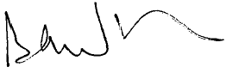

Brian Wilson  
Chairman

Contents

Main Points vii

Chapter 1: The Foreign Investment Review Board 1

Board membership 2

Operational costs in 2015‑16 4

Reforms 6

Chapter 2: Foreign Investment Trends 9

Foreign investment — the Australian perspective 9

History of foreign investment in Australia 12

Chapter 3: Foreign Investment Proposals Data 15

Proposals data overview 16

Overall applications considered 17

Chapter 4: Foreign Investment Compliance 39

Residential compliance investigations and outcomes 42

Penalties 45

Appendix A Methodological and Data Caveats 47

Appendix B Examination and approval process 51

Appendix C Glossary 55

# Main Points

* The most significant reforms to Australia’s foreign investment framework in 40 years were introduced in 2015‑16. The reforms were focused around building a stronger compliance program and a fees system to fund it, while maintaining an assessment system based on the national interest.
* There were a number of high profile sensitive cases, dominated by the privatisation of state and territory electricity network assets and Australian ports of national significance. Strong interest in these assets is reflected in the increased number of business approvals in 2015‑16.
* Privatisation processes were a significant focus of the Board, which actively engaged with relevant state and territory governments, their advisers and relevant Commonwealth agencies as well as proposed bidders and their advisers. The increasing importance of such cases saw further policy development in relation to managing the national security risks around assets in critical sectors.
* Australia continued to attract a large volume of foreign investment applications. The number of foreign investment approvals grew to 41,445 compared with 37,953 in 2014‑15, largely driven by residential real estate transactions. This represented $247.9 billion of proposed investment in comparison to $191.9 billion in 2014‑15.
* For the third year in a row, China was the largest source of approved investment ($47.3 billion), driven by continuing approvals in the real estate sector. Overall the United States was the second largest source of approved investment but the largest investor in non‑real estate sectors.
* Lower screening thresholds introduced in 2015 saw an increased flow of agricultural land applications. The first report of the Foreign Ownership of Agricultural Land Register showed that, as at 30 June 2016, there were foreign interests in 13.6 per cent of agricultural land by area. The top two source countries were the United Kingdom and the United States.
* Proposed investment in residential real estate continues to be focused on investment in new dwellings, which is in line with the policy to encourage residential real estate investment that increases housing supply.
* High value commercial property approvals increased in 2015‑16; up by more than $10 billion and 100 approvals on 2014‑15. Some of this growth can be explained by multiple applicants for two large transactions.
* Since assuming the role in 2015, the Australian Taxation Office has worked to increase compliance with and enforcement of the foreign investment rules for real estate. In 2015‑16, divestments were issued in 39 cases for residential properties valued at $48.7 million.

# Chapter 1: The Foreign Investment Review Board

The Foreign Investment Review Board (the Board) is a non‑statutory body established in 1976 to advise the Treasurer and the Government on foreign investment matters. The Board’s functions are advisory only. Responsibility for making decisions on foreign investment policy and investment proposals rests with the Treasurer.

During 2015‑16, the Board comprised six part‑time members and a full‑time Executive Member. The Government seeks to attract members of the Board with deep knowledge and experience in a range of sectors that can actively contribute to the Board’s responsibilities. Strong probity procedures are in place to ensure any conflicts of interest that may occur are managed appropriately.

### Board Responsibilities:

* Examine proposed investments that are subject to the *Foreign Acquisitions and Takeovers Act 1975* (the Act) and supporting legislation, and to make recommendations to the Treasurer and other Treasury portfolio ministers on the national interest implications of these proposals.
* Provide advice on the operation of the foreign investment framework and related matters.
* Provide guidance to foreign persons and their representatives or agents on the operation of the foreign investment framework.
* Monitor and ensure compliance with the framework.
* Foster awareness and understanding, both in Australia and abroad, of Australia’s policy on foreign investment.

## Board membership

**Mr Brian Wilson**

*Chairman since 16 April 2012*

*Board member since 10 December 2009*

Mr Wilson is Deputy Chancellor of the University of Technology Sydney, a non‑executive director of Bell Financial Group and a member of the Payments System Board of the Reserve Bank of Australia. He was a member of the Commonwealth Government’s Review of Australia’s Superannuation System, the Specialist Reference Group on the Taxation of Multinational Enterprises in Australia and the Australian Taxation Office Superannuation Reform Steering Committee. Mr Wilson retired in 2009 as a Managing Director of the global investment bank Lazard, after co‑founding the firm in Australia in 2004 and was previously a Vice‑Chairman of Citigroup Australia and its predecessor companies.

**Mr Michael D’Ascenzo AO**

*Board member since 2 January 2013*

Mr D’Ascenzo is recognised internationally for his leadership and expertise in taxation, administration, governance and policy. Mr D’Ascenzo was Commissioner of Taxation from January 2006 to December 2012. In January 2010 he was appointed an Officer of the Order of Australia for service to public administration and in 2012 he was awarded the Chartered Accountants’ Federal Government Leader of the Year. Mr D’Ascenzo is currently a member of the Clean Energy Regulator, as well as an adjunct professor at the University of New South Wales and a professorial fellow at Melbourne University. He was also a non‑executive director of Australia Post 2013 to 2016.

****Mr Patrick Secker**

*Board member since 17 December 2013*

Mr Secker brings extensive agricultural sector experience to the Board. He was a primary producer, agricultural retailer and company director before entering politics as the member for the rural South Australian electorate of Barker. Mr Secker has a degree in economics and has participated in a number of parliamentary agricultural committees over many years. His parliamentary career included serving as Opposition Whip and Deputy Speaker of the House of Representatives. Mr Secker has also served as an elected member in local government for 11 years including deputy mayor, chairman of various committees including planning, library, development plan and works. He also chaired the Southern and Hills LGA and co‑chaired the South Australian Government Mt Lofty Ranges Strategy Review.

**Ms Alice Williams**

*Board member since 16 July 2015*

Ms Williams has over 25 years of senior management and Board level experience in the corporate and Government sectors. Ms Williams was previously a Director at JP Morgan, NM Rothschild and Ansett Australia. She has been a consultant to listed corporations in Australia and the Gulf States and state and federal regulatory bodies. She is a former director of the Australian Accounting Standards Board, State Trustees and a Commissioner of the Victorian Competition and Efficiency Commission. Ms Williams’ current directorships include Cooper Energy Ltd, Equity Trustees Ltd, Djerriwarrh Investments Ltd, Defence Health, Racing Victoria and Barristers Chambers Limited.

**Mr David Irvine AO**

*Board member since 3 December 2015*

Mr Irvine has significant national security expertise as a former Director‑General of both the Australian Security Intelligence Organisation and the Australian Secret Intelligence Service. He is also a former Australian Ambassador to China and former Australian High Commissioner to Papua New Guinea. He is currently an Adjunct Professor in the Australian Graduate School of Policy and Security at Charles Stuart University and a member of the National Archives of Australia Advisory Council.

**Mr David Peever**

*Board member since 1 February 2016*

Mr Peever retired as Managing Director of Rio Tinto Australia in October 2014 after 27 years with Rio Tinto. Mr Peever is also Chairman of Cricket Australia and a Director of the International Cricket Council, a Non‑Executive Director of the Australian Foundation Investment Company and the Melbourne Business School. He is a member of the Prime Minister’s Indigenous Advisory Council and the Chief of Defence’s Gender Equality Advisory Board. He chaired the Minister of Defence’s First Principles Review of Defence and following the acceptance of the Review by Government, now chairs the Oversight Board which helps guide implementation of the Review’s recommendations. Mr Peever is also a non‑executive director of the Stars Foundation.

**Mr Rob Donelly**

*Executive Member of the Board since 15 September 2014*

The position of Executive Member is held by the Division Head of Treasury’s Foreign Investment Division. The Executive Member provides the link between the Board and the Treasury, which provides secretariat support to the Board.

The Foreign Investment Review Board Secretariat

The Foreign Investment Review Board is supported by a Secretariat which assists the Board in fulfilling its responsibilities. The Secretariat consists of Treasury’s Foreign Investment Division and the International Programs Division of the Australian Taxation Office.

### Treasury

The Foreign Investment Division is responsible for the day‑to‑day administration of the foreign investment framework in relation to business, agriculture and commercial land proposals. The Division also provides advice to the Board and the Government on foreign investment issues and policy.

### The Australian Taxation Office

Since May 2015, the Australian Taxation Office (ATO) has handled residential real estate compliance activities. Since 1 December 2015 the ATO has administered all aspects of foreign investment in residential real estate including screening of applications. The ATO also has responsibility for the collection of all foreign investment application fees and for administering the register of foreign ownership of agricultural land.

## Operational costs in 2015‑16

### The Board $0.4 million

Remuneration of Board members was around 90 per cent of total Board expenses, with the remainder expended on travel, car hire and incidentals. Board members’ fees are determined by the Remuneration Tribunal.

### Treasury $7.1 million

These expenses mainly comprised employee salary and administrative costs. Over the course of 2015‑16, the Division employed an average of 46 full‑time Treasury staff and a number of external contractors and consultants including lawyers from the Australian Government Solicitor.

### The Australian Taxation Office $9.2 million

Over the course of 2015‑16, ATO staffing built to 55 full‑time equivalents with staff employed across the residential real estate application screening process, data matching and compliance activities, and the development and maintenance of foreign ownership registers with total expenditure of $4.2 million. A further $5 million was allocated for IT operating costs and corporate overheads.

A $10 million capital payment was allocated to the development of IT systems to support the introduction of the new fee regime, the foreign ownership registers and the residential real estate application process, compliance and penalty programs.

Stakeholder engagement

Regular and meaningful engagement with the investment community is instrumental to a functional and robust foreign investment framework. Stakeholder engagement is a ‘two‑way’ avenue, enabling the Board and Secretariat to provide information on the framework as well as obtaining valuable feedback on the framework and the broader investment context.

As part of screening cases the Secretariat also engages with other government agencies to seek their advice on matters considered under the national interest test, where they have expertise. For example, national security agencies on national security matters.

To communicate new requirements under the reforms that were introduced on 1 December 2015, Treasury held 15 face‑to‑face sessions with the investment community in Brisbane, Melbourne, Perth and Sydney. Since then, the FIRB Secretariat has continued to seek feedback on the regime from a range of stakeholders, including meeting with the Foreign Investment Committee of the Law Council of Australia three times during 2016.

Integral to Treasury’s efforts to better engage with the broader community has been locating members of the Division in Treasury’s Sydney Office. Having a Treasury team based in Sydney full‑time has allowed the FIRB Secretariat to pursue a comprehensive stakeholder engagement strategy focusing on:

* building and maintaining relationships to understand perspectives from the investment community;
* exploring specific trends and issues; and
* providing and receiving feedback on the regime, including the reforms.

Between September 2015 and December 2016, Treasury, led by the Sydney Office, had over 90 meetings with a range of external stakeholders including law firms, investors, investment banks, industry bodies and other industry participants. Four investor forums were also held in 2016, in which investors were able to hear directly from senior FIRB representatives and provide valuable and timely feedback about the foreign investment regime.

The ATO has also undertaken significant stakeholder engagement activities in relation to residential real estate and the agricultural land register. This includes developing targeted communications to raise awareness, particularly for existing and potential investors, and establishing a Foreign Investment Reforms Working Group which meets regularly with key agents, accounting and law firms. The ATO also had over 1,200 attendees, including foreign investors and advisors, at face‑to‑face events held across Australia from March 2015 to May 2016.

Further detail on the ongoing stakeholder engagement being undertaken by and on behalf of the Board is included in the Regulator Performance Framework Report 2015‑16.

The Foreign Investment Regime

The Australian Government seeks to maintain an open foreign investment regime which balances encouraging foreign investment flows while ensuring foreign investment is not contrary to the national interest.

The Australian Government seeks to ensure that foreign investment is appropriately monitored and benefits all Australians. This Government, like previous governments, supports a case‑by‑case approach to considering foreign investment proposals. Under the *Foreign Acquisitions and Takeovers Act 1975*, the Treasurer can block proposals found to be contrary to the national interest, or can impose conditions on an investment to address national interest concerns.

## Reforms

This reporting period saw the most significant changes to the regime in over 40 years. Following public consultation on 2 May 2015 the Government announced a package of reforms to strengthen the foreign investment framework. The reforms commenced on 1 December 2015.

The key elements of the reforms included:

* increased enforcement of the residential real estate rules by establishing a dedicated unit within the ATO to review cases and strengthen compliance;
* stronger sanctions and more flexible penalties to make it easier to pursue foreign investors that breach the rules;
* application fees to ensure that Australian taxpayers no longer have to fund the cost of administering the system;
* increased scrutiny around agricultural investments by lowering the applicable screening thresholds; and
* improved transparency through a comprehensive register of foreign ownership of agricultural land.

The reforms also provided an opportunity to modernise the regime and make it clearer for investors. For example, one of the key improvements was the incorporation of former policy‑only requirements (such as those relating to foreign government investors) into the legislative framework to increase legal certainty for investors.

Compliance costs and complexity were reduced by removing some routine cases from the system and more closely aligning key concepts and definitions with other corporate legislation such as the *Corporations Act 2001*.

### Foreign ownership registers

As part of the 2015 foreign investment reforms, the Government announced three registers to increase transparency around foreign ownership of Australian assets.

The Agricultural Land Register was announced on 11 February 2015 and the first report was released on 7 September 2016. The Government also committed to introducing a Register of Foreign Ownership of Water Entitlements (Water Register). This will provide greater oversight of the level of foreign ownership of water assets.

The ATO will administer the Water Register alongside the Agricultural Land Register. From 1 July 2017, foreign persons will be required to register information about their existing water holdings and subsequent acquisitions of water entitlements and rights with the ATO.

The Australian Government is also providing funding to the states and the ACT under a National Partnership Agreement to enable them to undertake system changes to transfer the data on sales and transfers of real property involving foreign persons to the ATO in order to establish a National Register of Foreign Ownership of Land Titles.

Agricultural Land Register

The Agricultural Land Register was introduced in 2015 to increase transparency around the level of foreign ownership of agricultural land. All foreign investors with an interest in agricultural land are required to register that interest, regardless of the value of the land, within 30 days of a change of ownership.

Treasury has been actively involved in the establishment and implementation, with the ATO administering the Register and receiving information directly from foreign investors. Foreign persons who already owned agricultural land had until 29 February 2016 to register that interest with the ATO.

The first report from the Register was released on 7 September 2016 and includes aggregated data on the number of properties that are foreign owned, by land size, by state and territory, and by land use as at 30 June 2016. The report found that foreign investors had an interest in 13.6 per cent of Australian agricultural land by area. The top five source countries for foreign investment in Australian agricultural land at this date were:

* UK — 27.5 million ha (52.7 per cent of foreign‑owned agricultural land, or 7.2 per cent of total agricultural land)
* USA — 7.7 million ha (14.8 per cent of foreign‑owned agricultural land or 2 per cent of total agricultural land)
* Netherlands — 3.0 million ha (5.7 per cent of foreign‑owned agricultural land or 0.8 per cent of total agricultural land)
* Singapore — 1.9 million ha (3.6 per cent of foreign‑owned agricultural land or 0.5 per cent of total agricultural land)
* China — 1.5 million ha (2.8 per cent of foreign‑owned agricultural land or 0.4 per cent of total agricultural land)

Critical infrastructure changes

The *Foreign Acquisitions and Takeovers Regulation 2015* was amended in 2016 to remove the exemption for private foreign investors acquiring an interest in critical infrastructure assets purchased directly from state and territory governments.

From 31 March 2016, foreign investment approval has been required for critical infrastructure assets for sale by state and territory governments to both private and foreign government investors.

Critical infrastructure includes public infrastructure (an airport or airport site; a port; infrastructure for public transport; electricity, gas, water and sewerage systems); existing and proposed roads, railways, inter‑modal transfer facilities that are part of the National Land Transport Network or are designated by a state or territory government as significant or controlled by the government; telecommunications infrastructure; and nuclear facilities.

The 2015‑16 period saw an increasing number of state and territory asset privatisations. The Board and FIRB Secretariat pro‑actively engaged with state and territory governments through this period as well as potential bidders and advisers.

The increasing importance of such cases saw further policy development in relation to managing the national security risks around assets in critical sectors.

On 23 January 2017, the Treasurer and Attorney‑General launched a dedicated Critical Infrastructure Centre to manage the complex and evolving national security risks to Australia’s critical infrastructure.



# Chapter 2: Foreign Investment Trends

## Foreign investment — the Australian perspective

Australia has traditionally relied on inward foreign investment to meet the shortfall between domestic saving and domestic investment.

Foreign investment plays an important and beneficial role in the Australian economy because it helps drive economic growth, creates skilled jobs, improves access to overseas markets and enhances productivity.

The stock of foreign direct investment (FDI) in Australia at the end of December 2015 stood at $735.5 billion. This was an increase of about $49.3 billion (or a little more than seven per cent) on 2014.

FDI has consistently made up around one quarter of total foreign investment over the last ten years.

By supplementing national saving, foreign capital allows Australia to enjoy higher living standards now (by financing current consumption), and into the future (by providing finance for investment which in turn should lead to higher growth in national income and hence living standards) than would otherwise be sustainable. FDI provides a stable source of financing that brings with it technology and skills from overseas.

Historically, Australia has experienced successive waves of foreign investment.

At the beginning of the 20th century, most foreign investment came from the United Kingdom (UK). After World War II, investment surged from the United States (US), as multi‑nationals invested in Australia’s growing industries, including manufacturing and mining.

In more recent times, there has been an increase in investment from Asia — first, large parcels of investment from Japan beginning in the 1980s, and now, increasingly from emerging economies such as China. Chart 2.1 shows the stock of FDI in Australia from the top 5 investing countries: the US, Japan, the UK, the Netherlands and China.

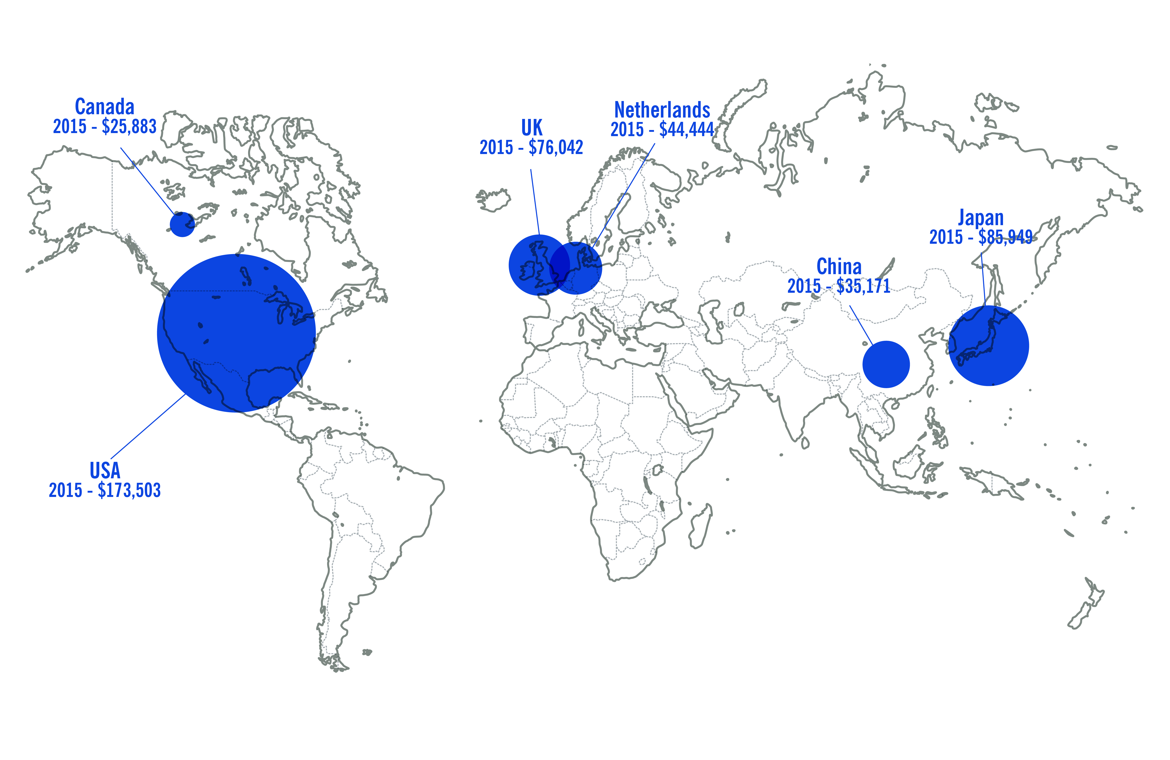Chart 2.1: Stock of FDI in Australia by country as at 31 December 2015 ($m)

Source: ABS 5352.0

Chart 2.2 depicts trends in FDI levels from Australia’s top five largest inward investor countries over time. The US remains Australia’s dominant inward investor country, accounting for almost a quarter (23.6 per cent) of the total stock of FDI at the end of 2015.

At the end of 2015, Japan (11.7 per cent of total FDI stock) overtook the UK (10.3 per cent of total FDI stock) for the first time as Australia’s second major source of inward FDI.

China was the fifth largest source country of FDI stock in Australia, accounting for around 4.8 per cent of all FDI in Australia.

Chart 2.2: Stock of FDI in Australia



Source: ABS 5352.0

Note: China excludes SARs and Taiwan.

In recent times, the mining sector has been the main target industry for FDI, representing 40.1 per cent of total FDI stock in Australia at the end of 2015. However, the growth in FDI stock in the mining sector has slowed since the peak of the mining investment boom in 2011. In 2015, the stock of mining investment grew by 6.4 per cent, less than half the growth rate of 13.8 per cent in 2014.

The second largest recipient of FDI is the manufacturing sector, at 11.7 per cent of the total FDI stock at the end of 2015. However, the stock of FDI in the manufacturing sector remains below its 2013 level.

The real estate sector recieved the third largest amount of total FDI stock at 8.7 per cent of total FDI stock at the end of 2015. This reflects a significant growth of 36.8 per cent on the previous year.

## History of foreign investment in Australia

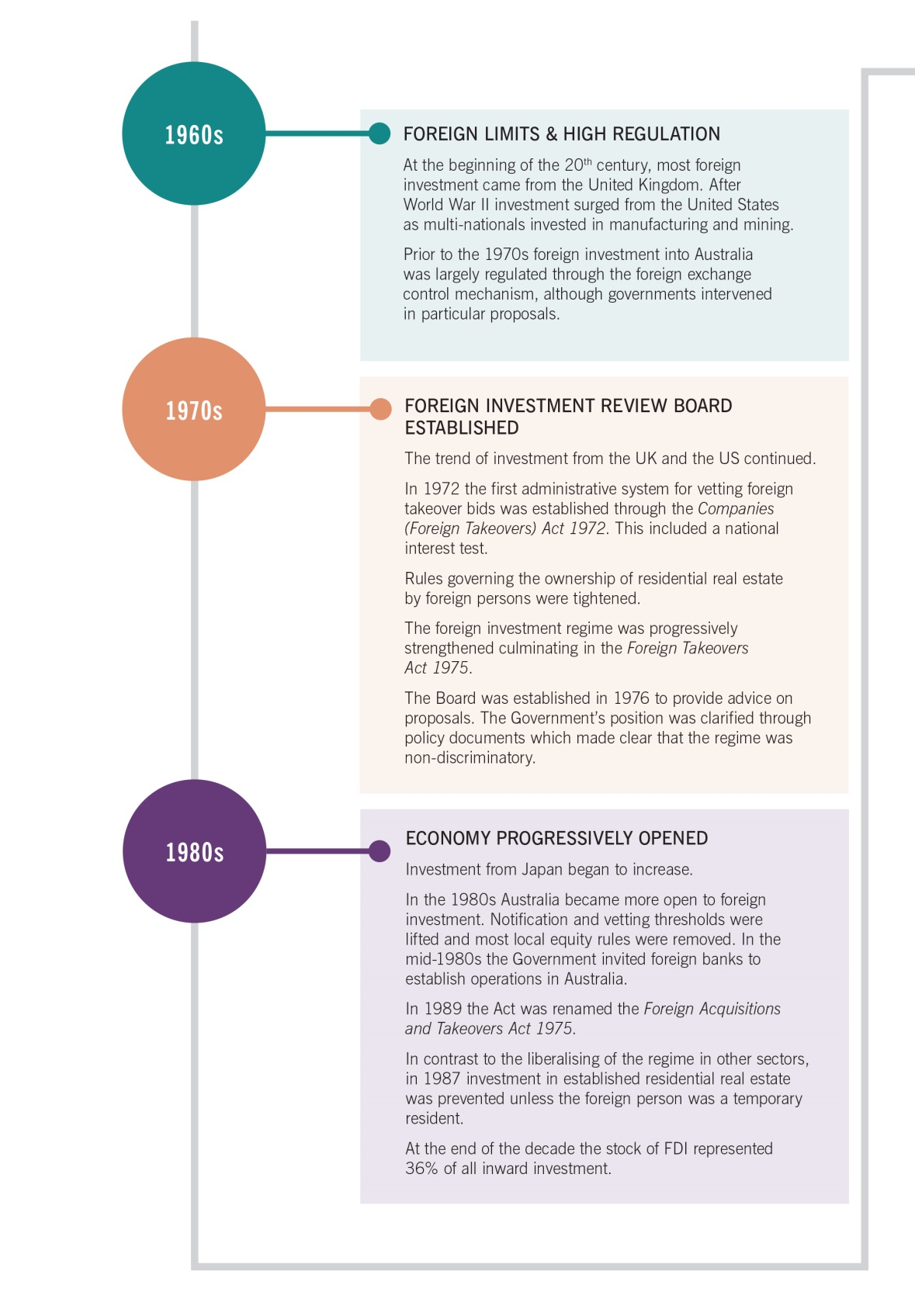

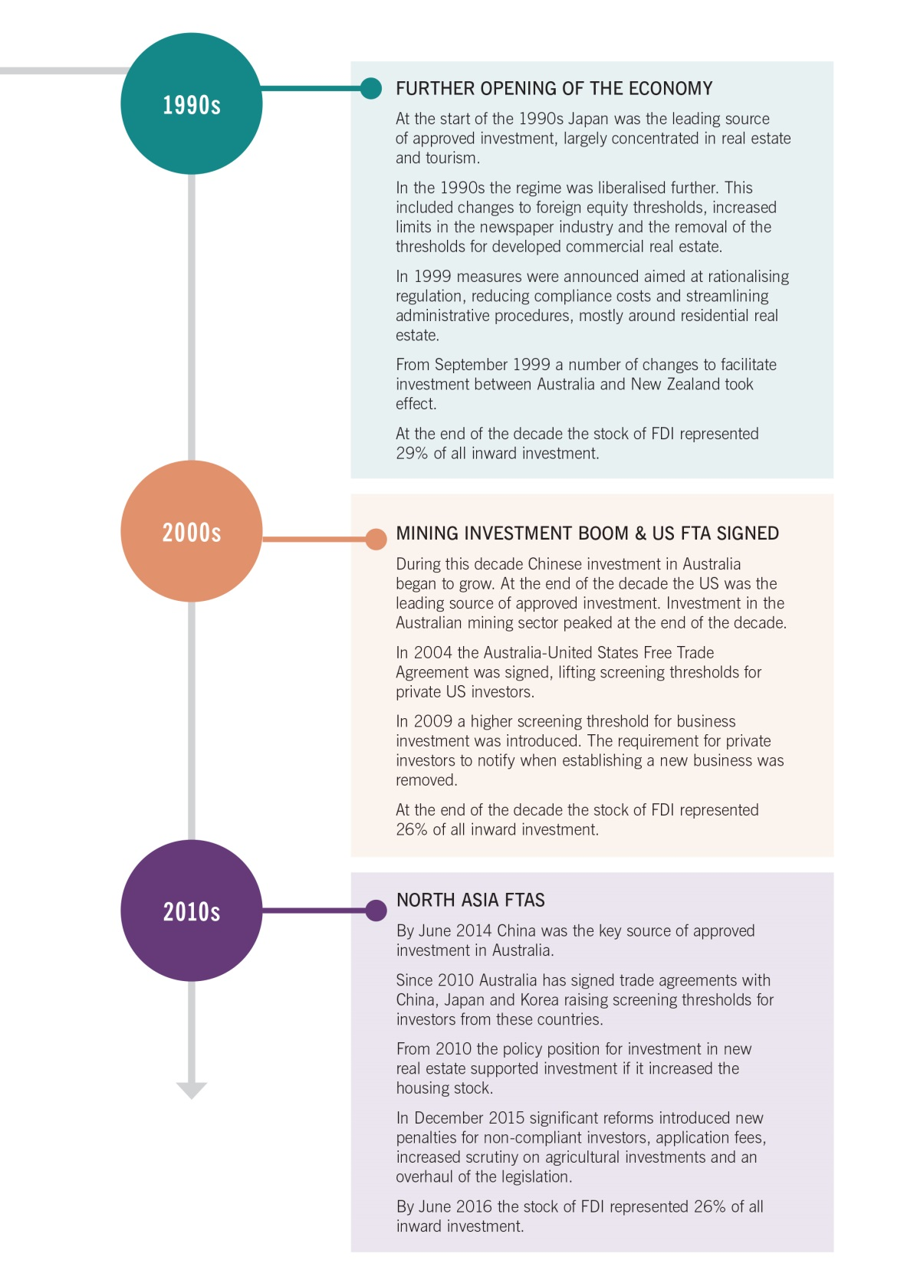



# Chapter 3: Foreign Investment Proposals Data

This chapter provides an overview of applications considered in 2015‑16. It provides information on proposed investment falling within the scope of Australia’s Foreign Investment Policy (the Policy), the *Foreign Acquisitions and Takeovers Act 1975* (the Act) and supporting legislation.

Features of the Foreign Investment Review Board statistics

This section analyses all investment proposals that were finalised (approved, rejected, withdrawn or exempt) during 2015‑16, irrespective of the date the application was submitted. The term ‘proposed investment’ is used widely throughout this report. The value of proposed investment is an estimate of the following at the time of the approval:

* acquisition costs (including shares, real estate or other assets); and/or
* costs of both establishment and development in the case of new businesses.

There are a number of caveats that need to be applied in interpreting this data and these are set out in detail at Appendix A. Importantly, the approvals data do not measure total foreign investment made in any year or changes in net foreign ownership levels in Australia. Trends in actual investment are measured by the Australian Bureau of Statistics (ABS) and show a more stable trend over time than the approvals data. The foreign investment trends section of this report provides the actual investment data.

In addition, policy changes, legislative changes and changes to reporting methodologies over time can limit the comparability of data.

## Proposals data overview

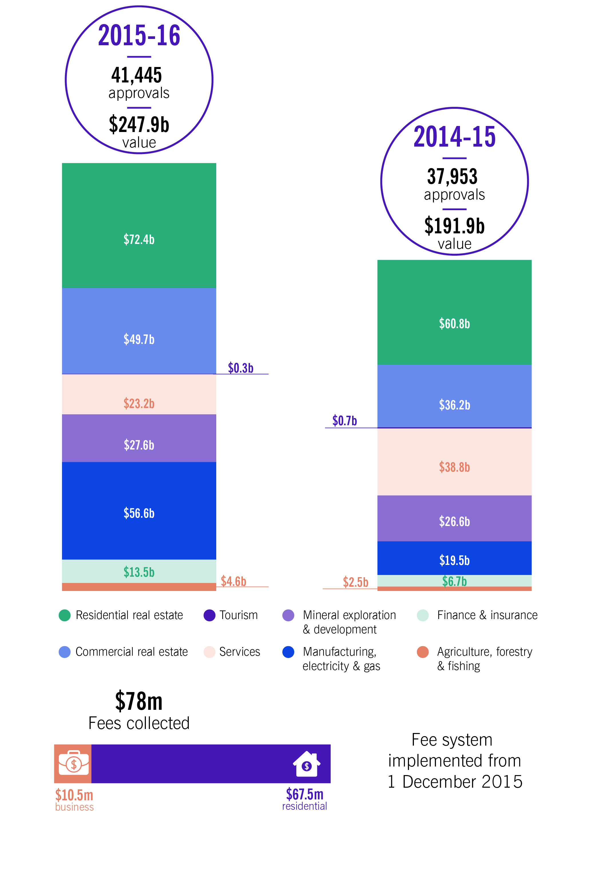

When considering this data please note:

Approvals data do not measure total foreign investment made in any year or changes in net foreign ownership levels in Australia. Approvals data can be impacted by large one‑off proposed transactions, affecting the comparability of industry data across years.

## Overall applications considered

In 2015‑16, the number of applications approved grew to 41,445 compared with 37,953 in 2014‑15. This represented $247.9 billion of proposed investment, up from $191.9 billion in 2014‑15.

There was a significant increase in the number of applications submitted in the immediate lead‑up to 1 December 2015. Around 16,000 applications were received in November 2015, including almost 8,000 in the week before 1 December 2015. By comparison, the average number of monthly applications for 2014‑15 was around 3,200 per month. The short term increase is most likely attributable to the introduction of fees for applications submitted from 1 December 2015.

Fewer applications were approved with conditions during 2015‑16 than in 2014‑15 although the number of conditional business approvals increased.

This can be explained by an increase in the number of approvals for new dwellings (which are not typically subject to conditions on approval) matched with a decrease in approvals for established dwellings (which are typically subject to conditions on approval). This is consistent with the Government’s policy to channel foreign investment in residential real estate into investment that increases the housing stock. However, the value of applications approved with conditions increased significantly, reflecting large, one‑off transactions in sensitive sectors.

### Withdrawn applications

In 2015‑16, 1,319 applications were withdrawn. Prior to the December 2015 reforms, an applicant may have withdrawn and resubmitted their application to extend the statutory deadline. However, as part of the reforms, the extension process was simplified so the period to consider an application can be extended when requested by the applicant. We expect to see a relative decline in the number of applications that are withdrawn in future years.

### Exempt applications

In 2015‑16, there were 244 exempt applications where the action was out of scope of the Act.

As part of the December 2015 reforms to modernise and simplify the legislation, some acquisitions which had required screening prior to 1 December 2015 no longer required screening from that date. Where an application was received, but a decision not made before 1 December 2015, and the application subsequently did not require screening, the applicant was notified that the acquisition did not require approval from the Treasurer.

### Variations

The Act allows investors to apply for variations to no objection notifications, to conditions that are imposed in no objection notifications and to exemption certificates.

The Treasurer may vary the content of a no objection notification or exemption certificate if the Treasurer is satisfied that it is not contrary to the national interest. Variation applications are considered on a case‑by‑case basis.

### Rejected applications

There were five applications which were prohibited from proceeding. Four of these were in the residential real estate sector and one in the commercial real estate sector.

Table 3.1: Applications considered: 2012‑13 to 2015‑16 (number of proposals)



Note: Figures include corporate reorganisations (99 in 2015‑16). This data is excluded in other approvals analysis unless otherwise noted.

2015‑16 figures were impacted by the 1 December 2015 reforms, which may impact comparability of data. The 2014‑15 figures have also been revised. Further details are at Appendix A.

Table 3.2: Applications decided: 2012‑13 to 2015‑16 (value of proposed investment)



Note: Totals may not add due to rounding.

‘0.0’ indicates a figure of less than $50 million.

Figures include corporate reorganisations (99 in 2015‑16, including 14 in the real estate sector).

The 2015‑16 figures were impacted by the 1 December 2015 reforms, which may affect data comparability. The 2014‑15 figures have also been revised. Further details are at Appendix A.

### Approval values

The majority of approvals for investments below $50 million relate to residential real estate (because of the requirement that all residential acquisitions must be notified). There continued to be an increase in the number of residential real estate approvals in 2015‑16. However, the rate of growth was significantly lower than in 2014‑15.

There was a distinct increase in the number and value of approvals for proposals valued at $2 billion or above. This growth in high value transactions accounted for most of the increase in the total value of approvals. It reflects an increase in foreign investment into infrastructure assets as states and territories increasingly seek to privatise these assets and the scope of the asset class diversifies.

There were a number of significant high‑value transactions during 2015‑16 where foreign investment approval may have been required by one or more parties. As such, the number and value of approvals may reflect a figure that is significantly higher than would actually proceed, particularly for high value transactions as represented in Table 3.3.

Table 3.3: Total approvals by value: 2012‑13 to 2015‑16



Note: Totals may not add due to rounding.

Excludes corporate reorganisations (99 in 2015‑16).

The 2015‑16 figures were impacted by the 1 December 2015 reforms, which may affect data comparability. The 2014‑15 figures have also been revised. Further details are at Appendix A.

Approvals by sector

Chart 3.1: Share of total approvals by industry sector in 2015‑16, by value



Note: Totals may not add due to rounding. Corporate reorganisations are excluded (99 in 2015‑16).

Approvals data can be impacted by large one‑off proposed transactions. This ‘lumpiness’ should be taken into account when comparing industry data across years.

In 2015‑16, real estate remained the largest industry sector by number and value of approvals, increasing by $25.1 billion. The value of approvals also increased in the manufacturing, electricity and gas sector (up by $37.1 billion) and finance and insurance sector (up by $6.75 billion).

There was also an increase in agricultural land approvals, by number and value, in part reflecting the lower screening threshold applying since 1 March 2015. Data from future years will provide a better sense of the investment trends in agricultural land.

Table 3.4: Total approvals by industry sector: 2012‑13 to 2015‑16



1. Proposed investment includes new dwelling exemption certificates provided to real estate developers (previously off‑the‑plan approvals) and approvals for exemption certificates. Further details are provided in the section on real estate.

Note: Total number of approvals in Table 3.4 may be greater than or equal to the number of approvals in Tables 3.1 and 3.3 as the case management system allows for reporting by target, including industry sectors (for example, one proposal to acquire two targets that operate in separate sectors will appear as one approval per sector).

Totals may not add due to rounding.

Excludes corporate reorganisations (99 in 2015‑16).

The manufacturing, electricity & gas sector has been renamed to improve clarity. The industries covered by this sector have not changed from previous annual reports.

The 2015‑16 figures were impacted by the 1 December 2015 reforms, which may affect data comparability. The 2014‑15 figures have also been revised. Further details are at Appendix A.

### Agriculture, forestry and fishing

In 2015‑16, 227 approvals were given for proposed investment in the agriculture, forestry and fishing sector worth $4.6 billion. The two largest source countries of investment by value in this sector remain the US ($1.3 billion) and China ($996 million).[1]

**$4.6b**

**approved**

**investment**

On 1 March 2015, the agricultural land screening threshold was lowered from $252 million per acquisition to $15 million cumulative. This means that more agricultural land applications, particularly for lower value transactions, were screened from this time. Due to this change, around 110 proposals for agricultural land valued at approximately $1.4 billion were screened in 2015‑16 that otherwise would not have been screened previously.

### Finance and insurance

The value of approved proposed investment in the finance and insurance sector doubled from $6.75 billion in 2014‑15 to $13.5 billion in 2015‑16. This was despite a decrease in the number of approvals. It was primarily the result of a small number of high value transactions in the financial sector.

**$13.5b**

**approved**

**investment**

S. Kidman and Co. Limited

Throughout 2015‑16 the Foreign Investment Review Board reviewed several foreign investment applications to purchase S. Kidman and Co. Limited (Kidman). Kidman was Australia’s largest private landowner, holding 101,411 square kilometres equal to approximately 1.3 per cent of Australia’s total land area and 2.5 per cent of all agricultural land. The ten Kidman cattle stations were located across South Australia (SA), Western Australia, the Northern Territory and Queensland. One of the Kidman stations, Anna Creek, has significant landholdings within the Woomera Prohibited Area (WPA) defence zone in SA.

Given the size and significance of the Kidman properties and the national security issues around access to the WPA, on 19 November 2015 the Treasurer announced that he would not allow the sale to proceed. The applicants withdrew their applications before the Treasurer’s Final Order was formalised. Following this, a revised proposal which excised the Anna Creek property was submitted by a joint venture 80 per cent owned by Chinese entity Dakang Australia Holdings Pty Ltd and 20 per cent owned by Australian entity Australian Rural Capital. On 29 April 2016, after careful consideration the Treasurer made a preliminary decision that the proposal was contrary to the national interest.

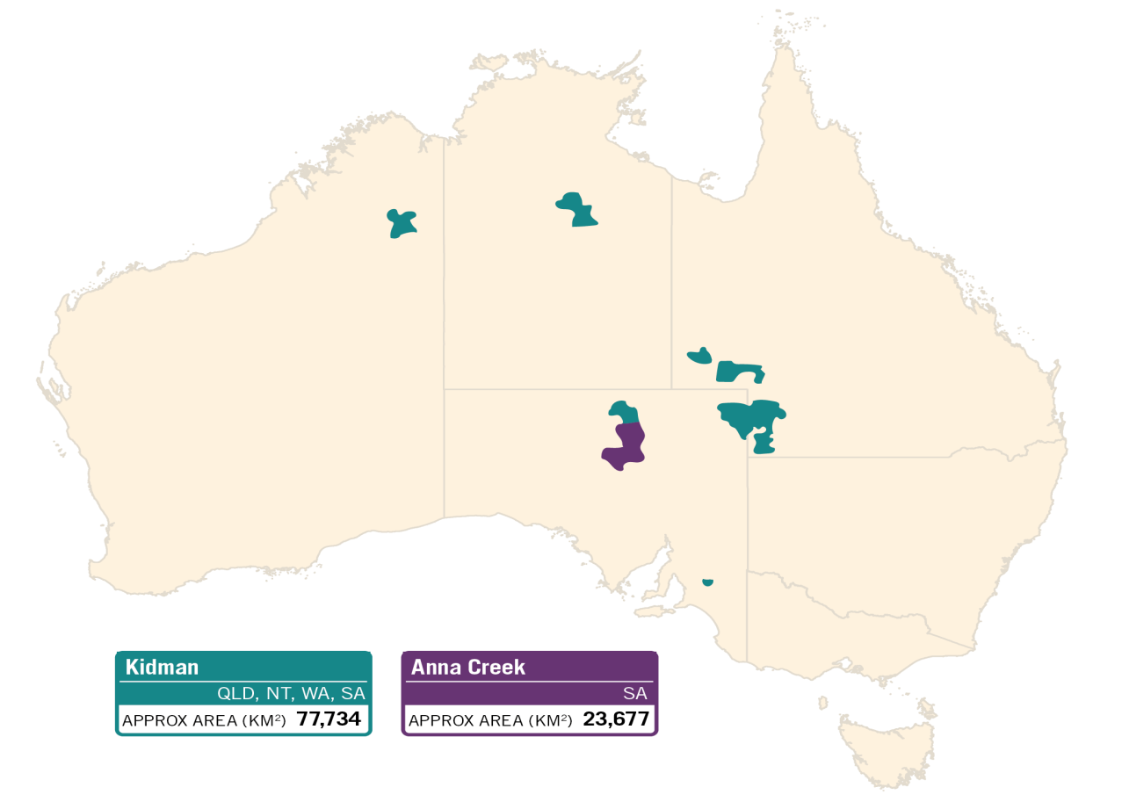

S. Kidman and Co. Limited (continued)

Following the April decision, Kidman undertook a new sales process, engaging with a wide range of interested parties, including new Australian bidders. In October 2016, Australian Outback Beef Pty Ltd, 67 per cent owned by Australian entity Hancock Beef Pty Ltd and 33 per cent owned by Chinese entity Shanghai CRED Real Estate Stock Co. Ltd, entered into an agreement to acquire up to a 100 per cent interest in Kidman, excluding the Anna Creek property.

The Treasurer was satisfied that Australian parties had sufficient opportunity to participate in the new sales process, and announced that he had decided that the proposed transaction was not contrary to the national interest, subject to the imposition of tax conditions.

### Manufacturing, electricity and gas

The $56.6 billion worth of proposed investment approved in 2015‑16 in the manufacturing, electricity and gas sector was almost triple the value of approved investment in the sector in 2014‑15, despite the similar number of approvals.

**$56.6b**

**approved**

**investment**

The significant increase in the value of proposed investment can be explained by a small number of transactions for which foreign investment approval was required, including the 99 year lease of TransGrid.

Table 3.5: Manufacturing, electricity and gas sector approvals: 2012‑13 to 2015‑16



1. Comprises: textile, leather, clothing and footwear; polymer product and rubber products; primary metal and metal product; fabricated metal products; transport equipment; machinery and equipment; and furniture manufacturing.

Note: Totals may not add due to rounding.

State and Territory Asset Privatisation

During 2015‑16, the FIRB Secretariat continued to pro‑actively engage with state and territory governments in the privatisation of electricity network assets and Australian ports of national significance.

This work resulted in constructive engagement and cooperation between the FIRB Secretariat, the relevant state and territory governments, their advisers and relevant Commonwealth agencies to identify potential national interest concerns and to develop mitigations early in the privatisation process. Bidders and their advisers were also encouraged to engage early with the FIRB Secretariat to ensure that complex investment proposals were fully understood.

The FIRB Secretariat engaged with the NSW Government and potential bidders to ensure that national interest considerations were addressed in the 99 year leases of TransGrid and Ausgrid, both critical infrastructure assets for NSW and the National Electricity Market. It also pro‑actively engaged with key stakeholders involved with the privatisations of the Port of Darwin and the Port of Melbourne as well as the possible forthcoming privatisations of Fremantle Port and Utah Point.

On 25 November 2015, the NSW Government announced ‘NSW Electricity Networks’, a consortium comprising Australian investors, a Canadian pension fund and Middle Eastern sovereign wealth funds, as the successful bidder for the 99 year lease of TransGrid, the NSW electricity transmission network. Extensive consultation allowed the Treasurer to apply safeguards to ensure that operational control of the network remained in Australia and that TransGrid’s boards comprise Australian citizens and residents. Protections were also applied to ensure that electricity supply data and personal information is held and accessed solely within Australia.

The FIRB Secretariat also engaged with potential bidders for the Port of Darwin, including Landbridge. However, at the time the Port of Darwin was privatised, the successful bidder who was a privately owned Chinese investor did not require foreign investment approval because of an exemption under the *Foreign Acquisitions and Takeovers Act 1975* for interests acquired directly from an Australian government by foreign private investors.

### Mineral exploration and development

There were 182 approvals given in 2015‑16 for $27.6 billion of proposed investment in the mineral exploration and development sector. The number and value of approvals was almost unchanged from 2014‑15.

**$27.6b**

**approved**

**investment**

The value of approvals for proposed investment in 2015‑16 is inflated by the Australian component of Royal Dutch Shell’s takeover of BG Group Plc. The decline in applications submitted since 2012 in the mining, exploration and development sector is consistent with the broader decline in mining investment in the Australian economy.

Table 3.6: Mineral exploration and development sector approvals:   
2012‑13 to 2015‑16



1. Comprises: exploration and other mining support services; and other non‑metallic minerals mining and quarrying.

Note: Totals may not add due to rounding.

### Services

There were 162 approvals for proposed investment in the services sector in 2015‑16, a decline of 70 approvals on the previous year, with a corresponding decrease in value from $38.8 billion to $23.2 billion. This represents a return to levels of investment last seen in 2012‑13.

**$23.2b**

**approved**

**investment**

The services sector approval data is typically affected by large one‑off transactions. For example, in 2014‑15 approval was given for the acquisition of Toll Holdings by Japan Post (transport), a large one‑off transaction which partly explains the lower value of approvals for proposed investment in the transport sub‑sector in 2015‑16. There was also a large one‑off transaction in the construction sub‑sector in 2014‑15 which is reflected in the significantly higher value of approvals in that year. 2014‑15 was also marked by a large number of approvals for proposed investment in hotels, as reflected in the accommodation, food and beverage sub‑sector data. The lower number of approvals in 2015‑16 may not necessarily reflect a decreasing interest in the hotel sector, but be the result of the higher monetary thresholds for non‑vacant commercial land which have applied since 1 December 2015.

Table 3.7: Services (excluding tourism) sector approvals:   
2012‑13 to 2015‑16



1. Comprises: accommodation; food and beverage services.
2. Comprises: publishing (including internet); motion picture and sound recording activities; broadcasting (including internet); and telecommunication services (including internet).
3. Comprises: building construction; heavy and civil engineering construction and services to construction.
4. Comprises: hospitals; medical and other health care services; residential and social assistance services.
5. Comprises: property and real estate operators; professional, scientific and technical services; computer system design services; and administrative services.
6. Comprises: wholesaling of basic material, machinery and equipment, grocery, liquor and tobacco products; and retailing of fuel, food and other store based retailing.
7. Comprises: road, rail, water, air and space, postal and courier (pickup and delivery), warehousing and storage; and transport support services.
8. Comprises: repair and maintenance; public administration; defence; and education related services.

Note: Totals may not add due to rounding.

### Real estate

There were 40,755 applications approved for proposed investment in real estate (comprising commercial and residential proposals) with a total value of $122.1 billion in 2015‑16. This is an increase of around 25 per cent in the value of real estate approvals for the second year in a row. Unlike earlier years where growth in the value of approvals was a result of applications in the residential real estate sector, growth in the value of applications in real estate in 2015‑16 was driven by high value approvals in the commercial real estate sector.

**$122.1b**

**approved**

**investment**

### Commercial real estate

In 2015‑16 there was a significant increase in applications for commercial real estate. Foreign investment approval was given for 606 approvals valued at $49.7 billion. The increase was driven by investment in developed commercial property, and includes approvals given for multiple applicants in respect of two large transactions during this period.

**$49.7b**

**approved**

**investment**

The increasing interest in commercial property reflects favourable liquidity conditions and Australia’s attractive yields relative to the international market.

Table 3.8: Investment in commercial real estate by type of approval and number of proposals approved: 2012‑13 to 2015‑16



Note: * From 1 December 2015, annual programs under the new provisions in the Act are known as exemption certificates.

Totals may not add due to rounding.

Table 3.9: State and territory distribution of proposed investment in commercial real estate in 2015‑16



1. Comprises approved proposals where the proposed investment is to be undertaken in more than one state or territory.

Note: Totals may not add due to rounding.

‘‑‘ indicates a figure of zero or a figure less than $10 million.

‘*’ indicates between 1 and 9 approvals.

### Residential real estate

**$72.4b approved investment**

In 2015‑16, a total of 40,149 residential real estate applications were approved for proposed investment worth $72.4 billion.

Over the last four years the proportion of all residential real estate approvals for development has steadily increased and represents 85.4 per cent of all residential approvals in 2015‑16. Approvals which are for development include approvals for new dwellings, vacant land and redevelopment of existing residential property that increases the housing stock. This aligns with Australia’s foreign investment policy, which seeks to attract investment that increases the housing stock.

Chart 3.2: Number of approvals by State & Territory



Three‑quarters of all residential real estate approvals were for purchases in Victoria and New South Wales. This is consistent with recent years and reflects strong demand for residential property in Sydney and Melbourne.

Foreign investment and residential real estate prices

In December 2016, Treasury published a working paper which explored the relationship between foreign demand for residential real estate and dwelling prices. The paper, which used foreign investment approvals data from mid‑2010 to early 2015, found that the effect of foreign investment on residential property prices was small. It also suggested that supply constraints contributed to high dwelling prices in Australian capital cities.

Foreign investment in residential real estate was concentrated in Melbourne and Sydney over the period of the study. While Melbourne received more foreign investment approvals than Sydney, price growth in Sydney was much stronger than in Melbourne.

The paper suggests that foreign demand increased prices by between $80 and $122 in Melbourne and Sydney in each quarter. This is modest when compared to the average quarterly increase of $12,800 in Australia’s two largest cities during the period.

Chart 3.3: Location of foreign investment approvals   
(1 July 2010 — 31 March 2015)

Note: Melbourne postcodes between 3000 and 3207; Sydney postcodes between 2000 and 2234

Source: http://treasury.gov.au/PublicationsAndMedia/Publications/2016/Foreign‑Investment‑and‑  
Residential‑Property‑Price‑Growth.

Developed

Established dwellings (or developed residential premises) can generally only be purchased by temporary residents for use as their home while they remain in Australia. A small number of approvals are given for foreign persons that operate a substantial Australian business to acquire an established dwelling to house their Australian based staff.

In 2015‑16, 5,877 approvals were given for established dwellings, a decrease of 36 per cent from 2014‑15. The decrease can be attributed to a range of reasons including housing market conditions, state and territory policy changes, a shift to investment in new dwellings, and the introduction of fees and processing changes. Additionally, the introduction of the established dwelling exemption certificate enables foreign persons to receive pre‑approval to purchase a single established dwelling and notify its location once purchased, rather than requiring the person to seek individual approvals for each dwelling they may be seeking to purchase until they successfully purchase one dwelling. In 2015‑16, the established dwelling exemption certificate was limited to use for purchases of an established dwelling made through an auction process.

For development

Australia’s foreign investment policy encourages investment in the residential real estate sector which helps build supply. The 34,264 approvals given for development include approvals for new dwellings, vacant land and other residential property for development. This represents a growth of 24 per cent growth on approvals granted in 2014‑15 for property for development.

The new dwelling exemption certificate allows developers to receive pre‑approval for foreign investors to purchase new residences valued under $3 million in a development. The developer is required to market the dwellings locally and must report on all purchases made by foreign persons (which can occur over a number of years). As the value of the investment reported against this exemption certificate represents the maximum amount foreign persons may acquire under the certificate, the approved investment figure may overstate the extent of actual foreign purchases.

Table 3.10: Investment in residential real estate by type of approval and number of proposals approved: 2012‑13 to 2015‑16



Note: Totals may not add due to rounding.

* Established dwelling exemption certificates were introduced with the 1 December 2015 reforms.

^ From 1 December 2015, annual programs under the new provisions in the Act are known as exemption certificates.

The 2015‑16 figures were impacted by the 1 December 2015 reforms, which may affect data comparability.

Table 3.11: State and territory distribution of proposed investment in residential real estate in 2015‑16



(a) Comprises approved proposals where the proposed investment is to be undertaken in more than one state or territory.

Note: Totals may not add due to rounding.

‘‑‘ indicates a figure of zero or a figure less than $10 million.

Table 3.12: State and territory distribution of proposed investment in residential real estate by industry subtype in 2015‑16



1. Comprises approved proposals where the proposed investment is to be undertaken in more than one state or territory.

Note: Totals may not add due to rounding.

Excludes exemption certificates and corporate reorganisations.

^ Developer includes new dwelling exemption certificate approvals provided to real estate developers (previously off‑the‑plan approvals). Further details are provided in the section on real estate.

‘‑‘ indicates a figure of zero or a figure less than $10 million.

‘*’ indicates between 1 and 9 approvals.

Investor countries

In 2015‑16, China was the largest source of foreign investment approvals by both value and number. While the value of approvals for Chinese investors did increase, it increased by less than 6 per cent since 2014‑15. This was a significantly lower increase in comparison to the greater than 60 per cent increase in the value of approvals between 2013‑14 and 2014‑15.

The value of approvals for Chinese investors represents 26 per cent of the total value of approvals. Investors from China received approval for a number of large value transactions included in the manufacturing, electricity and gas sector, for example TransGrid. Chinese interest in Australia’s real estate sector remains strong with the value of approvals for Chinese investors growing by 31 per cent since 2014‑15.

The US remained the second largest source country for foreign investment approvals by value and the largest investor in non‑real estate transactions. Interest from US investors in the agricultural sector has been strong, with approvals increasing by over $700 million from 2014‑15.[2] There was significant growth in the value of approvals for US investors in the financial and insurance sector. This is the result of two large acquisitions in this sector.

The next three top source countries of proposed investment by value were Netherlands (ranked 14th in 2014‑15), Canada (ranked 5th in 2014‑15), and the United Arab Emirates (ranked 12th in 2014‑15). The significant shift in Netherland’s ranking to fourth is a result of Royal Dutch Shell’s takeover of BG Group Plc, which included Australian assets.

Investors from the United Arab Emirates were part of the consortium for the 99‑year lease of TransGrid. Investors from the United Arab Emirates also received approval for a number of large value investments in commercial real estate.

Kuwait was not in the top 18 countries listed in the 2014‑15 annual report but was ranked 8th in 2015‑16, primarily because foreign investment approval was required for investors from Kuwait for the 99‑year lease of TransGrid.

Proposed investment in 2015‑16 by selected country, disaggregated by sector, is shown in Table 3.13.

Table 3.13: Approvals by country of investor by industry sector in 2015‑16



Notes applying to Table 3.13

Note: Totals may not add due to rounding.

‘‑‘ indicates a figure of $10 million or less.

1. Includes overseas territories.
2. China excludes Special Administrative Regions and Taiwan.
3. Other comprises all other countries not in the largest 18 countries based on total proposed investment approved, as well as proposed investment approved which cannot be attributed to a country.
4. One new dwelling exemption certificate (previously advanced ‘off‑the‑plan’ certificate) equates to one approval in terms of the number of approvals but the entire value of the proposed development is included in the value columns. Further details are provided in the section on real estate.
5. Comprises proposals where an Australian controlled investment manager acting on behalf of an investor operates independently of the interest holders in the investor, or an Australian investor(s) jointly intends to make a proposed investment with a foreign investor, or jointly establish a new business with a foreign government investor.
6. These figures indicate the total number of proposals in which investors from the particular country have an interest. Those involving investment originating from more than one country count as one proposal for each of the countries concerned.

# Chapter 4: Foreign Investment Compliance

The Australian Government supports the foreign investment regime through education and promotion of the framework, rigorous screening practices and a robust compliance program.

### Education and promotion

The Board and its Secretariat undertake numerous activities to educate and provide information to individuals and organisations affected directly and indirectly by the foreign investment framework. These activities include presenting at industry forums and seminars, providing information such as the Guidance Notes and the Investor Obligations — Fact Sheets (which are available on the Board’s website); responding to written enquiries and providing information through the general enquiries helpline and the compliance hotline. For further information on the Board’s engagement activities see the 2015‑16 FIRB Regulator Performance Framework Report, available at the Board’s website.

### Rigorous screening practices

When screening new applications, the applicant’s past compliance with the foreign investment regime is considered. This includes reviewing whether past transactions have been correctly notified and ensuring conditions relating to past proposals are met. Instances of non‑compliance may result in more stringent conditions being imposed on future approvals or even rejection. The application screening process is outlined in Appendix B on page 51.

### Compliance program

General compliance and monitoring work includes the following activities:

* investigations triggered by data matching and interpretation of trends. These investigations can include analysis of case histories, reviews of shareholding structures among listed Australian companies and regular monitoring of property market leasing and sales activity;
* investigations triggered by information received from members of the public;
* monitoring to ensure that foreign persons are complying with the condition attached to, or scope of, their approvals; and
* liaising with a range of government agencies including relevant national security agencies, the Department of Immigration and Border Protection, the Australian Securities and Investments Commission, the Australian Criminal Intelligence Commission and the Australian Federal Police.

It is general practice to report potential non‑compliance with the Act to the Department of Immigration and Border Protection, the ATO, the Australian Federal Police, national security agencies and other government agencies as appropriate.

### Penalties and enforcement powers

The Act provides a number of powers to enforce the foreign investment rules. Criminal and civil penalties may be applied for breaches of the Act, including where a foreign person takes an action that has not received prior foreign investment approval or breaches a condition of a foreign investment approval. For more significant breaches, an investor may be ordered to divest (by requiring the parties to sell shares, assets or property). Civil penalties can also be applied to third parties who knowingly assist foreign investors to break the rules.

There are additional civil penalties in relation to residential land, including requiring an investor to forfeit capital gains made on divestment of a property. Less significant breaches of the foreign investment rules in relation to residential real estate may be addressed by way of an infringement notice (instead of a higher civil penalty). Less serious contraventions would involve circumstances where:

* the investor makes a full disclosure of the breach before it is detected;
* a breach occurs, and approval would have been granted had they given prior notice; or
* the person has inadvertently breached a condition of an existing foreign investment approval, but would have received approval had they applied to have those conditions varied.

Strengthening residential compliance

A key part of the 2015 reforms was to strengthen the integrity of the foreign investment framework.

To enable stronger enforcement of the foreign investment rules, all residential real estate functions were transferred to the ATO. This move took advantage of the existing compliance expertise within the ATO, especially its data‑matching systems.

Data matching is a key tool used to identify possible breaches of the foreign investment rules. The use of data matching capabilities involves cross matching of tax, financial records, immigration and real property data to target investigations and detect patterns, trends and drivers of non‑compliance. Analytical models have been developed to identify patterns across advisers, financers, or geographic areas which will support further risk assessment and investigation selection.

Stricter penalties were also introduced to make it easier to pursue foreign investors who breach the rules. From 1 December 2015, criminal penalties were increased to $135,000 or three years imprisonment for individuals and to $675,000 for companies. Divestment orders are now supplemented by civil penalties and infringement notices for less serious breaches. Further, to ensure that people who break the rules do not profit from their actions, a new civil penalty was introduced to capture any capital gain made on divestment of a property.

Third parties who knowingly assist a foreign investor to breach the rules are subject to civil and criminal penalties, including fines of $45,000 for individuals and $225,000 for companies.

A reduced penalty period was in place from 2 May 2015 until 30 November 2015 to encourage those in breach of the residential foreign investment rules to self disclose. Investors who came forward during this period were given 12 months to divest of their property where they were found to be in breach of the rules, rather than the typical 90 days.

## Residential compliance investigations and outcomes

The data reported in this section is based on residential real estate compliance investigations from 1 July 2015 to 30 June 2016. Data reflects outcomes of investigations as at 30 June 2016.

During 2015‑16, 2,104 cases were identified for investigation. 1,637 investigations were completed, with 260 investors found to have breached Australia’s foreign investment rules. Concessional divestments were required in 39 cases for residential property valued at $48.7 million.[3]

Compliance investigations have involved a broad range of residential property and varying severity of breaches. Breaches include:

* failure to seek approval before the purchase of a property;
* failure to sell an established property once the owner’s temporary resident visa expires;
* temporary resident visa holders owning more than one established property;
* Australian companies and trusts controlled by foreign persons owning established properties;
* failure to comply with the conditions of an approval, such as not using a property as a principal place of residence, renting out a dwelling or failing to commence construction or to redevelop the property within specified timeframes; and
* failure to vary conditions which required certain actions within a specified period within two months of the end of the period.

Table 4.1: Outcomes of completed investigations in 2015‑16

|  |  |  |
| --- | --- | --- |
| Compliance outcomes | Number of investigations | Percentage of total |
| Concessional divestment (a) | 39 | 15.0 |
| Formal divestment (b) | 0 | 0.0 |
| Self divestment (c) | 15 | 5.8 |
| Retrospective approval | 147 | 56.5 |
| Change of conditions | 59 | 22.7 |
| Total outcomes | 260 | 100.0 |

1. Concessional divestments are for self disclosed breaches from investors during the reduced penalty period between 2 May 2015 and 30 November 2015.
2. Formal divestments are those where a formal disposal order was issued under the Act.
3. Self divestments are where an investor disposes of a property during an investigation.

Outcomes of investigations include divestments, retrospective approvals and variations of conditions. In some circumstances an infringement notice may have also been applied. Infringement notice data is reported separately on page 45. Investors granted retrospective approvals for actions taken after 1 December 2015 are required to pay an application fee based on the value of the property. Variations to conditions requested after 1 December 2015 also attract a fee.

Where a breach is detected, foreign persons are generally given an opportunity to re‑engage with the foreign investment regime. Retrospective approvals and variations of conditions established by previous approvals are only granted in circumstances where an approval or variation would have been granted had an application been made. For example, if an investor had applied for a variation to extend the required timeframe to develop land this would likely be approved if sufficient evidence was provided that the lack of progress was due to circumstances outside of their control (such as delays in obtaining local government approvals). Where this investor was identified through compliance work because they had not obtained a variation it would generally not be contrary to the national interest to allow the investor to continue to build on the land within a reasonable time frame. Compliance with a revised condition will continue to be monitored and enforcement action taken where required.

### Investigations by location

Almost half of all compliance investigations related to residential property purchased in Victoria. One‑third of investigations related to property in New South Wales. This geographic distribution reflects the location of the properties that were found to have been purchased in breach of the foreign investment rules. Chart 4.1 shows the geographic distribution of compliance investigations in 2015‑16.

Chart 4.1: Location of compliance investigations in 2015‑16

### Investigations by source

The 2,104 cases identified for investigation in 2015‑16 came from a range of sources including community information, data matching and self‑disclosures. Just over 80 per cent of self‑disclosures were received during the reduced penalty period. Table 4.2 provides a breakdown of the source of investigations.

Table 4.2: Source of investigations in 2015‑16

|  |  |  |  |
| --- | --- | --- | --- |
| Source of Case | No. | Percentage | Description |
| Self‑disclosure | 368 | 17.5 | Self‑disclosures made from 2 May 2015 to 30 June 2016 |
| Community information | 1,226 | 58.3 | Information received from ‘dob ins’ made by the community |
| Other referrals | 136 | 6.5 | Internal ATO referrals and referrals received from other Government agencies, media reports |
| Data matched | 374 | 17.8 | ATO data matching sources |
| Total received | 2,104 | 100.0% |  |

Information from community members makes up over half of the items received for investigation. Although it is a valuable source of intelligence for the ATO, less than one per cent of investigations arising from community information involve a breach of the Act. In most cases, the owners of the properties reported by community members are Australian citizens or permanent residents and are exempt from the Act.

Table 4.3: Outcomes of investigations in 2015‑16 by source

|  |  |  |
| --- | --- | --- |
| Source | No. of completed investigations | No. of breaches |
| Community information | 1,094 | 9 |
| Self disclosure | 336 | 222 |
| Other referrals and datamatching | 206 | 29 |
| Total | 1,636 | 260 |

### Reduced penalty period outcomes

A reduced penalty period was in place from 2 May 2015 to 30 November 2015. This period was to encourage investors to declare existing breaches of the foreign investment rules. The reduced penalties allowed investors 12 months to divest their illegally held properties, instead of the usual 90 day formal divestment period.

There were 302 foreign persons who came forward during the reduced penalty period. The total value of properties disclosed was $438.5 million. 206 people who came forward were found to be in breach, involving 223 properties valued at $304.8 million. The other 96 who came forward were found not to be in breach of the Act. Table 4.4 shows the outcomes for the 223 properties held in breach.

Table 4.4: Outcomes of completed reduced penalty period investigations

|  |  |  |  |
| --- | --- | --- | --- |
| Outcome | No. of properties in breach | | Percentage |
| Retrospective approval | | 115 | 52 |
| Variation of conditions | | 56 | 25 |
| Concessional divestment | | 41 | 18 |
| Self‑divestment | | 11 | 5 |
| Total | | 223 | 100 |

## Penalties

As a part of the 2015 reforms the penalty regime was expanded to include civil penalties and infringement notices in addition to criminal penalties for breaches of the Act.

In 2015‑16, no cases involving criminal prosecution or civil penalties were completed. Criminal prosecution and civil penalties are considered where the breach of the foreign investment regime is more serious. This could occur where conditional approval was obtained but evidence exists to demonstrate the conditions were disregarded from the outset. For example, approval was received to purchase an established dwelling on condition that the foreign person occupies the house and it is not rented, but immediately following the acquisition, the foreign person rents out the property and does not occupy it. Another example would be deliberately purchasing an established property using a company structure with Australian shareholders, then transferring the shares to a foreign person in an attempt to avoid detection. Criminal and civil penalties must be issued by a relevant court.

Infringement notices are issued for less serious breaches of the foreign investment regime where a civil penalty could otherwise be applied. For example, acquiring a property prior to lodging an application for foreign investment approval provided foreign investment approval would have been given and the applicant does not have a poor compliance history. In 2015‑16, 114 infringement notices were issued totalling $514,020 in penalties.

There are two levels of infringement notices which impose different financial penalties. A Tier 1 infringement notice will be issued where the breach is self‑reported. A Tier 2 infringement notice will be issued where the breach is identified as a result of the ATO’s compliance activity. Table 4.5 shows the infringement notices issued by tier in 2015‑16.

Table 4.5: Infringement notices issued in 2015‑16

|  |  |  |
| --- | --- | --- |
| Tier | No. | Value $ |
| Tier 1 | 84 | 190,020 |
| Tier 2 | 30 | 324,000 |
| Total | 114 | 514,020 |

# Appendix A Methodological and Data Caveats

This appendix provides an overview of the main methodological and data caveats that apply to proposal data in this Annual Report. While a useful source of data on proposed foreign direct investment in Australia, the Board urges caution in the use of these statistics, particularly when making comparisons with earlier years or alternate data sources on foreign investment.

Methodological and data caveats

* The statistics contained in this Annual Report do not measure total foreign investment made in any year, nor do they measure changes in net foreign ownership levels in Australia. They reflect investor intentions (not actual purchases) to acquire Australian assets. They can be skewed by very large investment proposals and multiple proposals for the same target.
* There are substantial differences between these statistics on proposed investments and actual investment flows. The latter are more reliably captured by the Australian Bureau of Statistics, which seeks to reflect more comprehensively investment transactions between residents of Australia and non‑residents.
* Data capture, systems and reporting methodologies change over time and from this Annual Report onwards much of the data is an aggregation of separate data captured by Treasury and the ATO.
* Data presented for earlier years may also have been revised since last published. This Annual Report includes two material revisions to 2014‑15 data:
  + the total value of applications has been revised down by $2.75 billion due to a data revision for approvals in the agriculture sector. This also flows through to approvals by country, with this revision being split 65:20:15 between China, Singapore and the United States (US); and
  + the split between conditional and unconditional approvals by both number and value has been revised to allocate more cases to approved with conditions. The impact by value is far more significant than the impact by number.
* The figures are based on the assumption that investment funds will be sourced from overseas. The extent to which approved investment proposals will actually be funded from outside of Australia and result in foreign capital inflows depends not only upon whether they are implemented, but also upon the proportion that is financed from foreign sources. The proposed funds to be invested may be contributed by Australians, for example, where they are in partnership with foreign interests, or where the investment is financed from existing Australian operations.
* The source of proposed investment identified in the Board statistics does not necessarily reflect the range of shareholders. For example, the source may be attributed to a company’s single substantial shareholder, or if a company’s shares are widely held, the country of domicile or incorporation may be recorded.
* The data do not necessarily reflect a change in foreign ownership as, in some cases, both the target and the purchaser are foreign persons.
* The proposed investment of an approved proposal is the amount advised by the applicant or the best estimate based on the available information. It represents an estimate of the expected proposed investment in the 12 months from the approval unless the approval is granted for a longer period (if the proposal is implemented).
  + Where an approved acquisition is a part of an offshore acquisition, the proposed investment figure is calculated based on the share attributable to the approved acquisition in Australia.
  + Where amounts are in a foreign currency, this is converted to Australian dollars based on the exchange rate at the time of the decision.
  + There are some approved proposals for which proposed investment is treated as nil. Examples of this include internal corporate reorganisations, financing arrangements and where foreign government investor lenders take security interests, but do not have approval to retain ownership after any enforcement of such security interests.
* The statistics may include some transactions that do not actually proceed. They include:
  + proposals that are approved in a given year but which are not actually implemented in that year or at all;
  + approvals for multiple potential acquirers of the same target (including for potential consortium participants that are yet to determine their final maximum percentage interest); and
  + approvals for shares or units where only a portion of the intended shares or units may be acquired.
* Acquisitions of diversified company groups are classified into a single industry sector according to the major activity of the group, such as in a diversified mining company with interests in various minerals. Acquisitions of real estate to be used for purposes incidental to the main business activity of the purchaser are classified according to that activity.[4]

### Policy scope and changes

The breadth of the data reflects the requirements of Government policy at the time. The data do not cover foreign investments below the various screening thresholds that apply under the Act. Nor does the data cover follow‑on investments to expand the capital stock of existing foreign‑owned businesses (both in existing areas and into related areas). See the Board’s website ([www.firb.gov.au](http://tweb/sites/mg/fitpd/FIRB/Annual%20Report%20(written%20only)/2013-14/2013-14%2012%20Feb/www.firb.gov.au)) for the current thresholds.

Furthermore, policy and legislative change can have a considerable impact on the continuity of data. For instance, changes in the Policy that have occurred since the mid‑1980s have affected the number of some types of proposals, limiting comparability over time. These changes include:

* the increase in the general asset threshold in 1999 from $5 million to $50 million and again in December 2006 from $50 million to $100 million;
* the increase in the offshore takeovers threshold in December 2006 from the general asset threshold ($50 million at the time) to $200 million;
* the introduction of the higher $800 million threshold (indexed on 1 January each year) for US investors from 1 January 2005;
* the harmonisation in 2009 of the four lowest thresholds for private business investment to a single threshold of $219 million (indexed on 1 January each year);
* the abolition in 2009 of the requirement for private investors to notify when establishing a new business valued above $10 million;
* the introduction of indexation in 2012 for the general monetary threshold for commercial developed real estate that is not heritage‑listed;
* the extension of the higher monetary thresholds available to US investors to New Zealand (NZ) investors as of 1 March 2013;
* the revised definition of foreign government investor introduced in March 2013;
* the introduction of changes in 2009 and 2010 to the screening arrangements for temporary residents purchasing residential real estate;
* the reclassification in 2009 of accommodation facilities from residential real estate to commercial developed real estate;
* changes in immigration policies that control the number of temporary resident visa holders, which largely determines the level of foreign investment in established (second‑hand) residential dwellings;
* the higher monetary thresholds already available to US and NZ investors, were extended to investors from Korea (from 12 December 2014), Chile (from 1 January 2015) and Japan (from 15 January 2015);
* the lowering of the general agricultural land screening threshold from $252 million to $15 million (cumulative) from 1 March 2015; and
* the significant 1 December 2015 reforms which included:
  + the introduction of fees for foreign investment applications;
  + the introduction of a $55 million threshold for direct investments in agribusiness;
  + the shift of many requirements from Policy into legislation;
  + modernisation of the foreign investment legislation including changes to exemptions and the substantial interest threshold;
  + changes to Exemption Certificates; and
  + the increase in the monetary threshold for commercial developed land that is not sensitive from $55 million to $252 million.

### Administrative practices

Changes in administrative practice (for example, data collection and record keeping) and foreign investment application requirements have also impacted on year‑to‑year data comparability. Examples of this include the following:

* The implementation of a new case management system and a user‑based web portal for lodging foreign investment applications in November 2013 significantly improved data collection capabilities and processing efficiency for proposals in residential real estate. Data capture and reporting procedures for non‑residential real estate proposals transitioned to the new case management system from 1 July 2014.
* The most recent Australian and New Zealand Standard Industrial Classification (ANZSIC 2006) was adopted for data recording and reporting purposes as part of the new case management system. Year to year comparability of pre 2014‑15 data may be limited.
* The shift of residential real estate cases to the ATO from 1 December 2015.

# Appendix B Examination and approval process

The examination of foreign investment proposals is rigorous. The assessment process seeks to ensure that particular proposals are not contrary to Australia’s national interest. In fulfilling this objective, proposals are examined with a view to identifying any sensitivity regarding the national interest and determining whether these sensitivities can be mitigated or managed.

### Board involvement

The Board provides advice on the application of the foreign investment framework across the range of proposals received and on foreign investment policy issues. It provides specific advice on the more significant applications received and also reviews the general handling of other applications. The Board performs this role with the benefit of weekly reports on proposals received and through regular meetings and discussions with the Executive Member and Secretariat officers. Formal Board meetings are generally held monthly, with telephone discussions taking place in the intervening weeks. The Board members draw on their considerable collective and individual professional and commercial experience in discharging their advisory role.

### Handling of commercially sensitive and personal information

The Board recognises that much of the information required to assess a proposal will be commercially sensitive or of a private or confidential nature. Consequently, appropriate measures are in place to ensure that confidentiality is protected.

In the event that access to confidential information is sought for purposes other than the assessment of an application, the Act contains explicit provisions on the circumstances in which information may be used or disclosed. This can include the administration of specified Commonwealth statutes, information disclosed to certain law enforcement bodies and information provided with written consent. Unauthorised disclosure of protected information under the Act is an offence subject to a maximum of two years imprisonment, a $21,600 fine, or both.

Application Screening Process

Key elements of the application screening process are outlined below.

### Initial examination

The initial examination seeks to determine whether an application meets the notification requirements for a proposal in so far as the Act applies, whether the application contains sufficient detail and that the correct application fee has been paid. Timing is also considered, including deadlines that are commercially important to the applicant. The Board has direct and early involvement in significant or sensitive applications.

### Consultation arrangements

For significant proposals, consultations are undertaken with Australian federal government departments, state and territory government departments, national security agencies and authorities with responsibilities relevant to the proposals. Advice and comments provided by such agencies are important in assessing the implications of proposals and in particular, in determining whether they raise any national interest issues. The Board may also receive unsolicited submissions from third parties.

### National interest factors

The Act empowers the Treasurer to prohibit an investment if satisfied it would be contrary to the national interest. However, the general presumption is that foreign investment is beneficial, given the important role it plays in Australia’s economy.

The national interest, and what would be contrary to it, is not defined in the Act. Instead, the Treasurer can decide in each case whether the investment would be contrary to the national interest. Across all proposals the Government typically considers the following factors:

* national security;
* competition;
* other Government policies (including taxation);
* impact on the economy and the community; and
* the character of the investor.

Recognising their significance, additional factors are considered as part of the national interest test for proposed investments in the agricultural sector and for residential land as well as for applications made by foreign government investors. General guidance on the national interest factors is published in Australia’s Foreign Investment Policy.

### Extending the statutory timeframe

The Act requires a decision to be made within 30 calendar days of the correct fee being paid and provides a further 10 calendar days for the applicant to be notified of the decision. If a decision is not made within this time or the applicant has not been advised, the application is deemed to be ‘approved’ since ‘no objection’ to the proposal has been made.

If a proposal cannot be decided within 30 days, because the proposal is complex or further information is needed to properly assess it, the Treasurer can issue an Interim Order extending the timeframe up to a further 90 days. Alternatively, the applicant can voluntarily extend the decision period where it is clear that more time will be required.

### Approvals and Conditions

When assessing more significant proposals, the Board’s approach is to work closely with applicants. If a foreign investment proposal raises potential national interest concerns, these concerns are discussed with the applicant and the applicant is provided an opportunity to comment. If the applicant proposes mitigating actions, these will also be taken into account.

Where the Treasurer considers that an application raises no national interest concerns or that any concerns are adequately addressed by conditions, the applicant is notified in writing of no objection or no objection subject to conditions. Once an applicant receives a no objection or no objection subject to condition notification, the applicant may proceed with the proposal. If national interest concerns remain and may not be able to be addressed, the proposal may be blocked by the Treasurer.

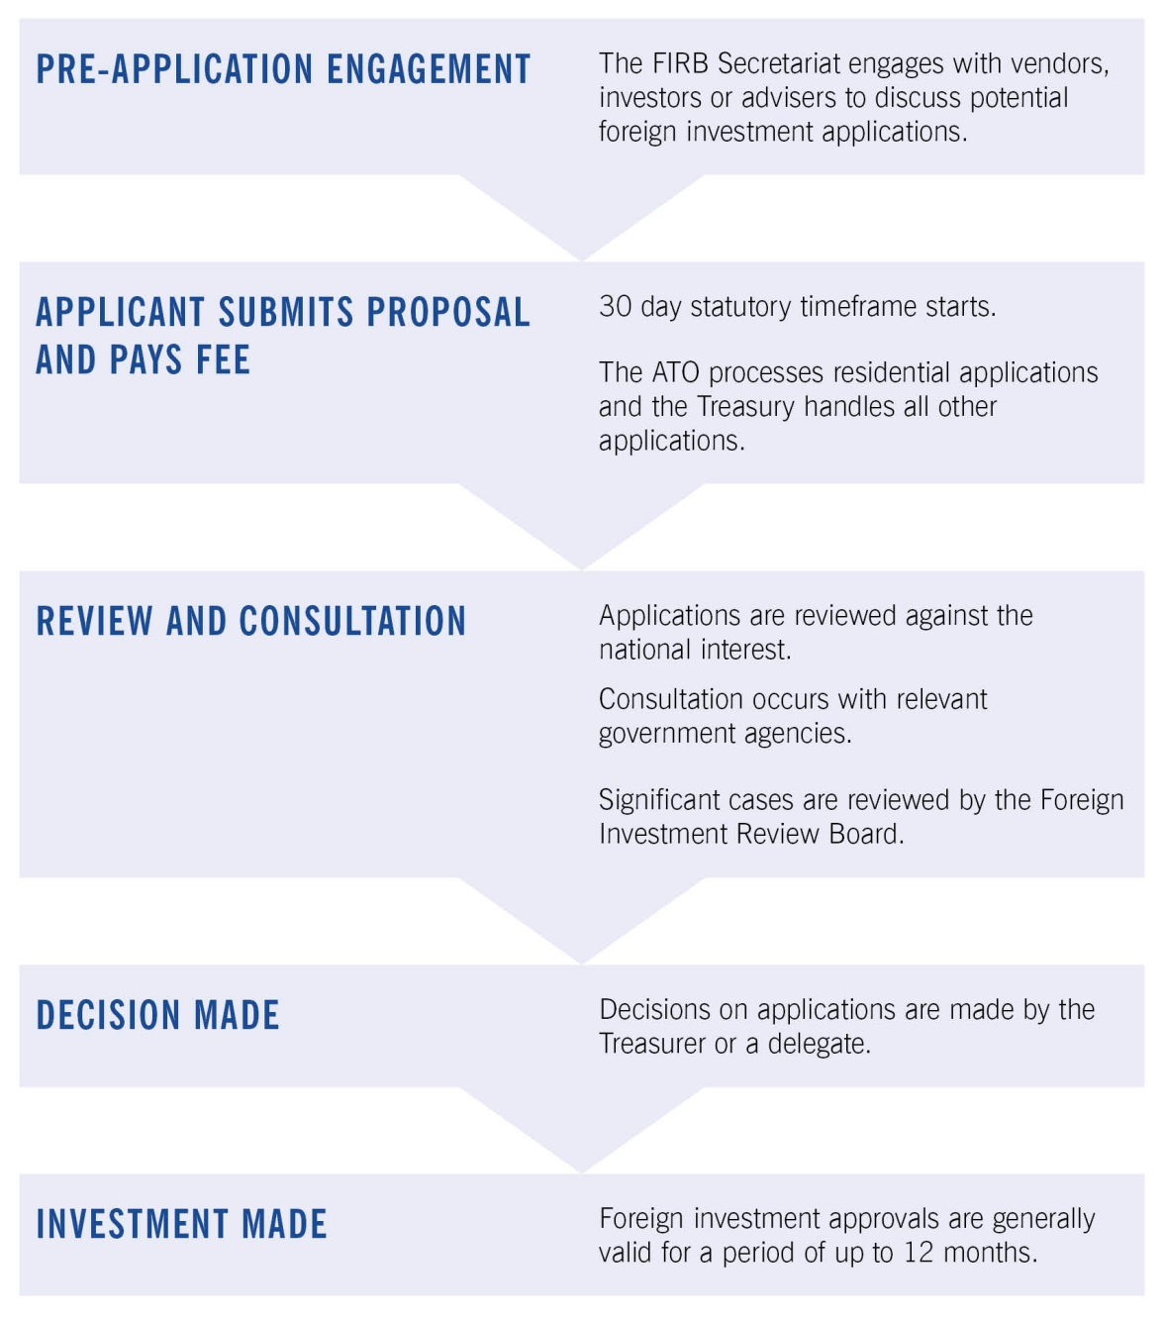

# Appendix C Glossary

|  |  |
| --- | --- |
| Act | The *Foreign Acquisitions and Takeovers Act 1975* (as in force during 2015‑16) |
| Agricultural land | Land in Australia that is used, or that could reasonably be used, for a primary production business. The regulations may provide that land of a specified kind is not agricultural land. |
| Commercial land | Land in Australia or the seabed of the offshore area, other than land:   * used wholly and exclusively for a primary production business; or * on which there is at least one dwelling (except commercial residential premises); or * on which the number of dwellings (except commercial residential premises) that could reasonably be built is less than the number prescribed by the regulations (10, during 2015‑16). |
| Established dwelling | A dwelling (except commercial residential premises) on residential land that is not a new dwelling. |
| Exemption certificates for foreign person | An exemption certificate which allows foreign persons to acquire real estate assets up to a specified monetary limit within a defined region. Generally includes conditions requiring the foreign person to report actual purchases and any other conditions that would normally be applied for the type of land to be purchased. Prior to 1 December 2015, the equivalent to these exemption certificates were known as annual programs. |
| Foreign government investor | A foreign government investor includes:   * a foreign government or separate government entity; * a corporation or trustee of a trust in which:   + a foreign government or separate government entity, alone or together with one or more associates, holds a substantial interest (that is, an interest of at least 20 per cent); or   + foreign governments or separate government entities of more than one foreign country (or parts of more than one foreign country), together with any one or more associates, hold an aggregate substantial interest (that is, an interest of at least 40 per cent); * a general partner of a limited partnership in which:   + a foreign government or separate government entity, alone or together with one or more associates, holds an interest of at least 20 per cent; or   + foreign governments or separate government entities of more than one foreign country (or parts of more than one foreign country), together with any one or more associates, hold an aggregate interest of 40 per cent or more; * a corporation, trustee or general partner of a kind described in the two dot points above, assuming the references to foreign government (or foreign governments) in those dot points include references to a foreign government investor (or foreign government investors) within the meaning of those dot points. |
| Foreign person | Foreign person means:   * an individual not ordinarily resident in Australia; or * a corporation in which an individual not ordinarily resident in Australia, a foreign corporation or a foreign government holds a substantial interest ; or * a corporation in which two or more persons, each of whom is an individual not ordinarily resident in Australia, a foreign corporation or a foreign government, hold an aggregate substantial interest ; or * the trustee of a trust in which an individual not ordinarily resident in Australia, a foreign corporation or a foreign government holds a substantial interest ; or * the trustee of a trust in which two or more persons, each of whom is an individual not ordinarily resident in Australia, a foreign corporation or a foreign government, hold an aggregate substantial interest; or * a foreign government; or * any other person, or any other person that meets the conditions, prescribed by the regulations. |
| New dwelling | A dwelling (except commercial residential premises) that will be, is being or has been built on residential land and that:   * has not been previously sold as a dwelling; and * either has not been previously occupied; or if the dwelling is contained in a development and the dwelling was sold by the developer of the development — has not been previously occupied for more than 12 months total. |
| Ordinarily resident | 1. An individual who is not an Australian citizen is ordinarily resident in Australia at a particular time if and only if:  a. the individual has actually been in Australia during 200 or more days in the period of 12 months immediately preceding that time; and  b. at that time:  i. the individual is in Australia and the individual’s continued presence in Australia is not subject to any limitation as to time imposed by law; or  ii. the individual is not in Australia but, immediately before the individual’s most recent departure from Australia, the individual’s continued presence in Australia was not subject to any limitation as to time imposed by law.  2. Without limiting paragraph (1)(b), an individual’s continued presence in Australia is subject to a limitation as to time imposed by law if the individual is an unlawful non‑citizen within the meaning of the *Migration Act 1958.* |
| Residential land | Land in Australia if:   * there is at least one dwelling on the land; or * the number of dwellings that could reasonably be built on the land is less than the number prescribed by the regulations (10 in 2015‑16); and * does not include land:   used wholly and exclusively for a primary production business; or  on which the only dwellings are commercial residential premises. |
| Substantial interest | A person holds a substantial interest in an entity or trust if:   * for an entity—the person holds an interest of at least 20 per cent in the entity; or * for a trust (including a unit trust)—the person, together with any one or more associates, holds a beneficial interest in at least 20 per cent of the income or property of the trust. |
| Temporary resident | An individual who:  1. holds a temporary visa under the *Migration Act 1958* that allows the individual to remain in Australia for a continuous period of more than 12 months (disregarding the amount of that period remaining); or  2. meets the following conditions:  i. the individual is residing in Australia;  ii. the individual has applied for a permanent visa under the *Migration Act 1958*;  iii. the individual holds a bridging visa under that Act that allows the individual to remain in Australia until the application has been finally determined; or  3. meets the conditions prescribed by the regulations. |
| Vacant land | Land is vacant if there is no substantive permanent building on the land that can be lawfully occupied by persons, goods or livestock. |

1. The value of approvals in agricultural land included in the 2014‑15 Foreign Investment Review Board Annual Report has been revised. In 2014‑15, the value of approvals for agricultural investments for investors from China was $710 million, not $2,494 million as originally published in the annual report. For investors from the US, the value of approvals was $593 million, not $1,005 million as originally published in the annual report. For investors from Singapore, the value of approvals was $70 million, not $619 million as originally published in the annual report.
2. The value of approvals in agricultural land included in the 2014‑15 Foreign Investment Review Board Annual Report has been revised. In 2014‑15, the value of approvals for investors from China was $710 million, not $2,494 million as originally published in the annual report. For investors from the US, the value of approvals was $593 million, not $1,005 million as originally published in the annual report. For investors from Singapore, the value of approvals was $70 million, not $619 million as originally published in the annual report.
3. The value of properties is based on the value at the time the foreign person acquired the property.
4. 4 Data to end of 2013‑14 has been compiled by reference to the *Australian and New Zealand Standard Industrial Classification* (ANZSIC 1993), except: newspaper printing and publishing are allocated to the services industry sector (ANZSIC 1993 classifies these under manufacturing); some manufacturing activities have been grouped together as the resource processing sector (resource processing included activities that, through processing, value add to natural resources. For example, cotton ginning, flour and sugar milling, smelting and refining of mineral resources, abattoirs and wood chipping); and tourism is recorded as a separate industry sector rather than being included with the other service industries. Data from 2014‑15 is compiled by reference to the *Australian and New Zealand Standard Industrial Classification* (ANZSIC 2006) and the Board will no longer be reporting on resource processing.