Register of Foreign Ownership of Agricultural Land
  - Report of registrations as at 30 June 2017

Contents
Introduction 3
A quick note on methodology 3
Summary of key findings 4
Findings 6
Table 1: Proportion of agricultural land with a level of foreign ownership 6
Table 2: Foreign interests in freehold and leasehold land 6
Table 3: Summary of foreign interests in Australian agricultural land 7
Table 4: Foreign interests in agricultural land by land use (‘000 ha) 7
Table 5: Size of foreign interests in agricultural land apportioned by top ten source countries (‘000 ha) 8
Chart 1: Proportion of agricultural land with a level of foreign ownership, by Statistical Area Level 4 (SA4) 10
Attachment A: Background 11
Attachment B: Definitions 12
‘foreign person’ 12
‘foreign government investor’ 12
‘agricultural land’ 13
Attachment C: Methodology 14
Attachment D: Land registration form fields 15

Introduction
The Register of Foreign Ownership of Agricultural Land (the Agricultural Land Register) was established to provide greater transparency about the level of foreign ownership of Australia’s agricultural land.
The Commissioner of Taxation reports annually to the Treasurer on the operation of the Register of Foreign Ownership of Water or Agricultural Land Act 2015 (the Act) and is required to publish aggregate statistics of foreign ownership each year. This is the second report of the Agricultural Land Register and includes registrations made by foreign persons between 1 July 2015 and 30 June 2017. The first report was released on 7 September 2016 and included information about agricultural land registered by foreign persons as at
30 June 2016.
Foreign persons are required to register their interests in agricultural land within 30 days of a specified event occurring, this includes the acquisition or disposal of those interests. Details of these events are at Attachment A. The definition of ‘foreign person’ includes entities with a level of foreign ownership of at least 20 per cent, so the Agricultural Land Register captures details of entities even when the majority of shareholders are Australian. The definition of ‘foreign person’ is at Attachment B.
Consistent with Australia’s broader foreign investment screening regime, the details of investors are not made publicly available. The taxation law also restricts the release of information which could identify, or be used to identify, an individual or entity.

A quick note on methodology
The statistics in this report need to be interpreted in conjunction with the information about the methodologies used, provided in Attachment C.
Figures in tables have been rounded. Any discrepancies in the tables between totals and sums of components are due to rounding.
To calculate the proportion of foreign interests in agricultural land, a benchmark measure of the total agricultural land area in Australia is used. The benchmark is taken from agricultural commodity surveys and censuses conducted by the Australian Bureau of Statistics (ABS). The previous Agricultural Land Register report (Agland 2016) used the data from the ABS 2014-15 Rural Environment and Agricultural Commodities Survey (REACS).
This year, the ABS 2015-2016 Agricultural Census has been used in calculations. However, the scope of the census is different from previous years’ REACS and the ABS has warned that the 2014-2015 REACS and the 2015-2016 Agricultural Census are not directly comparable. As such, care should be taken when comparing Table 1 in this report to
Agland 2016.
The Australian Taxation Office (ATO) will continue to use the ABS Agricultural Census and annual REACS in the future.
See 7121.0 - Agricultural Commodities, Australia, 2015-16 – Explanatory Notes for more information on the ABS surveys.

Summary of key findings
The total area of agricultural land in Australia with a level of foreign ownership has fallen from 52.1 million hectares at 30 June 2016 to 50.5 million hectares at 30 June 2017.
Since the release of Agland 2016, the ABS has revised the total amount of agricultural land in Australia. To reflect this change and provide a basis for comparison across 2016 and 2017, the 2016 figure for the total level of foreign ownership in agricultural land has been adjusted to 14.1 per cent.
The proportion of agricultural land with a level of foreign ownership (foreign held) has fallen from 14.1 per cent (adjusted) at 30 June 2016 to 13.6 per cent at 30 June 2017.
There have been some significant changes in foreign ownership of agricultural land across states and territories.
The majority of these changes are due to the acquisition and disposal of agricultural land by foreign investors, and existing agricultural land holders changing their status to or from a foreign person.
Key findings on a national basis include:
- Over 98 per cent of foreign held agricultural land is held within Australian incorporated entities.
- Around 80 per cent of foreign held agricultural land is held on a leasehold basis.
- Over 85 per cent of foreign held agricultural land is used for livestock purposes.
- The United Kingdom remains the largest foreign agricultural land holder (2.6 per cent of agricultural land), followed by China (2.5 per cent of agricultural land) and the United States of America (0.7 per cent of agricultural land).
- Changes in agricultural land interests by country of ownership compared to Agland 2016 can be attributed to:
  - new registrations of acquisitions of agricultural land that have settled since 1 July 2016;
  - agricultural land that has been sold to Australian entities and has been removed from the register;
  - agricultural land that has been sold to other foreign entities with a different foreign country of ownership;
  - foreign entity restructures which have resulted in a change of the foreign entity’s status as a foreign person; and
  - changes to Table 5 to better reflect the level of foreign ownership of agricultural land by countries.
- There have been several large transactions which have altered the country of ownership of agricultural land. For example, the sale of S Kidman and Co to Australian Outback Beef has increased the level of Chinese ownership of agricultural land by 2.6 million hectares (0.7 per cent), as Chinese investors have a 33 per cent interest in Australian Outback Beef.

Key findings on a state and territory basis include:
- An increase of 44.9 per cent (3,968,000 ha) in Western Australian foreign held agricultural land, primarily due to new registrations of acquisitions of agricultural land that have settled since 1 July 2016.
- Decreases in foreign held agricultural land by:
  - 33.0 per cent (2,360,000 ha) in South Australia
  - 10.8 per cent (1,910,000 ha) in Queensland
  - 9.8 per cent (1,483,000 ha) in the Northern Territory.
In response to feedback provided about Agland 2016, this year’s report includes a breakdown of foreign held agricultural land on a regional basis, using ABS Statistical
Area 4 (SA4) level standards.

Findings

Table 1: Proportion of agricultural land with a level of foreign ownership
State/Territory | Foreign Interests  (‘000 ha) |  | Australian Agricultural Land  (‘000 ha) | Percent Foreign  (per cent)
 | 2015-2016 | 2016-2017 |  | 2015-2016 | 2016-2017
NSW/ACT | 2,375 | 2,487 | 53,464 | 4.4 | 4.7
VIC | 607 | 634 | 10,676 | 5.7 | 5.9
QLD | 17,658 | 15,748 | 127,551 | 13.8 | 12.3
WA | 8,841 | 12,809 | 76,802 | 11.5 | 16.7
SA | 7,156 | 4,796 | 47,580 | 15.0 | 10.1
TAS | 342 | 354 | 1,459 | 23.4 | 24.3
NT | 15,169 | 13,686 | 53,546 | 28.3 | 25.6
Total | 52,147 | 50,515 | 371,078 | 14.1 | 13.6

Table 2: Foreign interests in freehold and leasehold land
State/Territory | Freehold  (‘000 ha) | Leasehold  (‘000 ha) | Total  (‘000 ha)
NSW/ACT | 2,253 | 680 | 2,934
VIC | 589 | 76 | 665
QLD | 5,482 | 10,903 | 16,386
WA | 1,059 | 11,752 | 12,810
SA | 144 | 4,655 | 4,800
TAS | 306 | 48 | 354
NT | 64 | 13,622 | 13,686
Total | 9,898 | 41,737 | 51,635

Table 3: Summary of foreign interests in Australian agricultural land
State/Territory | No. of properties | Area  (‘000 ha)
NSW/ACT | 1,949 | 2,487
VIC | 1,726 | 634
QLD | 1,356 | 15,748
WA | 1,214 | 12,809
SA | 612 | 4,796
TAS | 924 | 354
NT | 75 | 13,686
Total | 7,856 | 50,515

Table 4: Foreign interests in agricultural land by land use (‘000 ha)
State/ Territory | Crops | Livestock | Horticulture | Other farming | Forestry | Non-farming | Unreported
NSW/ACT | 672 | 1,213 | 82 | 57 | 114 | 110 | 239
VIC | 74 | 90 | 6 | 14 | 419 | 16 | 16
QLD | 335 | 13,304 | 78 | 13 | 355 | 184 | 1,479
WA | 526 | 10,951 | 105 | 23 | 175 | 513 | 516
SA | 26 | 4,633 | 7 | 8 | 80 | 38 | 3
TAS | 5 | 52 | 18 | 3 | 268 | 5 | 3
NT | 1 | 12,711 | 0 | 0 | 11 | 16 | 946
Total | 1,639 | 42,954 | 296 | 118 | 1,422 | 882 | 3,204

Table 5: Size of foreign agricultural land interests by source country - top 10
Country | Area of land with foreign interests  (‘000 ha) |  | Foreign owned portion  (‘000 ha)
 | 2015-16 | 2016-17 | 2016-17
United Kingdom | 27,504 | 16,445 | 9,752
China | 1,463 | 14,422 | 9,112
United States of America | 7,727 | 2,693 | 2,550
Netherlands | 2,976 | 4,708 | 2,509
Canada | N/A | 2,130 | 2,034
Switzerland | 1,069 | 2,227 | 1,888
Singapore | 1,862 | 1,763 | 1,763
Philippines | 1,119 | 1,121 | 1,121
Saudi Arabia | N/A⁶ | N/A⁶ | 660
South Africa | N/A⁶ | 648 | 648
Total for top 10 countries | 46,123 | 46,801 | 32,037
Total for all countries | 52,147 | 50,515 | 36,573

Australia | N/A | N/A | 13,942
Background information on obtaining source country information
As part of the registration information, entities and trusts are required to provide their country of nationality. Source country information has been verified using information provided by registrants, ATO data sources and manual data collection.
Where the registered owner is an individual, the nationality the person reported in their registration is treated as the source country. Where the registered owner is a company or trust, the source country of the beneficial owner is used to determine the nationality. Where shares or interests are widely held, the agricultural land held by the entity or trust is attributed to a source country based on the location of the directors or the country where the entity is headquartered or publicly listed depending on information available.
The attribution of a source country to foreign held agricultural land continues to evolve as new information on beneficial ownership comes to light. Certain changes in source country land holdings since Agland 2016 can be attributed to the ATO’s continued investigations into source country ownership.

Adjustment to methodology
In the ‘foreign owned portion’ column of Table 5 the amount of registered agricultural land held by the entity or trust is apportioned according to the interest held by that foreign investor.
This provides additional information to that used to calculate the ‘area of land with foreign interests’ columns of Table 5 of this report, which reflects the methodology used in Table 5 in Agland 2016. In Agland 2016, the size of agricultural land interests by source country was determined by attributing all of the agricultural land held by foreign owners to foreign countries regardless of the level of Australian interest in the entity (Area of land with foreign interests).
The revised approach better reflects the actual level of foreign interest attributed to a country given that an entity or trust may only hold an interest of 20 per cent or more to meet the definition of ‘foreign person’ (refer to Attachment B). It also better reflects the level of foreign interest where a consortium from multiple countries holds the land.
For example, CattleCo, a foreign person, is ultimately owned by United Kingdom investors (30 per cent) and Australian investors (70 per cent). CattleCo owns 2 million hectares of agricultural land. Table 5 of this report apportions 0.6 million hectares of the agricultural land to the United Kingdom (which represents 30 per cent) and 1.4 million hectares to Australia. Table 5 of Agland 2016 apportioned 2 million hectares of the land to United Kingdom, with none of the land being apportioned to Australia.
Figures using both the Agland 2016 approach (Area of land with foreign interests) and the revised approach (Foreign owned portion) have been included in the above table to assist in comparing the figures to last year’s report.

Chart 1: Proportion of agricultural land with a level of foreign ownership, by Statistical Area Level 4 (SA4)
The following chart represents the proportion of agricultural land with a level of foreign ownership for each SA4 regional area.

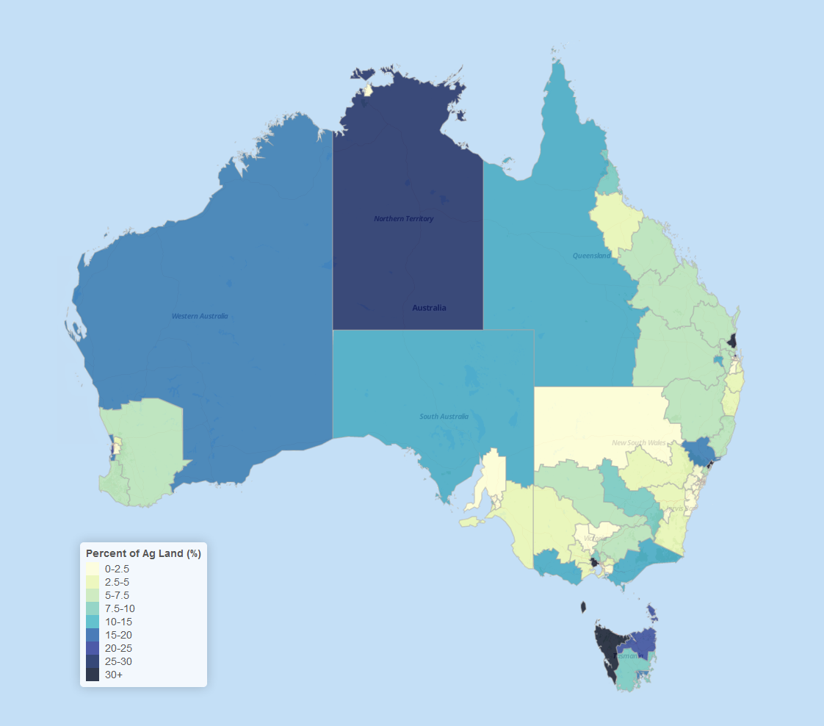
Chart 1 is produced by calculating the proportion of agricultural land with a level of foreign ownership for each SA4 regional area. This is calculated by dividing the total amount of foreign held agricultural land in each region by the total amount of agricultural land in each region.
The total amount of foreign held agricultural land in each region uses data collected by the ATO to 30 June 2017. As the ATO only collects data on foreign holdings, ABS data on total land holdings is used to calculate the proportion of foreign owned land in each region. The ABS 2010-11 Agricultural Census was used for this purpose (while a 2015-16 Agricultural Census has been published it does not yet provide the underlying data needed for this report — changes in the data since 2010-11 would not have a significant impact on the reported results).

Attachment A: Background
The Agricultural Land Register was established on 1 July 2015 and is administered by the ATO. The Act requires foreign persons with an interest in agricultural land to register that interest on the Agricultural Land Register, regardless of the value of the land.
Ultimately the obligation to register correctly lies with the foreign person and penalties exist under the Taxation Administration Act 1953 where a person fails to register correctly.
Section 16 of the Act allows the Commissioner to correct or update information on the Agricultural Land Register.
Investors are required to notify the ATO within 30 days if they:
- are a foreign person starting to hold agricultural land; or
- are a foreign person ceasing to hold agricultural land; or
- become a foreign person while holding agricultural land; or
- cease to be a foreign person while holding agricultural land; or
- are a foreign person holding land that becomes agricultural land; or
- are a foreign person holding land that ceases to be agricultural land.
An interest in agricultural land includes a freehold interest or the right to occupy land under a lease (including a sublease or licence) where the term of the lease or licence (including any extension or renewal) is reasonably likely to exceed five years.
A stocktake was conducted between 1 July 2015 and 29 February 2016 to enable existing foreign person landholders to register their land. During this time, the ATO used data matching to identify and contact investors who may have met the definition of foreign person and who held Australian land that may have met the definition of agricultural land.

Attachment B: Definitions
This attachment provides information on the definitions of ‘foreign person’ and ‘agricultural land’ as detailed in the Act. Further information on the definitions can be found in the Guidance Notes on the Foreign Investment Review Board (FIRB) website at: www.firb.gov.au.

‘foreign person’
The term ‘foreign person’ is defined in section 4 of the Act. It states that the term has the same meaning as ‘foreign person’ as defined in section 4 of the Foreign Acquisitions and Takeovers Act 1975.
In general, a ‘foreign person’ is:
- an individual not ordinarily resident in Australia; or
- a foreign government or foreign government investor; or
- a corporation, trustee of a trust or general partner of a limited partnership where an individual not ordinarily resident in Australia, a foreign corporation or a foreign government holds a substantial interest of at least 20 per cent; or
- a corporation, trustee of a trust or general partner of a limited partnership in which two or more foreign persons hold an aggregate substantial interest of at least 40 per cent.

‘foreign government investor’
A ‘foreign government investor’ is:
- a foreign government or separate government entity, a corporation or trustee of a trust, or a general partner of a limited partnership in which:
  - a foreign government or separate government entity holds a substantial interest of at least 20 per cent; or
  - foreign governments or separate government entities of more than one foreign country (or parts of more than one foreign country) hold an aggregate substantial interest of at least 40 per cent.

‘agricultural land’
‘Agricultural land’ is defined in section 4 of the Act as land in Australia that is used, or that could reasonably be used, for a primary production business.
Section 5 of the Act provides that rules may be made that specify land that will not be considered agricultural land for the purposes of the Agricultural Land Register. The Register of Foreign Ownership of Water or Agricultural Land Rules 2017 provides that the following land will not be considered agricultural land for the purposes of the Act:
- Land that is not currently being wholly or predominantly used at that time for a primary production business and:
  - zoning approval is required from government before the land could be used for primary production; or
  - the land is currently used, or proposed to be used for mining or activities ancillary to mining; or
  - the land is used for environmental protection or conservation under a law of the Commonwealth, a state or a territory or a legally binding agreement; or
  - the land is located within an area that has been approved by a government authority as an industrial estate; or
  - the size of the land is under one hectare; or
  - the land has been approved by a government authority for use as a tourist facility, an outdoor education establishment or an outdoor recreation facility that is open to the public; or
  - an application has been made to re-zone the land to not allow the land to be used for a primary production business, or approval has been sought to use the land for mining activities; or
  - the land is used for wind or solar power station(s), including when an approval is in place to allow the wind or solar farm to be established or operated on the land, or the land was acquired solely for the purpose of meeting a requirement of government approval for the solar or wind farm.
- Land where the only primary production business the land could reasonably be used for is a primary production business relating to submerged plants and animals.

Attachment C: Methodology
This is an overview of the main methodological caveats that apply to the data in this report.
- Data was extracted from the Agricultural Land Register database on 30 June 2017.
- Some registrations have been altered in accordance with section 16 of the Act when it has been determined via data matching or manual data collection that the registrant has provided incorrect information. The validation of registrations is an ongoing exercise, with information validated using ATO risk algorithms, third party data sources and manual data collection.
- Registrants were able to enter the area of their land holdings onto the Agricultural Land Register in any unit of measurement. The ATO has converted into hectares any land holdings reported in a different unit of measurement.
- Entities and trusts were required to report their country of incorporation. However, this is not necessarily a reflection of the foreign source country of the investor. Source country information has been obtained using information provided by registrants, ATO data sources and manual data collection.
- Properties were given a unique identifier in the form of a composite of the property name/address, suburb and state/territory. Counts of properties were based on instances of unique identifiers.
- Properties were assigned geographic coordinates using a geocoding algorithm. Each property was assigned a Statistical Area (Level 4) based on its geographic coordinates, (shown in Chart 1).
- In some instances, the same property has been registered twice - by a foreign person with a freehold interest in the land and by another foreign person with a leasehold interest in the land, as required under the Act. To avoid double counting, only the freehold interest was counted. However, in Table 2, the land size information from both freehold and leasehold registrations has been included.
- The definition of agricultural land under the Foreign Acquisitions and Takeovers Act 1975 includes ‘land in Australia that is used, or that could reasonably be used, for primary production purposes’. Due to the broad nature of this definition it is possible that the Agricultural Land Register includes land that is not captured as part of the ABS Agricultural Census. This may have the effect of overstating the total proportion of Australian agricultural land that is foreign held.

Attachment D: Land registration form fields
Each registrant must complete the following mandatory fields:
- Name
- Position
- Address
- Mobile/cell number
- Contact email
Reason for registration
- Acquisition of agricultural land
- Cease to hold agricultural land
- Change in status: To foreign person
- Change in status: From foreign person
- Change in status: To agricultural land
- Change in status: From agricultural land
Entity/ownership details
- Name
- Country of incorporation (where registrant is a trust or company)
- Address
- Date of birth/nationality (where registrant is an individual)
- Contact details
- Mobile/cell number
- Contact email
Land title details
- Property name and address
- Lot/plan
- Land area
- Land use
- Title holding type (leasehold or freehold)
- Date of event
- Market value of land in Australian dollars
- Percentage interest in the land
These fields are voluntary fields as they do not apply to each registrant:
- Visa and passport details
- ABN/ACN/ABRN/other client identifier
- Trading name
- FIRB approval number

The Australian Statistical Geography Standard (ASGS) is the Australian Bureau of Statistics' geographical framework, effective from July 2011.
This table uses the ABS 2015-2016 Agricultural Census for comparison of reporting years.
In some instances, the same property has been separately registered by a foreign person with a freehold interest in the land and a foreign person with a leasehold interest in the land, as required under the Act. Land size information from both registrations has been included in Table 2 only. As a result, the total hectares held by foreign persons is greater in Table 2 than elsewhere in this report.
Details of land use were not provided by all registrants.
The reduction in US land holdings can be partly attributed to the ATO’s continued investigations into source country ownership.
N/A means the country would have been outside the top 10, hence the data has not been provided.
This excludes the Australian portion below.
This reflects the share of Australian investors’ equity in land captured by the register. The register can capture entities with foreign ownership of 20 per cent share or more, which means there may be a significant portion of Australian equity.
As defined in section 5 of the Foreign Acquisitions and Takeovers Act 1975.
Land that is not agricultural land for the purposes of the Register of Foreign Ownership of Water or Agricultural Land Act 2015 is outlined in section 44 of the Foreign Acquisitions and Takeovers Regulation 2015.
In some cases, the nationality or country of incorporation of a nominal investor may have been identified, rather than the nationality or country of incorporation of the ultimate beneficial owner.

