Register of foreign ownership of residential real estate
  - Insights into foreign purchases and sale of residential real estate for the period 1 July 2017 to 30 June 2018

OFFICIAL
External

Contents
Introduction 3
Methodology 4
Understanding the reporting period 4
Insights 5
Purchase transactions 7
Breakdown of purchase transactions by state or territory 7
Breakdown of purchases by property types 8
Sale transactions 12
Breakdown of sale transactions by state or territory 12
Breakdown of sale transactions - property types by state or territory 13

Introduction

A Register of foreign ownership of residential land has been established as part of the Australian Government’s commitment to increase transparency around foreign investment in Australia
Information has been extracted from the Register to provide insights into foreign purchases and sales of residential real estate. The information relates to residential real estate transactions (purchases or sales) by foreign persons between 1 July 2017 and 30 June 2018 (‘‘the reporting period’’).
Consistent with Australia’s broader foreign investment review regime, the details of foreign persons are not made available publicly. Taxation law also restricts the release of information which could identify, or be used to identify, an individual or entity. For these reasons, this information is presented in an aggregated format only.
Care should be taken in comparing the Insights data with the Foreign Investment Review Board (FIRB) Annual Report 2017-18. The FIRB Annual Reports contain proposed investment information. The Insights data reflects confirmed real estate transactions in the 2017-18 financial year and is not a full stocktake of foreign ownership in residential land.

Methodology
The Register holds information about purchase or sale transactions during 2017- 18 by foreign persons who have obtained prior foreign investment approval.
Purchase transactions are where:
- a foreign person (through self-registration) has indicated that they have settled on a residential property for which they had gained prior foreign investment approval and
- a foreign person (identified during compliance activity) that has settled property and failed to apply for foreign investment approval or
- through the collection of land titles data from participating states and territories, the ATO has matched a residential real estate transfer (purchase) and purchaser, to a corresponding property and foreign person that was previously issued foreign investment approval.
Similarly, sale transactions are where:
- a foreign person (through self-registration) has indicated that they have sold (and settlement has occurred on) a residential property for which they had gained prior foreign investment approval, or
- through the collection of land titles data, from participating states and territories, the ATO has matched a residential real estate transfer (sale) and vendor to a corresponding property and foreign person that was previously issued foreign investment approval.
For a purchase or sale transaction to be included in the Insights, the settlement date for the transaction needs to have occurred within the reporting period.
The value is derived from the contract sale price and represents the transaction value at that time, not current market value.

Understanding the reporting period
Transactions | Included/Not included
Transactions wholly within reporting period | Included
Transaction starts before but settles within the reporting period | Included
Transaction starts within the reporting period but settles after | Not included
Transaction is wholly outside the reporting period | Not included
Foreign person becomes a permanent resident before reporting period | Not included
Foreign person becomes a permanent resident within the reporting period | Included

Insights
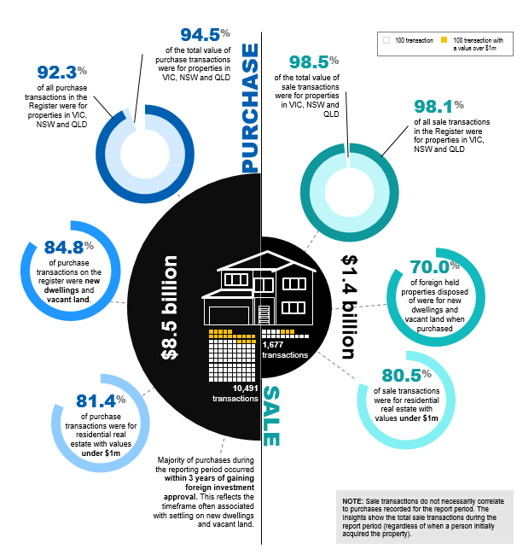
A summary of the key insights of purchase and sale transactions recorded in the Register of foreign ownership of residential land during the reporting period is detailed below.

Purchase transactions
- The total number of residential real estate purchase transactions during the reporting period with a level of foreign ownership was 10,491 with a value of 8.5 billion dollars.
- Victoria, New South Wales and Queensland represented 92.3 per cent of all transactions making up 94.5 per cent of the total value of purchase transactions recorded on the Register for the report period.
- 84.8 per cent of foreign held properties on the register were new dwellings and vacant land new dwellings.
- 81.4 per cent of residential property purchase transactions were for purchase transactions with values under 1 million dollars.
- The majority of purchases during the reporting period occurred within 3 years of gaining foreign investment approval. This reflects the timeframe often associated with settling on new dwellings and vacant land

Sale transactions
Sale transactions do not necessarily correlate to purchases recorded for the report period. The Insights show the total sale transactions during the report period (regardless of when a person initially acquired the property).
- The total number of residential real estate sale transactions during the report period with a level of foreign ownership was 1,677 with a value of 1.4 billion dollars.
- Victoria, New South Wales and Queensland represent 98.1 per cent of the number of sale transactions, making up 98.5 per cent of the value on the residential real estate register for the report period.
- 70.0 per cent of foreign held properties disposed of were for new dwellings and
vacant land when purchased
- 80.5 per cent of sale transactions were for residential real estate with values under 1 million dollars

Purchase transactions
The total number of residential real estate purchase transactions during the report period with a level of foreign ownership was 10,491 with a value of 8.5 billion dollars.
Victoria, New South Wales and Queensland represented 92.3 per cent of all transactions making up 94.5 per cent of the total value of purchase transactions recorded on the Register for the report period.
New dwellings represented 64.9 per cent of purchase transactions, followed by 19.9 per cent for vacant land and 15.2 per cent for established dwellings.
The states with the greatest number of purchase transactions by property type are as follows:
- New South Wales - New dwellings
- Victoria - Vacant land
- Victoria - Established dwellings

New dwellings represented 60.3 per cent of the value of all purchase transactions, followed by established dwelling with 30.3 per cent and vacant land with 9.3 per cent.
There were 1,942 purchase transactions for properties valued greater than one million dollars.
Of the 10,491 purchase transactions during the reporting period, 322 registrants became a permanent resident or gained Australian citizenship during the year and are included in these statistics.

Breakdown of purchase transactions by state or territory
The breakdown of purchase transactions by property types new dwellings, vacant land and established dwellings in the reporting period is detailed below.
- The majority of residential purchase transactions were for properties with values under 1 million dollars (81.5.per cent).
- Victoria had 4,459 transactions with 779 valued at more than 1 million dollars and was the top state for established dwellings and vacant land
- New South Wales had 3,084 transactions with 957 valued at more than 1 million dollars and was the top state for new dwellings.
- Queensland had 2,136 transactions with 142 valued at more than 1 million dollars.
- Western Australia had 425 transactions with 37 valued at more than 1 million dollars.
- South Australia had 257 transactions with 22 valued at more than 1 million dollars.
- Tasmania had 86 transactions with less than 5 transactions valued at more than 1 million dollars.
- The Australian Capital Territory had 41 transactions with less than 5 transactions valued at more than 1 million dollars.
- The Northern Territory had less than 5 transactions
- Of the purchase transactions, 81.5 per cent were for properties with values under 1 million dollars.

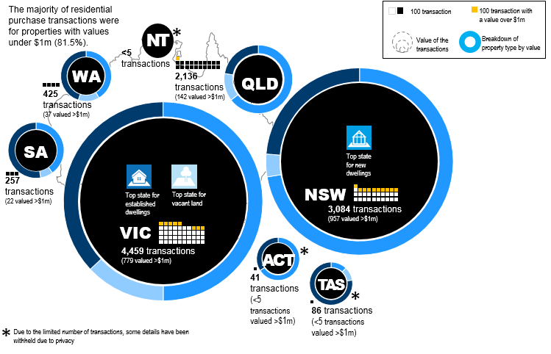

Breakdown of purchases by property types
The breakdown of purchase transactions by property types new dwellings, vacant land and established dwellings in the reporting period is detailed below. Due to the limited number of transactions, some details have been withheld due to privacy.

New dwellings
- New South Wales had 2,570 transactions with a value of 2.4 billion dollars.
- Victoria had 2,455 transactions with a value of 1.7 billion dollars.
- Queensland had 1,458 transactions with a value of 842.4 million dollars.
- Western Australia had 178 transactions valued at 108.1 million dollars.
- South Australia had 109 transactions valued at 57.8 million dollars.
- The Australian Capital Territory had 28 transactions valued at 15.2 million dollars.
- Tasmania had 10 transactions valued at 4.7 million dollars.
- The limited number of transactions in the Northern Territory details have been withheld due to privacy.
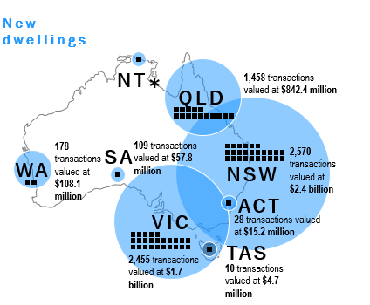

Vacant land
- Victoria had 1,323 transactions valued at 451.5 million dollars.
- Queensland had 381 transactions valued at 170.7 million dollars.
- New South Wales had 233 transactions valued at 129.6 million dollars.
- Western Australia had 101 transactions valued at 35.1 million dollars.
- South Australia had 30 transactions valued at 10.5 million dollars.
- Tasmania had 18 transactions valued at 4.0 million dollars.
- The Northern Territory did not record any transactions.

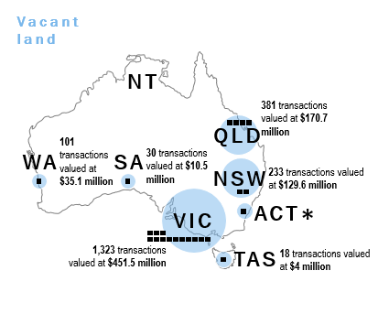

Established dwellings
- Victoria had 681 transactions valued at 1.3 billion dollars.
- New South Wales had 281 transactions valued at 783.8 million dollars.
- Queensland had 297 transactions valued at 290.0 million dollars.
- Western Australia had 146 transactions valued at 117.1 million dollars.
- South Australia had 118 transactions valued at 75.83 million dollars.
- Tasmania had 58 transactions valued at 30.2 million dollars.
- The limited number of transactions in the Northern Territory details have been withheld due to privacy

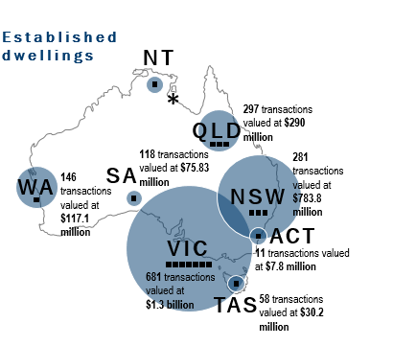

Sale transactions
The total number of residential real estate sale transactions by foreign persons during the report period was 1,677 with a value of 1.4 billion dollars.
Sale transactions do not necessarily correlate to purchases recorded for the report period; the Insights show the total sale transactions during the report period (regardless of when a person initially acquired the property).
Victoria, New South Wales and Queensland represent 98.1 per cent of the number of sale transactions, making up 98.5 per cent of the value of sales for the reporting period.
The states with the greatest number of sale transactions by property type are as follows:
- New South Wales - New dwellings
- Victoria - Vacant land
- Victoria - Established dwellings
New dwellings represented 42.0 per cent of the value of all sale transactions, followed by established dwelling with 41.0 per cent and vacant land with 17.0 per cent.
There were 327 sale transactions for properties valued greater than one million dollars.
The property type reflects the type of property at time of purchase, e.g. new dwellings were new at the time of purchase.
Property values are not reported where the total number of sales is less than five. This approach is taken to avoid the possibility of report data being used to identify an individual or entity.
There are 146 sale transactions reflecting registrants who became permanent residents or gained Australian citizenship during the reporting period that have been included in these figures.
No sale transactions were recorded for the ACT and Northern Territory.
Values represent the contract value, not the current market value of the property at the
time of reporting.

Breakdown of sale transactions by state or territory
The breakdown of sale transactions by state or territory in the reporting period is detailed below.
- The majority of residential sale transactions were for properties with values under 1 million dollars (80.5 per cent).
- Victoria had 817 transactions with 142 valued at more than 1 million dollars and was the top state for established dwellings and vacant land by value.
- New South Wales had 571 transactions with 145 valued at more than 1 million dollars and was the top state for new dwellings.
- Queensland had 257 transactions with 35 valued at more than 1 million dollars.
- Western Australia had 14 transactions with less than 5 transactions valued at more than 1 million dollars.
- South Australia had 9 transactions with less than 5 transactions valued at more than 1 million dollars.
- Tasmania had 9 transactions with zero transactions valued at more than 1 million dollars.
- The Australian Capital Territory and Northern Territory did not record any sale transactions

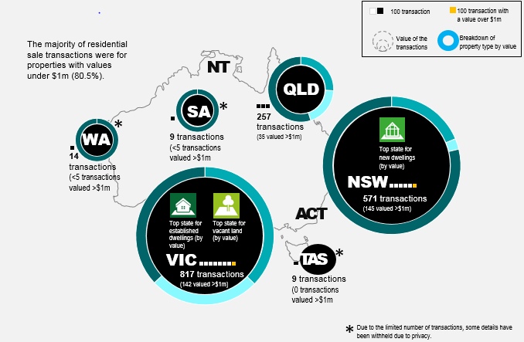

Breakdown of sale transactions - property types by state or territory
The breakdown of sales by property types new dwellings, vacant land and established dwellings by state or territory in the reporting period is detailed below. Due to the limited number of transactions, some details have been withheld due to privacy.

New dwellings
- Victoria had 333 transactions valued at 225 million dollars.
- New South Wales had 361 transactions valued at 303.2 million dollars.
- Queensland had 92 transactions valued at 43.3 million dollars.
- Due to the limited number of transactions in the Western Australian, South Australia and Tasmania details have been withheld due to privacy.
- The Northern Territory and the Australian Capital Territory did not record any transactions.

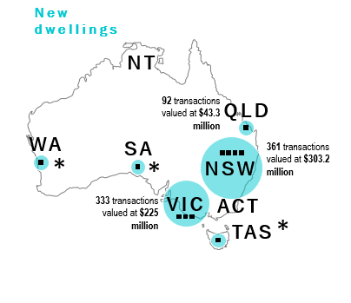

Vacant land
- Victoria had 281 transactions valued at 155.6 million dollars.
- Queensland had 56 transactions valued at 32.6 million dollars.
- New South Wales had 48 transactions valued at 40.4 million dollars.
- Due to the limited number of transactions in the Western Australian, South Australia and Tasmania details have been withheld due to privacy.
- The Northern Territory and the Australian Capital Territory did not record any transactions.

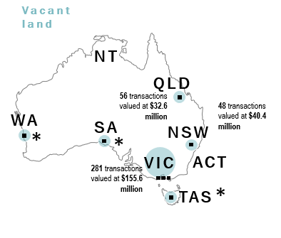

Established dwellings
- Victoria had 203 transactions valued at 222.7 million dollars.
- Queensland had 109 transactions valued at 92.6 million dollars.
- New South Wales had 162 transactions valued at 226.6 million dollars.
- Due to the limited number of transactions in Tasmania details have been withheld due to privacy.
- The Northern Territory and the Australian Capital Territory did not record any transactions.

