Register of foreign ownership of residential real estate
  - Insights into foreign purchases and sale of residential real estate for the period 1 July 2018 to 30 June 2019

OFFICIAL
External

Contents
Introduction 3
Methodology 4
Understanding the reporting period 4
Insights 5
Purchase Transactions 7
Breakdown of purchase transactions by state or territory 7
Breakdown of purchase transactions by property types 8
Sale Transactions 12
Breakdown of sale transactions by state or territory 12
Breakdown of sale transactions - property types by state or territory 14
Purchase Trends 17
Sale Trends 21

Introduction

The Register of foreign ownership of residential land has been established as part of the Australian Government’s commitment to increase transparency around foreign investment in Australia.
Information has been extracted from the Register to provide insights into foreign purchases and sales of residential real estate over two reporting periods. The information relates to residential real estate transactions (purchases or sales) by foreign persons between 1 July 2018 to 30 June 2019 (2018-19) and 1 July 2017 to 30 June 2018 (2017-18) reporting periods.
Consistent with Australia’s broader foreign investment review framework, the details of foreign persons are not made available publicly. Taxation law also restricts the release of information which could identify, or be used to identify, an individual or entity. For these reasons, this information is presented in an aggregated format only.
Care should be taken in comparing the Insights data with the Foreign Investment Review Board (FIRB) Annual Reports. The FIRB Annual Reports contain proposed investment information. The Insights data reflects confirmed real estate transactions and is not a full stocktake of foreign ownership in residential land.

Methodology
The Register holds information about purchase or sale transactions by foreign persons who obtained foreign investment approval.
Purchase transactions are where:
- a foreign person (through self-registration) has indicated that they have settled on a residential property for which they had gained prior foreign investment approval, and
- a foreign person (identified during compliance activity) that has settled property and failed to apply for foreign investment approval or
- through the collection of land titles data from participating states and territories, the ATO has matched a residential real estate transfer (purchase) and purchaser, to a corresponding property and foreign person that was previously issued foreign investment approval.
Similarly, sale transactions are where:
- a foreign person (through self-registration) has indicated that they have sold (and settlement has occurred on) a residential property for which they had gained prior foreign investment approval, or
- through the collection of land titles data from participating states and territories, the ATO has matched a residential real estate transfer (sale) and vendor to a corresponding property and foreign person that was previously issued foreign investment approval.
For a purchase or sale transaction to be included in the Insights, the settlement date for the transaction needs to have occurred within the relevant reporting period.
For purchase transactions if a property was purchased and then sold during the report period, the purchase is included in these figures.
The value is derived from the contract sale price and represents the transaction value at that time, not current market value.

Understanding the reporting period
Transactions | Included/Not included
Transactions wholly within reporting period | Included
Transaction starts before but settles within the reporting period | Included
Transaction starts within the reporting period but settles after | Not included
Transaction is wholly outside the reporting period | Not included
Foreign person becomes a permanent resident before reporting period | Not included
Foreign person becomes a permanent resident within the reporting period | Included

Insights
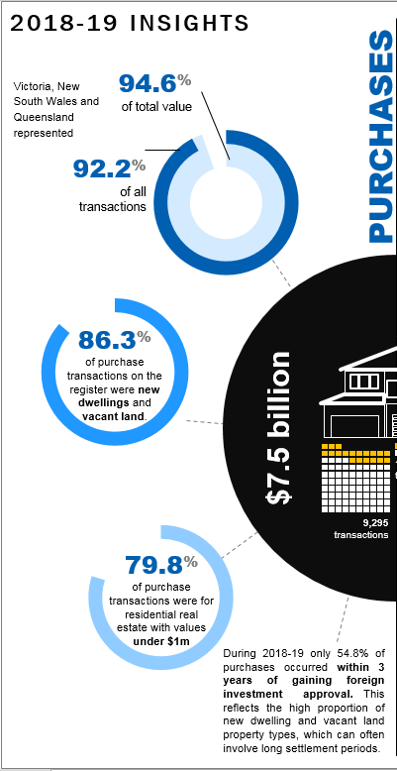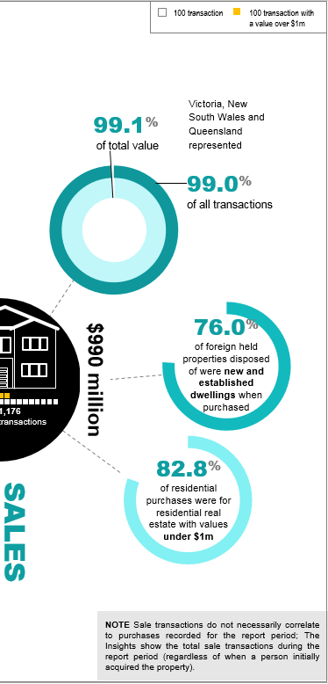
A summary of the key insights of purchase and sale transactions recorded in the Register of foreign ownership of residential land during the period 1 July 2018 to 20 June 2019 is detailed below.

Purchases
- The total number of residential real estate purchase transactions was 9,295 with a value of 7.5 billion dollars.
- Victoria, New South Wales and Queensland represented 92.2 per cent of all transactions and 94.6 per cent of the total value of purchase transactions recorded on the Register for the reporting period.
- 86.3 per cent of purchase transactions on the Register were new dwellings and vacant land
- 79.8 per cent of purchase transactions were for residential real estate with values under 1 million dollars.
- During 2018-19 only 54.8 per cent of purchases occurred within 3 years of gaining foreign investment approval. This reflects the high proportion of new dwelling and vacant land property types, which can often involve long settlement periods

Sales
Sale transactions do not necessarily correlate to purchases recorded for the report period; The Insights show the total sale transactions during the report period (regardless of when a person initially acquired the property).
- The total number of residential real estate sale transactions during the reporting period was 1,176 with a value of 990 million dollars.
- Victoria, New South Wales and Queensland represented 99.0 per cent of sale transactions and 99.1 per cent of the total sale transactions value.
- 76.0 per cent of foreign held properties disposed of were new and established dwellings when purchased.
- 82.8 per cent of residential purchases were for residential real estate with values under 1 million dollars.

Purchase Transactions
In 2018-19, the total number of residential real estate purchase transactions with a level of foreign ownership was 9,295 with a value of 7.5 billion dollars. Overall there was an 11.4 per cent reduction in the number of purchase transactions and 11.8 per cent reduction in the value of transactions when compared to 2017-18.
Victoria, New South Wales and Queensland represented 92.2 per cent of all purchase transactions and make up 94.6 per cent of the total value of purchase transactions recorded on the Register for the 2018-19 period. Similarly, in 2017-18, Victoria, New South Wales and Queensland represented 92.3 per cent of all purchase transactions, making up 94.5 per cent of the total value.
New dwellings represented 68.9 per cent of purchase transactions, followed by 17.4 per cent for vacant land and 13.7 per cent for established dwellings in 2018-19. Compared to 2017-18, new dwellings represented 64.9 per cent of purchase transactions, followed by 19.9 per cent for vacant land and 15.2 per cent for established dwellings.
The states with the greatest number of purchase transactions in both 2017-18 and 2018-19 by property type are: New South Wales - New dwellings, Victoria - Vacant land and Established dwellings.
Residential properties with values under 1 million dollars formed most residential property purchase transactions, accounting for 79.8 per cent of property transactions in 2018-19. This compares to 81.5 per cent in 2017-18.
Of the 9,295 purchase transactions in 2018-19, 146 registrants became a permanent resident or gained Australian citizenship during the year and are included in these statistics.
New dwellings represented 70.2 per cent of the value of all purchase transactions, followed by established dwelling with 21.5 per cent and vacant land with 8.3 per cent in 2018-19.
There were 1,874 purchase transactions for properties valued greater than one million dollars in 2018-19.

Breakdown of purchase transactions by state or territory
The breakdown of purchase transactions by state or territory in the reporting period is detailed below.
- Victoria had 3,768 transactions with 661 valued at more than 1 million dollars and was the top state for established dwellings and vacant land.
- New South Wales had 3,151 transactions with 1,034 valued at more than 1 million dollars and was the top state for new dwellings.
- Queensland had 1,648 transactions with 128 valued at more than 1 million dollars.
- Western Australia had 344 transactions with 32 valued at more than 1 million dollars.
- South Australia had 201 transactions with 15 valued at more than 1 million dollars.
- Tasmania had 107 transactions and less than 5 transactions valued at greater than 1 million dollars.
- The Australian Capital had 67 transactions and less than 5 transactions valued at greater than 1 million dollars.
- The Northern Territory had 9 transactions and zero transactions valued at greater than 1 million dollars.
- Of the purchase transactions, 79.8 per cent were for properties with values under 1 million dollars.

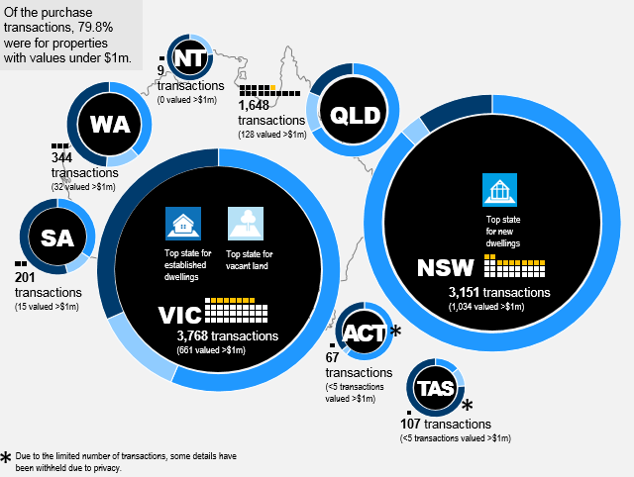

Breakdown of purchase transactions by property types
The breakdown of purchase transactions by property types new dwellings, vacant land and established dwellings in the reporting period is detailed below. Due to the limited number of transactions in various states, some details have been withheld due to privacy.

New dwellings
- New South Wales had 2,832 transactions with a value of 2.8 billion dollars.
- Victoria had 2,247 transactions with a value of 1.6 billion dollars.
- Queensland had 1,054 transactions with a value of 695.2 million dollars.
- Western Australia had 145 transactions valued at 79.7 million dollars.
- South Australia had 72 transactions valued at 38.3 million dollars.
- The Australian Capital Territory had 42 transactions valued at 21.5 million dollars.
- Tasmania had 13 transactions valued at 6.2 million dollars.
- The Northern Territory did not record any transactions.
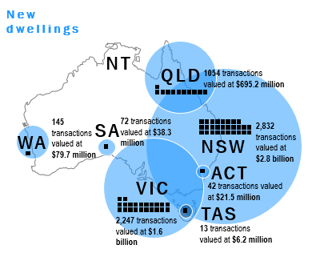

Vacant land
- Victoria had 956 transactions valued at 340.6 million dollars.
- Queensland had 379 transactions valued at 144.5 million dollars.
- New South Wales had 149 transactions valued at 90.4 million dollars.
- Western Australia had 68 transactions valued at 26.8 million dollars.
- South Australia had 36 transactions valued at 12.7 million dollars.
- Tasmania had 23 transactions valued at 4.7 million dollars.
- The Northern Territory had less than 5 transactions.
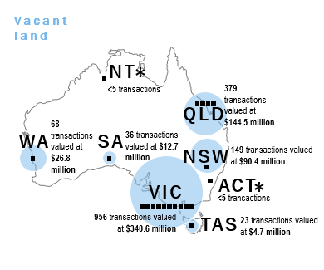

Established dwellings
- Victoria had 565 transactions valued at 899.7 million dollars.
- New South Wales had 170 transactions valued at 310.9 million dollars.
- Queensland had 215 transactions valued at 194.5 million dollars.
- Western Australia had 131 transactions valued at 101.8 million dollars.
- South Australia had 93 transactions valued at 60.5 million dollars.
- Tasmania had 71 transactions valued at 34.4 million dollars.
- The Northern Territory had 7 transactions valued at 2.4 million dollars.
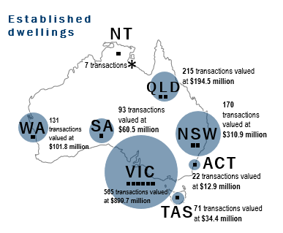

Sale Transactions
The total number of residential real estate sale transactions by foreign persons during 2018-19 period was 1,176, with a value of 990 million dollars. Overall there was a 29.9 per cent reduction in the number of sale transactions and a 27.3 per cent reduction in the value of sale transactions when compared to 2017-18.
Sale transactions numbers reflect any sale transactions made by foreign persons within the reporting period, regardless of when the initial purchase was made.
Victoria, New South Wales and Queensland represent 99.0 per cent of the number of sale transactions, making up 99.1 per cent of the value of sale for the reporting period. Compared to 2017-18, these states represented 98.1 per cent of all sale transactions and 98.5 per cent of the value. No sale transactions were recorded for the Northern Territory.
In 2018-19, new dwellings represented 50.0 per cent of sale transactions, followed by 26.0 per cent for established dwellings and 24.0 per cent for vacant land. The property type reflects the type of property at time of purchase, e.g. new dwellings were new at the time of purchase.
Victoria had the greatest number of sale transactions across all property types in 2018-19. Compared to 2017-18, NSW had the greatest sale count for new dwellings and Victoria has the greatest count for vacant land and established dwellings.
Properties with values under 1 million dollars represented 82.8 per cent of sale transactions. This is a slight increase when compared to the proportion of sale transactions in 2017-18 of 80.5 per cent.
There are 241 sale transactions reflecting registrants who became permanent residents or gained Australian citizenship during the 2018-19 report period that have been included in these figures.
Property values are not reported where the total number of sales is less than five. This approach is taken to avoid the possibility of report data being used to identify an individual or entity.
Established dwelling represented 42.3 per cent of the value of all sale transactions, followed by new dwellings with 40.1 per cent and vacant land with 17.6 per cent in 2018-19.
There were 202 sale transactions for properties valued greater than one million dollars in 2018-19.

Breakdown of sale transactions by state or territory
The breakdown of sale transactions by state or territory in the reporting period is detailed below.
- Victoria had 601 sale transactions with 100 valued greater than one million dollars and was the top state for established dwellings and vacant land (by value).
- New South Wales had 320 sale transactions with 80 valued greater than one million dollars and was the top state for new dwellings (by value).
- Queensland had 243 transactions with 20 valued greater than one million dollars.
- South Australia, and Tasmania each had less than 5 sale transactions with less than 5 valued greater than one million dollars.
- Western Australia had less than 5 sale transactions with zero valued greater than one million dollars
- The majority of residential sale transactions were for properties with values under 1 million dollars (82.8 per cent).

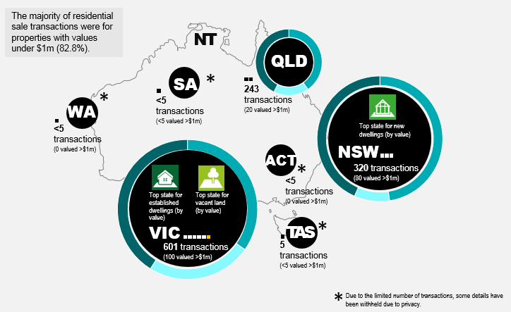

Breakdown of sale transactions - property types by state or territory
The breakdown of sale transactions by property types new dwellings, vacant land and established dwellings by state or territory in the reporting period is detailed below. Due to the limited number of transactions, some details have been withheld due to privacy.

New dwellings
- Victoria had 264 transactions valued at 166.5 million dollars.
- New South Wales had 202 transactions valued at 171.2 million dollars.
- Queensland had 118 transactions valued at 57.3 million dollars.
- South Australia, Tasmania, the Australian Capital Territory and Western Australia each had less than 5 transactions.
- The Northern Territory had nil transactions.
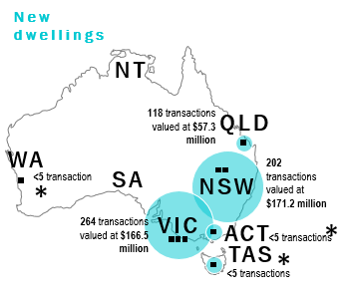

Vacant land
- Victoria had 187 transactions valued at 115.9 million dollars.
- New South Wales had 47 transactions valued at 32.9 million dollars.
- Queensland had 46 transactions valued at 24.3 million dollars.
- South Australia and Tasmania each had less than 5 transactions.
- The Northern Territory, Western Australia and the Australian Capital Territory each had nil transactions.

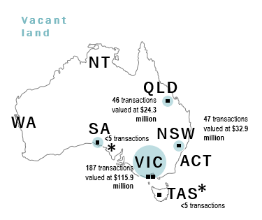

Established dwellings
- Victoria had 150 transactions valued at 197.0 million dollars.
- Queensland had 79 transactions valued at 60.5 million dollars.
- New South Wales had 71 transactions valued at 156.2 million dollars.
- Tasmania had less than 5 transactions.
- South Australia, the Northern Territory, the Australian Capital Territory, and Western Australia each had nil transactions.

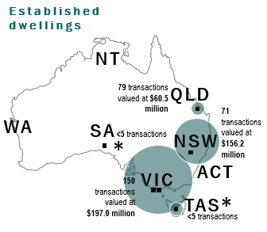

Purchase Trends

There was an 11.4 per cent reduction in the number of purchase transactions in 2018-19 when compared to 2017-18. The value of transactions also reduced by 11.8 per cent when compared to 2017-18.

ACT, NT, NSW and Tasmania show an increase in purchase counts when compared to 2017-18 and remaining states show an overall reduction when compared to their own state.

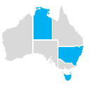

The percentage of purchase transactions that were for residential real estate with values under 1 million dollars in 2018-2019 was 79.8 per cent in 2018-19 compared to 81.5 per cent in 2017-2018.
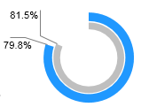

Majority of foreign purchases on the Register were new dwellings and vacant land with 86.3 per cent 2018-2019 compared to 84.8 per cent in 2017-2018.
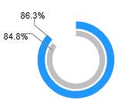

NSW and VIC were the states with the greatest number of purchase transactions by property type in both years.
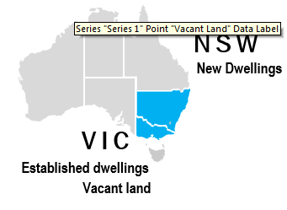

When comparing the percentage change in 2018-19 purchase transactions by property type to 2017-18, vacant land had the greatest reduction of 22.6 per cent. Established dwellings reduced by 20.1 per cent and new dwellings reduced by 5.9 per cent.

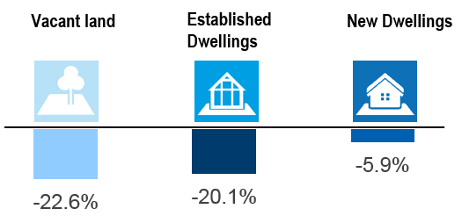

The following table summarises purchase transaction trends by state or territory in 2018-2019 compared to 2017 -18 broken down by property type.

State/Territory | New Dwelling |  | Vacant Land |  | Established Dwelling
 | 2017-18 | 2018-19 | 2017-18 | 2018-19 | 2017-18 | 2018-19
ACT* | 28 | 42 | <5 | <5 | 11 | 22
NSW | 2,570 | 2,832 | 233 | 149 | 281 | 170
NT* | <5 | - | - | <5 | <5 | 7
QLD | 1,458 | 1,054 | 381 | 379 | 297 | 215
SA | 109 | 72 | 30 | 36 | 118 | 93
TAS | 10 | 13 | 18 | 23 | 58 | 71
VIC | 2,455 | 2,247 | 1,323 | 956 | 681 | 565
WA | 178 | 145 | 101 | 68 | 146 | 131

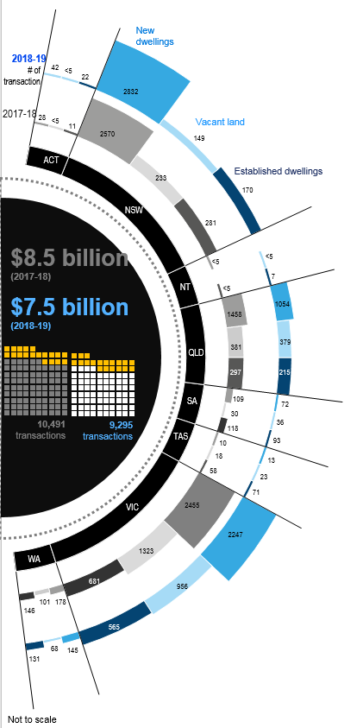

Sale Trends
There was a 29.9 per cent reduction in sale transactions in 2018-19 when compared to 2017-18. The value of sale transactions also reduced by 27.3 per cent when compared to 2017-18.

There was a decrease in sale counts when compared to 2017-18 in all states, other than the ACT.
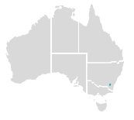
The percentage of sale transactions that were for residential real estate with values under 1 million dollars was 82.8 per cent in 2018-2019 compared to 80.5 per cent in 2017-2018.
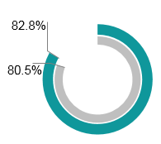
Majority of sale transactions involved properties registered as new dwellings or established dwellings with 76.0 per cent in 2018-2019 compared to 76.7 per cent in 2017-2018.
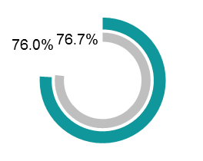
Victoria had the greatest number of sale transactions by all property types in 2018-19. In 2017-18 and NSW had the greatest number for new dwellings.
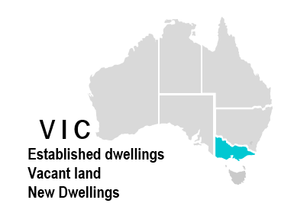

When comparing per cent change in 2018-19 sale transactions by property to 2017-18, established dwellings had the greatest reduction of 38.3 per cent, vacant land reduced by 27.9 per cent and new dwellings reduced by 25.6 per cent.
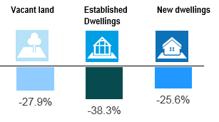

The following table summarises sale transaction trends by state or territory in 2018-2019 compared to 2017-18 broken down by property type.

State/Territory | New Dwelling |  | Vacant Land |  | Established dwelling
 | 2017-18 | 2018-19 | 2017-18 | 2018-19 | 2017-18 | 2018-19
ACT* | - | <5 | - | - | - | -
NSW | 361 | 202 | 48 | 47 | 162 | 71
NT* | - | - | - | - | - | -
QLD | 92 | 118 | 56 | 46 | 109 | 79
SA | <5 | - | <5 | <5 | 7 | <5
TAS | <5 | <5 | <5 | <5 | <5 | <5
VIC | 333 | 264 | 281 | 187 | 203 | 150
WA | <5 | <5 | <5 | - | 11 | -

