Register of foreign ownership of water entitlements
  - Report of registrations as at 30 June 2020

Contents
Introduction 3
Methodology 4
Summary of key findings 5
Findings 10
Foreign held water entitlement – Volume 10
Foreign held water entitlement by resource 12
Foreign held water entitlement in the Murray-Darling Basin 14
Foreign held water entitlement by regulated/unregulated water resource 16
Foreign held water entitlement by water use 17
Foreign held water entitlement by type 19
Foreign share and Australian share of water entitlements 21
Foreign held water entitlement by foreign share by country – top 10 countries 23
Background information on obtaining source country information 25
Attachment A: Background 26
Attachment B: Definitions 28
Attachment C: Methodological caveats 30
Attachment D: Bureau of Meteorology (BOM) data 31
Attachment E: Water entitlement registration forms 32

Introduction
The Register of Foreign Ownership of Water Entitlements (Water Register) was established to provide greater transparency about the level of foreign ownership of Australia’s water entitlements.
The Commissioner of Taxation reports annually to the Treasurer on the operation of the Register of Foreign Ownership of Water or Agricultural Land Act 2015 (the Act) and is required to publish aggregate statistics of foreign ownership each year.
This is the third report of the Water Register (Water Report 2020) and includes water entitlement registrations received from foreign persons between 1 July 2017 and 31 July 2020 for water entitlements held to 30 June 2020.
Since 1 July 2017, foreign persons have been required to register their holdings in registrable water entitlements and contractual water rights with the Australian Tax Office (ATO). A foreign person may register at any time during the year, but no later than 30 days after the end of the financial year in which the event occurred. A person who gives a notice of registrable water entitlement must also advise if they cease to hold the entitlement or right, cease to be a foreign person, or there is a change in the volume or the share of the water resource.
The Water Register collects details about the foreign person, including name and contact details; country of incorporation where the registrant is an entity; or nationality, passport and visa details where the registrant is an individual.
A ‘foreign person’ is defined in the Foreign Acquisitions and Takeovers Act 1975 and includes individuals and entities with foreign ownership of 20% of more. Using this definition, the Water Register captures water entitlements with a level of foreign ownership of 20% or more; such entitlements are referred to as ‘foreign held’. As a result, there may be a portion of Australian equity in the same water entitlement. The breakdown of the foreign share and Australian share of the ‘foreign held’ water entitlement is presented in this report in Figure 12.
Consistent with the principles applied in Australia’s broader foreign investment regime, the details of investors are not made publicly available. Taxation law also restricts the release of information which could identify, or be used to identify, an individual or entity.

Methodology
The ATO has undertaken comparative analyses using information from the Water Register and the Bureau of Meteorology (BOM) information of water entitlement on issue in Australia to estimate the level of foreign ownership of water entitlements.
The BOM is required to collect, manage and disseminate Australia’s water information under the Water Act 2007 and publishes details of Australian water entitlements on issue annually in the Water Markets Dashboard on its website. The ATO uses this information to determine the percentage of Australian water entitlements on issue which have a level of foreign ownership. At 30 June 2020, the BOM reported 39,383 gigalitres (GL) of water entitlements were on issue in Australia.
The BOM Water Markets Dashboard does not capture water rights that are issued outside State Water Planning frameworks. The volume of foreign held water entitlements attributed in the Water Register at 30 June 2020 to water rights that are outside the State Water Planning frameworks was 3 GL, down from 17GL at 30 June 2019. Many of the rights issued outside the State Water Planning frameworks are within Queensland and the Northern Territory, and have been issued with zero volumes. The level of foreign ownership expressed as a proportion of the total water entitlements is potentially marginally overstated, as the 3 GL of foreign held water rights outside of the State Water Planning frameworks are included in the tables, but the total water rights outside of the State Water Planning frameworks are not included in the the total available water entitlements taken from the BOM Water Markets Dashboard. However, 3 GL represents less than 0.1% of the foreign held water rights.
The approach to the administration of water resources varies across the states and territories and hence data collected by the Water Register is not entirely consistent across those jurisdictions. In particular, certain water licences are issued which give a volumetric limit (maximum volume of water which can be taken) where other water entitlements are issued with a nominal volume (typically a maximum volume of water that may be taken in a given period). Water entitlements with a volumetric or nominal value are included in the Water Register in accordance with what is issued on the individual entitlement. However, the BOM Water Market Dashboard only captures entitlements issued with a nominal limit. This difference will result in a slight overstatement of the overall level of foreign ownership when compared to the total Australian water entitlements on issue.
In the Water Report 2020 there is a total of 244 GL of water entitlements which are flagged as contractual rights (leases) held by foreign persons which are also water entitlements held by different foreign persons. This figure is not included in the tables as it would double count the water held by foreign entities.
The statistics in this report need to be interpreted in conjunction with the methodological caveats outlined in Attachment C of this report. Figures in the tables have been rounded. Any discrepancies in the tables between totals and sums of components are due to rounding.
Acknowledgements
This report was developed in consultation with the Bureau of Meteorology, Department of Agriculture, Water and the Environment and the Treasury, and uses information from the BOM – Water information and the Murray-Darling Basin Authority websites.

Summary of key findings
The total volume of foreign held water entitlements in Australia with a level of foreign ownership has increased from 4,113 gigalitres (GL) at 30 June 2019 to 4,299 GL at 30 June 2020.
Using the BOM measure of Australian water entitlements, the estimated proportion of water entitlement with a level of foreign ownership as at 30 June 2020 is 10.9%.
Figure 1 illustrates the proportion of foreign held water entitlements against the BOM measure of total Australian water entitlement on issue as at 30 June 2020.

Figure 1: Foreign held water entitlement against the BOM measure of total Australian water entitlement on issue as at 30 June 2020

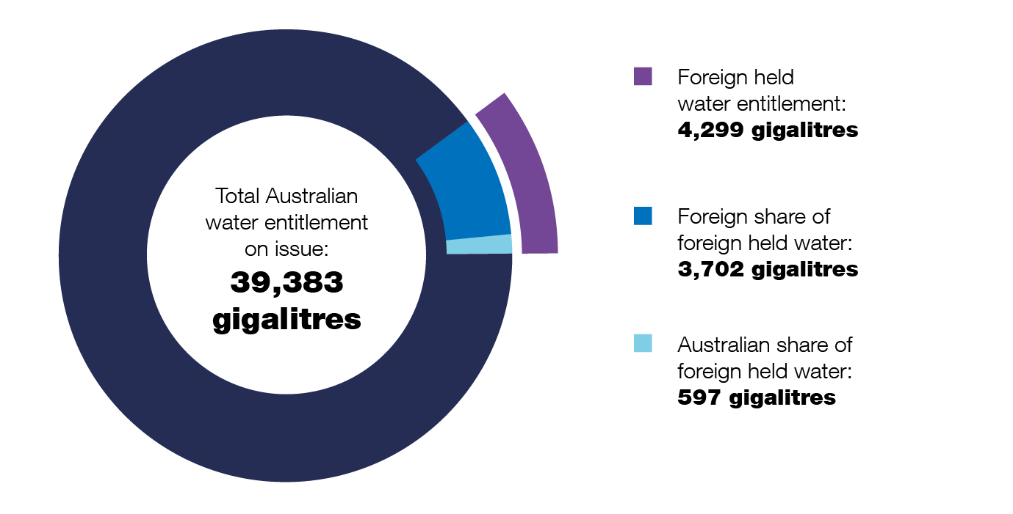

Figure 2 shows the proportion of water entitlement with a level of foreign ownership as at 30 June for each year from 2018 to 2020. The level of foreign ownership has increased from 10.5% as at 30 June 2019 to 10.9% as at 30 June 2020.

Figure 2: Water entitlement with a level of foreign ownership – 3 year comparison
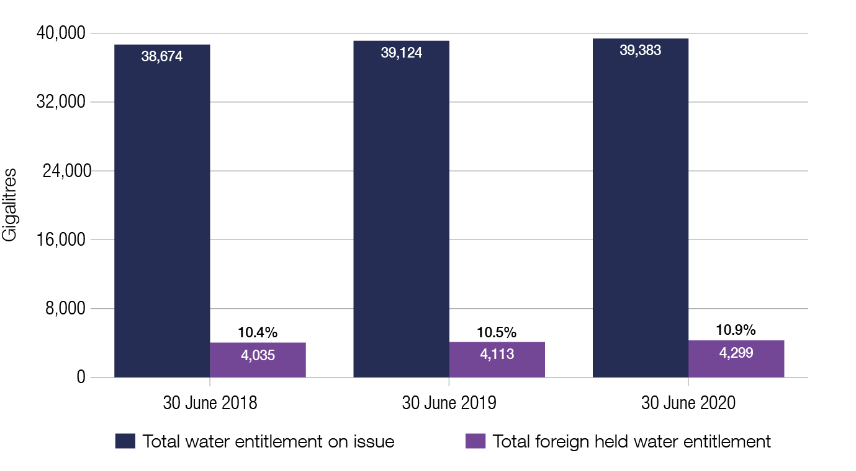
Figure 3 shows the foreign held water entitlement as a proportion of the total Australian water entitlement by country. The top four water entitlement holders by country are Canada with 1.8%, China and the United States of America with 1.7% and the United Kingdom with 0.9% of the total Australian water entitlement (compared with the top four countries listed in the Report of registrations as at 30 June 2019: China, United States of America, United Kingdom, Canada). Refer to Table 8.

Figure 3: Foreign held water entitlement by country
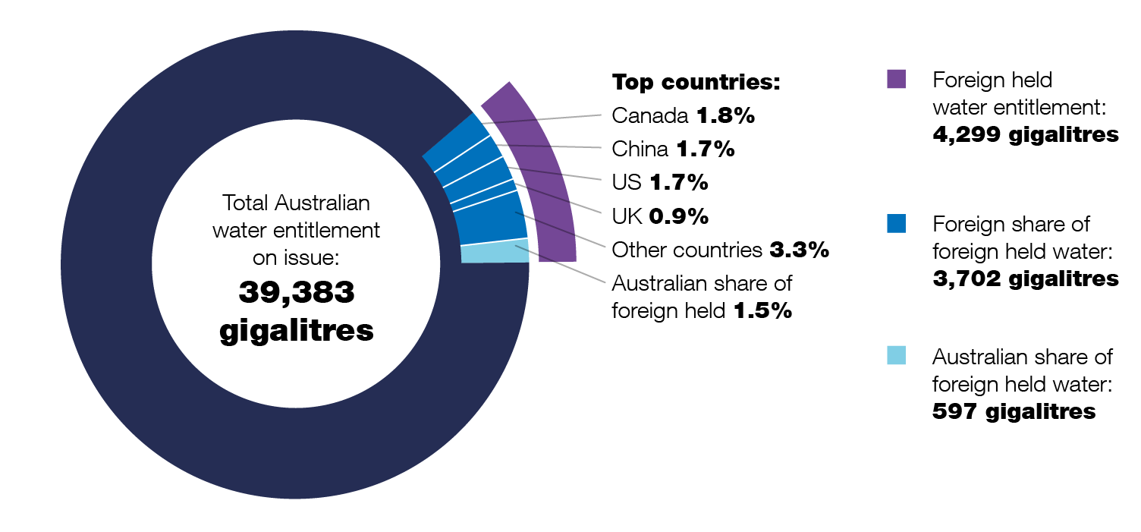

Figure 4 shows that of the 4,299 GL foreign held water entitlements, 71.9% is held by the top 10 countries. Refer to Table 8.

Figure 4: Foreign held water entitlement by top 10 countries
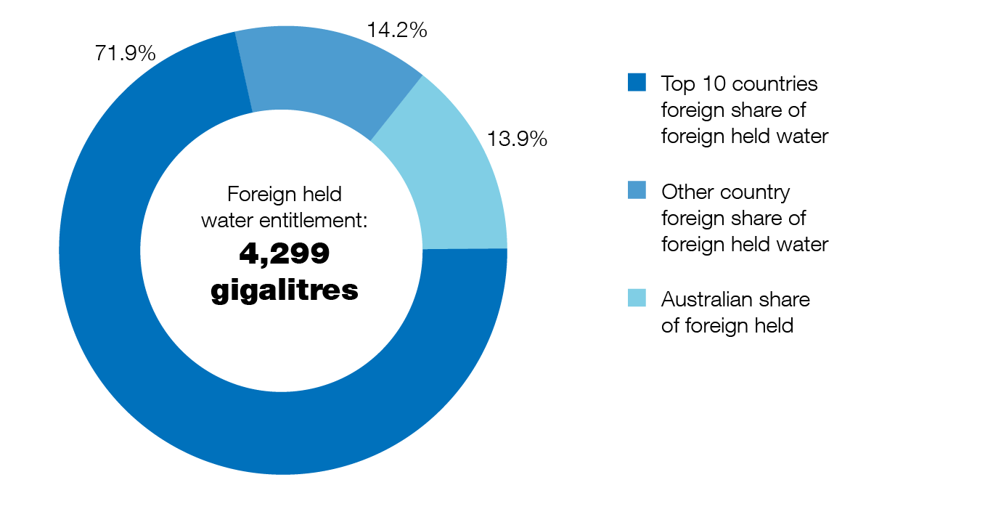

Figure 5 shows the main uses of foreign held water entitlements are agriculture (66.5%) and mining (23.6%).

Figure 5: Foreign held water entitlement by water use
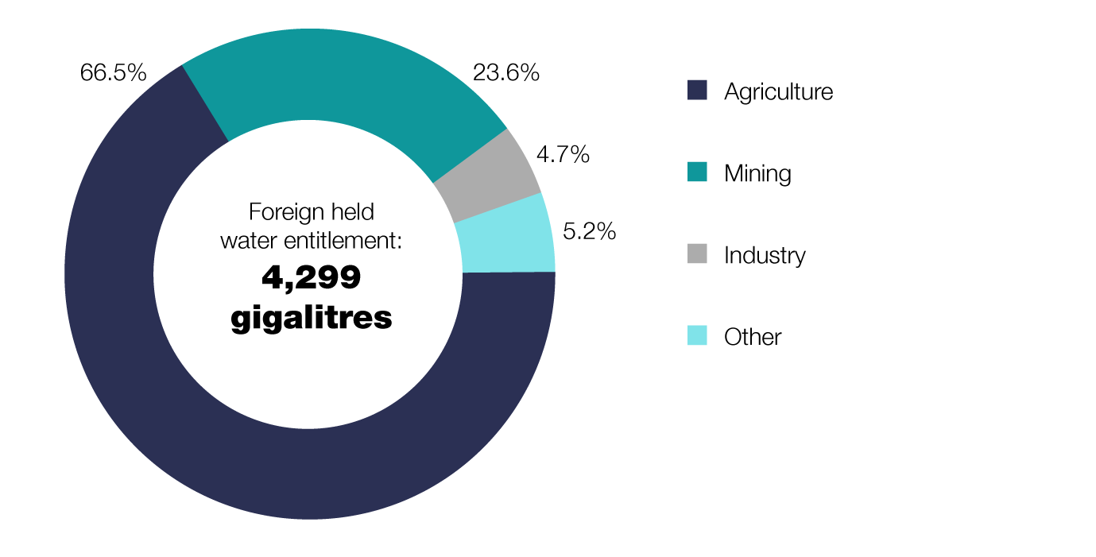

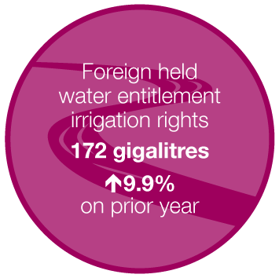
Water entitlements held as irrigation rights and leases form only a small proportion of foreign held water entitlements – refer to Table 7.
Approximately 4.0% of foreign held water entitlements are irrigation rights which are issued by irrigation infrastructure operators.
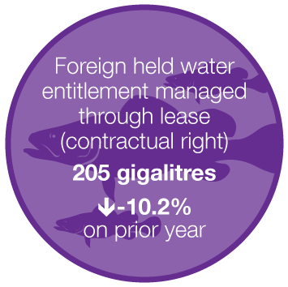
Approximately 4.8% of foreign held water entitlement are managed through leases (contractual right)

Figure 6 shows approximately 52.0% (2,234 GL) of foreign held water entitlement is within the Murray-Darling Basin. This equates to 11.3% of the total Murray-Darling Basin water entitlement on issue. Refer to Table 4.
Figure 6: Water entitlement with a level of foreign ownership as at 30 June 2020 in the Murray-Darling Basin
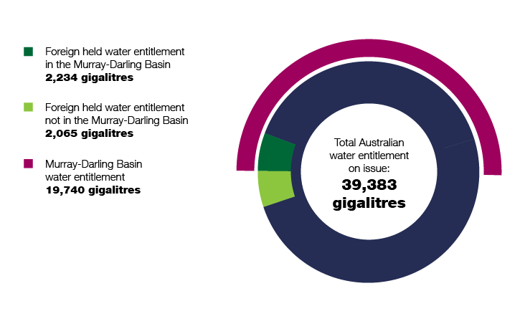
Figure 7 shows the net change of foreign held water entitlement by state or territory as at 30 June 2020 when compared to the prior year. Refer to Table 2 for further information. There was an increase in the amount of foreign held water entitlement in each state as at 30 June 2020 when compared to the prior year, except for the Northern Territory with no change recorded.

Figure 7: Foreign held water entitlement by state or territory – net change compared to prior year
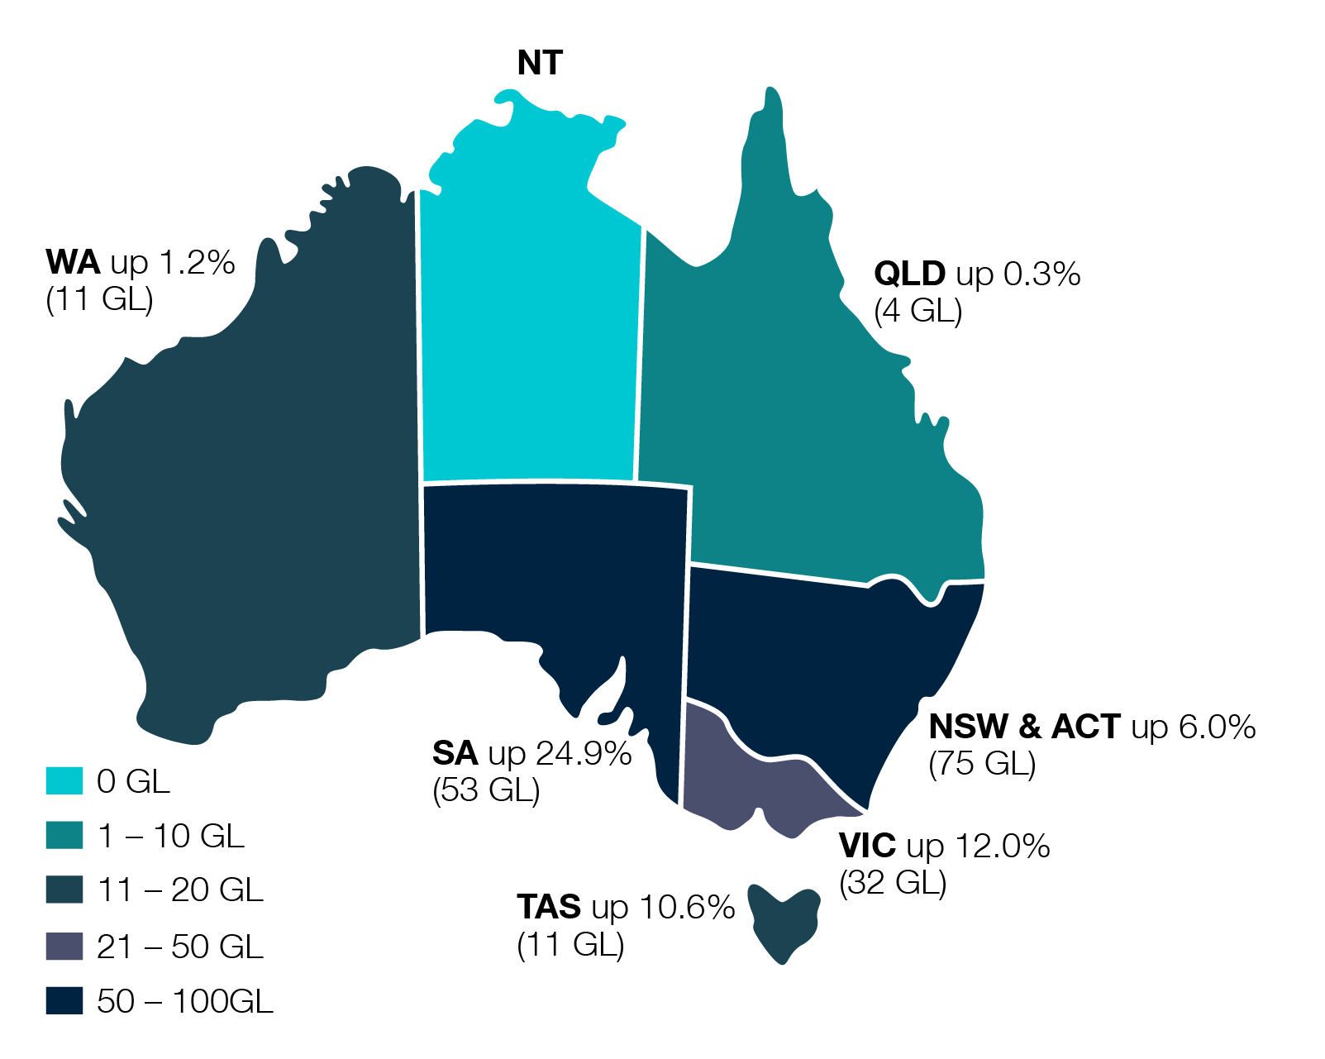

Findings

Foreign held water entitlement – Volume
Table 1 shows the foreign held water entitlement by state or territory as at 30 June for each year from 2018 to 2020. The table also shows the foreign held water entitlement as a proportion of the total water entitlement on issue at 30 June 2020 by state and territory.

Table 1: Foreign held water entitlement by state or territory as at 30 June 2020
 | Foreign held water entitlement |  |  | Total water entitlement on issue | Foreign held water entitlement as a proportion of total water entitlement on issue
State or territory | 30 June 2018  (GL) | 30 June 2019  (GL) | 30 June 2020  (GL) | 30 June 2020  (GL) | 30 June 2020  (%)
New South Wales/ACT | 1,306 | 1,260 | 1,335 | 15,011 | 8.9
Northern Territory | 19 | 32 | 32 | 597 | 5.4
Queensland | 1,219 | 1,301 | 1,305 | 6,952 | 18.8
South Australia | 192 | 213 | 266 | 2,752 | 9.7
Tasmania | 98 | 104 | 115 | 2,384 | 4.8
Victoria | 205 | 267 | 299 | 7,558 | 4.0
Western Australia | 995 | 936 | 947 | 4,129 | 22.9
Total | 4,035 | 4,113 | 4,299 | 39,383 | 10.9
Notes
- The ‘foreign held water entitlement as a proportion of the total water entitlement on issue %’ is the ratio of foreign held water entitlement in that state as at 30 June 2020 to the total water entitlement on issue for each state and territory.
- The total ‘foreign held %’ of 10.9% is the ratio of foreign held water entitlement (4,299 GL) across all states against the total water entitlement on issue in Australia (39,383 GL).
- Zero volume registrations - There were 678 registrations of water entitlement with a reported volume of zero. Of these, 268 were issued for gas and petroleum or mining exploration licences. Exploration licences can be granted for a specific term and allow the water entitlement holder to take and use water which might be found during exploration activities. Where the quantity of water which may be uncovered during exploration is unknown, a zero amount is stated in the registration.
- Other reasons declared by registrants with zero volume include water monitoring bores, water search bores (such as mining or exploration), water supply works and water licences from unregulated water resource.

Table 2 shows the foreign held water entitlement by state or territory at 30 June for each year from 2018 to 2020.

Table 2: Foreign held water entitlement by state or territory - volume change
 | Foreign Held Water Entitlement
State or territory | 30 June 2018  (GL) | 30 June 2019  (GL) | 30 June 2020  (GL) | Change  %
New South Wales/ACT | 1,306 | 1,260 | 1,335 | 6.0
Northern Territory | 19 | 32 | 32 | 0.0
Queensland | 1,219 | 1,301 | 1,305 | 0.3
South Australia | 192 | 213 | 266 | 24.9
Tasmania | 98 | 104 | 115 | 10.6
Victoria | 205 | 267 | 299 | 12.0
Western Australia | 995 | 936 | 947 | 1.2
Total | 4,035 | 4,113 | 4,299 | 4.5
Notes:
- The change % shows the movement in the foreign held water entitlement as at 30 June 2020 compared to 30 June 2019 within each state or territory.
- The total change in foreign held water entitlement across each state or territory as at 30 June 2020 is 4.5% when compared to 30 June 2019.

Foreign held water entitlement by resource
Table 3 shows the foreign held water entitlement by resource in each state or territory, as a proportion of the total water entitlement on issue in each state or territory by resource.

Table 3: Foreign held water entitlement by state or territory - resource
 | Foreign held water entitlement | Foreign held water entitlement | Total water entitlement on issue | Foreign held water entitlement as a proportion of total water entitlement on issue
State or territory  Resource | 30 June 2019  (GL) | 30 June 2020  (GL) | 30 June 2020  (GL) | 30 June 2020  (%)
New South Wales and ACT
Groundwater | 342 | 343 | 1,971 | 17.4
Surface water | 918 | 992 | 13,040 | 7.6
Northern Territory
Groundwater | 32 | 32 | 326 | 9.7
Surface water | - | - | 271 | 0.0
Queensland
Groundwater | 117 | 117 | 1,160 | 10.1
Surface water | 1,167 | 1,184 | 5,792 | 20.5
Undefined | 18 | 4 | NA | NA
South Australia
Groundwater | 176 | 226 | 1,554 | 14.5
Surface water | 38 | 40 | 1,198 | 3.4
Tasmania
Groundwater | 1 | 1 | 20 | 6.7
Surface water | 103 | 114 | 2,364 | 4.9
Victoria
Groundwater | 19 | 23 | 923 | 2.4
Surface water | 226 | 255 | 6,635 | 3.8
Undefined | 22 | 22 | NA | NA
Western Australia
Groundwater | 899 | 911 | 3,113 | 29.2
Surface water | 36 | 36 | 1,016 | 3.5
Undefined | 1 | 1 | NA | NA
Total State or territory
Groundwater | 1,584 | 1,651 | 9,068 | 18.0
Surface water | 2,488 | 2,621 | 30,315 | 8.6
Undefined | 41 | 27 | NA | NA
Grand Total | 4,113 | 4,299 | 39,383 | 10.9

Notes:
- Groundwater is a major source of water for agriculture, mining and industry across Australia and in some regions is the only reliable source of water. Surface water is a significant contributor to agriculture and other uses particularly in eastern Australia where topography and river systems have facilitated the development of agriculture and industries.
- Undefined resources (NA) in Table 3 relate to foreign held water entitlement registrations where the resource (groundwater or surface water) was not specified by the registrant.
- The ‘Foreign held water entitlement as a proportion of total water entitlement on issue %’ is the ratio of foreign held water entitlement in that state or territory to the total water entitlement on issue for each state or territory, by resource.

Figure 8 compares the change in volume of foreign held water entitlement by resource as at 30 June 2020 to the volume of foreign held water entitlement by resource as at 30 June 2019.

Figure 8: Foreign held water entitlement by resource – three year comparison 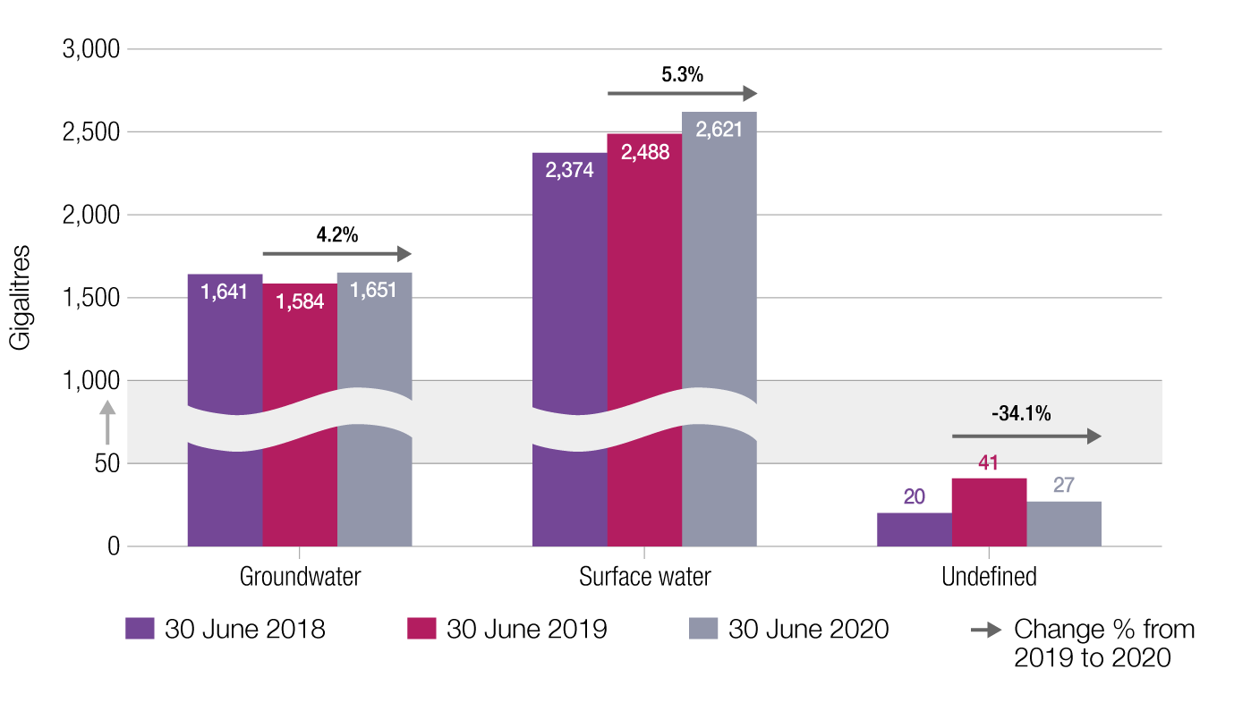

Foreign held water entitlement in the Murray-Darling Basin
The Murray-Darling Basin (MDB) is defined by the catchment areas of the Murray and Darling rivers and their many tributaries. The MDB covers 75% of New South Wales, more than 50% of Victoria, 15% of Queensland and 8% of South Australia, and all of the Australian Capital Territory. A geographic view of the northern and southern basin can be found on the Murray-Darling Basin Authority website.
The MDB contributes to the majority of irrigated agriculture in Australia - generally around 40% of agriculture (dryland and irrigated). It covers the two longest rivers in Australia, the Murray and Darling Rivers. The MDB contains slightly over 50% of the total volume of Australian water entitlement on issue (surface and groundwater) and covers over one million square kilometres.
The BOM reports the total 30 June 2020 water entitlement on issue in the MDB is 19,740 GL with:
- 2,394 GL for total groundwater in the Northern MDB and Southern MDB and
- 17,346 GL for total surface water in the Northern MDB and Southern MDB.
Table 4 shows the foreign held water entitlement in the Murray-Darling Basin (MDB) as a proportion of the total water entitlement by surface water and groundwater as at 30 June 2020.

Table 4: Foreign held water entitlement in the Murray-Darling Basin
Murray-Darling Basin (MDB) | 30 June 2020  Foreign held water entitlement  (GL) | 30 June 2020  Total  water entitlement on issue - MDB  (GL) | 30 June 2020  Foreign held  water entitlement as a proportion of total water entitlement on issue - MDB  (%)
Surface water
Northern MDB | 1,212 | 4,045 | 30.0
Southern MDB | 780 | 13,301 | 5.9
Groundwater
Northern MDB | 42 | 2,394 | 10.1
Southern MDB | 147
MDB – Unknown | 53
Total | 2,234 | 19,740 | 11.3
Notes:
- The ‘foreign held water entitlement as a proportion of total water entitlement on issue – MDB’ is the ratio of foreign held water entitlement in the MDB to the total water entitlement on issue in the MDB by surface water and groundwater in the Northern and Southern basins.
- Foreign held water entitlements in the Northern and Southern MDB is derived by manually mapping the water system notified by the registrant to third party Northern and Southern MDB BOM information. This information is for illustrative purposes only and care should be taken when comparing data from this table to other sources.
- Lachlan surface water is included in Southern MDB – Surface water figures.
- ‘MDB – Unknown’ includes registrations which have groundwater systems as ‘Lachlan’ and ‘Barwon’ as these are categorised in both ‘Southern MDB’ and ‘Northern MDB’ groundwater and the Register does not have the information to determine in which segment of the MDB these registrations should be assigned.

Table 5 shows the foreign held water entitlement in the Northern and Southern MDB as at 30 June for each year from 2018 to 2020 by resource. There is an overall increase in foreign held water entitlements of 3.4% in the MDB as at 30 June 2020 when compared to foreign held water entitlements as at 30 June 2019.
The table indicates ‘MDB Northern groundwater’ has increased by 250% (30 GL) and the ‘MDB - Unknown’ shows a reduction of 38.4% (32 GL). This is primarily attributed to:
- the ability to clarify groundwater registrations previously listed as ‘MDB - Unknown’ on the Water Register as ‘Groundwater Northern MDB’. During the year the ATO introduced additional system categories to the registration form. As part of the change, existing registrations that were listed as ‘MDB - Unknown’ were reviewed and updated to reflect the ‘Northern MDB’ or ‘Southern MDB’, and
- movement within the register of buys and sells.

Table 5: Foreign held water entitlement in the Murray-Darling Basin
Murray-Darling Basin | 30 June 2018  Foreign held water entitlement  (GL) | 30 June 2019  Foreign held water entitlement  (GL) | 30 June 2020  Foreign held water entitlement  (GL) | Change  (%)
Surface water
Northern MDB | 882 | 1,169 | 1,212 | 3.7
Southern MDB | 738 | 748 | 780 | 4.3
Groundwater
Northern MDB | 9 | 12 | 42 | 250.0
Southern MDB | 140 | 144 | 147 | 2.1
MDB – Unknown | 83 | 86 | 53 | -38.4
Total | 1,852 | 2,160 | 2,234 | 3.4
Note: The ‘Change %’ shows the change in the volume from 2019 to 2020 by resource.

Foreign held water entitlement by regulated/unregulated water resource
Table 6 shows the foreign held water entitlement by regulated and unregulated water resource for surface water as at 30 June from 2018 to 2020. The table also shows the proportion of water entitlement with a level of foreign ownership at 30 June 2020 by water resource.

Table 6: Foreign held water entitlement by regulated and unregulated water resource – Surface water
 | Foreign held water entitlement |  |  | Total water entitlement on issue | Foreign held water entitlement as a proportion of total water entitlement on issue
Water Resource | 30 June 2018  (GL) | 30 June 2019  (GL) | 30 June 20  (GL) | 30 June 2020  (GL) | 30 June 2020  (%)
Regulated | 2,002 | 2,041 | 2,169 | 19,811 | 10.9
Unregulated | 249 | 338 | 343 | 10,503 | 3.3
Not specified | 123 | 109 | 110 | - | -
Total | 2,374 | 2,488 | 2,622 | 30,314 | 8.6
Notes:
- The ‘foreign held water entitlement as a proportion of total water entitlement on issue’ is the ratio of foreign held water entitlement by water resource to the total water entitlement on issue by water resource.
- The total water entitlement on issue for regulated and unregulated is sourced from the BOM Water Market Dashboard. The dashboard only includes a breakdown of regulated and unregulated flow control for surface water.
- Most of the regulated water comes from the southern MDB in the south eastern part of Australia.
- ‘Not specified’ includes registrations where the registrant did not specify if the water resource flow was regulated or unregulated.

Foreign held water entitlement by water use
The Water Register collects information about the use of the water entitlement. Registrants are required to register the relevant percentage of use against one or more of the 14 types of water use available on the registration form. For the purpose of this report, the different water uses have been grouped into four categories as follows:
- Agriculture which contains crops, forestry, horticulture and stock usages
- Mining
- Industry which contains construction, energy, industrial, manufacturing and transport usages
- Other category which contains tourism, trade, other and research usages.
Figure 9 shows the foreign held water entitlement as at 30 June for each year from 2018 to 2020 by water use. The ‘Change %’ shows the change in the volume from 2019 to 2020.

Figure 9: Foreign held water entitlement by water use – 3 year comparison 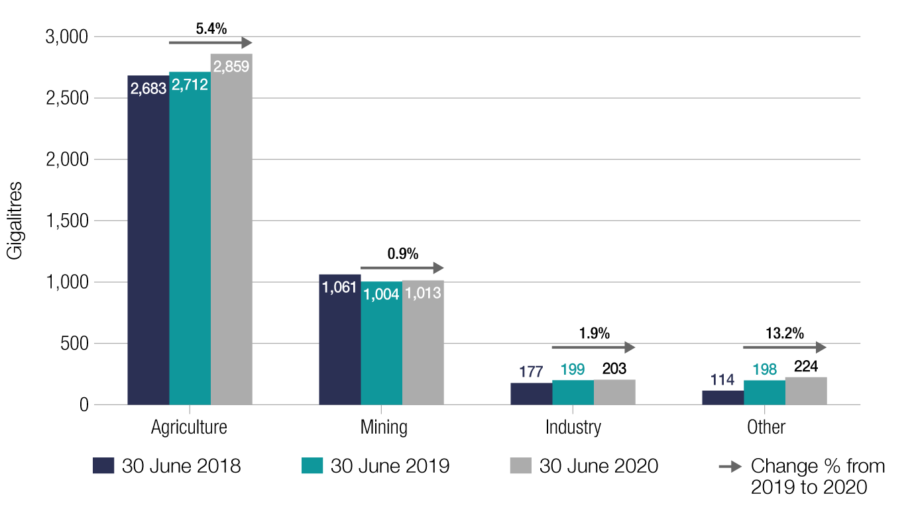
Notes:
- Some water usage does not fit within a category and registrants have appropriately listed the use as ‘Other’. This includes water supply to townships for mining company employees, water used for dairy farm activities and pasture irrigation for stock feed. Where the use type ‘Other’ was registered, the water entitlement was reconciled against third party information. Where a more appropriate category was confirmed (e.g. agriculture), the Water Register was updated accordingly. Otherwise, the Water Register and the data in Figure 9 reflect the type of water use provided by the registrant. The data should only be used as an indication of water usage
- Not all industries need to hold rights to water. Food processing and other water-using industries located in or near cities and towns are likely to source their water requirements through town supply and services. Conversely, manufacturing and processing industries such as wineries which are located in rural and remote regions are likely to hold rights to water required for their operation.

Figure 10 shows the proportions of water use against the four grouped water usage categories agriculture, mining, industry and other as at 30 June 2020 within each state or territory.

Figure 10: Foreign held water entitlement by water use – state or territory
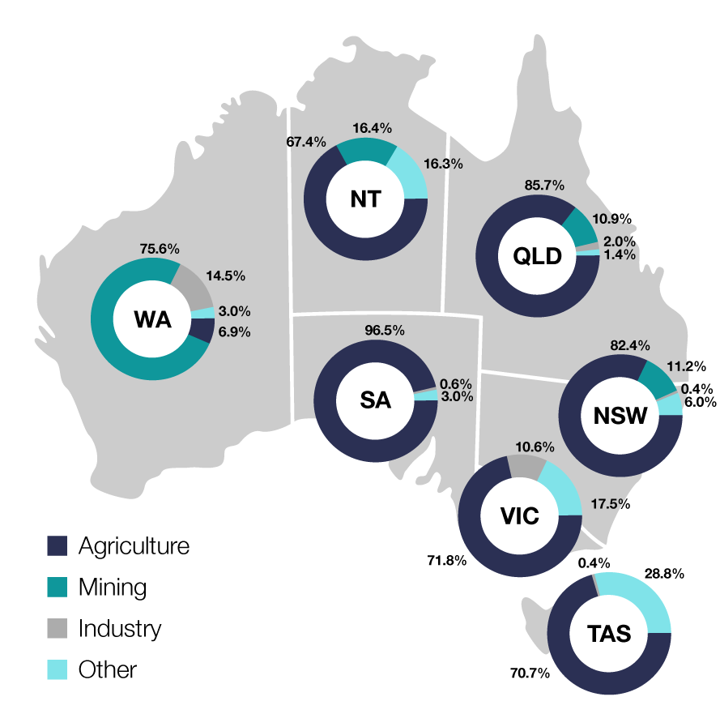
Note:
- Consistent with Figure 9, the main use for foreign held water entitlement in most states is agriculture, except for Western Australia, where the majority of foreign held water is used in mining.

Foreign held water entitlement by type
Table 7 shows the foreign held water entitlement by type for each state or territory as at 30 June 2020.

Table 7: Foreign held water entitlement by state or territory – type
State or territory | Irrigation right  (GL) | Lease  (contractual right) (GL) | Water access entitlement (GL) | Total  (GL)
New South Wales/ACT | 136 | 45 | 1,154 | 1,335
Northern Territory | - | - | 32 | 32
Queensland | 1 | 11 | 1,293 | 1,305
South Australia | 1 | 1 | 264 | 266
Tasmania | 9 | 1 | 105 | 115
Victoria | 17 | 1 | 281 | 299
Western Australia | 8 | 146 | 793 | 947
Total | 172 | 205 | 3,922 | 4,299
Notes:
- An irrigation right is a right a person has against an irrigation infrastructure operator to receive water. While this may be similar to a lease (contractual right) as a contract may be involved, a lease is a right that a person holds to another person’s water entitlement (other than an irrigation infrastructure operator).
- A ‘water access entitlement’ is an ongoing entitlement to a share of water from a resource plan or other water management area. This is sometimes called a water access right.

Figure 11 shows the foreign held water entitlement by type for each year from 2018 to 2020. The percentage change in the foreign held entitlement by type at 30 June 2020 compared to the prior year is also shown.

Figure 11: Foreign held water entitlement by type – three year comparison
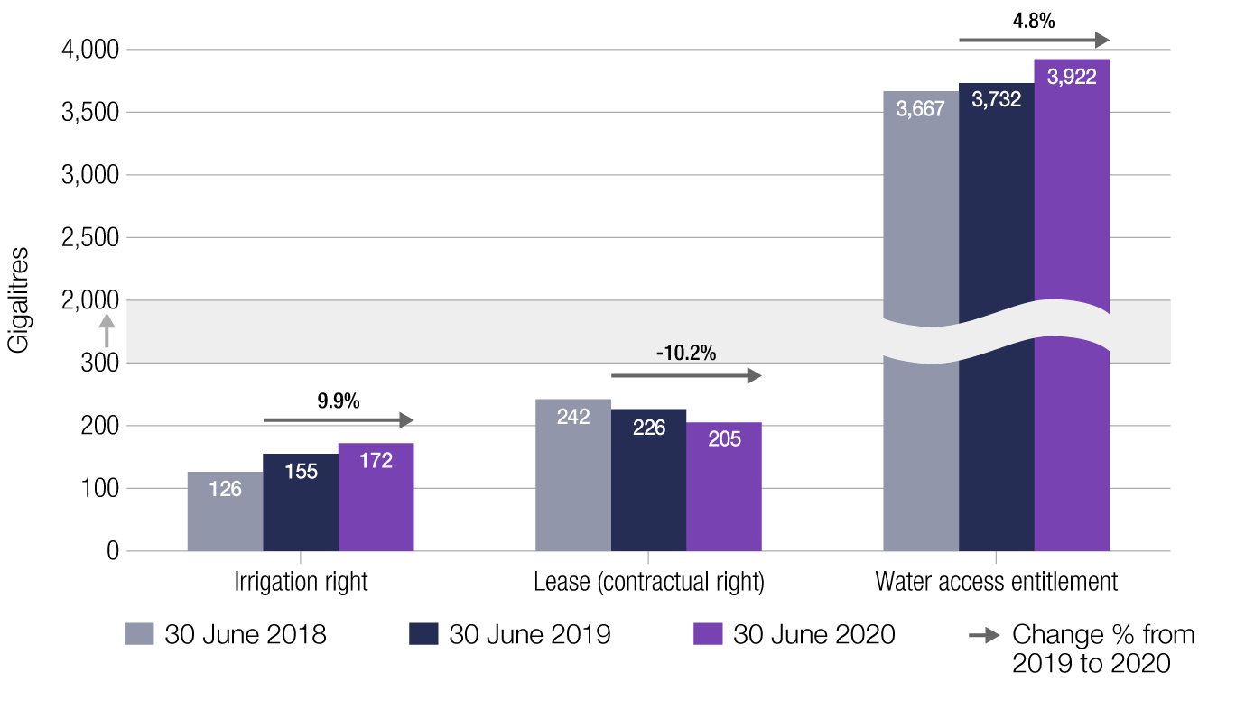

Foreign share and Australian share of water entitlements
Figure 12 shows the foreign share and Australian share of foreign held water entitlements at 30 June 2020 for each year from 2018 to 2020.
At 30 June 2020, of the total foreign held water entitlement of 4,299 GL, the Australian share was 597 GL (13.9%) and the foreign share was 3,702 GL (86.1%). In the prior year, of the total foreign held water entitlement of 4,113 GL, the Australian share was 594 GL (14.4%) and the foreign share was 3,519 GL (85.6%).

Figure 12: Foreign share and Australian share of foreign held water entitlement
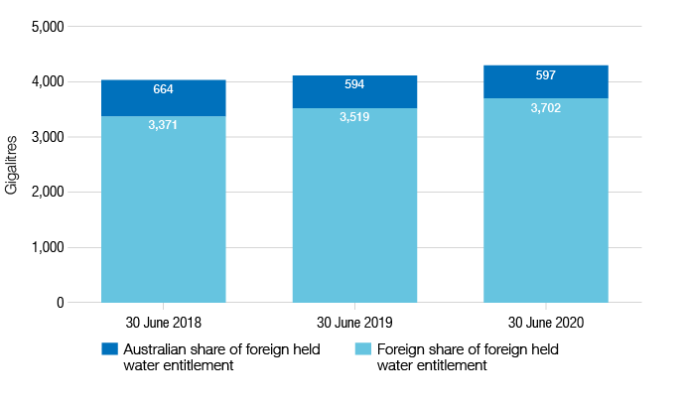
Notes:
- The water entitlements captured in Figure 12 are foreign held. Refer to Background Information on Obtaining Source Country for how the split between Australian share and foreign share is determined.

Figure 13 shows the foreign share and Australian share of foreign held water entitlements at 30 June 2020 for each year from 2018 to 2020 by state or territory.

Figure 13: Foreign share and Australian share of foreign held water entitlement by state or territory
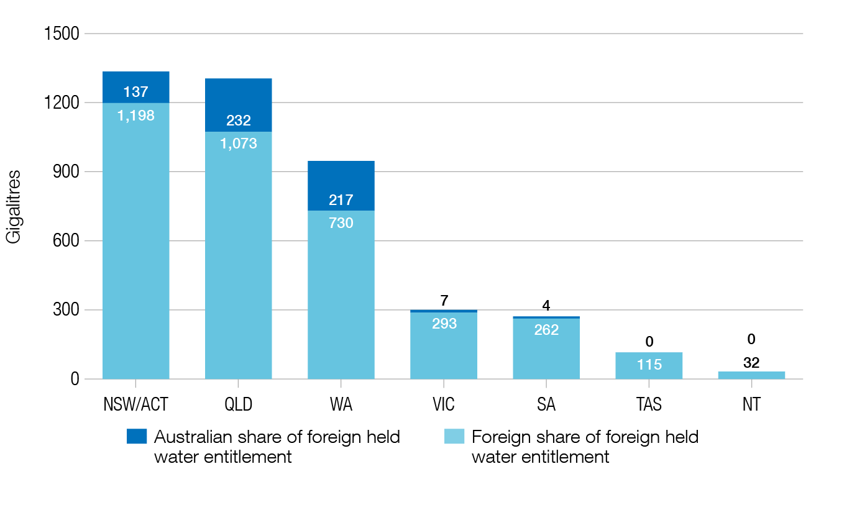

Foreign held water entitlement by foreign share by country – top 10 countries

Table 8 shows the foreign share of the foreign held water entitlement by the top 10 countries as at 30 June 2020. This excludes the Australian share of the total foreign held water entitlement. The top 10 countries hold an 83.5% of the foreign share of 3,702 GL which are foreign held.

Table 8: Foreign held water entitlement – Top 10 countries
Country | 30 June 2018  Foreign held water entitlement  (GL) | 30 June 2019  Foreign held water entitlement  (GL) | 30 June 2020  Foreign held water entitlement  (GL)
Canada | 212 | 295 | 698
China | 732 | 756 | 662
United States of America | 720 | 713 | 660
United Kingdom | 411 | 394 | 375
France | 139 | 158 | 158
Hong Kong | 80 | 118 | 129
Netherlands | 92 | 98 | 104
Belgium | 102 | 102 | 103
Switzerland | 136 | 128 | 103
Germany | 32 | 58 | 99
Total for top 10 countries | 2,656 | 2,934 | 3,092
Notes:
- To avoid identifying individuals and entities, only the top 10 countries are shown.
- The nationality of the registrant holding the interest in the water entitlement is collected in the register. The statistics in Table 8 represent the foreign country component of water entitlements held by the foreign entity.
- As at 30 June 2020 the foreign held water entitlement by Canada increased to 698 GL. The changes of rankings resulted from a combination of reductions in foreign held water entitlements by Chinese, US and UK companies, accompanied by an increase in the same reporting period by Canadian companies in its foreign held water entitlements. In addition, there were changes in the level of foreign ownership of Australian companies already holding water entitlements.
- The top 10 country ranking as at 30 June 2020 does not reflect ranking for the prior year. Prior year figures are included to enable a comparison of the top 10 countries over time.
- The main usage of foreign held water entitlements by the top 10 countries in Table 8 as at 30 June 2020 are:
  - Agriculture: Canada, China, United States of America, Hong Kong, Netherlands and Germany
  - Industry: France
  - Mining: United Kingdom, Switzerland and Belgium
- The main usage of water entitlements for each country in the top 10 is determined by using the largest water usage proportion in the Water Register for that country.

Background information on obtaining source country information
As part of the registration information, owners are required to provide their country of nationality. Source country information has been verified using information provided by registrants, ATO data sources and manual data collection.
Where the registered owner is an individual, the nationality of the person reported in their registration is treated as the source country. Where the registered owner is a company or trust, the nationality of the beneficial owner is used to determine the source country. Where the beneficial owner is identified as an Australian citizen who is not ordinarily resident in Australia (and hence a foreign person), the source country has been allocated to the country they are ordinarily resident in.
The beneficial owner is determined by using resources within ATO and other agencies such as Department of Immigration and Border Protection and ASIC. Where shares or interests are widely held for companies or trusts, the water entitlement held is attributed to a source country based on the location of the directors or the country where the entity (or trustee) is headquartered or publicly listed depending on information available.
As a hypothetical example, Crops Partners, a foreign person entity, is ultimately owned by United Kingdom investors (30%) and Australian investors (70%). If Crops Partners has a water entitlement of 200 GL, this ownership would be reflected in Table 8 with 60 GL of water entitlement against the United Kingdom (which represents 30%). Furthermore, in Figure 12, 60 GL of water entitlement would be attributed to the ‘Foreign share of foreign held water entitlement’ and 140 GL to ‘Australian share of foreign held water entitlement’ (representing the remaining 70%).
This illustrates that foreign held water entitlements reported on the Water Register by foreign person entities may also have a significant level of Australian ownership. This is occurs due to the nature of the definition of foreign person under the Foreign Acquisitions and Takeovers Act 1975.
The attribution of a source country to a registration of foreign held water entitlement will continue to evolve as ownership changes occur over time.

Attachment A: Background
In 2015, as part of the foreign investment reforms, the Government undertook to introduce and pass legislation to establish a Register of Foreign Ownership of Water by 1 December 2016. The Register of Foreign Ownership of Agricultural Land Amendment (Water) Act 2016 was subsequently passed (assented to on 7 December 2016) and the Register established.
While the Commonwealth has an interest in foreign investment and the management of Australia’s water resources, state and territory governments have primary responsibility for managing water resources which includes: allocating water among users; water licensing; water extraction conditions; water processing (including buying and selling conditions); and water monitoring.
Normally, foreign acquisitions of interests in water are not directly screened under Australia’s foreign investment screening framework, but may be part of other types of investments that are screened. As interests in water are often attached to agricultural land, or are assets of Australian businesses, such acquisitions may be screened through the agricultural land screening requirements, or through the acquisition of securities or business assets.
When assessing the national interest in relation to foreign acquisitions in the agricultural sector, the Government considers a range of factors including agricultural productivity and reliability of agricultural production, biodiversity and environmental issues, and the prosperity of local and regional communities.
From 1 July 2017, foreign persons have been required to register their interests in registrable water entitlements and contractual water rights, and certain changes in those interests, with the ATO. A stocktake was conducted between 1 July 2017 and 31 November 2017 to enable existing foreign persons to register their holdings in water entitlements. During this time, the ATO used data matching to contact investors who may have met the definition of a foreign person and who held Australian land that may also have water entitlements. State and territory websites published articles encouraging registrations as did other water management service providers (such as irrigation infrastructure operators and regional water management organisations). The ATO developed a self-registration online form prior to the commencement of the stocktake period on 1 July 2017.
A foreign person may register at any time during the year (for example, when the event occurs), but no later than 30 days after the end of the financial year in which the event occurred.
A foreign person needs to register their interest in a registrable water entitlement or a contractual water right, when:
- they acquire a registrable water entitlement or contractual water right under a contract where the term of the contract is likely to exceed five years after the person starts to hold the right; or
- they become a foreign person while holding a registrable water entitlement or contractual water right under a contract where the term of the contract is likely to exceed five years after the person becomes a foreign person.
A foreign person needs to update their existing registration when:
- they dispose of the registrable water entitlement or contractual water right;
- they stop being a foreign person; or
- the volume of their registrable water entitlement or contractual water right changes.
The Register of Foreign Ownership of Water or Agricultural Land Act 2015 requires the Productivity Commission to inquire into the effectiveness, costs and benefits of the Register of Foreign Ownership of Water Entitlements by the end of 2021. This inquiry is underway, with further information available from the Productivity Commission website: www.pc.gov.au.

Attachment B: Definitions
This attachment provides information on the definitions as detailed in the Register of Foreign Ownership of Water or Agricultural Land Act 2015 and Register of Foreign Ownership of Water or Agricultural Land Rules 2017.
‘contractual water right’
A ‘contractual water right’ is defined as a contractual right (including a deed) that a person or other entity holds (alone or jointly) to another person’s ‘registrable water entitlement’.
A contract between an irrigator and an ‘irrigation infrastructure operator’ for a volume of water is an irrigation right and not a ‘contractual water right’ even though a contract might be involved. The ‘contractual water right’ is intended to include only those entitlements which are leased or otherwise obtained from a person other than an ‘irrigation infrastructure operator’ who holds that water entitlement.
‘conveyance water’
The volume of water that can be attributed to ‘conveyance water’ is the additional water that is required to deliver water to users, and includes water lost in transit from its source to end users due to seepage, leakage, evaporation or other similar effects.
Note that the exemption for ‘conveyance water’ is only available to ‘irrigation infrastructure operators’, not to individual entitlement holders.
‘foreign person’
The term ‘foreign person’ is defined in section 4 of the Act. It states that the term has the same meaning as ‘foreign person’ as defined in section 4 of the Foreign Acquisitions and Takeovers Act 1975.
In general, a ‘foreign person’ is:
- an individual not ordinarily resident in Australia; or
- a foreign government or foreign government investor; or
- a corporation, trustee of a trust or general partner of a limited partnership where an individual not ordinarily resident in Australia, a foreign corporation or a foreign government holds a substantial interest of at least 20%; or
- a corporation, trustee of a trust or general partner of a limited partnership in which two or more foreign persons hold an aggregate substantial interest of at least 40%.
‘irrigation infrastructure operator’
An ‘irrigation infrastructure operator’ is an entity which operates for the purposes of delivering water for irrigation (Water Act 2007, s7(4)).
An ‘irrigation infrastructure operator’ will only be required to register water holdings and interests where the ‘irrigation infrastructure operator’ meets the definition of a ‘foreign person’, the ‘irrigation infrastructure operator’ holds entitlements to water (or portions of entitlements) that are not subject to irrigation rights, or the ‘irrigation infrastructure operator’ holds entitlements to water (or portions of entitlements) that are not ‘conveyance water’.

‘registrable water entitlement’
A ‘registrable water entitlement’ is:
- an irrigation right – which is a right a person has against an ‘irrigation infrastructure operator’ to receive water (but excludes a water access right or a water delivery right)
- a right (including an Australian water access entitlement) conferred by or under a law of a state or territory to do either or both of the following:
  - to hold water from a water resource in Australia
  - to take water from a water resource in Australia.
A water entitlement given to an irrigator by an ‘irrigation infrastructure operator’ is considered an irrigation right and so is a registrable water entitlement.
Exclusions
The following types of water rights will be excluded from the definition of a ‘registrable water entitlement’:
- stock and domestic rights, and harvestable rights used for stock and domestic purposes
- riparian rights
- annual water allocations
- rights held by an ‘irrigation infrastructure operator’ to the extent that either another person holds an irrigation right in relation to that right, or they are for ‘conveyance water’.

Attachment C: Methodological caveats
This is an overview of the main methodological caveats that apply to the data in this report.
- Data was extracted from the Register on 31 July 2020 as registrants have 30 days after the end of each financial year to register movements in their water entitlement for the previous financial year. This is designed to reduce the administrative overhead for foreign persons who have an ongoing obligation to maintain records on the Register.
- Some registrations have been altered in accordance with section 16 of the Act when it has been determined via data matching or manual data collection that the registrant has provided incorrect information. The validation of registrations is an ongoing exercise, with information validated using third party data sources and manual data collection.
- Registrants were prompted to enter the volume of water entitlements in mega litres. The ATO has vetted each registration to check the registrant has entered correct volumes into the Register.
- Entities and trusts were required to report their country of incorporation and the nationality of the owner. However, this is not necessarily a reflection of the foreign source country of the investor. Source country information has been obtained using information provided by registrants, ATO data sources and manual data collection. In some cases, the nationality or country of incorporation of a nominal investor may have been registered, rather than the nationality or country of incorporation of the ultimate beneficial owner.
- In some instances, the same water entitlement has been registered twice - by a foreign person with the original water entitlement issued and by another foreign person with either a contractual or irrigation right. These ‘duplicates’ have been removed from all tables in the report.
- Registrants are not required to identify the basin in which the water entitlement is managed. Water systems on the registration form have been taken from state or territory data. Mapping the water system to the Murray-Darling Basin was undertaken by identifying water systems within the Murray-Darling Basin and assigning whether it is Northern region, Southern region or Groundwater. As this is a manual process, care should be taken in using the Murray-Darling Basin data.
- Usage is determined by the registrant and more than one category of usage can be chosen during registration. Where a registrant chooses ‘Other’, the ATO has investigated and assigned to a different category where appropriate.

Attachment D: Bureau of Meteorology (BOM) data

Table 9: Total water entitlement on issue by state or territory – Bureau of Meteorology

State or territory | 30 June 2018  State or territory Water entitlement on issue  (GL) | 30 June 2019  State or territory Water entitlement on issue  (GL) | 30 June 2020  State or territory Water entitlement on issue  (GL) | % Change
New South Wales/ACT | 14,971 | 14,990 | 15,011 | 0.14%
Northern Territory | 572 | 571 | 597 | 4.55%
Queensland | 6,631 | 6,772 | 6,952 | 2.66%
South Australia | 2,751 | 2,756 | 2,752 | -0.15%
Tasmania | 2,284 | 2,337 | 2,384 | 2.01%
Victoria | 7,621 | 7,751 | 7,558 | -2.49%
Western Australia | 3,844 | 3,947 | 4,129 | 4.61%
Total | 38,674 | 39,124 | 39,383 | 0.66%
Note:
- The ‘Change %’ shows the change in the volume from 2019 to 2020 by water entitlement on issue.

Attachment E: Water entitlement registration forms
- Each registrant must complete the following fields:
- Name
- Position
- Address
- Mobile/cell number
- Contact email

Reason for registration
- Acquisition of water entitlement
- Cease to hold water entitlement
- Change in status: To foreign person
- Change in status: From foreign person
- Change in details (change in volume)

Entity/ownership details
- Name
- Country of incorporation (where registrant is a trust or company)
- Address
- Date of birth/nationality (where registrant is an individual)
- Contact details
- Mobile/cell number
- Contact email
These fields are voluntary fields as they do not apply to each registrant:
- Visa and passport details
- ABN/ACN/ABRN/other client identifier
- Trading name
- FIRB approval number

Water details
- Water entitlement type (Water Access Entitlement, Irrigation Right, Contractual Right, Water Access Right)
- Issuing entity type (state water or non-water state authority, Irrigation Infrastructure Operator, 3rd party)
- Issuing entity name
- State/territory
- Entitlement identifier
- Issue date
- Water system
- Resource type
- Flow control
- Reliability
- Volume (ML)
- Term of Lease (if applicable)
- Lease end date (if applicable)
- Percentage of ownership
- Sector/usage detail

Section 17 of the Register of Foreign Ownership of Water or Agricultural Land Act 2015.
As registrants have 30 days after the end of a financial year to update the Water Register, the Water Report will include all registrations up to 31 July each year for water entitlements issued up to 30 June.
Refer to Attachments A, B and E in this report for more information.
Refer to Attachment E in this report for more information on data collected.
The Foreign Acquisitions and Takeovers Act 1975 definition of ‘foreign person’ is included at Attachment B.
See Attachment D for a breakdown of State or territory water entitlements on issue
BOM website, Water information. bom.gov.au/water/index.shtml
Murray-Darling Basin Authority website. mdba.gov.au
The increase in the total volume of water entitlements on issue reflects an increase in the number of water plans resulting in more water use progressively being brought under water management regimes. It does not mean more water is being made available for use each year (Bureau of Meteorology)
BOM website, Water Markets Dashboard. ‘Entitlements on issue summary – Australia.’ bom.gov.au/water/dashboards/#/water-markets/national/state/eoi
NSW/ACT is combined as Taxation law restricts the release of information which could identify, or be used to identify, an individual or entity
The Bureau of Meteorology Water Market Dashboard does not include zero volume water entitlements.
Unregulated and regulated water resource is defined in the BOM Glossary for Water Markets Report: bom.gov.au/water/awid/product-water-status-water-market-reports.shtml
mdba.gov.au/discover-basin/landscape/geography
BOM website, Water Markets Dashboard. ‘Entitlements on issue summary – Murray-Darling Basin’. bom.gov.au/water/dashboards/#/water-markets/mdb/eoi.
The BOM does not distinguish between the Northern and Southern areas within the MDB for groundwater. The total groundwater in the MDB is 2,394 GL.
BOM NWA 2012: bom.gov.au/water/nwa/2012/mdb/contextual/physicalinformation.shtml
The terms regulated/unregulated for the purposes of the flow control field on the registration form has the same meaning given in the Australian Water Information dictionary used in BOM Water Market Reports. The terms can be found at bom.gov.au/water/awid/product-water-status-water-market-reports.shtm
As defined in section 5 of the Foreign Acquisitions and Takeovers Act 1975.
BOM website, Water Markets Dashboard. ‘Entitlements on issue summary – Australia.’ bom.gov.au/water/dashboards/#/water-markets/national/state/eoi
BOM website, Water Markets Dashboard. ‘Entitlements on issue summary – Australia.’ bom.gov.au/water/dashboards/#/water-markets/national/state/eoi
BOM website, Water Markets Dashboard. ‘Entitlements on issue summary – Australia.’ bom.gov.au/water/dashboards/#/water-markets/national/state/eoi
NSW/ACT is combined as Taxation law restricts the release of information which could identify, or be used to identify, an individual or entity.

