Register of foreign ownership of residential land
Insights into foreign purchases and sales of residential real estate for the period 1 July 2019 to 30 June 2020

The Register of foreign ownership of residential land has been established as part of the Australian Government’s commitment

to increase transparency around foreign investment in Australia.
Information has been extracted from the Register to provide insights into foreign purchases and sales of residential real estate over three reporting periods. The information relates to residential real estate transactions (purchases or sales) by foreign persons over the periods 1 July 2019 to 30 June 2020 (2019–20), 1 July 2018 to 30 June 2019
(2018–19), and 1 July 2017 to 30 June 2018 (2017–18).
Consistent with Australia’s broader foreign investment review framework, the details of foreign persons are not made available publicly. Taxation law also restricts the release of information which could identify, or be used to identify, an individual or entity. For these reasons, this information is presented in an aggregated format only.
Transactions | Included/Not included
Transaction starts before but settles within the reporting period | Included
Transaction starts within the reporting period but settles after | Not included
Foreign person becomes a permanent resident before reporting period | Not included
Foreign person becomes a permanent resident within the reporting period | Included

Care should be taken in comparing the Insights data with the Foreign Investment Review Board (FIRB) Annual Reports. The FIRB Annual Reports contain proposed investment information. The Insights data reflects confirmed real estate transactions and is not a full stocktake of foreign ownership in residential land.

Methodology
The Register holds information about purchase or sale transactions by foreign persons who obtained foreign investment approval. Purchase transactions are where:
- a foreign person through self-registration has indicated that they have settled on a residential property for which they had gained prior foreign investment approval, and a foreign person identified during compliance activity that has settled property and failed to apply for foreign investment approval, or
- through the collection of land titles data from participating states and territories, the ATO has matched a residential real estate transfer (purchase) and purchaser to a corresponding property and foreign person that was previously issued foreign investment approval.
Similarly, sale transactions are where:
- a foreign person through self-registration has indicated that they are no longer a foreign person, have sold (and settlement has occurred on) a residential property for which they had gained prior foreign investment approval, or
- through the collection of land titles data from participating states and territories, the ATO has matched a residential real estate transfer (sale) and vendor to a corresponding property and foreign person that was previously issued foreign investment approval.
For a purchase or sale transaction to be included in the Insights, the settlement date for the transaction needs to have occurred within the relevant reporting period. For purchase transactions, if a property was purchased and then sold during the report period, the purchase is included in these figures.
The value is derived from the contract sale price and represents the transaction value at that time, not current market value. The dwelling type – vacant land, new dwelling or established dwelling – reflects the type of dwelling at the time of purchase.
Understanding the reporting period

DE-33186

2019 –20 Insights

Purchases

In 2019 –20, the total number of residential real estate purchase transactions with a level of foreign ownership was 7,482
with a value of 6.0 billion dollars.
Sales
The total number of residential real estate sale transactions by foreign persons during the 2019 –20 period was 1,957 with a value of 1.5 billion dollars.

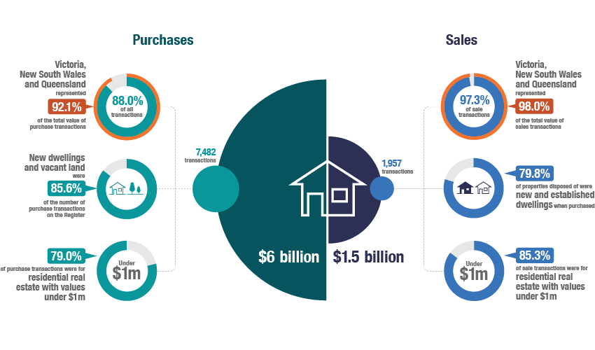

Purchase transactions in 2019 –20
Victoria, New South Wales and Queensland represented 88.0 per cent
of all purchase transactions and make up 92.1 per cent of the total value of purchase transactions recorded on the Register for the 2019–20 period.

- The concentration of transactions in Victoria, New South Wales and Queensland fell slightly in 2019–20 from 92.2% of all purchase transactions, making up 94.6% of the total value.
- New dwellings represented 67.8 per cent of purchase transactions, followed by 17.8 per cent for vacant land and 14.4 per cent for established dwellings in 2019 –20. In comparison, in 2018 –19,
new dwellings represented 68.9 per cent of purchase transactions, followed by 17.4 per cent for vacant land and 13.7 per cent for established dwellings.
- The state with the greatest number of purchase transactions for all property types in 2019–20 was Victoria. In 2018–19 NSW had the greatest purchase transactions for new dwellings and Victoria had the greatest purchase transactions for vacant land and established dwellings.
- Residential properties with values under 1 million dollars formed the majority of residential property purchase transactions, accounting for

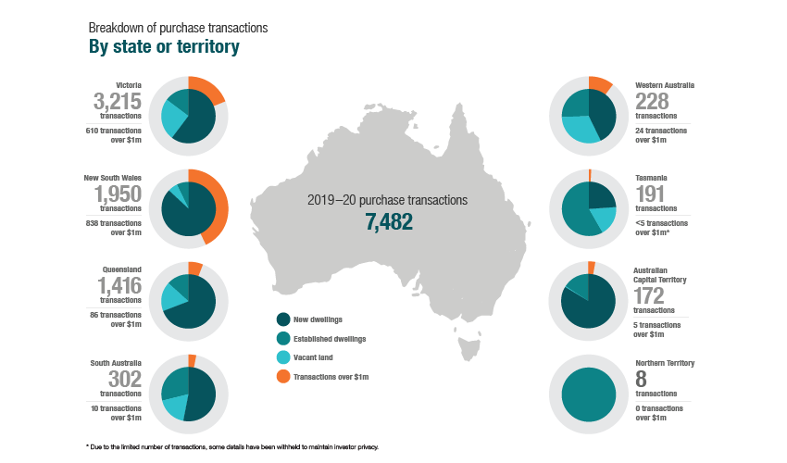

79.0 per cent of property transactions in 2019–20. This compares to 79.8 per cent in 2018–19.
- Of the 7,482 purchase transactions in 2019–20, 115 registrants became a permanent resident or gained Australian citizenship during the year and are included in these statistics.

Breakdown of 2019 –20 purchase transactions by property type

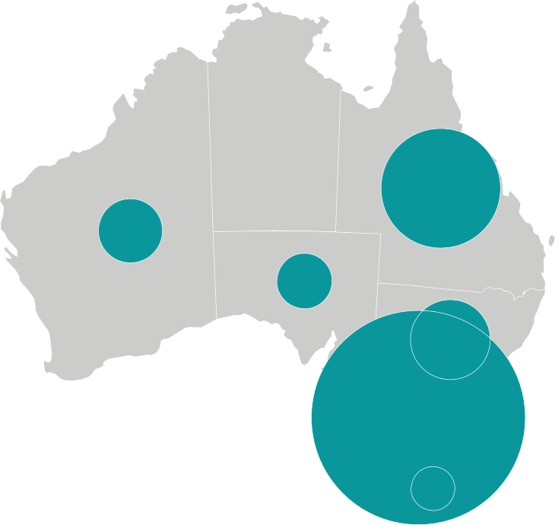

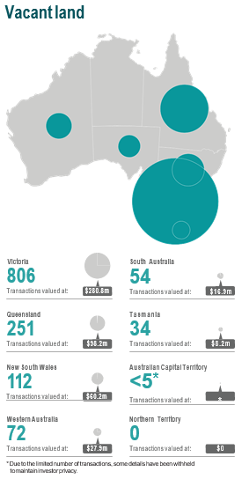
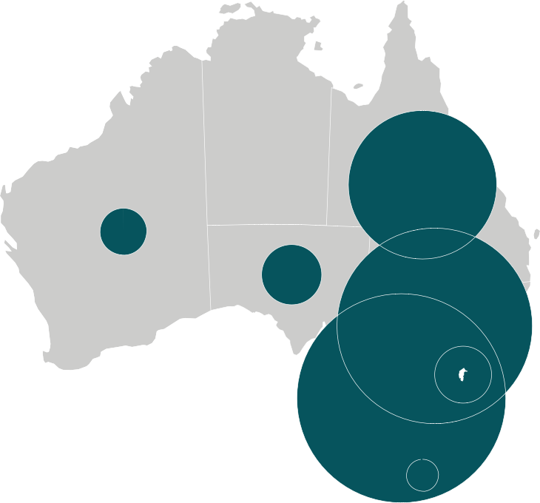
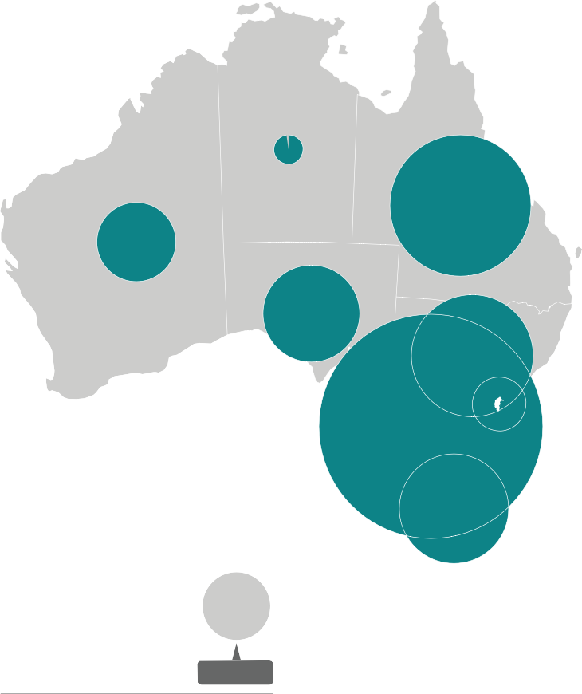
Vacant land
New dwellings
Victoria
Australian Capital Territory
1,943 144
Transactions valued at: $1.43b Transactions valued at: $78.8m
New South Wales
Western Australia
1,700 98
Transactions valued at: $1.81b Transactions valued at: $72.5m
Queensland
Tasmania
980 46
Transactions valued at: $612.1m Transactions valued at: $24.4m
South Australia
Northern Territory
161 0
Transactions valued at: $83.6m Transactions valued at: $0
Established dwellings
Victoria
South Australia
466 87
Transactions valued at: $763.6m Transactions valued at: $49.9m
Queensland
Western Australia
185 58
Transactions valued at: $189.2m Transactions valued at: $40.5m
New South Wales
Australian Capital Territory
138 27
Transactions valued at: $302.9m Transactions valued at: $17.2m
Tasmania
Northern Territory
111 8
Transactions valued at: $53.4m Transactions valued at: $3.9m

Victoria

806
Transactions valued at: $280.8m
South Australia

54
Transactions valued at: $16.9m

Queensland

251
Transactions valued at: $98.2m
Tasmania

34
Transactions valued at: $8.2m

New South Wales

112
Transactions valued at: $60.2m
Australian Capital Territory
<5*
Transactions valued at: *

Western Australia

72
Transactions valued at: $27.9m
Northern Territory

0
Transactions valued at: $0

Sale transactions in 2019 –20
Victoria, New South Wales and Queensland represent 97.3 per cent

of all sale transactions, making up 98.0 per cent of the value of sale transactions for the reporting period.

- In comparison, in 2018–19 Victoria, New South Wales and Queensland represented 99.0 per cent of all sale transactions and 99.1 per cent of the value.
- In 2019–20, new dwellings represented 57.4 per cent of sale transactions, followed by 22.3 per cent for established dwellings and 20.2 per cent for vacant land. The property type reflects the type of property at time of purchase, e.g. new dwellings were new at the time of purchase.
- Victoria had the greatest number of sale transactions across all property types in both 2019–20 and 2018–19.
- Properties with values under 1 million dollars represented
85.3 per cent of sale transactions. This is a slight increase when compared to the proportion of sale transactions in 2018–19 of
82.8 per cent.
- There are 44 sale transactions reflecting registrants who became permanent residents or gained Australian citizenship during the 2019–20 report period which have been included in these figures.
- Sale transactions numbers reflect any sale transactions settled
by foreign persons within the reporting period, regardless of when the initial purchase was contracted.

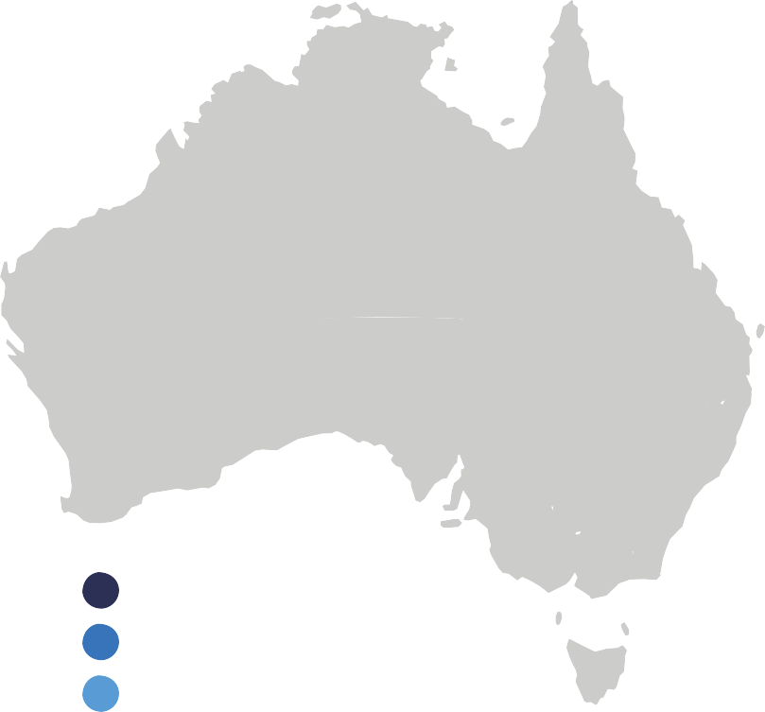
Breakdown of sale transactions
By state or territory

Victoria

961
transactions
125 transactions
over $1m

New South Wales

574
transactions
117 transactions
over $1m

Queensland

370
transactions
41 transactions
over $1m

Western Australia

19
transactions
<5 transactions
over $1m*

2019 –20 sale transactions
1,957

New dwellings Established dwellings Vacant land Transactions over $1m

South Australia

17
transactions
<5 transactions over $1m*

Tasmania

10
transactions
<5 transactions over $1m*

Australian Capital Territory

6
transactions
<5 transactions over $1m*

Northern Territory

0
transactions
0 transactions over $1m

* Due to the limited number of transactions, some details have been withheld to maintain investor privacy.

Breakdown of 2019 –20 sale transactions by property type

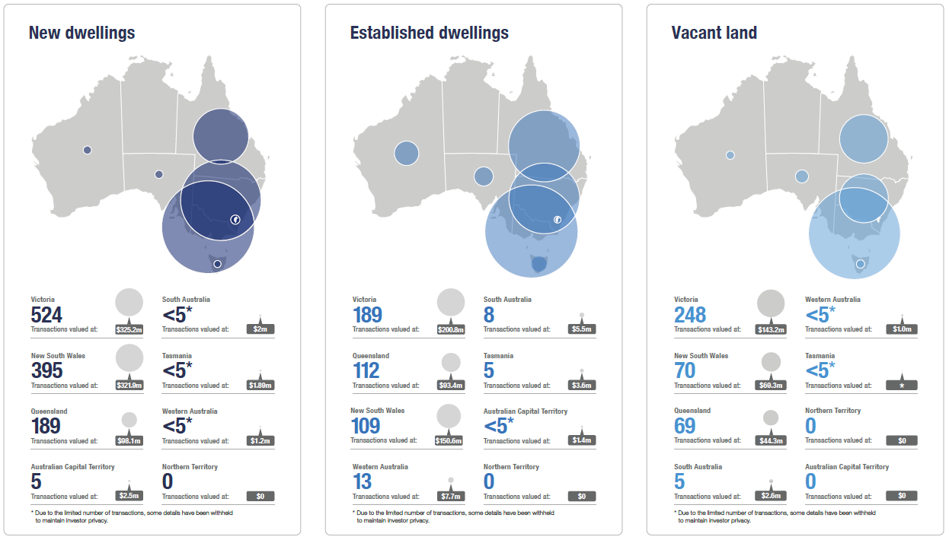

Three-year comparison of purchase transactions

Purchase transactions have declined over the three years from 2017–18 to 2019 –20. There was
a 19.5 per cent reduction in the number of purchase transactions in 2019 –20 when compared to 2018 –19. The value of transactions also reduced by 19.8 per cent in 2019 –20 when compared to 2018 –19.

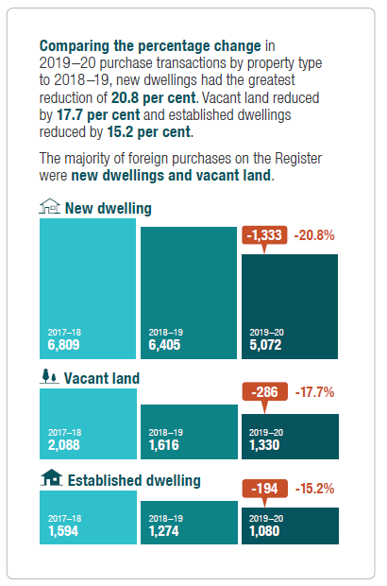
Counts
-1,196
-11.4%
Values
-1,813 -19.5% $1b -11.8%
$1.5b -19.8%
2017–18
10,491
2018 –19
9,295
2019 –20
7,482
2017–18
$8.5b
2018 –19
$7.5b
2019 –20
$6.0b
Purchase transactions by state or territory
The ACT, SA and Tasmania show an increase in purchase counts in 2019 –20 when compared to 2018 –19. The remaining states show an overall reduction.
Purchase transactions with values under $1m
The percentage of purchase transactions for residential real estate with values under $1m has been stable over the 3 years 2017–18 to 2019 –20.
VIC
4,459
3,768
NSW
3,215
3,084
3,151
2019–20 79.0%
QLD
1,950
2,136
1,648
1,416
SA
257
201
302
425
344
228
2018–19
79.8%
81.5% 2017–18
WA

86
TAS 107
191
41
ACT 67
172
<5*
NT 9
8
0
1,000
2,000
2017–18
3,000
2018 –19
4,000
5,000
2019 –20
* Due to the limited number of transactions, some details have been withheld to maintain investor privacy.

Purchase transaction trends by state or territory in the three years 2017-18, 2018 –19 and 2019 –20 show New South Wales and Victoria had greatest number in each property type.

New dwelling
VIC
2,455
2,247
1,943
2,570
NSW
2,832
1,700
1,458
QLD
1,054
980
109
SA 72
161

178
WA 145
98

10
TAS 13
46

28
ACT 42
144

<5*
NT 0
0

0 500
1,000
1,500
2,000
2,500
3,000
2017–18
2018 –19
2019 –20
* Due to the limited number of transactions, some details have been withheld
to maintain investor privacy.
Vacant land
1,323
VIC
956
806
233
NSW 149
112
QLD
381
379
251
30
SA 36
54

101
WA 68
72

18
TAS 23
34

<5*
ACT <5*
<5*

0
NT <5* 0
0 500
1,000
1,500
2,000
2,500
3,000
2017–18
2018 –19
2019 –20
* Due to the limited number of transactions, some details have been withheld
to maintain investor privacy.
Established dwelling
681
VIC 565
466

281
NSW 170
138
QLD
297
215
185
118
SA 93
87

146
WA 131
58

58
TAS 71
111

11
ACT 22
27

<5*
NT 7
8

0 500
1,000
1,500
2,000
2,500
3,000
2017–18
2018 –19
2019 –20
* Due to the limited number of transactions, some details have been withheld
to maintain investor privacy.

Three-year comparison of sale transactions

Sale transactions have increased in 2019-20 when compared to both 2017–18 and 2018 –19.
There was a 66.4 per cent increase in sale transactions in 2019 –20 when compared to 2018 –19. The value of sale transactions also increased by 49.0 per cent when compared to 2018 –19.

2019 –20
1,957

2017–18
1,677

2019 –20
$1.5b

2017–18
$1.4b

2018 –19
1,176

2018 –19
$990m
601
Counts
781
66.4%
Values
$486m 49.0%
-501 -29.9%
$372m -27.3%
Sale transactions by state or territory
There was an increase in sale counts when compared to 2018 –19 in all states and the Australian Capital Territory.
Sale transactions with values under $1m
The percentage of sale transactions for residential real estate with values under $1m has increased from 80.5% in 2017–18 to 85.3% in 2019–20.
VIC
817
961
NSW
320
571
574
2019–20 85.3%
257
QLD 243
370
WA
14
<5* 19
9
<5* 17
9
5
10
0
<5* 6
0
0
0
0
2018–19
82.8%
80.5% 2017–18
SA

TAS ACT
NT
200
400
2017–18
600
2018 –19
800
1,000
2019 –20
* Due to the limited number of transactions, some details have been withheld to maintain investor privacy.

2019 –20
1,124

2017–18
790

2018 –19
588

2017–18
391

2019 –20
396
2018 –19
282

2017–18
496

2019 –20
437

2018 –19
306
Comparing percentage change in 2019 –20 sale
transactions by property type to 2018 –19, new dwellings had the greatest increase of 91.1 per cent. Vacant land increased by 40.4 per cent and established dwellings increased by 42.8 per cent.
The majority of sale transactions involved properties registered as new or established dwellings.
New dwelling
+536 91.1%
Vacant land
+114 40.4%
Established dwelling
+131 42.8%

Sale transaction trends by state or territory in the three years
2017–18, 2018 –19 and 2019 –20 show New South Wales and Victoria

had greatest number in each property type.

New dwelling
333
VIC
264
524
361
NSW
202
395
92
QLD
118
189

<5*
WA <5*
<5*

<5*
SA 0
<5*

<5*
TAS <5*
<5*

0
ACT <5* 5

0
NT 0
0

0 100 200
2017–18
300
2018 –19
400
500
600
2019 –20
* Due to the limited number of transactions, some details have been withheld
to maintain investor privacy.
Vacant land
281
VIC
187
248
NSW
48
47
70
QLD
56
46
69
<5*
WA 0
<5*

<5*
SA <5* 5

<5*
TAS <5*
<5*

0
ACT 0
0

0
NT 0
0

0 100 200
2017–18
300
2018 –19
400
500
600
2019 –20
* Due to the limited number of transactions, some details have been withheld
to maintain investor privacy.
Established dwelling
203
VIC 150
189

162
NSW 71
109

109
QLD 79
112

11
WA 0
13

7
SA <5* 8

<5*
TAS <5* 5

0
ACT 0
<5*

0
NT 0
0
0
100 200
2017–18
300
2018 –19
400
500
600
2019 –20
* Due to the limited number of transactions, some details have been withheld
to maintain investor privacy.

