Register of foreign ownership of agricultural land
  - Report of registrations as at 30 June 2021

Contents
Introduction 3
Summary of key findings 5
Findings 10
Foreign held agricultural land by Australian states and territories 10
Agricultural land with a level of foreign ownership, by Statistical Area Level 4 (SA4) 12
Foreign and Australian share of foreign held agricultural land 14
Foreign held agricultural land by number of properties 15
Foreign held agricultural land by land use 16
Foreign held interests in freehold and leasehold land by Australian state and territory 18
Foreign held interests in freehold and leasehold land 19
Attachment A: Background 25
Attachment B: Definitions 26
Attachment C: Land and Water registration form fields 28
Attachment D: Methodology 29
Attachment E: ABS historical data 31

Introduction

The Register of foreign ownership of agricultural land (the Agricultural land register) was established to provide greater transparency about the level of foreign ownership of Australia’s agricultural land.

The Commissioner of Taxation reports annually to the Treasurer on the operation of the Register of Foreign Ownership of Water or Agricultural Land Act 2015 (the Act) and is required to publish aggregate statistics of foreign ownership each year. This is the sixth report of the Agricultural land register (Agland 2021) and includes registrations made by foreign persons between 1 July 2015 and 30 June 2021.

It is mandatory for foreign persons to register their holdings in agricultural land within 30 days of a specified event occurring, including the acquisition or disposal of those holdings.

Details of specific events are outlined in Attachment A. In this report, ‘foreign held’ land is agricultural land in which a foreign person has ownership. This could be a freehold interest, or a leasehold interest or right to occupy agricultural land under a lease or licence that is likely to exceed five years. A foreign person may hold the interest alone, as a tenant in common or as a joint tenant.

The definition of ‘foreign person’ includes entities with a level of foreign ownership of at least 20%, so the Agricultural land register captures details of entities even when the majority of shareholders are Australian.

For more information on the definition of ‘foreign person’ refer to Attachment B.

Information collected during registration is detailed at Attachment C.

Consistent with Australia’s foreign investment framework, the details of investors are not made publicly available. Taxation law also restricts the release of information which could identify, or be used to identify, an individual or entity. For these reasons, and because the Act only requires aggregated statistics, information beyond what is presented in this report will not be made available.

A quick note on methodology

The Australian Taxation Office (ATO) has undertaken additional comparative analyses using Australian Bureau of Statistics (ABS) information on agricultural land holdings in Australia to estimate the relative proportion of foreign held Australian agricultural land. This estimated proportion is referred to as the ‘level of foreign ownership’.

To calculate the estimated proportion of foreign held agricultural land, a benchmark measure of the total agricultural land area in Australia is used. The benchmark is taken from Rural Environment and Agricultural Commodities Survey (REACS) or censuses conducted by the ABS. See 7121.0 – Agricultural Commodities, Australia, 2019-20 Explanatory Notes for more information on the ABS 2019–20 REACS.

The REACS is conducted annually in the years between the five-yearly agricultural census.

The REACS uses a sample methodology to estimate the total agricultural land area and the estimates are subject to sampling variability.

For Agland 2021, the ABS 2019–2020 REACS is used to estimate the relative proportion of foreign held Australian agricultural land. Similarly, Agland 2020 used the benchmark data from the ABS 2018–2019 REACS.

To ensure legislative requirements are met, this report is produced as soon as practicable after 30 June each year, using the most recently available REACS data at the time of publication.

Care should be taken when relying on this comparative analysis as differences in population between the Agricultural Land Register and ABS commodity surveys and censuses affect the accuracy and reliability of this analysis.

Figures in the tables and diagrams have been rounded. Any discrepancies between totals and sums of components are due to rounding.

The statistics in this report need to be interpreted in conjunction with the information about the methodological caveats outlined in Attachment D.

The report includes an analysis of agricultural land with foreign ownership on a regional basis, using ABS Statistical Area (SA4) level standards.

Summary of key findings

The total area of agricultural land in Australia with a level of foreign ownership has decreased by 0.1% from 53.026 million hectares at 30 June 2020 to 52.985 million hectares at 30 June 2021.

Using the ABS measure of total agricultural land area in Australia, the estimated proportion of agricultural land with a level of foreign ownership at 30 June 2021 is 14.1%.

Figure 1 shows the area of foreign held agricultural land against the ABS measure of total Australian agricultural land to show the level of foreign ownership as at 30 June 2021.

Figure 1: Agricultural land with a level of foreign ownership as at 30 June 2021
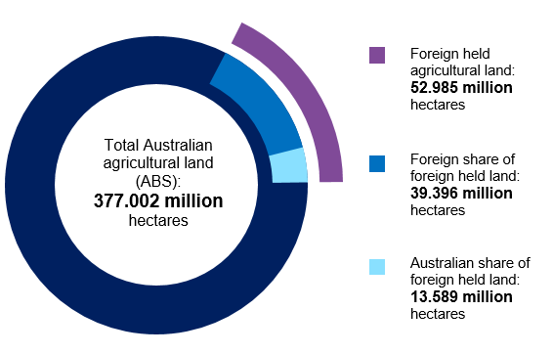
As at 30 June 2021, the estimated proportion of agricultural land with a level of foreign ownership is 14.1%, compared to13.8% in the prior year. While the amount of agricultural land with foreign ownership decreased in 2020-21, the level of foreign ownership relative to the ABS figure for total Australian agricultural land increased.This is attributed to a drop in the level of land used for agricultural purposes reported by the ABS compared to the prior year. The drop is due to the impact of natural disasters on agricultural activities; drought and flooding experienced in New South Wales and Queensland; and bushfires experienced in New South Wales, Queensland and Victoria.

Figure 2 shows the proportion of agricultural land with a level of foreign ownership as at 30 June for each year from 2016 to 2021. The level of foreign ownership of agricultural land has remained relatively stable over the past six years.

Figure 2: Agricultural land with a level of foreign ownership – six year comparison
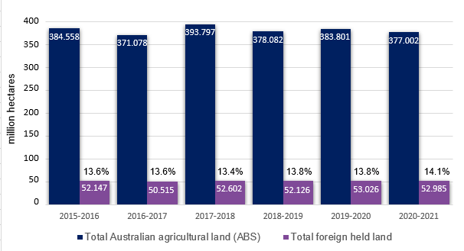

Figure 3 shows a 2 year comparison of foreign held agricultural land and the number of foreign held properties.
There was an overall decrease in the amount of foreign held agricultural land of 0.1% (0.04 million hectares) and an 3.9% increase in the number of foreign held agricultural land properties (387) when compared to 2020.
Figure 3: Foreign held agricultural land and property count – two year comparison
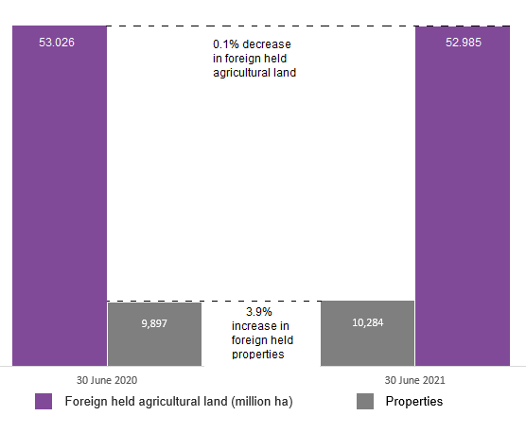

When comparing the type of agricultural land use to the prior year, the area of land used for crops increased by 5.2% and other farming increased by 2.7%. There was a 0.3% reduction in livestock. Refer to Figure 6.

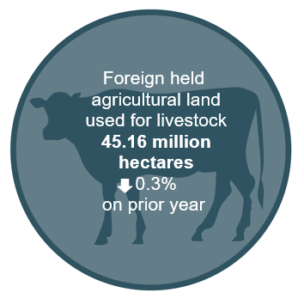
Over 85% of agricultural land with foreign ownership is used for livestock

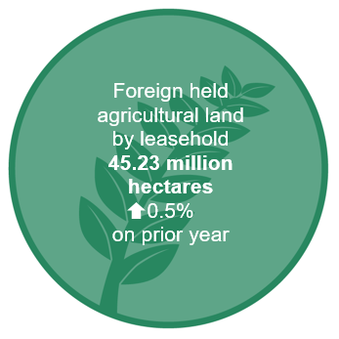
Around 83% of agricultural land with foreign ownership is held on a leasehold basis
When the total foreign held freehold and leasehold interests are aggregated, China has the largest holding of total Australian agricultural land of 2.3%. This is followed by the United Kingdom with 2.2%, the United States of America with 0.8%, Netherlands with 0.7% and Canada with 0.6%. Refer to Table 5

Generally, the changes in agricultural land interests by country of ownership compared to Agland 2020 can be attributed to:

  - new registrations of acquisitions of agricultural land that have settled since the last report
  - agricultural land that has been sold to Australian entities and has been removed from the register
  - agricultural land that has been sold to other foreign entities with a different foreign country of ownership
  - foreign entity restructures which have resulted in a change of the foreign entity’s status as a foreign person.

There was a change in the amount of foreign held agricultural land in each of the states and territories as at 30 June 2021 when compared to the prior year. The level of foreign held agricultural land increased in Western Australia, Victoria, New South Wales/Australian Capital Territory and Tasmania and it decreased in the Northern Territory, Queensland and South Australia.

Figure 4 shows the net change of foreign held agricultural land by state or territory. Refer to Table 2 for further information.

Figure 4: Foreign held agricultural land by state or territory – net change compared to prior year

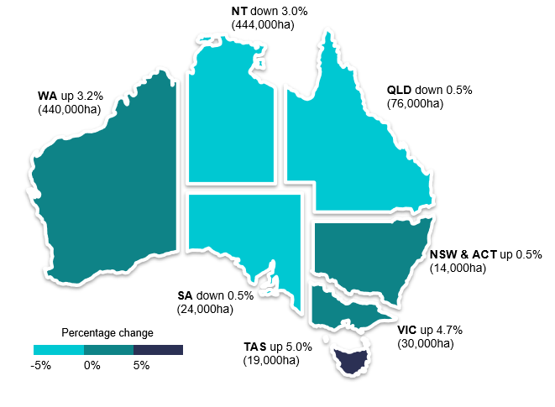

Findings

Foreign held agricultural land by Australian states and territories

Table 1: Foreign held agricultural land by state or territory as at 30 June 2021

 | Foreign held agricultural land  (‘000 ha) |  |  |  |  |  | Australian agricultural land  (‘000 ha) | Foreign held  (%)
State or territory | 30 June 2016 | 30 June 2017 | 30 June 2018 | 30 June 2019 | 30 June 2020 | 30 June 2021 | 2019-2020 REACS | 30 June 2021
NSW/ACT | 2,375 | 2,487 | 2,553 | 2,557 | 2,660 | 2,674 | 51,303 | 5.2
VIC | 607 | 634 | 660 | 618 | 639 | 669 | 11,261 | 5.9
QLD | 17,658 | 15,748 | 15,758 | 15,490 | 15,724 | 15,648 | 128,702 | 12.2
WA | 8,841 | 12,809 | 13,699 | 13,855 | 13,954 | 14,394 | 84,965 | 16.9
SA | 7,156 | 4,796 | 4,933 | 4,943 | 4,949 | 4,925 | 45,351 | 10.9
TAS | 342 | 354 | 362 | 356 | 382 | 401 | 1,570 | 25.5
NT | 15,169 | 13,686 | 14,637 | 14,307 | 14,718 | 14,274 | 53,850 | 26.5
Total | 52,147 | 50,515 | 52,602 | 52,126 | 53,026 | 52,985 | 377,002 | 14.1

Notes:

- The area of agricultural land with a level of foreign ownership by Australian states and territories is compared to the latest benchmark information, by states and territories from the ABS REACS to identify the estimated proportion of agricultural land that has a level of foreign ownership.

- The ‘foreign held per cent’ is the ratio of agricultural land with a level of foreign ownership to the total of Australian agricultural land for each state or territory.

- Differences between the Agricultural land register and ABS commodity surveys and censuses affect the accuracy and reliability of the above proportions. For example, the ABS total agricultural land figure does not include agricultural land held by entities whose primary business activity is forestry. In regions such as Tasmania and Victoria that have a large proportion of forestry the proportion of agricultural land that is foreign owned is therefore likely overstated.

- See Table 4 for further details on land usage by state or territory.

- Information on historical agricultural land totals (from the ABS) is at Attachment D.

Table 2 shows the land size comparison at 30 June 2021 compared to the land size in the two prior years by Australian states and territories. The change percentage shows the change in the land size at 30 June 2021 compared to the land size at 30 June 2020 in each state or territory.

Table 2: Foreign held agricultural land by state or territory – Land size comparison

State or territory | 30 June 2018  (‘000 ha) | 30 June 2019  (‘000 ha) | 30 June 2020  (‘000 ha) | 30 June 2021 (‘000 ha) | Change  (%)
NSW/ACT | 2,553 | 2,557 | 2,660 | 2,674 | 0.5
VIC | 660 | 618 | 639 | 669 | 4.7
QLD | 15,758 | 15,490 | 15,724 | 15,648 | -0.5
WA | 13,699 | 13,855 | 13,954 | 14,394 | 3.2
SA | 4,933 | 4,943 | 4,949 | 4,925 | -0.5
TAS | 362 | 356 | 382 | 401 | 5.0
NT | 14,637 | 14,307 | 14,718 | 14,274 | -3.0
Total | 52,602 | 52,126 | 53,026 | 52,985 | -0.1

Notes:

- It is not possible to reconcile the percentage changes reflected in Table 2 against annual movements in the estimate of the percentage of total agricultural land held by foreign persons, due to annual fluctuations in ABS total agricultural land estimates.

Agricultural land with a level of foreign ownership, by Statistical Area Level 4 (SA4)

Chart 1 shows the proportion of agricultural land with a level of foreign ownership for each SA4 regional area as at 30 June 2021.

Chart 1: Proportion of agricultural land with a level of foreign ownership, by SA4
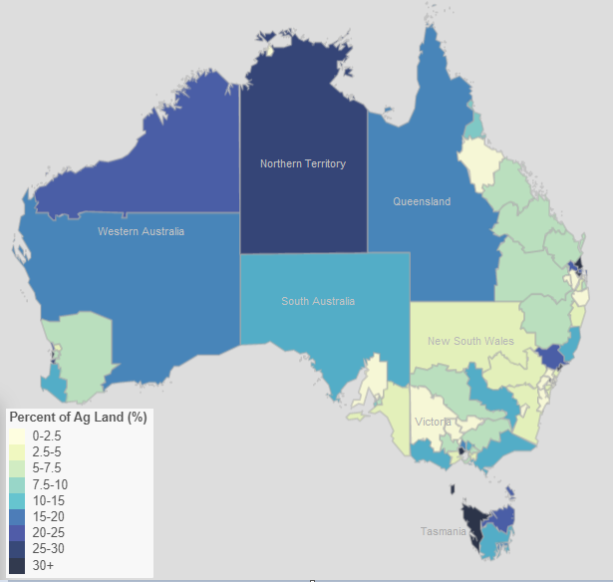

Notes:

- The proportion of agricultural land with a level of foreign ownership for each SA4 regional area is calculated by dividing the total amount of foreign held agricultural land in each region by the total amount of agricultural land in each region. The SA4 regional areas are based on postcodes geographically coded to each statistical area.
- Statistical Areas Level 4 (SA4) are geographical areas built from whole Statistical Areas Level 3 (SA3s).
SA4 regions are the largest sub-State regions in the Main Structure of the Australian Statistical Geography Standard (ASGS). Whole SA4s aggregate to Greater Capital City Statistical Areas (GCCSA) and State and Territory. There are 107 SA4 regions covering the whole of Australia without gaps or overlaps.

- The total amount of foreign held agricultural land in each region uses data collected by the ATO to 30 June 2021. As the ATO only collects data on foreign holdings, ABS data on total land holdings is used to estimate the proportion of land with a foreign ownership interest in each region. The ABS 2019–20 REACS and the ABS SA4 standards was used for this.

- Differences between the Agricultural land register and ABS commodity surveys and censuses affect the accuracy and reliability of this analysis. For example, the ABS total agricultural land figure does not include agricultural land held by entities whose primary business activity is forestry. In regions such as Tasmania and Victoria that have a large proportion of forestry the proportion of agricultural land that is foreign owned is therefore likely overstated.

- This information is for illustrative purposes only and care should be taken when using this information for any other purpose.

Foreign and Australian share of foreign held agricultural land

Figure 5 shows the foreign and Australian share of foreign held agricultural land as at 30 June for each year from 2018 to 2021. The register records foreign person entities that have a foreign ownership share of 20% or more. This means there may also be a significant portion of Australian ownership in those same parcels of land.

Figure 5: Foreign and Australian share of foreign held agricultural land
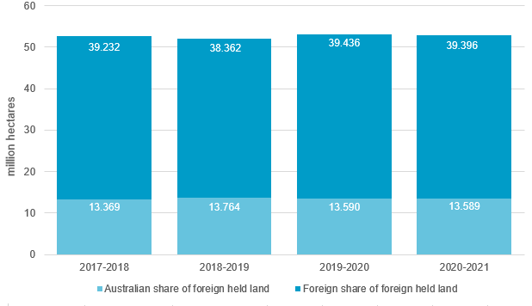

Note:

- As at 30 June 2021, of the 52.985 million hectares of foreign held Australian agricultural land, 25.6% (13.59 million hectares) is indirectly held by Australian investors who have shares in foreign person entities. When compared to the prior year there has been a 0.1% decrease in the foreign share proportion of the foreign held land and the Australian share of foreign held land has remained constant.

Foreign held agricultural land by number of properties

Table 3 shows the number of foreign held properties on the Agricultural land register by state and territory as at 30 June for each year from 2018 to 2021.

Table 3: Foreign held agricultural land – Number of properties held comparison over four years

State or territory | 30 June 2018  (No. of properties) | 30 June 2019  (No. of properties) | 30 June 2020  (No. of properties) | 30 June 2021  (No. of properties)
NSW and ACT | 2,213 | 2,386 | 2,450 | 2,580
VIC | 1,889 | 1,938 | 2,014 | 2,187
QLD | 1,477 | 1,543 | 1,620 | 1,693
WA | 1,382 | 1,394 | 1,449 | 1,564
SA | 679 | 703 | 741 | 815
TAS | 988 | 995 | 1,529 | 1,344
NT | 81 | 85 | 94 | 101
Total | 8,709 | 9,044 | 9,897 | 10,284

Note:

- In this table the figures for numbers of properties measures property titles. Multiple (sometimes hundreds) of titles can transfer between two parties in one acquisition, and the property number may not be an accurate reflection of the amount of land changing hands. For example, while there was a 10.0% net increase (74) in the number of foreign held properties in South Australia as at 30 June 2021, the overall land size decreased by around 0.5% for 24,000 hectares as detailed in Table 2.

Foreign held agricultural land by land use

Table 4 illustrates land use by state and territory across categories collected in the Agricultural land register as at 30 June 2021.

Table 4: Foreign held agricultural land by land use as at 30 June 2021

State or territory | Crops  (‘000 ha) | Livestock  (‘000 ha) | Horticulture  (‘000 ha) | Other Farming  (‘000 ha) | Forestry  (‘000 ha) | Non-farming  (‘000 ha) | Unreported  (‘000 ha) | Total
NSW and ACT | 667 | 1,466 | 81 | 44 | 97 | 82 | 238 | 2,674
VIC | 119 | 74 | 7 | 14 | 418 | 19 | 16 | 669
QLD | 465 | 13,068 | 87 | 55 | 327 | 217 | 1,429 | 15,648
WA | 739 | 12,444 | 105 | 19 | 183 | 393 | 511 | 14,394
SA | 35 | 4,750 | 9 | 10 | 77 | 40 | 3 | 4,925
TAS | 7 | 64 | 5 | 4 | 314 | 6 | 2 | 401
NT | 3 | 13,294 | 0 | 0 | 13 | 17 | 946 | 14,274
Total | 2,036 | 45,159 | 294 | 150 | 1,428 | 773 | 3,145 | 52,985

Notes:

- The registration form includes land use categories of crop, livestock, intensive horticulture, forestry, other farming, non-farming. Where registrants did not report the land use, this is shown in the ‘Unreported’ column.

- The non-farming category is an undefined term and requires registrants to determine the land use. Examples where this has been selected include land zoned for mining or used as a mining buffer.

Figure 6 shows foreign held agricultural land by land use and compares the percentage change in foreign held agricultural land by land use as at 30 June 2021 to foreign held agricultural land as at 30 June 2020.

Figure 6: Foreign held agricultural land by land use – comparison
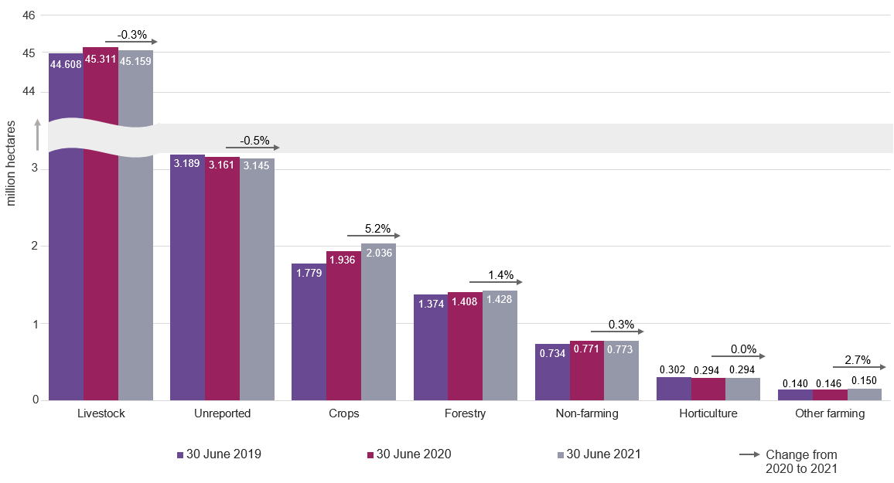

Notes:

- The land use categories are derived from information submitted on the Land and Water Registration Form, where a foreign person selects the most appropriate category. The available categories are crop, livestock, intensive horticulture, forestry, other farming and non-farming. Where a foreign person did not report the land use, this is shown in the ‘Unreported’ column.

- The non-farming category is an undefined term. Examples include land zoned for mining or used as a mining buffer.

Foreign held interests in freehold and leasehold land by Australian state and territory
Figure 7 shows the ratio of freehold and leasehold land to the total foreign held land by state and territory reported on the register as at 30 June 2021. The aggregate freehold interest is 9.633 million hectares, and aggregate leasehold interest is 45.226 million hectares.

Figure 7: Foreign held interests in freehold and leasehold land by state and territory as at 30 June 2021 (million hectares)
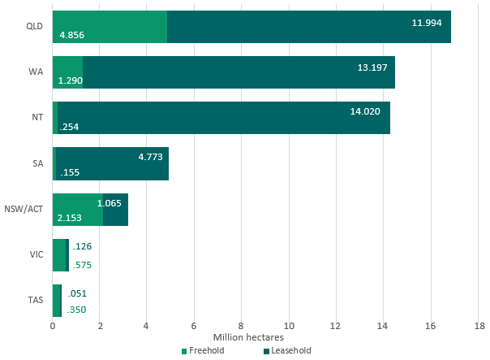

Notes:

- In some instances, the same property has been separately registered by a foreign person with a freehold interest in the land and by another foreign person with a leasehold interest in the land, as required under the Act. Land size information from both registrations has been included in this table and so do not add to 52.985 million hectres.

- As a result, the total leasehold and freehold hectares held by foreign persons is greater in Figure 7 than data illustrated in Tables 1 to 4 and Figures 1 to 6.

Foreign held interests in freehold and leasehold land

Table 5 shows the foreign share of the foreign held freehold and leasehold land by the top 10 countries as at 30 June 2021. This excludes the Australian share of the total foreign held freehold and leasehold land.

The changes in the country ranking of the United States of America and the Netherlands
when compared to the prior year is predominantly attributed to increased leasehold interests
held by the United States of America. Notably:

  - the United States of America increased its leasehold interests in forestry plantations
  - the overall interests of Canada were lower due to division of assets between related entities with varying countries of ownership.
  - China’s overall interest was lower by around 700,000 hectares due to the sale of two large perpetual leases.
  - Hongs Kong’s overall interest increased due to new leasehold agreements

Table 5: Foreign held freehold and leasehold agricultural land - Top 10 countries

Country | Freehold  (‘000 ha) | Leasehold  (‘000 ha) | Total foreign held (‘000 ha) | Agricultural land with a level of foreign ownership (%)
China | 830 | 7,669 | 8,499 | 2.3
United Kingdom | 886 | 7,365 | 8,251 | 2.2
United States of America | 1,371 | 1,555 | 2,926 | 0.8
Netherlands | 1,661 | 1,156 | 2,817 | 0.7
Canada | 564 | 1,887 | 2,451 | 0.6
Bahamas | 0 | 2,201 | 2,201 | 0.6
Switzerland | 297 | 1,852 | 2,149 | 0.6
Germany | 207 | 1,937 | 2,144 | 0.6
South Africa | 101 | 1,761 | 1,862 | 0.5
Hong Kong | 277 | 1,502 | 1,779 | 0.5

Notes:

- To avoid identifying individuals and entities, only the top 10 countries are shown.

- In some instances, the same property has been separately registered by a foreign person with a freehold interest in the land and by a foreign person with a leasehold interest in the land, as required under the Act. Land size information from both registrations has been included in this table.

- The level of foreign ownership in agricultural land is derived by calculating total foreign held agricultural land as a proportion of the 2019–20 REACS total of 377.002 million hectares.

- The changes in country ranking are attributed to sales and purchases by respective countries. Further information for current and prior year holdings for the top 10 countries for freehold and leasehold respectively are detailed in Table 6 and Table 7.
Figure 8 shows the foreign share and Australian share of foreign held freehold agricultural land as at 30 June for each year from 2019 to 2021.

Figure 8: Foreign held freehold agricultural land – Foreign and Australian share of foreign held land

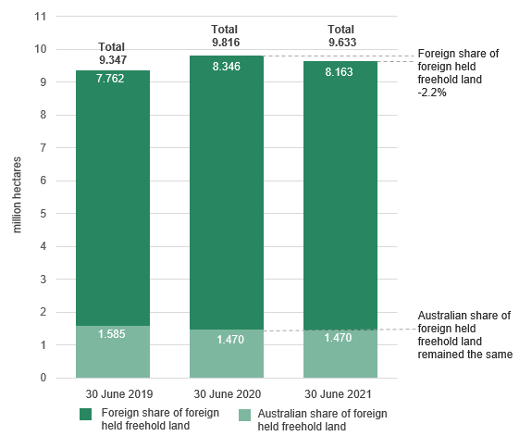

Notes:

- As at 30 June 2021, of the 9.633 million hectares of freehold land held by foreign persons:

- the Australian share was 1.470 million hectares with no change from last year
- the foreign share was 8.163 million hectares with a 2.2% decrease on the prior year.

Table 6 shows the top 10 countries holding freehold land by size of agricultural land as at 30 June 2021. The top 10 country ranking as at 30 June 2021 does not reflect ranking for prior year. Prior year figures are included to enable a comparison of the top 10 countries over time.

Table 6: Foreign held freehold agricultural land by foreign share – Top 10 countries

Foreign share of foreign held - freehold land
(‘000 ha)
Country | 30-Jun-19 | 30-Jun-20 | 30-Jun-21
Netherlands | 1,653 | 1,648 | 1,661
United States of America | 1,230 | 1,310 | 1,371
United Kingdom | 908 | 882 | 886
China | 840 | 824 | 830
Canada | 435 | 907 | 564
Saudi Arabia | 496 | 498 | 500
Denmark | 356 | 327 | 325
Switzerland | 208 | 257 | 297
Hong Kong | 184 | 243 | 277
Germany | 186 | 201 | 207

Notes:
- In this table, the freehold land by size for the top 10 countries only shows the foreign share of the foreign held freehold land and excludes the Australian share of the total foreign held freehold land.

- To avoid identification of individuals and entities, only the top 10 countries are shown.

Figure 9 shows the foreign and Australian share of foreign held agricultural leasehold land.

Figure 9: Foreign held leasehold agricultural land – Foreign and Australian share of foreign held land
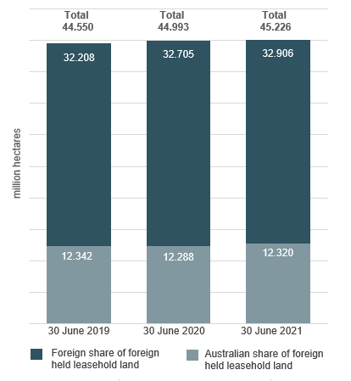

Notes:

- Of the 45.226 million hectares of foreign held leasehold land:

  - the Australian share was 12.320 million hectares with a 0.3% increase on the prior year, and
  - the foreign country share was 32.906 million hectares with a 0.6% increase on the prior year.

Table 7 shows the top 10 nationalities holding leasehold land by size of agricultural land as at 30 June 2021. The top 10 country ranking as at 30 June 2021 does not reflect ranking for prior year. Prior year figures are included to enable a comparison of the top 10 countries over time.

Table 7: Foreign held leasehold agricultural land by foreign share – Top 10 countries

Foreign share of foreign held land - Leasehold
(‘000 ha)
Country | 30 June 2019 | 30 June 2020 | 30 June 2021
China | 8,313 | 8,374 | 7,669
United Kingdom | 8,118 | 7,284 | 7,364
Bahamas | 2,201 | 2,201 | 2,201
Germany | 1,933 | 1,933 | 1,937
Canada | 1,694 | 1,703 | 1,887
Switzerland | 1,804 | 1,822 | 1,852
South Africa | 1,131 | 1,691 | 1,761
United States of America | 996 | 1,442 | 1,555
Hong Kong | 1,181 | 1,219 | 1,502
Netherland | 1,143 | 1,153 | 1,156

Notes:

- The leasehold land by size for the top 10 countries only shows the portion of the foreign held land owned by foreign countries and excludes any Australian share in the foreign held entity.

- To avoid identification of individuals and entities, only the top 10 countries are shown.

Background information on obtaining source country information

The annual report includes information on the level of ownership by source country. For the purpose of preparing the statistical report, we attribute a source country to each registration. This is done to enhance transparency at an aggregated level consistent with the policy objective for the Agricultural land register.
As part of the registration information, owners who are individuals or partnerships are required to provide their country of nationality. Companies are required to provide their country of incorporation.
Where the registered owner is an individual, the nationality of the person reported in their registration is treated as the source country.
Where the registered owner is a company or trust, it is the nationality of the person/s who appear to control the entity that is used to attribute the source country rather than the country of incorporation. Where the person who controls the entity is identified as an Australian citizen who is not ordinarily resident in Australia (and hence a foreign person), the source country is attributed to the country they are ordinarily resident in.
Where shares or interests are widely held for companies or trusts, the interest in agricultural land held is attributed to a source country based on the location of the directors or the country where the entity (or trustee) is headquartered or publicly listed depending on information available.
The country of control is assessed using data resources within the ATO and other agencies such as Department of Immigration and Border Protection and Australian Securities and Investment Commission.

The attribution of a source country to foreign held agricultural land continues to evolve as new information comes to light.

Attachment A: Background

The Agricultural Land Register was established on 1 July 2015 and is administered by the ATO. The Act requires foreign persons with an interest in agricultural land to register that interest on the Agricultural land register, regardless of the value of the land or the requirement to have FIRB approval. This is referred to in this report as foreign ownership of agricultural land.

Ultimately the obligation to register correctly lies with the foreign person and penalties exist under the Taxation Administration Act 1953 where a person fails to register correctly. Section 16 of the Act allows the Commissioner to correct or update information on the Agricultural land register.

Investors are required to notify the ATO within 30 days of a specified event occurring. These specified events include:

- a foreign person starts to hold agricultural land
- a foreign person ceases to hold agricultural land
- an investor becomes a foreign person while holding agricultural land
- an investor ceases to be a foreign person while holding agricultural land
- a foreign person holds land that becomes agricultural land
- a foreign person holds land that ceases to be agricultural land.

An interest in agricultural land includes a freehold interest or the right to occupy land under a lease (including a sublease or licence) where the term of the lease or licence (including any extension or renewal) is reasonably likely to exceed five years.

A stocktake was conducted between 1 July 2015 and 29 February 2016 to enable existing foreign person landholders to register their land. During this time, the ATO used data matching to identify and contact investors who may have met the definition of foreign person and who held Australian land that may have met the definition of agricultural land.

Attachment B: Definitions

This attachment provides information on the definitions of ‘foreign person’ and ‘agricultural land’ as detailed in the Act. Further information on the definitions can be found in the guidance notes on the Foreign Investment Review Board website at firb.gov.au

Definition of a foreign person

The term ‘foreign person’ is defined in section 4 of the Act. It states that the term has the same meaning as ‘foreign person’ as defined in section 4 of the Foreign Acquisitions and Takeovers Act 1975.

In general, a ‘foreign person’ is:

- an individual not ordinarily resident in Australia
- a foreign government or foreign government investor
- a corporation, trustee of a trust or general partner of a limited partnership where an individual not ordinarily resident in Australia, a foreign corporation or a foreign government holds a substantial interest of at least 20%
- a corporation, trustee of a trust or general partner of a limited partnership in which two or more foreign persons hold an aggregate substantial interest of at least 40%.

Definition of agricultural land

‘Agricultural land’ is defined in section 4 of the Act as land in Australia that is used, or that could reasonably be used, for a primary production business.

Section 5 of the Act provides that the rules may specify land that will not be considered agricultural land for the purposes of the Agricultural land register. The Register of Foreign Ownership of Water or Agricultural Land Rules 2017 provides that the following land will not be considered agricultural land for the purposes of the Act:

- Land that is not currently being wholly or predominantly used at that time for a primary production business and:

  - zoning approval is required from government before the land could be used for primary production

  - the land is currently used, or proposed to be used for mining or activities ancillary to mining

  - the land is used for environmental protection or conservation under a law of the Commonwealth, a state or a territory or a legally binding agreement

  - the land is located within an area that has been approved by a government authority as an industrial estate

  - the size of the land is under one hectare

  - the land has been approved by a government authority for use as a tourist facility, an outdoor education establishment or an outdoor recreation facility that is open to the public

  - an application has been made to re-zone the land to not allow the land to be used for a primary production business, or approval has been sought to use the land for mining activities

  - the land is used for wind or solar power station(s), including when an approval is in place to allow the wind or solar farm to be established or operated on the land, or the land was acquired solely for the purpose of meeting a requirement of government approval for the solar or wind farm.

- Land where the only primary production business the land could reasonably be used for is a primary production business relating to submerged plants and animals.

Attachment C: Land and Water registration form fields

Each registrant must complete the following mandatory fields:

Contact details
- Name
- Position
- Address
- Mobile/cell number
- Contact email

Reason for registration
- Acquisition of agricultural land
- Cease to hold agricultural land
- Change in status to or from a foreign person
- Change in status to or from agricultural land

Entity and ownership details
- Name
- Country of incorporation (where registrant is a trust or company)
- Reason why the company or trust is a foreign person
- Address
- Date of birth
- Nationality (where registrant is an individual or where country of incorporation is entered as Australia)
- Address
- Mobile/cell number
- Contact email

Land title details
- Property address
- Title information
- Land area
- Land use categories include crop, livestock, Intensive horticulture, forestry, Other farming, non farming
- Land value
- Title holding type (leasehold or freehold)
- Date of event
- Percentage interest in the land

Attachment D: Methodology

This is an overview of the main methodological caveats that apply to the data in this report.

- Data was extracted from the Agricultural land register database for properties settled as at 30 June 2021.

- Some registrations have been corrected or updated in accordance with section 16 of the Act when it has been determined via data matching or manual data collection that the registrant has provided incorrect information. The validation of new and existing registrations is an ongoing exercise, with information reconciled against third party data sources and manual data collection.

- Registrants are required to enter the area of their land holding in metres squared (m2) which is then converted to hectares for reporting purposes. The ATO has converted into hectares any land holdings reported in a different unit of measurement.

- Entities and trusts were required to report their country of incorporation and the nationality of the owner. However, this is not necessarily a reflection of the foreign source country of the investor. Source country information has been obtained using information provided by registrants, ATO data sources and manual data collection.

- Properties are given a unique identifier in the form of a composite of the property name, address, suburb and state or territory. Counts of properties were based on instances of unique identifiers.

- Properties were assigned geographic coordinates using a geocoding algorithm. Each property was assigned a Statistical Area (Level 4) based on its geographic coordinates, (shown in Chart 1).

- In some instances, the same property has been registered twice - by a foreign person with a freehold interest in the land and by another foreign person with a leasehold interest in the land, as required under the Act. Information in Tables 1 to 4 and Figures 1 - 6 does not include leasehold registrations where a property has been already been registered as freehold. However, in Figure 7 and Table 5, the land size information from both freehold and leasehold registrations has been included by state and territory and the top 10 countries respectively. Figure 8 and Figure 9 and Table 6 and Table 7 separately show the size of foreign held agricultural land by freehold and leasehold respectively.

- The definition of agricultural land under the Foreign Acquisitions and Takeovers Act 1975 includes ‘land in Australia that is used, or that could reasonably be used, for primary production purposes’. Due to the broad nature of this definition it is possible that the Agricultural Land Register includes land that is not captured as part of the ABS Agricultural Census or ABS REACS. This may have the effect of overstating the total proportion of Australian agricultural land that is foreign held. Importantly, entities whose primary business is forestry are not captured by ABS agricultural data that has been used for comparative purposes in this report. As at 30 June 2021, land use attributed to forestry on the Register was 1.428 million hectares, representing 0.38% of the 2019-20 REACS.

- The Act requires foreign persons to notify of certain changes to their holdings. The movement in country rankings and holding by country may be in part be attributed to instances where a registration is updated following, for example, an internal company reorganisation, where the same entity owns the land but there has been a change in the country of control.

Attachment E: ABS historical data

Table 8: Total area of Australian agricultural by state or territory – ABS agricultural land

State/Territory | 2018-19 REACS  (‘000 ha) | 2019-20 REACS  (‘000 ha) |  | Change  %
NSW/ACT | 52,357 | 51,303 |  | -2.0
VIC | 11,465 | 11,261 |  | -1.8
QLD | 133,147 | 128,702 |  | -3.3
WA | 82,201 | 84,965 |  | 3.4
SA | 46,104 | 45,351 |  | -1.6
TAS | 1,456 | 1,570 |  | 7.8
NT | 57,071 | 53,850 |  | -5.6
Total | 383,801 | 377,002 |  | -1.8

Notes:

- A comparison of total area of agricultural land split by state and territory over the last two years illustrates movement in all agricultural land in Australia using ABS data.

- The movement in agricultural land between each year is indicated as ‘change %’ for each state and territory.

In particular, it should be noted that the ABS does not capture entities whose primary business activity is forestry as part of their agricultural surveys or census, whereas forestry land holdings are captured as part of the Agricultural Land Register.
The Australian statistical geography standard (ASGS) is the ABS’s geographical framework, effective from July 2016.
ABS: Agricultural Commodities, Australia – Changes in this and forthcoming issues
Care should be taken when comparing percentage foreign ownership of agricultural land across years as estimates are taken from annually-updated ABS REACS. These are subject to sampling variability. For example, the 2018-19 ABS REACS reported a 1.5% increase in the total amount of agricultural land across Australia with the total area increasing from 378 million hectares in 2017–18 to 383.8 million hectares in 2018-19.
ABS – statistical areas
The Australian statistical geography standard (ASGS) is the ABS's geographical framework, effective from July 2016.
The ABS does not capture entities whose primary business activity is forestry as part of their agricultural surveys or census, however forestry land holdings are captured as part of the Agricultural Land Register.
As defined in section 5 of the Foreign Acquisitions and Takeovers Act 1975.
Land that is not agricultural land for the purposes of the Register of Foreign Ownership of Water or Agricultural Land Act 2015 is outlined in section 44 of the Foreign Acquisitions and Takeovers Regulation 2015.
In some cases, the nationality or country of incorporation of a nominal investor may have been identified, rather than the nationality or country of incorporation of the ultimate beneficial owner.

