

Register of foreign ownership of residential land

**Insights into foreign purchases and sales of residential real estate for the period 1 July 2020 to 30 June 2021**

The **Register of foreign ownership of residential land** has been established

##### to increase transparency around foreign investment in Australia.

Information has been extracted from the Register to provide insights into foreign purchases and sales of residential real estate over four reporting periods. The information relates to residential real estate transactions (purchases or sales) by foreign persons over the periods 1 July 2020 to 30 June 2021 (2020-21), 1 July 2019 to 30 June 2020 (2019–20), 1 July 2018 to 30 June 2019 (2018–19), and 1 July 2017 to 30 June 2018 (2017–18).

Consistent with Australia’s broader foreign investment review framework, the details of foreign persons are not made available publicly. Taxation law also restricts the release of information which could identify, or be used to identify, an individual or entity. For these reasons, this information is presented in an aggregated format only.

Care should be taken in comparing the Insights data with the Foreign Investment Review Board (FIRB) Annual Reports. The FIRB Annual Reports contain proposed investment information. The Insights data reflects confirmed real estate transactions and is not a full stocktake of foreign ownership in residential land.

**Methodology**

The Register holds information about purchase or sale transactions by foreign persons who obtained foreign investment approval. Purchase transactions are where:

* a foreign person through self-registration has indicated that they have settled on a residential property for which they had gained prior foreign investment approval, and a foreign person identified during compliance activity that has settled property and failed to apply for foreign investment approval, or
* through the collection of land titles data from participating states and territories, the ATO has matched a residential real estate transfer (purchase) and purchaser to a corresponding property and foreign person that was previously issued foreign investment approval.

Similarly, sale transactions are where:

* a foreign person through self-registration has indicated that they are no longer a foreign person, have sold (and settlement has occurred on) a residential property for which they had gained prior foreign investment approval, or
* through the collection of land titles data from participating states and territories, the ATO has matched a residential real estate transfer (sale) and vendor to a corresponding property and foreign person that was previously issued foreign investment approval.

For a purchase or sale transaction to be included in the Insights, the settlement date for the transaction needs to have occurred within the relevant reporting period. For purchase transactions, if a property was purchased and then sold during the report period, the purchase is included in these figures.

The value is derived from the contract sale price and represents the transaction value at that time, not current market value. The dwelling type – vacant land, new dwelling or established dwelling – reflects the type of dwelling at the time of purchase.

**Understanding the reporting period**

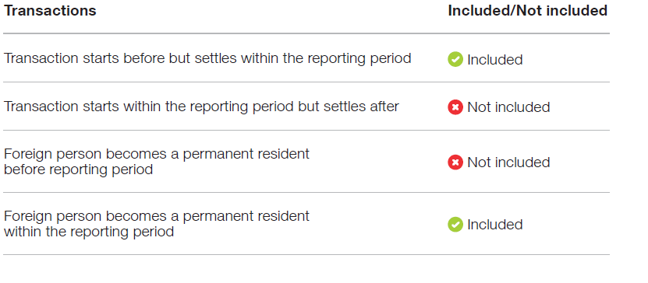

## 2020 –21 Insights

#### Purchases

##### From 1 July 2020 to 30 June 2021, 5,310 residential real estate purchase transactions had a level of foreign ownership, with a total value of $4.2 billion.

**Sales**

##### The total number of residential real estate sale transactions by foreign persons during the 2020‑21 period was 3,103, with a total value of $2.7 billion.

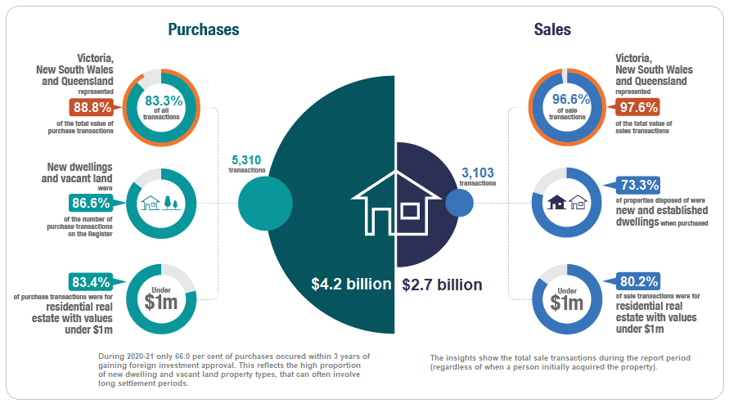

**Purchase transactions in 2020 –21**

Victoria, New South Wales and Queensland represented **83.3 per cent**

of all purchase transactions and make up **88.8 per cent** of the total value of purchase transactions recorded on the Register for the 2020–21 period.

* The concentration and value of transactions in Victoria, New South Wales and Queensland fell slightly in 2020–21 from 88.0% of all purchase transactions and 92.1 per cent of the total value.
* New dwellings represented 68.6 per cent of purchase transactions, followed by 18.0 per cent for vacant land and 13.4 per cent for established dwellings in 2020 –21. In comparison, in 2019 –20, new dwellings represented 67.8 per cent of purchase transactions, followed by 17.8 per cent for vacant land and 14.4 per cent for established dwellings.
* Across Australia, purchase transactions fell by 29.0 per cent. The state with the greatest number of purchase transactions for all property types in 2020–21 was Victoria, the same result as in 2019-20. New South Wales had the largest decrease in property purchases with a fall of 50.1 per cent.
* Residential properties with values under 1 million dollars formed the majority of residential property purchase transactions, accounting for 83.4 per cent of property transactions 2020-21. This compares to 79.0 per cent in 2019-20.
* Of the 5,310 purchase transactions in 2020–21, 111 registrants became a permanent resident or gained Australian citizenship during the year and are included in these statistics.

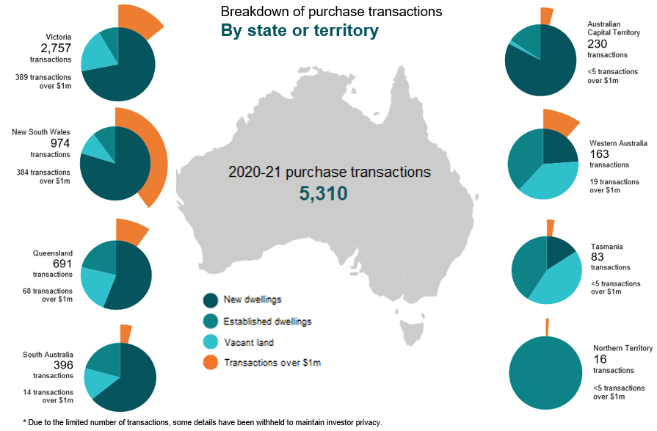

## Breakdown of 2020 –21 purchase transactions by property type

## 

**$0**

## Sale transactions in 2020 –21

Victoria, New South Wales and Queensland represent **96.6 per cent**

##### of all sale transactions, making up **97.6 per cent** of the value of sale transactions for the reporting period.

* In comparison, in 2019–20 Victoria, New South Wales and Queensland represented 97.3 per cent of all sale transactions and 98.0 per cent of the value.
* In 2020–21, new dwellings represented 45.6 per cent of sale transactions, followed by 27.7 per cent for established dwellings and 26.7 per cent for vacant land. The property type reflects the type of property at time of purchase, e.g. new dwellings were new at the time of purchase.
* Victoria had the greatest number of sale transactions across all property types in both 2020–21 and 2019–20.
* Properties with values under 1 million dollars represented

80.2 per cent of sale transactions. This is a slight decrease when compared to the proportion of sale transactions in 2019–20 of 85.3 per cent.

* Sale transactions numbers reflect any sale transactions settled

by foreign persons within the reporting period, regardless of when the initial purchase was contracted.



## Breakdown of 2020 –21 sale transactions by property type

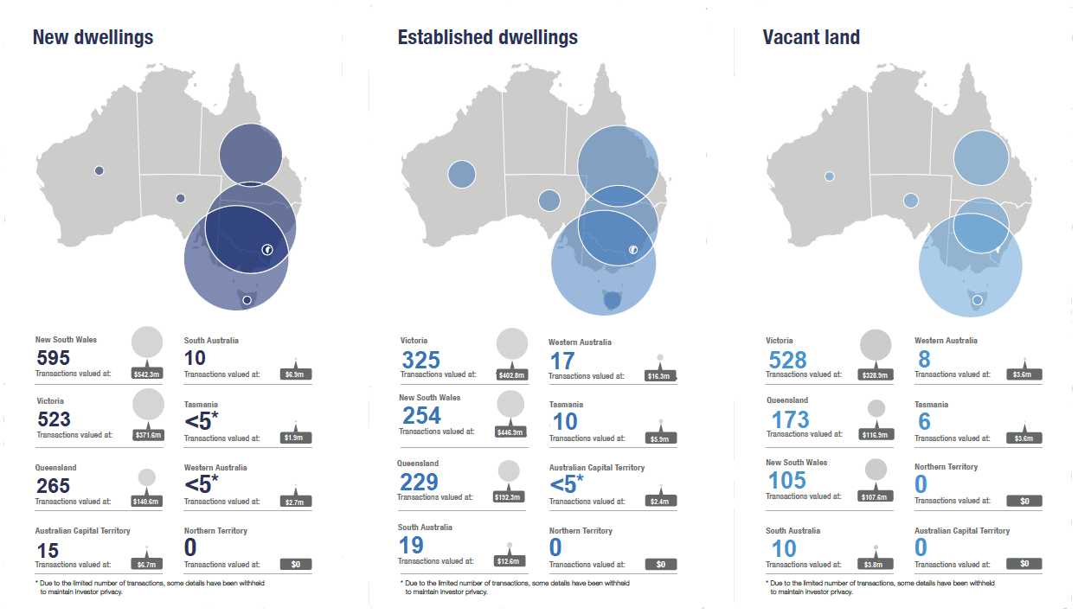

## Four-year comparison of purchase transactions

##### Purchase transactions have declined over the four years from 2017‑18 to 2020‑21. There was

a **29.0 per cent reduction** in the number of purchase transactions in 2020‑21 when compared to 2019‑20. The value of transactions also **reduced by 30.0 per cent** in 2020‑21 when compared to 2019‑20.

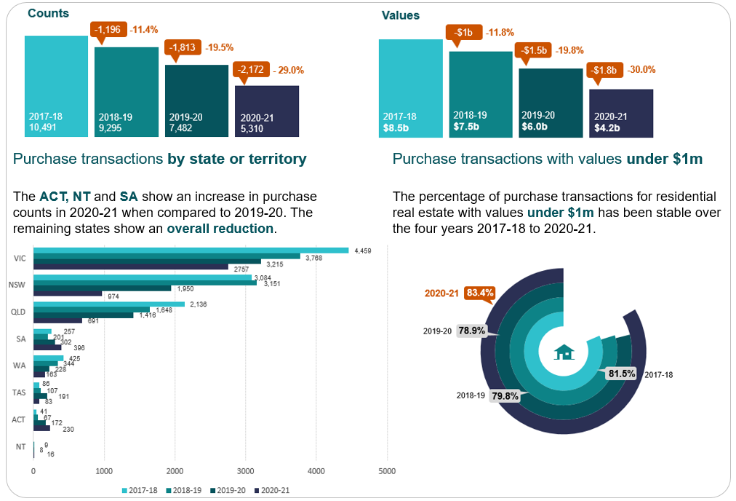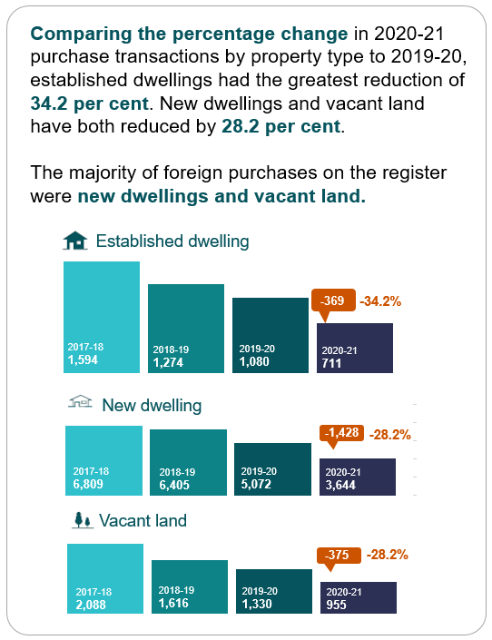

##### Purchase transaction trends by state or territory in the four years 2017‑18, 2018‑19, 2019‑20 and 2020‑21 show **New South Wales** and **Victoria** had greatest number in each property type.

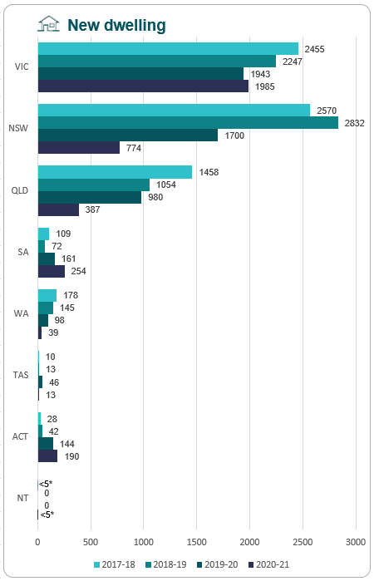 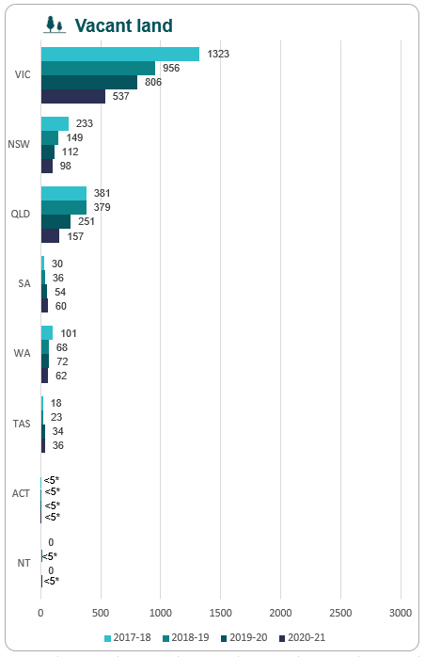 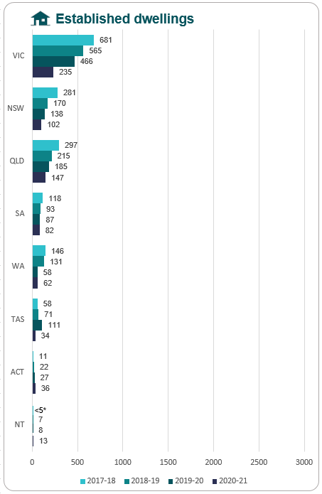

*Due to the limited number of transactions, some details have been withheld to maintain investor privacy.

## Four-year comparison of sale transactions

##### Sale transactions have increased in 2020-21 when compared to 2017-18, 2018-19 and 2019‑20.

There was a 58.6 per cent increase in sale transactions in 2020‑21 when compared to 2019-20. The value of sale transactions also increased by 83.9 per cent when compared to 2019‑20.

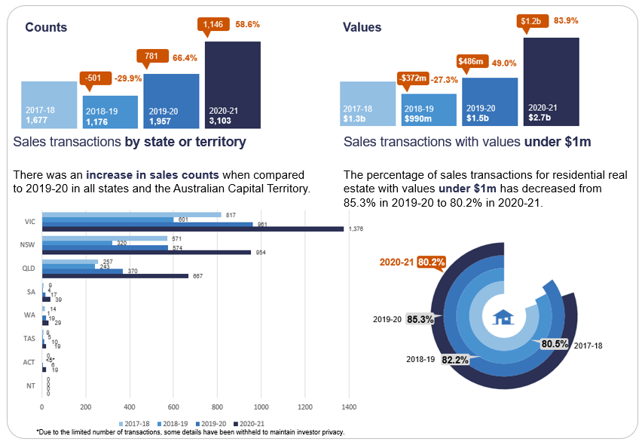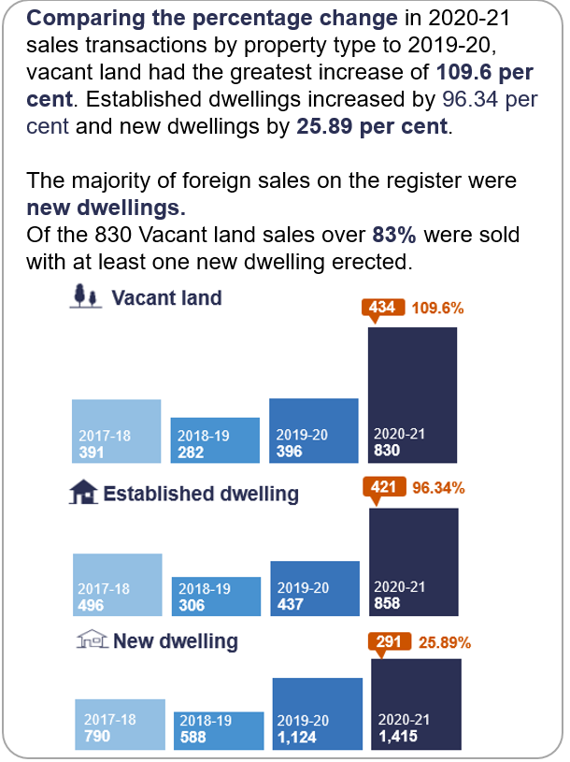

##### Sale transaction trends by state or territory in the four years

2017–18, 2018 –19, 2019 –20 and 2020-2021 show **New South Wales**

and **Victoria** hadthe greatest number in each property type.

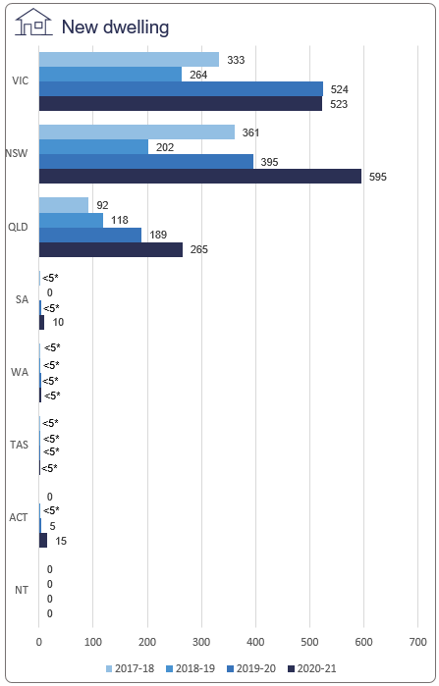 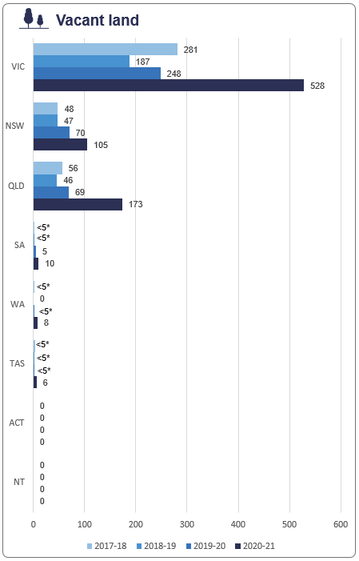 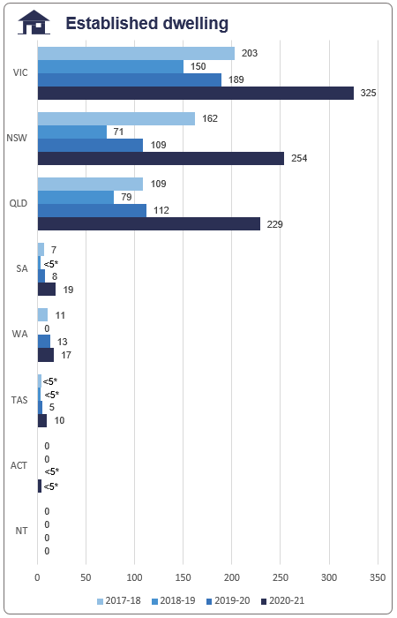

*Due to the limited number of transactions, some details have been withheld to maintain investor privacy.