Fees on foreign investment applications
Last updated: 9 July 2021.
This guidance document incorporates content from the pre-1 January 2021 FIRB website and Guidance Notes 29 and 30, as well as new content indicated by a sidebar. Please note, this is a temporary provision to assist reader’s transition to these new guidance documents and may be removed in due course.
- Foreign persons are required to pay a fee for each application made, or notice given under the Foreign Acquisitions and Takeovers Act 1975 (the Act). The fee for a notice or application will generally depend on the value and kind of action that has been taken or is proposed to be taken.
- From 1 January 2021, amendments to the Foreign Acquisitions and Takeovers Fees Imposition Act 2015 (the Fees Act) and the introduction of the Foreign Acquisitions and Takeovers Fees Imposition Regulations 2020 (Fees Regulation) changed the way that fees are calculated for applications and notices.
- Fees are generally payable at the time an application or notice is lodged. For most applications, the statutory timeframe of 30 days for making a decision on an application or notification will not start until the correct fee has been paid.
- An applicant may give notice, at the same time, of multiple actions that are proposed to be taken, or have been taken, under the same agreement. The fee payable for these actions may be adjusted under the ‘single agreement rule’.
- Other rules apply in particular circumstances that may result in a fee being adjusted. Investors should familiarise themselves with these rules.
- Fees are applicable where an applicant wishes to vary a no objection notification, notice imposing conditions or exemption certificate. Fees are also applicable where an action is ‘called-in’ by the Treasurer or where an investor notifies the Treasurer of a retrospective action.
- There is an annual vacancy fee for foreign owners of residential dwellings if the dwelling is not residentially occupied or rented out for more than 183 days (approximately 6 months) in a year.
- The Treasurer may waive or remit the whole or a part of a fee that is payable, if satisfied that it is not contrary to the national interest. All applications for fee waivers or remissions will be considered on a case-by-case basis and all decisions are final.
- Please note, fee amounts included in this Guidance Note have been indexed for the financial year starting on 1 July 2021.

Looking for more?
A: When does a fee apply and how is it paid? 3
B: How much are the fees 4
C: Adjusting fees and lower fee rules 14
D: Fees for exemption certificates 19
E: Fees for retrospective applications 28
F: Fees for variations 29
G: Specific guidance on fees for residential land 30
H: Determining the ‘kind of action’ taken 33
I: Internal reorganisations 37
J: Indexation of fees 39
K: Fee waivers and remissions 40
L: Schedule of fees for single actions and exemption certificates 42
Further information 43

A: When does a fee apply and how is it paid?
Fees are payable at the time an application is made or notice is given. For most applications, the statutory timeframe of 30 days for making a decision will not start until the correct fee has been paid.
The fees that are payable depend on the value and type of action being taken, and whether special fee rules apply.

Fees and statutory timeframes
Foreign persons are required to pay a fee for each application made, or notice given, under the Act and the Foreign Acquisitions and Takeovers Regulation 2020 (the Regulation) (limited exceptions apply).
In most cases, the statutory timeframe of 30 days for making a decision will not commence until the correct fee has been paid.
For actions that have been ‘called-in’ by the Treasurer, the fee must be paid within 30 days of the ‘call-in’ notice being given. In these circumstances, the statutory timeframe will commence once the notice is given rather than when the fee has been paid.
Applicants should accurately describe their proposed action in their application or notice and determine the expected fee at the time of lodgement.
Understating the consideration or inaccurately describing action(s) for which the application or notice relates may result in delays to the statutory timeframe commencing.
Where there has been an overpayment of a fee by an applicant, the statutory timeframe will have commenced when the fee was paid. The overpaid amount will be remitted.

How is the fee paid?
Once a foreign investment application has been lodged through the applicable Portal, applicants will receive an application receipt.
- For residential land applications, which are lodged through the Australian Taxation Office (the ATO) Portal, applicants will receive an on-screen confirmation containing the fee details.
- For non-residential applications, which are lodged through the FIRB Application Portal, applicants will receive an email advising that an initial fee estimate based on the information they have provided in their online application will be calculated within several business days, at which time they will receive the details via email to make payment. Please note, this initial fee estimate may be subject to change as a result of the review process. Once the fee has been paid, applicants will receive a notification which will include details of the 30 day statutory deadline.
On-screen messages and emails will include the applicants unique Payment Reference Number (PRN) and details on how to pay the fee. It is important to use the correct PRN provided to you for payment of your application. To ensure your fee payment is received, please provide your PRN exactly as it appears on the application confirmation page. Do not add spaces, names, hyphens or other text with this number. Missing or incorrect PRNs may cause a delay to the processing of your application.
Payment options include Government EasyPay, BPay, Direct Credit and transfer from an overseas bank account. Fees paid by cheque will not be accepted. When paying the fee, ensure monies are in Australian dollars and all applicable transaction fees are accounted for, as a shortfall will delay application processing.

B: How much are the fees
Fees apply to all foreign persons, including foreign government investors, unless otherwise specified.
The fee for a notice or application will generally depend on the value of the consideration for the target. See the Key Concepts Guidance Note for calculating consideration.
The fee for most actions will increase in consideration tiers (known as the ‘fee constant’). The fee constant for an acquisition of residential land is $1 million, agricultural land is $2 million, and commercial land is $50 million. Generally speaking, this means that fees for a single action will rise in increments of $12,700 per fee constant.
There is also a maximum fee cap, which provides that fees cannot exceed $503,000.
Some actions may not have a clear consideration amount (such as starting a new business or internally reorganising assets and entities inside a wholly-owned group of entities). A flat fee will be payable for these actions.
A lower, flat fee may be available for transactions that meet certain criteria. See Adjusting fees and lower fee rules for further detail.
Where an action is a reviewable national security action, the fee will be 25 per cent of the fee for an equivalent notifiable action of the same kind and value.
The vast majority of notices or applications will involve a single action, such as an acquisition of securities in an entity or title of land. See Fees for a single action for further detail.
In some cases, a person may wish to notify of a group of actions that will be taken together under a single agreement. Fees for these actions are worked out together, with a separate fee payable for each kind of action (such as land) instead of each individual action. For guidance on how to determine the ‘kind of action’ that relates to a specific transaction, see Determining the ‘kind of action’ taken. See Fees for multiple actions for further detail.
A person may also apply for an exemption certificate for interests or kinds of interests. The fee for exemption certificates will depend on the type of certificate – which are designed to cater for different kinds of foreign investment. For ‘general exemption certificates’, the fee will be 75 per cent of the fee for an equivalent notifiable action – or in the case of a reviewable national security action exemption certificate, 25 per cent of the fee for an equivalent notifiable action. For ‘residential exemption certificates’, fees will generally be equal to the fee for an equivalent notifiable action for acquiring an interest in residential land or a flat fee. See Fees for exemption certificates for further detail.

Fees for a single action
The fee relating to applications covering single actions can generally be determined by first establishing the kind of action taking place, and then, if applicable, working out the fee in respect to the relevant consideration value. See the Key Concepts Guidance Note for information on calculating consideration.
The fee for most actions will increase in proportion to the fee constant. The fee constant for an acquisition of residential land is $1 million of consideration, agricultural land is $2 million of consideration and commercial land is $50 million of consideration. Generally speaking, this means that fees rise in increments of $12,700 per fee constant. For further information, see sections 8 to 12 of the Fees Regulation.
Where an action is a reviewable national security action, the fee will be 25 per cent of the fee for an equivalent notifiable action (see section 17 of the Fees Regulation).
There is also a maximum fee cap, which provides that fees for a single action cannot exceed $503,000 (or in the case of reviewable national security actions, $125,750). See sections 10 and 17 of the Fees Regulation.
Table 1 provides a short summary of fees for a single action.
Table 1: Kinds of actions and applicable fees
Kind of action ^{(a)} |  | Applicable fees ^{(b)}
Land | Residential land | Fee tiers increase every $1 million of consideration;  Fees start at $6,350 for acquisitions of $1 million or less,^{(c)} rising to a maximum of $503,000 for acquisitions of more than $40 million
 | Agricultural land | Fee tiers increase every $2 million of consideration;  Fees start at $6,350 for acquisitions of $2 million or less,^{(c)} rising to a maximum of $503,000 for acquisitions of more than $80 million
 | Commercial land and tenements | Fee tiers increase every $50 million of consideration;  Fees start at $6,350 for acquisitions of $50 million or less,^{(c)} rising to a maximum of $503,000 for acquisitions of more than $2 billion
Businesses and entities (excl. land entities)
Starting an Australian business (including starting a national security business) |  | $2,000 flat fee
Entering agreements and altering documents |  | $12,700 flat fee
Internal reorganisations |  | $12,700 flat fee
(a) for guidance on how to determine the ‘kind of action’ that relates to a specific transaction, see Determining the ‘kind of action’ taken. See also Fees when a single action is captured by two or more provisions of the Act;
(b) where an action is a reviewable national security action, fees are calculated at 25 per cent of the fee for an equivalent notifiable action.
(c) under section 53 of the Fees Regulation, a lower fee of $2,000 will apply where the consideration value of an action is less than $75,000. See Adjusting fees and lower fee rules for further information.

Table 2 provides a summary of the different fee tiers for single actions involving residential land, agricultural land, commercial land, tenements, businesses and entities. For a more complete schedule of fees for a single action (including reviewable national security actions) see here.
Table 2: Kinds of actions and applicable fees
Consideration for the action |  |  | Applicable fee
Residential land | Agricultural land | Commercial land, tenements, businesses and entities | Fee for single action | Fee for single Reviewable national security action ^{(a)}
Less than $75,000 ^{(b)} | Less than $75,000 ^{(b)} | Less than $75,000 ^{(b)} | $2,000 | $500
$1 million or less | $2 million or less | $50 million or less | $6,350 | $1,587.50
$2 million or less | $4 million or less | $100 million or less | $12,700 | $3,175
$3 million or less | $6 million or less | $150 million or less | $25,400 | $6,350
$4 million or less | $8 million or less | $200 million or less | $38,100 | $9,525
$5 million or less | $10 million or less | $250 million or less | $50,800 | $12,700
… | … | … | … | …
Over $40 million | Over $80 million | Over $2 billion | $503,000 maximum fee | $125,750 maximum fee
(a) where an action is a reviewable national security action, fees are calculated at 25 per cent of the fee for an equivalent notifiable action.
(b) under section 53 of the Fees Regulation, a lower fee of $2,000 will apply where the consideration value of an action is less than $75,000. See the de minimis rule for further information.
Note: for the complete schedule of fees for a single action (including reviewable national security actions) see here.
An example of how to calculate a single action fee is below.
Example 1 – determining a single action fee
- Where the consideration is less than or equal to the relevant fee constant (that is, $1 million for residential land, $2 million for agricultural land or $50 million for commercial land, tenements, businesses and entities), the fee will be $6,350.
- Where consideration is above the fee constant, the fee is calculated as follows:
  - If the consideration is a multiple of the relevant fee constant, the fee would be equal to: (multiple - 1) x $12,700.
  - If the consideration is not a multiple of the relevant fee constant, the fee would be equal to: multiple (rounded down to the nearest whole number) x $12,700.

Fees when a single action is covered by two or more provisions of the Act
Only a single fee is payable for any action covered by the Act. If a single transaction constitutes an action under multiple provisions of the Act, or the action is an acquisition of Australian land and the land is more than one kind of land (for example agricultural land and vacant commercial land), then only one fee will be applicable.
Where a single transaction constitutes an action under multiple provisions of the Act, the fee will be the highest fee payable for a single action, disregarding the fee payable for the other kind of action(s) or land. See section 48 of the Fees Regulation.
Example 2 – single action that is covered by two or more provisions
A foreign government investor proposes to acquire 100 per cent of the securities in an entity that predominately owns interests in mining and exploration tenements for $290 million. As a result of the one transaction, the foreign government investor may be taken to have acquired a substantial interest in an Australian entity, acquired an interest in securities in an entity, acquired a direct interest in an Australian entity and acquired an interest of more than 10 per cent in securities in a mining, production or exploration tenement entity.
Section 48 of the Fees Regulation provides that the foreign government investor would only be liable for a single fee, being the highest of the possible single fees applicable for the transaction.
In this case, the fee is calculated by using the consideration ($290 million) and applying it to the fee formula for acquiring an interest in commercial land, interest in a tenement, business or entity. The relevant fee payable would be $63,500.
Example 3 – determining the fee for mixed-use land
A foreign person acquires an interest in agricultural land that contains a dwelling. The land is not used wholly and exclusively for a primary production business. As a result, the foreign person may be taken to acquire an interest in both agricultural land and residential land. Despite this, only the single highest fee would be payable for the acquisition, being the fee payable for residential land.

To avoid doubt, actions relating to interests in land entities are treated as an action to acquire an interest in the dominant type of land of the land entity (see here for further information). If an action is an internal reorganisation, only a fee for an internal reorganisation will apply irrespective of any other provisions that may cover an action (see here for further information). Similarly, a lower fee will apply for actions that satisfy a lower fee rule (see here for further information).

Fees for multiple actions
In certain circumstances, a foreign person may be considered to take, or have taken, multiple actions in the one transaction. These circumstances can include (but are not limited to):
- acquiring a consolidated group of entities (e.g. by acquiring a single parent entity);
- acquiring a farm which includes several legal titles of land; or
- acquiring a business, which could involve acquiring the assets of a business and an interest in land (for example, a long commercial lease).
Separate fees will generally apply for each action. However, where multiple actions are taken together under a ‘single agreement’, the fees for each action will generally be adjusted so that the total fee depends on the aggregate consideration for each kind of action instead of treating each interest separately.
What constitutes an agreement for the purposes of the applicable fee is not defined in the Act but would be expected to depend on the following:
- the existence of a single contract or sale agreement, or inter-conditional agreements;
- the close connection of the targets to each other (e.g. several titles of land being geographically contiguous); and
- the relationship of the vendors to each other, and/or the acquirers to each other.
Multiple actions taken under a single agreement can be submitted under a single application through the FIRB portal. Please note, there may be delays and errors in fee estimates if notices for multiple actions given under one application in the Portal are not covered by a single agreement.
Actions that are internal reorganisations, and actions satisfying a lower fee rule (such as where the consideration for an acquisition is less than $75,000) are treated separately to any other action taken under the same agreement that does not meet the definition of an internal reorganisation or satisfy a lower fee rule for the purpose of working out the applicable fee. The fee for any of these particular actions is separately added to the fee for any remaining actions.
Regardless of the number of actions taken under a single agreement, the fee for a single agreement is capped at $503,000 (or $125,750 if the single agreement only involves reviewable national security actions).

Working out the fee for actions taken under a single agreement

Fees if all actions are of the same kind
Where a single agreement covers multiple actions of the same kind, the fee is worked out by treating those multiple actions as if they were a single action with a consideration equal to the total consideration of all those actions. For example, if an agreement covers multiple actions to acquire 10 titles of agricultural land with a consideration of $100,000 for each title, the fee for these actions is worked out as the fee that would apply for a single acquisition of agricultural land with a total consideration of $1 million.
Example 4 – single agreement involving multiple actions of the same kind (land)
An investor enters into a single agreement to acquire an agricultural property worth $12 million. The investor already owns other agricultural land in Australia worth more than $10 million. The property is split across six titles – and so each title is considered a separate action. Each title is valued at $2 million.
The fee is calculated by using the aggregate consideration ($12 million) – therefore the fee is considered against the fee formula for agricultural land. The applicable fee would be $63,500.
Example 5 – single agreement involving multiple actions of the same kind (business)
Under a single agreement, a foreign person proposes to acquire shares in two entities while also acquiring the assets of a separate business. The total value of consideration for these actions under the agreement is $150 million. Since all of these actions are business actions, the fee for these actions would be $25,400.

A separate fee is generally payable for reviewable national security actions to allow for the fee to be 25 per cent of the fee for an equivalent notifiable action. This split would enable the lower fee structure that would apply for reviewable national security actions to apply for those kinds of actions taken under a single agreement. An action will only be a reviewable national security action if it is not a significant action, notifiable action or notifiable national security action under the Act.
Example 6 – single agreement involving multiple actions of the same kind (land), including some actions that are reviewable national security actions
A foreign person proposes to acquire two commercial land titles under a single agreement. The acquisition of one of the titles is a reviewable national security action and the acquisition of the other title is a significant and notifiable action. Both titles are valued at $100 million each. The fee for the actions covered under the agreement would be equal to the sum of the fee for the single commercial land title that is a reviewable national security action (i.e. $3,175) and the fee for a commercial land title that is a notifiable action (i.e. $12,700). Summing these individual fees together, the total fee for this agreement is $15,875.
Example 7 – single agreement involving multiple actions of the same kind (business), including some actions that are reviewable national security actions
An applicant proposes to acquire interests in the securities of 10 entities under a single agreement, with a total consideration for the agreement of $100 million (apportioned equally across all entities).
Four of these acquisitions will be either significant actions, notifiable actions or notifiable national security actions. The fee for these four acquisitions is the same as a single acquisition of securities in an entity with a consideration of $40 million (i.e. $6,350).
The remaining six acquisitions will be reviewable national security actions. The fee for these actions is the same as a single reviewable national security action to acquire interests in the securities of an entity worth $60 million (i.e. $3,175).
Summing these individual fees together, the total fee for this agreement is $9,525.

Fees for multiple acquisitions of different kinds of land (the ‘dominant land test’)
A single agreement may cover multiple acquisitions of Australian land of different kinds, such as an acquisition of a farm and an adjacent dwelling. The total fee payable for land actions taken under a single agreement is worked out by determining the dominant kind of relevant land, and treating all the land actions as if they were a single acquisition of an interest in the dominant kind of land with consideration equal to the aggregate consideration for all the land actions. See section 51 of the Fees Regulation.
For the purposes of determining the dominant kind of relevant land, it may also be necessary to consider whether any of the actions involve an interest in a land entity, as a land entity is not treated as an interest in an entity, but as an interest in Australian land (see section 56 of the Fees Regulation). For further information see dominant land holding.

To work out the fee according to the dominant land test:
- Determine the total consideration for each kind of relevant land, with each interest in land corresponding to only one kind of relevant land.
The three kinds of relevant land are:
  - Residential land;
  - Agricultural land;
  - Commercial land and tenements
Please note: mixed-use land is treated as the kind of land which would result in the highest fee, and interests in land entities are treated according to the dominant land holding.
- The kind of relevant land with the highest consideration is the dominant kind of relevant land.
- The total fee for all land actions is the same as the fee that would apply for a single
acquisition of the dominant kind of land with a consideration equal to the aggregate consideration (the sum of all kinds of relevant land).
If applicable, the ‘dominant land test’ is completed separately for any actions that are reviewable national security actions to acquire interests in Australian land.
See Figure 1 below for how to determine the dominant land.

Figure 1 – determining the dominant land
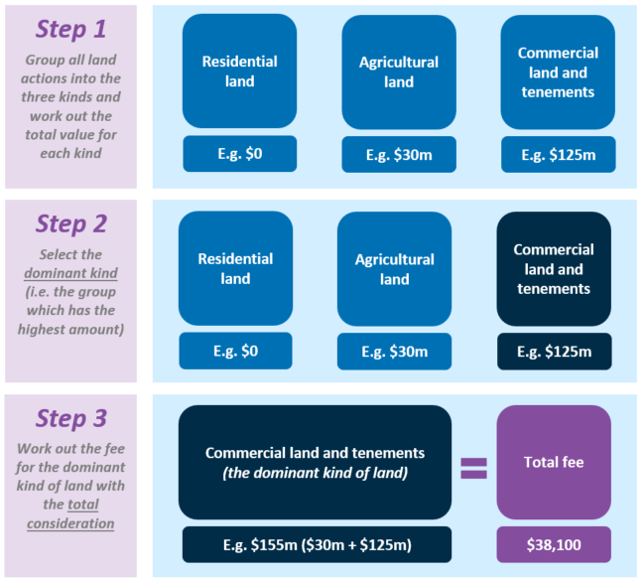
Note: if applicable, the ‘dominant land test’ is completed separately for any actions that are reviewable national security actions to acquire interests in Australian land. Mixed-use land is treated as the kind of land which would result in the highest fee, and interests in land entities are treated according to the dominant land holding.
Example 8 – single agreement involving multiple actions of different kinds (land)
Under one agreement, a foreign person proposes to take two or more land actions that are notifiable actions. In this case, the foreign investor is seeking to acquire $4 million of agricultural land and $180 million of commercial land, which has a total consideration of $184 million. The dominant land type would be the highest of those sums, which is commercial land. This means the fee for the land actions would be $38,100. Assuming there are no further actions taken as part of this agreement, this would be the final fee.
Example 9 – single agreement involving multiple actions of different kinds (land and land entity)
A foreign person is proposing to acquire three targets under one agreement, consisting of a $40 million entity that is considered a land entity (with predominately commercial land holdings), a $5 million parcel of commercial land, and a $15 million entity that is not a land entity.
To calculate the fee, the acquisition of the land entity would be treated as an acquisition in land. As the actions are part of the same agreement, the fee for the land entity would be worked out with the other land actions. Both land actions are acquisitions of commercial land, so the fee for these acquisitions would be equal to the fee for a single acquisition of commercial land with a consideration of $45 million ($6,350). This fee amount would be added to the fee for the entity acquisition ($6,350). The total fee payable would be $12,700.

Fee for multiple actions of different kinds
A single agreement may also cover multiple actions of different kinds. For example, a foreign person acquiring the assets of an Australian business as a going concern may need to enter a new lease over the business premises. These actions may be considered as being covered by a single agreement.
Although the legislation provides a method for working out the fee for the most complicated transactions, the vast majority of applications will be relatively simple to calculate. Generally, the fee payable for the more complicated agreements is the sum of the fees for each of the different kinds of actions covered under the agreement.
As mentioned above, a separate fee is generally payable for reviewable national security actions to allow for the fee to be 25 per cent of the fee for an equivalent notifiable action.
The following diagram (Figure 2) and process map (Table 3) can be followed to determine the correct fee payable. Each action taken under the agreement will only be considered as one kind of action (if necessary, determining that kind of action under “Fee when a single action is covered by two or more provisions of the Act”. For further information see sections 49 to 52 of the Fees Regulation.

Figure 2 – determining the fee for multiple actions covered under a
single agreement
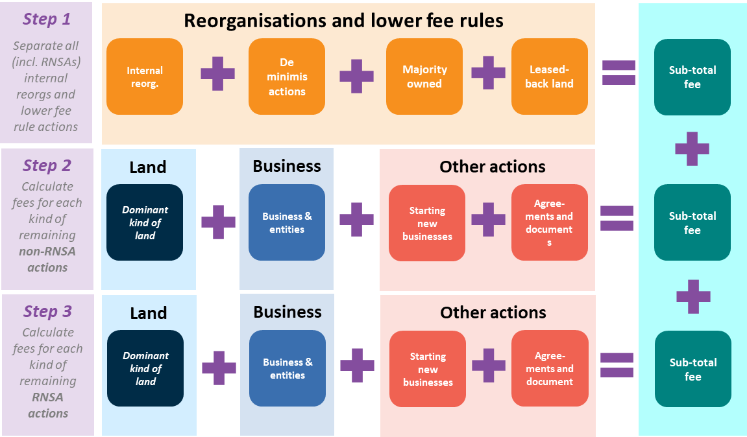
The fee payable in respect for actions covered under a single agreement is the sum of any of the following kinds of actions in Table 3 covered under the agreement.
Table 3: determining the fee for multiple actions covered under a
single agreement
If, under a single agreement, there are one or more actions that… | The fee for the action(s) is equal to…
constitute an internal reorganisation | $3,175 if all actions are RNSAs;  $12,700 otherwise
meet the ‘de minimis rule’ | $500 if all actions are RNSAs;  $2,000 otherwise
meet the ‘majority owner rule’ | $500 if all actions are RNSAs;  $2,000 otherwise
meet the ‘leasehold buyback’ rule | $500 if all actions are RNSAs;  $2,000 otherwise
are to acquire an interest in Australian land or tenements | The sum of the fees worked out under the ‘dominant land test’ separately for the RNSAs and the non-RNSAs
are to acquire an interest in entities, businesses or assets of a business (excluding land and land entities) | The sum of the fees worked out under ‘multiple actions of the same kind’ separately for the RNSAs and the non-RNSAs
If, under a single agreement, there are one or more actions that… | The fee for the action(s) is equal to…
are to start new Australian businesses | The sum of $500 for any relevant RNSAs, and $2,000 for any relevant non-RNSAs
are to enter or terminate agreements or alter documents | The sum of $3,175 for any relevant RNSAs, and $12,700 for any relevant non-RNSAs

Example 10 – single agreement involving multiple actions of different kinds
A foreign person is proposing to acquire three targets under one agreement, consisting of a $40 million entity that is considered a land entity (with predominately commercial land holdings), a $5 million parcel of commercial land, and a $15 million entity that is not a land entity.
To calculate the fee, the acquisition of the land entity would be treated as an acquisition in land. As the actions are part of the same agreement, the fee for the land entity would be worked out with the other land actions. Both land actions are acquisitions of commercial land, so the fee for these acquisitions would be equal to the fee for a single acquisition of commercial land with a consideration of $45 million ($6,350). This fee amount would be added to the fee for the entity acquisition ($6,350). The total fee payable would be $12,700.

C: Adjusting fees and lower fee rules

De minimis rule
Under section 53 of the Fees Regulation a lower fee of $2,000 will apply where the consideration value of an action is less than $75,000. Where the action is a reviewable national security action, the fee payable is 25 per cent of this de minimis fee.
This rule applies to land applications (residential land, agricultural land, commercial land, and mining and tenements), business, entity and securities related actions and notifiable national security actions but does not apply if the action is an internal reorganisation. In that case, the internal reorganisation fee will apply.
Example 11
A foreign person is proposing to acquire an interest in commercial land for $65,000. As this acquisition meets the definition of a de minimis action under section 53 of the Fees Regulation, the relevant fee would be $2,000.

If an agreement covers multiple actions for which the consideration for each action is less than $75,000, then only one fee will be payable for those actions that meet this rule. In this situation, the fee payable will be $2,000 unless all the actions are reviewable national security actions, in which case the fee payable will be 25 per cent of this lower fee.

Example 12
As part of one agreement, a foreign person is proposing to acquire five agricultural land titles, all of which are low value easements. Each easement has a consideration value of $50,000 and meets the definition of a de minimis action under section 53 of the Fees Regulation. In this instance, the relevant fee would be a total of $2,000 for all five de minimis actions.

Majority owner rule
Under section 54 of the Fees Regulation, a lower fee of $2,000 will apply where a foreign person already holds an interest of more than 50 per cent in Australian land, a tenement, securities in an entity or assets of an Australian business and the acquisition results in the person increasing their interest. Where the action is a reviewable national security action, the fee payable would be 25 per cent of this lower fee.
Example 13
A foreign person holds a 60 per cent interest in securities in the Australian entity, Aus Co, and is proposing to increase this interest to 80 per cent. The applicable threshold tests are met for the acquisition of an interest in securities. As the foreign person holds more than 50 per cent of the securities in the entity, the majority owner rule would apply to make the applicable fee $2,000.

If an agreement covers multiple actions, and the majority owner rule applies, then only one fee will be payable for those actions that meet this rule. In this situation, the fee payable will be $2,000, unless all the actions are reviewable national security actions in which case the fee payable will be 25 per cent of this lower fee.
This section does not apply if the action is considered an internal reorganisation or if the consideration of the action is less than $75,000. Similarly, the rule does not apply where an agreement entered into gives rise to a new interest. For example, where a foreign person materially alters or varies a leasehold interest to increase the term of the lease or expand the land covered by the lease. However, if the foreign person was increasing their interest in the lease beyond 50 per cent by buying-out an interest in the lease held by their joint venture party, this rule could apply.

Leasehold buybacks
Under section 55 of the Fees Regulation, a lower fee of $2,000 will apply for acquisitions of leasehold interests after a sale of a freehold interest. That is, where a foreign person acquires a leasehold interest in Australian land, and that foreign person previously held a legal interest in that land and sold that legal interest to the lessor. Where the action is a reviewable national security action, the fee payable would be 25 per cent of this lower fee.
Example 14
A foreign person sells their farm to another person for $10 million, with the condition that the foreign person is permitted to lease the farm for 10 years. Since the foreign person previously owned the legal interest in the farm, and the vendor of those interests would be the lessor of the lease, the fee for the foreign person to acquire the leasehold interest would be $2,000.

Where an agreement covers multiple actions that involve the acquisition of a leasehold interest after the sale of a freehold interest, then only one fee will be payable for those actions that meet this rule. In this situation, the fee payable will be $2,000 unless all the actions are reviewable national security actions, in which case the fee payable will be 25 per cent of this lower fee.
This section would not apply if the action is considered an internal reorganisation, if the consideration of the action is less than $75,000 or if the majority owner rule applies.
Example 15
A foreign person proposes to take three actions to acquire interests in agricultural land. The first two actions each satisfy the requirements of both the de minimis rule and the ‘majority owners rule’, and the third action satisfies the ‘leasehold buybacks rule’ set out in this section. A fee of $2,000 is payable in relation to the first two actions since they both satisfy the de minimis rule. A fee is not payable for these same actions under the majority owner rule. A fee of $2,000 is also payable for the third action. The total fee for the three actions is $4,000.

Fee adjustments for joint tenants
Under section 57 of the Fees Regulation, joint tenants refers to two or more persons that hold property jointly so that each owns an undivided share of the whole. Should one person die, their interest would pass to the surviving co-owner or co-owners.
If two or more persons acquire or propose to acquire an interest in a security, asset, tenement, trust or Australian land as joint tenants, then generally only one fee for the acquisition will be payable. Each joint tenant would be liable to pay the full fee, until the fee is paid. If one of the tenants pays a proportion of the fee, the fee that each joint tenant would be liable to pay is reduced by that proportion. If a joint tenant pays the full amount, the fee remaining for all other tenants would be reduced to nil.
Example 16
Two joint tenants acquire an interest in a dwelling and therefore would be liable to pay a fee of $12,700. After the first joint tenant pays $10,000, both joint tenants would be liable to pay the remaining $2,700.

Fee adjustments for tenants in common
Tenants in common refers to one or more persons who hold property in common with another person or persons so that each has a portion of interest in the whole property. Should one person die, this portion of interest passes to an heir or devisee who then becomes a tenant in common with the surviving co-owner or co-owners.
If two or more persons acquire or propose to acquire an interest in a security, asset, tenement, trust or Australian land as tenants in common, then the fee payable for that interest is equal to each tenants’ percentage ownership of the target.
Example 17
Two foreign persons propose to acquire an interest in a title of agricultural land for $2 million as tenants in common (with the first tenant to have an 80 per cent interest). The fee for the acquisition would be $6,350. Under this section, the first tenant would be liable for 80 per cent of this amount ($5,080) with the second tenant liable for the remainder ($1,270).

Under section 114 of the Act, if a fee is payable by a person for a notice or application, the person is not taken to have made the notice or application until the fee is either fully paid or waived.

Dominant land holding for land entities
A land entity refers to an agricultural land corporation, an agricultural land trust, an Australian land corporation or an Australian land trust. Generally, this means that more than 50 per cent of the value of the entities assets is in Australian land. For more information on land entities, please see the Business Guidance Note.
An acquisition of securities in a land entity may give rise to multiple notifiable or significant actions, including acquiring an interest in Australian land and acquiring a substantial interest in an Australian entity.
For the purposes of fees, an action to acquire an interest in a land entity is treated as an interest in Australian land of the same kind as the entity’s ‘dominant land holding’, rather than as an interest in an entity. See section 56 of the Fees Regulation.
To work out the land entity’s dominant land holding an investor will need to:
- identify all the kinds of relevant land in which the entity holds an interest at the time of the acquisition;
- make an assessment of the total value of the interests in each of those kinds of relevant land; and
- select the kind of relevant land with the highest total value.
Example 18
A foreign person proposes to acquire 20 per cent of the issued securities of a land entity for $50 million. A reasonable assessment of the value of the land holdings of the land entity for each kind of relevant land is $100 million in commercial land $60 million in agricultural land and $50 million in residential land.
Since commercial land is the kind of relevant land with the highest total value, commercial land would be the dominant land holding of the entity. Therefore, the acquisition of the securities in the land entity would be treated as an acquisition of commercial land with a consideration of $50 million (being the consideration for the actual transaction).

Where a land entity forms part of a single agreement, the dominant land holding may be a relevant input into the dominant land test. For further information, see Fees for multiple acquisitions of different kinds of land (the ‘dominant land test’).

Subdivision and amalgamation of Australian land
The subdivision or amalgamation of land will generally result in the extinguishment of the old title and the creation of a new title or titles resulting in an acquisition of a new interest in Australian land that can constitute a significant and notifiable action under the Act.
Where a foreign person already owns land immediately prior to subdivision or amalgamation, the Government considers the subdivision or amalgamation of that same land to have $0 consideration value.
In relation to exemption certificates, when calculating fees for an exemption certificate that covers a potential subdivision or amalgamation of land, the consideration value that is relevant to the subdivision or amalgamation is $0, meaning it will not form part of the financial limit permitted by the exemption certificate.
In relation to no objection notifications:
- where a foreign person notifies the Treasurer they intend to acquire Australian land then subdivide or amalgamate that same land, no fee will apply to the subdivision or amalgamation;
- where a foreign person fails to notify their intention to subdivide or amalgamate the land, they may require further foreign investment approval to undertake the subdivision or amalgamation. As the consideration value for the subdivision or amalgamation is $0, the de minimis rule applies (see de minimis rule above).
For further information on the subdivision or amalgamation of land please see Guidance Note 2 Key Concepts.

D: Fees for exemption certificates
Broadly speaking, there are three types of exemption certificates:
- ‘General exemption certificates’ which permit a foreign person to make a program of acquisitions without notifying of each proposed action separately.
- ‘Passive foreign government investor exemption certificates’ which grant a passive foreign government investor access to the higher monetary thresholds that apply to private foreign investors under certain conditions.
- ‘Residential exemption certificates’ which permit a foreign person to make a single acquisition such as an established dwelling in Bondi, or allow a property developer (including an Australian property developer) to sell certain dwellings.

Overview of ‘general exemption certificates’
General exemption certificates permit a foreign person to make a program of acquisitions without notifying of each proposed action separately. The different kinds of general certificate available cover the following kinds of actions:
- Interests in businesses or entities (section 42 of the Regulation);
- Interests in Australian land (section 58 of the Act);
- Interests in tenements and mining, production or exploration entities (section 43 of the Regulation);
- Notifiable national security actions (section 43BA of the Regulation); and
- Reviewable national security actions (section 43BB of the Regulation).
A foreign person may apply for a single exemption certificate (covering one of the kinds of interests above), and the fee will depend on the requested financial limit and kinds of covered actions of the exemption certificate. A foreign person may also combine multiple certificates in a single application, and the fee will depend on the total requested financial limit across all the certificates.
The fees for exemption certificates are calculated by separating the total requested financial limit of the certificate/s into three broad categories:
- The total requested value of residential land;
- The total requested value of agricultural land; and
- The total requested value of commercial land, tenements, businesses, and entities.
The fee is the sum of the fee for each category as if there were a single notifiable action of that kind with a consideration equal to the total requested financial limit for that kind of action.
If applicable, a separate per-action fee would also apply for other actions (such as starting a national security business) that is included in an exemption certificate application. These kinds of actions will only be considered in combination with other actions.
Depending on the type and combination of the general exemption certificate(s) sought, a different percentage discount may apply. For example, fees for general exemption certificates will be 75 per cent of the fee for an equivalent notifiable action. However, if the certificate applied for is only for a reviewable national security certificate, the fee will be 25 per cent of the fee for an equivalent notifiable action.
Fees for general exemption certificates will be capped at 75 per cent or 25 per cent of the maximum fee cap, as applicable (that is, $377,250 or $125,750 respectively). Further detail is below.

Working out the fee for a general exemption certificate
Recognising the complexity of some foreign investment applications, it is possible that an exemption certificate will deal with more than one kind of action and/or one application may refer to multiple exemption certificates that cover different kinds of interests.
As such, the fees for exemption certificates that cover single or multiple kinds of actions, are calculated by treating the same kind of actions permitted under a certificate as if they were a single action and the consideration was the financial limit permitted by the certificate.
For the purposes of working out the fee, the kinds of actions that are grouped together are: (1) residential land; (2) agricultural land; (3) commercial land, tenements, businesses and entities; and (4) other actions. Other actions include starting a national security business and certain other reviewable national security actions.
Depending on the type and combination of the general exemption certificate sought, a different percentage discount may apply:
- If the certificate is only a reviewable national security certificate
Where the exemption certificate application only covers reviewable national security actions, the fee will be 25 per cent of the fee for an equivalent notifiable action, with the fee for the certificate(s) capped at a maximum of $125,750.
- If the certificate(s) is not only a reviewable national security certificate
Where the exemption certificate application covers businesses or entities, Australian land, tenements and mining, production or exploration entities or notifiable national security actions, the fee will be will be 75 per cent of the fee for an equivalent notifiable action, with the fee for the certificate(s) capped at a maximum of $377,250; or
Where the exemption certificate application includes one of the above general exemption certificate types and a reviewable national security action certificate and the amount of reviewable national security actions cannot be specified, the fee will be 75 per cent of the fee for an equivalent notifiable action, with the fee for the certificate(s) capped at a maximum of $377,250.
This is summarised in the Figure 3.
Figure 3 – determining the fee for a general exemption certificate
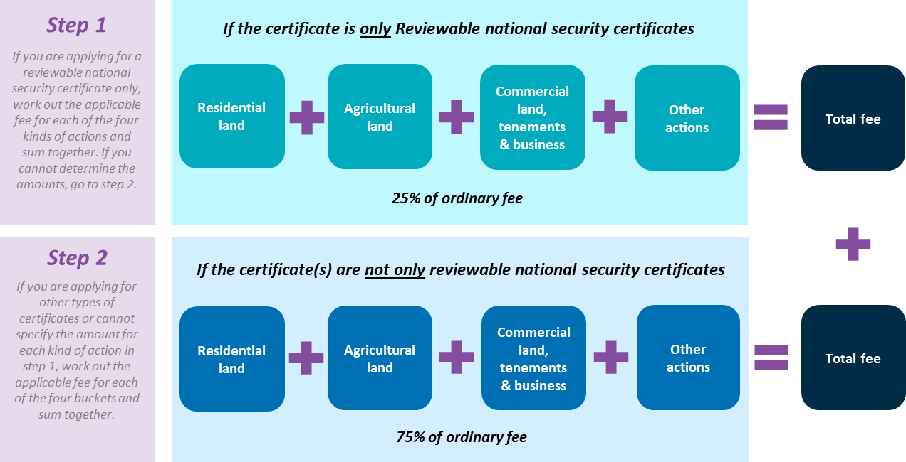
Note: for further information, including examples of where an investor is or is not able to specify an amount of reviewable national security actions, see below.
The below examples illustrate how this process applies in certain scenarios.
Example 19 – acquiring different types of Australian land under a single certificate
A foreign person applies for a single exemption certificate under section 58 of the Act to undertake a program of acquisitions of interests in Australian land. As part of the application, the person wants to acquire $5 million in residential land, $15 million in agricultural land, $75 million in commercial land, and $50 million in mining tenements.
The amount of fee for this application would be equal to 75 per cent of the sum of the fees for notifiable actions to acquire $5 million in residential land, $15 million in agricultural land, and $125 million in commercial land. That is, the amount of fee payable would be 75 per cent of $50,800 + $88,900 + $25,400, which is equal to $123,825.

Example 20 – reviewable national security action exemption certificate
A foreign person applies for a reviewable national security exemption certificate to undertake a program of acquisitions of interests in businesses which are reviewable national security actions. As part of the application, the person wants to acquire four businesses each with a consideration of $20 million.
As the foreign investor is only applying for a reviewable national security certificate, the amount of the fee for this application would be equal to 25 per cent of the fee for an equivalent notifiable action to acquire $80 million in commercial land. That is, the amount of the fee payable would be 25 per cent of $12,700, which is equal to $3,175.
Example 21 – maximum fee cap for exemption certificate applications
A foreign person applies for a single exemption certificate under section 58 of the Act to acquire $100 million of agricultural land. The amount of the fee for this application would be equal to 75 per cent of the sum of the fees for notifiable actions to acquire $100 million in agricultural land. The amount of the fee would be $377,250, which is equal to the maximum fee cap for a general exemption certificate.

Where an investor applies for multiple types of general exemption certificates at the same time or when the applications are made within close proximity of each other (i.e. within 14 days of the original application), only one fee will generally be payable for the total financial limit sought under the certificates. To avoid delays, it is recommended that the applications be submitted through the Portal at the same time, with a single cover letter describing the entire proposed program of acquisitions.
Example 22 – applying for a program of investments including land and entities
A foreign person applies for one land exemption certificate covering $5 million in agricultural land and $150 million in commercial land. At the same time, the applicant also applies for a business and entities exemption certificate covering $225 million in securities in entities.
The fee applicable for the certificate would be the sum of 75 per cent of the fee for $5 million in agricultural land, being $19,050, and 75 per cent of the fee for $375 million in commercial land (which is comprised of $150 million in commercial land and $225 million in securities in entities), being $66,675. The total fee payable would be $85,725.
Example 23 – national interest and notifiable national security approvals
A foreign person wants to make a $100 million program of acquisitions of Australian land. Since Australian land may also be national security land, the foreign person applies for a land exemption certificate and a notifiable national security exemption certificate. As long as the applicant submits the applications for the two exemption certificates within 14 days of each other, only one fee would be payable based on the total financial limit sought.
Since the foreign person in this scenario does not know the exact proportion of the total value of acquisitions that will be national security land, they may seek a total financial limit of $100 million across both certificates and therefore the fee would be calculated using the $100 million total.
Example 24 – combining business and land certificates for acquisitions of land entities
A foreign person wants to make a program of acquisitions of securities in entities. Some of these entities to be acquired may also be land entities under section 13 of the Regulation.
In this case, the applicant submits an application for an Australian land exemption certificate and a business and entities exemption certificate within 14 days, to ensure only one fee is payable based on the entire financial limit sought.

A special case is where a foreign person wants to apply for multiple types of general exemption certificates, including a reviewable national security certificate. There are two ways to determine the total fee payable in relation to the proposed program of acquisitions, and an investor may choose the most suitable method depending on their particular circumstances. The first option may result in a lower fee but will come with less flexibility.
- Where an investor can specify an amount of reviewable national security actions
- If the investor can specify subtotals of the requested financial consideration that would only be reviewable national security actions, the investor is able to benefit from the 25 per cent fee for these subtotals.
- The subtotal of the financial consideration would reflect the minimum financial limit corresponding to reviewable national security actions. Reviewable national security actions may also be covered by the broader certificate (but would not benefit from the lower fee for these actions).
- To choose this method, the foreign investor should apply for a reviewable national security certificate separately, and then apply for a combined exemption certificate covering the other requested kinds of general exemption certificate.
- Where an investor cannot specify an amount of reviewable national security actions
- Alternatively, an investor may simply apply for all the requested certificates at the same time, and pay 75 per cent of the full fee for the total requested consideration. This may be more appropriate where an investor is uncertain of the expected value of acquisitions that will be only reviewable national security actions and the expected value of acquisitions for other kinds of actions.
Figure 4 provides a diagrammatic illustration of how discounts for general exemption certificates work.

Figure 4 – determining the discount for general exemption certificates
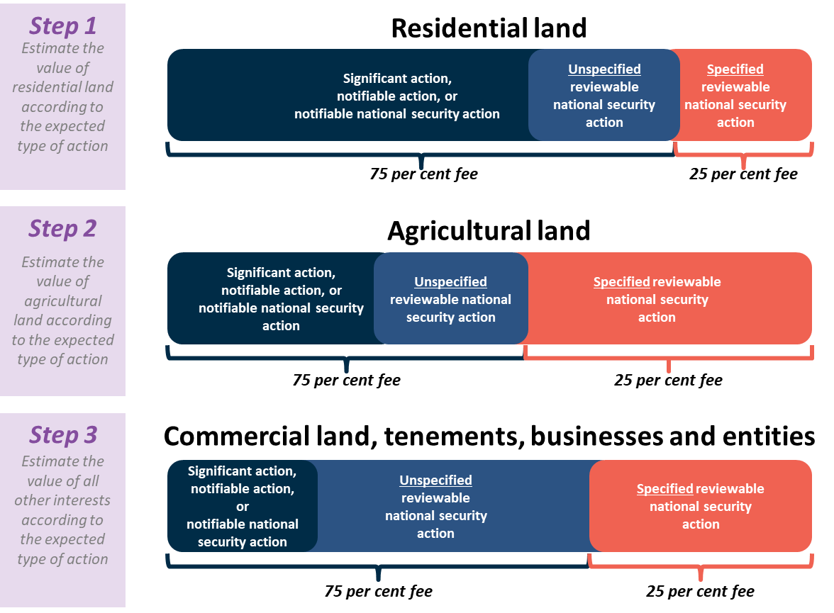
Note: the size of the coloured components of this chart are not to scale and simply show potential fee combinations. Where an investor is able to specify an amount of reviewable national security actions, they will receive a larger discount for those actions.
Example 25 – combining general exemption certificates with a reviewable national security certificate
A foreign person applies for an exemption certificate to acquire $1 billion in commercial land interests in shopping centres around Australia. The person recognises that, depending on the value and structure of the transactions, some of the interests to be acquired may be significant actions, notifiable actions, notifiable national security actions or reviewable national security actions. Therefore, the person applies for a land exemption certificate, a national security exemption certificate and a reviewable national security exemption certificate.
If the foreign person is unable to specify what proportion of the $1 billion financial limit will at least be spent on reviewable national security actions, the applicable fee would be 75 per cent of the fee for $1 billion worth of commercial land (i.e. $180,975).
However, if the foreign person is able to specify that at least $300 million of the $1 billion financial limit will be reviewable national security actions, the applicant may apply separately for a single reviewable national security exemption certificate to cover this amount and pay the lower fee ($15,875) for this certificate. The remaining $700 million could still be considered under a combined application for land, notifiable national security, and reviewable national security exemption certificates, and would have a fee of $123,825.
Example 26 – combining a general exemption certificate with a reviewable national security certificate
A foreign person wants to make a program of acquisitions of securities in entities over the next 24 months. The foreign person is able to specify that $200 million will be reviewable national security actions and $200 million will be covered under a Business and entities certificate. As such, the fee for the reviewable national security certificate would be 25 per cent of $38,100 (i.e. $9,525), while the fee for the Business and entities certificate would be 75 per cent of $38,100 (i.e. $28,575). This means the total fee would be $38,100.

Overview of ‘passive foreign government investor exemption certificate’
Where an entity (corporation, trustee of a unit trust or general partner of a limited partnership) in which foreign government investors hold a passive interest, yet does not satisfy the requirements of section 17(2) of the Regulation, the entity may apply under an exemption certificate pathway that will have the effect of putting them in the same position as a ‘foreign person’ as opposed to a ‘foreign government investor’.
The purpose of this exemption certificate pathway, which is informally known as a ‘passive foreign government investor exemption certificate’, is to grant an investor access to the higher monetary thresholds that apply to private foreign investors.
By receiving this kind of exemption certificate, actions made by passive foreign government investors under the relevant thresholds for private foreign investors will not be subject to review. However, any action(s) exceeding the thresholds for private foreign investors will need to receive approval, whether through a separate no objection notification or exemption certificate.
A flat fee of $50,200 will apply for investors who seek a passive foreign government investor exemption certificate.
For more information about this kind of exemption certificate, see Guidance Note 9.

Overview of ‘residential exemption certificates’
Fees for exemption certificates for one established dwelling or for residential land (other than established dwellings) will be the same fee that would apply for acquiring an interest in residential land. Fees for exemption certificates to sell new (or near-new) dwellings in a development to foreign persons will be a flat fee and a reconciliation payment based on the number of, and consideration payable for, dwellings acquired by foreign persons. See below for further information on each type of residential land certificate, including relevant examples.
Table 4 summarises the fee treatment for each type of residential exemption certificate. Further information on each type of residential land exemption is also below.
Table 4: types of residential exemption certificates
Type of exemption certificate | Fee treatment
Residential land (established dwellings)  section 59 of the Act | Ordinary fee for acquiring an interest in residential land
Residential land (other than an established dwelling)
section 43B of the Regulation
Residential land (new dwellings)  section 57 of the Act | $27,200 application fee plus 6 monthly reconciliation fee based on the number of, and consideration payable for, dwellings acquired by foreign persons
Residential land (near-new dwellings)
section 43A of the Regulation

Exemption certificates for one established dwelling or interest in residential land that is not an established dwelling
Foreign persons may apply for an exemption certificate under section 59 of the Act to acquire an interest in one unspecified established dwelling. For more information, see the Exemption Certificate Guidance Note.
Foreign persons can also apply for an exemption certificate under section 43B of the Regulation to acquire an interest in residential land other than established dwellings. For more information, see the Exemption Certificate Guidance Note.
Section 32 of the Fees Regulation provides that the application fee for both exemption certificates is the same fee that would be payable for an acquisition of residential land not being made under an exemption certificate.
Example 27
A foreign person who is temporarily living in Australia for work seeks to acquire an established dwelling in Bondi as a primary residence while working in Australia.
Since many established dwellings sell at auction, the foreign person applies for a certificate under section 59 of the Act for exemption to acquire any one established dwelling in Bondi up to $1 million. The fee for this exemption certificate would be $6,350.

If the person applies for both certificates but will only make one acquisition under the two certificates, a single fee of the highest fee payable under the two certificates will apply.

New (or near-new) dwelling exemption certificate
Persons such as property developers can apply for an exemption certificate under section 57 of the Act to sell new (or near-new) dwellings in a development to foreign persons, without each foreign person purchaser being required to seek their own approval. For further information, see the Residential Land and Exemption Certificate Guidance Notes.
Sections 30 and 31 of the Fees Regulation provides that the initial application fee for this exemption certificate is $27,200. The fee for a near-new dwelling exemption certificate is nil if the person (such as a property developer) had applied for, or been given, a new dwelling exemption certificate, provided both exemption certificates cover (or will cover) interests in relation to the same development.
Example 28
A property developer has already obtained an exemption certificate to sell new dwellings in a city development. As some of the apartments are considered near-new dwellings, the property developer subsequently applies for a near-new dwelling certificate. The fee for the near-dwelling certificate would be nil as both exemption certificates relate to the same development.

Reconciliation fees are also payable every six months for each new (or near-new) dwelling acquired under the certificate by foreign persons. The additional fee that is payable for each dwelling acquired by foreign persons is the amount that would have been payable if the foreign persons sought approval individually as set out in the above. This fee is payable by the developer on a six monthly basis, based on the number of acquisitions made under the exemption certificate over the previous six months. This is referred to as the reconciliation period.
Example 29
A property developer wants to obtain an exemption certificate to sell new dwellings in its multi-storey residential development to foreign persons. The developer applies for the exemption certificate and pays the initial fee of $27,200. The exemption certificate is granted and foreign persons acquire four new dwellings in the following six months. Three new dwellings are each purchased for $600,000 and one new dwelling is purchased for $1.2 million.
For the reconciliation period, the developer pays $6,350 for each new dwelling acquired by a foreign person valued at $1 million or less and pays $12,700 for the new dwelling acquired for $1.2 million. The total fee payable is $25,400.

E: Fees for retrospective applications
Where a foreign person has taken an action that would generally be captured under the Act before notifying the Treasurer and/or receiving a no objection notification they may apply for retrospective approval of that acquisition.
Similar to normal proposed investment applications, applications for retrospective approval can be made through the ATO website (for residential land approvals) or the FIRB website (for non-residential land approvals). For most retrospective notices, a fee will also need to be paid.
For most retrospective applications, fees are payable if the Treasurer makes an order or gives a no objection notification in relation to an action, that the person did not notify before taking the action and the action was not ‘called-in’ by the Treasurer. The fee is due before the end of 30 days after the order or notification is given.
Fees for retrospective cases are calculated as the fee payable if the action had been taken at the time the Treasurer gave an order or no objection notification. In most instances, this will be the fee that would be payable if the action was taken at the date the application is submitted.
Example 30
A foreign person takes a notifiable and significant action by acquiring a 20 per cent interest in an Australian entity in 2019, and does not notify the Treasurer before taking the action. The consideration for the acquisition was $5 million. The foreign person realises they breached the Act and decides to submit an application in January 2021 giving retrospective notice of the action. The Treasurer issues a no objection notification regarding the action in February 2021. The fee for the 2021 application would be calculated as if the action had been taken at the time of the Treasurer’s approval (that is, February 2021). The relevant fee is $6,350.

F: Fees for variations
Following the receipt of a no objection notification, notice imposing conditions or an exemption certificate, a foreign person may apply for a variation to these notifications or certificates, including varying the conditions imposed within. For information on whether a variation or new application is appropriate, please see the Key Concepts Guidance Note.
Fees are payable for variations. The level of fee is dependent on the materiality of the variation requested. For example:
- Where a variation is not of an immaterial or minor nature (i.e. standard variation), the fee will be $12,700; or
- Where a variation is of an immaterial or minor nature, the fee will be $2,000.
However, where an applicant paid a lower fee when the action was originally notified to the Treasurer, the fee payable to vary a no objection notification, notice imposing conditions or exemption certificate will be capped at the lower initial application fee.
Example 31 – variation of a no objection notification for residential land
A foreign person gives the Treasurer notice in September 2020 of a proposed acquisition of an established dwelling with a consideration of $1 million and is given a no objection notification. The applicable fee at the time was $5,800. In early 2021, the foreign person applies to vary the no objection notification.
The standard fee payable for a variation is $12,700. However, since the fee initially payable by the foreign person in relation to the notice of the proposed acquisition was $5,800, the fee payable for the variation application cannot exceed this amount. Therefore, the correct fee for the variation is $5,800.

To avoid delays in processing a variation, investors should ensure the correct fee is paid. General guidance on determining the materiality of a variation is below.

Determining the materiality of the variation requested
Examples where a request for a variation would not be of an immaterial or minor nature include situations where the applicant wants to:
- change or remove a condition imposed on them;
- extend the validity period of their no objection notification or exemption certificate;
- add a new wholly-owned subsidiary as an applicant.
Examples where a request for a variation would be of an immaterial or minor nature are limited to situations where the applicants wants to:
- fix a typographical error; or
- fix an error to the name of the acquirer, target, or property being acquired.

G: Specific guidance on fees for residential land

Overview
Residential land means land where there is at least one dwelling, or vacant land on which less than 10 dwellings could reasonably be built. It does not include land used wholly and exclusively for a primary production business, or on which the only dwellings are commercial residential premises (for more information, see the Residential Land Guidance Note).
Foreign persons generally require foreign investment approval before acquiring an interest in residential land in Australia, or varying a previous application that has already been decided.
Applications for residential land should be submitted to the ATO, please see the Overview Guidance Note for further detail on how to lodge an application.
Any application involving an action other than to only acquire interests in residential land must be submitted to the Treasury through the FIRB portal and not to the ATO. For further detail, see the Overview Guidance Note.
Applicable fees must be paid in full before an application is considered.
For most residential land applications, fees will depend on the price for the proposed acquisition. Generally, the fee for residential land acquisitions will increase every $1 million of consideration. See here for further information.
Where a specific property is unknown, a foreign investor may apply for an exemption certificate. Fees for exemption certificates for one established dwelling or for residential land (other than established dwellings) will be the same fee that would apply for acquiring an interest in residential land. See here for further information.
Fees for exemption certificates for property developers sell new (or near-new) dwellings in a development to foreign persons will be a flat fee and a reconciliation payment based on the number of, and consideration payable for dwellings acquired by foreign persons.
Investors should note that lower fee rules may apply to certain transactions. For further detail, see here.
Vacancy fees may also be charged if a foreign person acquires residential land which is then not genuinely occupied as a residence for greater than 183 days in the vacancy year. Vacancy fees therefore differ in that they are not payable at the time of an application but rather, are calculated following the vacancy fee return being lodged. For more information on how vacancy fees operate, see here.
In rare circumstances, the Treasurer may decide to waive the whole or part of a fee. For situations where this might occur please see guidance on residential fee waivers here.

How is the application fee paid?
Fees for residential real estate applications are payable to the ATO when the application is lodged. Information on how to pay the fee will be provided as part of the application process. It is important to use the correct ‘Payment Reference Number’ provided to you for payment of your application. Missing or incorrect payment reference numbers may cause a delay to the processing of your application.
For further information on how to pay an application fee, see here.

Fees for residential land
Foreign persons are required to pay a fee for each application made, or notice given, under the Act and the Regulation.
The fees that are payable for residential land applications depend on the consideration for the acquisition and whether any of the lower fee rules apply.
A summary of the fee schedule for residential land is at Table 5. These fees are relevant for determining the correct fee for all residential land applications, certain residential land exemption certificates and vacancy fees.
Table 5: Fee schedule for residential land
Acquiring an interest in residential land where the price of the acquisition is… | Fee payable
less than $75,000 ^{(a)} | $2,000
between $75,000 - $1,000,000 | $6,350
between $1,000,001 - $2,000,000 | $12,700
between $2,000,001 - $3,000,000 | $25,400
between $3,000,001 -$4,000,000 | $38,100
between $4,000,001 - $5,000,000 | $50,800
between $5,000,001 - $6,000,000 | $63,500
between $6,000,001 - $7,000,000 | $76,200
between $7,000,001 - $8,000,000 | $88,900
between $8,000,001 - $9,000,000 | $101,600
between $9,000,001 - $10,000,000 | $114,300
over $10 million | See here for the complete fee schedule
(a) under section 53 of the Fees Regulation, a lower fee of $2,000 will apply where the consideration value of an action is less than $75,000.

Working out the fee for residential land
The fees for residential land applications are set out above. The fee will be the same regardless of whether the residential land has an established dwelling, new (or near-new) dwelling, or is vacant.
Example 32
A foreign person wants to acquire a 50 per cent interest in residential land (other than as a tenant in common – see Example 17). The acquisition is a significant and notifiable action (under sections 43 and 47 of the Act). The price for the overall purchase of the residential land is $2 million. The price for the acquisition of the 50 per cent interest is $1 million.
The fee is calculated based on the consideration for the acquisition of the 50 per cent interest. The fee payable would be $6,350 as the price for the acquisition of the interest is $1 million or less and none of the fee adjustment or lowering rules apply.

Generally, a separate fee is payable for each residential land title for which a notice is given. This means that a foreign person must pay a separate fee for each title of land that is proposed to be acquired (unless part of a single agreement).
Example 33
An individual wants to acquire a property known as 1 Smith Street. The property consists of three separate titles, with an established dwelling on one title and vacant residential land on the other two titles. An application fee would be payable for each title as there will be an acquisition of residential land in relation to each separate title.

However, if within a single agreement an investor takes an action in acquiring residential land alongside other land or general actions (e.g. acquiring a business), then the investor should note how the Act deals with fees for multiple actions. See here for further information.

Fees for residential exemption certificates
Fees for exemption certificates for one established dwelling or for residential land (other than established dwellings) will be the same fee that would apply for acquiring an interest in residential land. See here for further information on each type of residential land certificate, including relevant examples.
Fees for exemption certificates for property developers to sell new (or near-new) dwellings in a development to foreign persons will be a flat fee and a reconciliation payment based on the number of, and consideration payable for dwellings acquired by foreign persons. See here for further information on each type of residential land certificate, including relevant examples.

Fees for residential variations
The fees for variations are consistent across all application types (including residential land), see here for more information.

Fee adjustment rules for residential land
The fees related to all actions within the Act, (including residential land) may be affected by the fee adjustment rules. For a complete outline of all the fee adjustment rules, including lower fee rules, please see here.

Vacancy fees
In addition to fees for residential land applications, a fee will generally be payable if the residential property is left vacant for significant periods of time (a vacancy fee).
The annual vacancy fee is levied on foreign owners of residential real estate where the property is not genuinely occupied as a residence either by the foreign owner themselves or a relative, or is genuinely occupied or available on the rental market (with terms of greater than 30 days) for at least 183 days in the vacancy year.
The vacancy year is defined within section 115 of the Act but generally refers to the first and each subsequent 12 month period after the person acquires the right to occupy the dwelling.
Further information on vacancy fees can be found in the Residential Land Guidance Note.

Fee Payable
The ATO will assess the vacancy fee amount that is payable following lodgement of the vacancy fee return by the foreign person.
Where a vacancy fee return is not lodged on time (i.e. within 30 days of the end of the vacancy year), the foreign owner of the property may be deemed to be liable to pay the vacancy fee, regardless of the number of days during the vacancy year in which the dwelling was residentially occupied or genuinely available for rent
Generally, the vacancy fee payable will be equivalent to the residential land application fee that was paid by the foreign person at the time the application for foreign investment approval was made to purchase the property. If this fee from the original application was waived, the amount of the fee is equal to the amount for an acquisition of residential land of $1 million or less (that is, $6,350).
Where the property was acquired under a New (or Near-New) Dwelling Exemption Certificate, the vacancy fee payable will be equal to the foreign investment application fee that would have been payable for the property, had the exemption certificate not been in place. The fee payable will be dependent on the value of the property.

Residential land fee waivers and remissions
Under section 115 of the Act the Treasurer may waive or remit the whole or a part of a fee that is payable, if satisfied that it is not contrary to the national interest to waive or remit the fee.
For information on circumstances which may give rise to a fee waiver or remission, see here.

H: Determining the ‘kind of action’ taken
In order to calculate the fee for an application it is important to understand the consideration and type or ‘kind of action’ taking place. In general, the fee framework works by taking a specific action under the Act (e.g. a significant or notifiable action, notifiable national security action or reviewable national security action) and converting it to one of the following ‘kinds of actions’:
- Residential land;
- Agricultural land;
- Commercial land, tenements and business;
- Starting a new business;
- Entering agreements or altering documents; and
- Internal reorganisations
It is important to note that these ‘kinds of actions’ are used throughout the fee framework as umbrella terms and may capture a range of actions under the Act. To assist investors calculate fees, the following concordance tables may be used to help determine the appropriate ‘kind of action’ taken.

Residential land | Useful resources and relevant sections of Act
Significant, notifiable, or notifiable national security action
acquiring an interest in residential land | Section 43  Section 47(2)(c)
acquiring an interest in Australian land that is both national security land and residential land | Section 43  Section 47(2)(c)  Section 55B(1)(d)  Section 5 of the Regulation (meaning of national security land)
Reviewable national security action
acquiring an interest in residential land | Section 55F

Agricultural land | Useful resources and relevant sections of Act
Significant, notifiable, or notifiable national security action
acquiring an interest in agricultural land | Section 43  Section 47(2)(c)
acquiring an interest in Australian land that is both national security land and agricultural land | Section 43  Section 47(2)(c)  Section 55B(1)(d)  Section 5 Regulation (meaning of national security land)
Reviewable national security action
acquiring an interest in agricultural land | Section 55F

Commercial land and tenements | Useful resources and relevant sections of Act
Significant, notifiable, or notifiable national security action
acquiring an interest in commercial land (whether the land is vacant or not); | Section 43  Section 47(2)(c)
acquiring an interest in a mining or production tenement | Section 43  Section 47(2)(c)
FGI acquiring an interest in a tenement or mining, production or exploration tenement entity | Section 56(1)(c) of the Regulation
acquiring an interest in Australian land that is both national security land and commercial land | Section 43  Section 47(2)(c)  Section 55B(1)(d)  Section 5 of the Regulation (meaning of national security land)
acquiring an interest in Australian land that is both national security land and a mining or production tenement | Section 55B(1)(d)  Section 5 of the Regulation (meaning of national security land)
acquiring an interest in an exploration tenement that is national security land | Section 5 of the Regulation (meaning of national security land)
Reviewable national security action
acquiring an interest in commercial land | Section 43  Section 47(2)(c)  Section 55F
acquiring an interest in mining or production tenements | Section 43  Section 47(2)(c)  Section 55F

Businesses and entities | Useful resources and relevant sections of Act
Significant, notifiable, or notifiable national security action
acquiring an interest in securities of an entity | Section 40(2)(b)
acquiring a substantial interest in an entity | Section 47(2)(b)
acquiring a direct interest in an Australian entity that is an agribusiness | Section 40(2)(a)  Section 47(2)(a)
acquiring a direct interest in an Australian business that is an agribusiness | Section 41(2)(a)  Section 47(2)(a)
acquiring an interest in assets of an Australian business | Section 41(2)(b)
acquiring a direct interest in an Australian entity or business (FGI) | Section 56(1)(a) of the Regulation
acquiring an interest of 5 per cent or more in an Australian media business | Section 55 of the Regulation
issuing securities in an entity | Section 40(2)(c)
Acquiring a direct interest in a national security business | Section 55B(1)(b)  Section 8AA of the Regulation
Acquiring a direct interest in an entity that carries on a national security business | Section 55B(1)(c)  Section 8AA of the Regulation
Reviewable national security action
acquiring an interest in an entity | Section 55D(1)(a)
acquiring an interest in an Australian business | Section 55E(1)(a)(i)
acquiring an interest in the assets of an Australian business | Section 55E(1)(a)(ii)
issuing securities in an entity | Section 55D(2)(i)

Starting a new business | Useful resources and relevant sections of Act
Significant, notifiable, or notifiable national security action
starting an Australian business (FGI) | Section 56(1)(b) of the Regulation
starting a national security business | Section 55
Reviewable national security action
starting an Australian business | Section 55E(2)

Entering agreements or altering documents | Useful resources and relevant sections of Act
Significant, notifiable, or notifiable national security action
entering an agreement relating to the affairs of an entity | Section 40(2)(d)
altering a constituent document of an entity | Section 40(2)(e)
Entering or terminating a significant agreement with an Australian business | Section 41(2)(c)
Reviewable national security action
entering an agreement relating to the affairs of an entity | Section 40(2)(d)
altering a constituent document of an entity | Section 40(2)(e)
Entering or terminating a significant agreement with an Australian business | Section 41(2)(c)

Internal reorganisations | Useful resources and relevant sections of Act
Significant, notifiable, or notifiable national security action
Any action(s) that constitute an internal reorganisation | Internal reorganisations  Section 41 of the Fees Regulation
Reviewable national security action
Any action(s) that constitute an internal reorganisation and are reviewable national security actions | Internal reorganisations  Section 41 of the Fees Regulation

I: Internal reorganisations
Where one or more actions meet the definition of an internal reorganisation, a specific fee for an internal reorganisation will apply.

What is an internal reorganisation?
The definition of an internal reorganisation is a fee concept. Section 41 of Fees Regulation provides that an internal reorganisation is an acquisition by an entity (the first entity) of:
- an interest in securities in another entity if:
- both entities are subsidiaries of the same holding entity; or
- the other entity is a subsidiary of the first entity; or
- an interest in an asset or Australian land from another entity if:
- both entities are subsidiaries of the same holding entity; or
- the other entity is the holding entity of the first entity; or
- the other entity is a subsidiary of the first entity.
For foreign government investors, the definition as it applies to interests in Australian land covers interests in tenements that are not interests in Australian land. For internal reorganisations which include more than one action a single fee will apply to all of the actions that meet the definition of an internal reorganisation.
For clarity, an action does not amount to an internal reorganisation when the acquisition is made by a foreign person that is not an entity, such as a natural person. It is also not an internal reorganisation when a new entity is included in the group corporate structure as the parent entity (ultimate owner) or the target is not a subsidiary of the same holding entity or subsidiary of the first entity prior to the acquisition by the first entity.

How does this affect the fee payable for associated actions?
The concept of internal reorganisations is relevant to determining the correct fee for actions that meet the definition of an internal reorganisation. It is not relevant to determining whether an action is a significant action, notifiable action or notifiable national security action. The above actions may be taken as part of an internal reorganisation. Where one or more actions meet the definition of an internal reorganisation, a specific fee for an internal reorganisation will apply.
The fee for internal reorganisations are set out below.
Types of action | Fee
Internal reorganisation | $12,700
Internal reorganisation where all of the actions are reviewable national security actions | $3,175
Investors should note that the internal reorganisation fee is the sole fee for actions that meet the definition of an internal reorganisation (independent of what type of notifiable, notifiable national security, reviewable national security or significant action the acquisition constitutes).
It is worth noting that de minimis and Majority Owner’s lower fee rules do not apply to internal reorganisations.
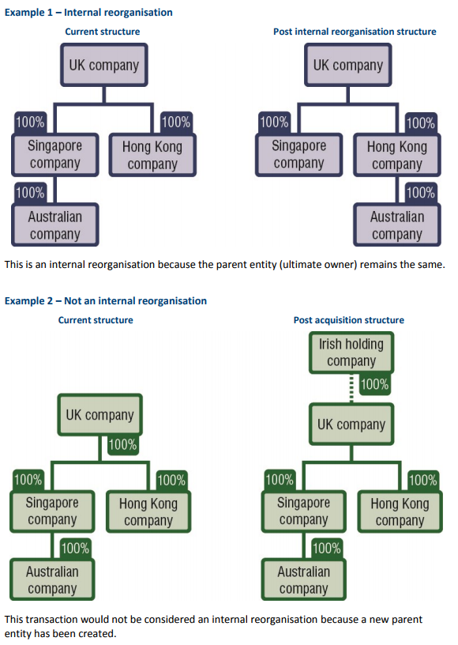

J: Indexation of fees
Fees for foreign investment applications and notices are indexed each financial year from the averages of the Australian Bureau of Statistics Consumer Price Index (CPI). New fees apply from 1 July each year and are calculated using the appropriate indexation factor.
Section 7, 8 and 9 of the Fees Act explains how the fees are worked out in financial years following the financial year in which the fee amount was legislated (2020-21). Where this results in an increase in certain fees for a financial year, the new fees will apply to applications made and notices given as of 1 July of that financial year.
At the beginning of each financial year, all figures in this Guidance Note will be updated to reflect indexation.

K: Fee waivers and remissions
There are only limited circumstances where a fee waiver or remission is likely to be granted. Waivers are assessed on a case-by-case basis. Applicants should not expect a particular outcome on a waiver or remission application, noting that the statutory timeframe for considering the application does not start until the correct fee has been paid.
Fees will generally not be waived or remitted simply because an application is not successful.
Fees will generally not be remitted where an application has been withdrawn. A resubmitted application that is substantially the same as a withdrawn application may receive a fee waiver.

Circumstances when fee waivers and remissions may apply
Under section 115 of the Act, the Treasurer may waive or remit the whole or a part of a fee that is payable if satisfied that it is not contrary to the national interest to waive or remit the fee.
All applications for fee waivers or remissions will be considered on a case-by-case basis. Applications for fee waivers and remissions will be considered through an internal review process. All decisions on fee waivers or remissions are final.
Generally, fees will not be waived or remitted in the following instances:
- On the outcome of an application or notice. Fees will not generally be remitted where a proposal does not get approval from the Treasurer, the applicant changes their mind or the investment has been unsuccessful.
- For example, a foreign person will generally not receive a fee waiver or remission following an unsuccessful competitive bid process. A foreign person in this circumstance may on a case-by-case basis request those fees to be credited to a subsequent application.
- A lower fee structure is applicable in the ultimate investment, when the applicant applied under a higher fee tier. For example, if a foreign person receives approval to purchase residential land for over $1 million but acquires the residential land at auction for under $1 million, the difference in fees will not be remitted.
- Where no acquisitions are made by foreign persons under an exemption certificate. Despite this, if a foreign person does not utilise the full financial limit of an exemption certificate, the Treasurer may consider allowing the remaining amount to be ‘rolled over’ to a future exemption certificate, effectively lowering the cost of a future application. This would be assessed on a case-by-case basis and roll over amounts would likely need to be more than the relevant fee constant.
- Where an application has been withdrawn. However, for applications or notices that are resubmitted and are substantially the same or similar action, the fee for the latter application or notice may be waived. This will be considered on a case-by-case basis, taking into account the extent that the latter application or notice is similar to the withdrawn application or notice.
There are limited circumstances where a fee waiver or remission is likely to be granted. These include:
- If there would be a different fee outcome compared with if the same acquisition were structured differently for certain residential land applications. For example, a fee waiver may be considered for foreign persons who are close relatives (for example, spouses) and are purchasing residential property as tenants in common. This requires different notices and fees for each foreign person, compared to the situation where the property was being acquired by joint tenants who would require one notice and one fee.
- Acquisitions by unincorporated consortiums. A partial fee waiver will generally be considered for unincorporated consortiums where there are multiple foreign persons providing notices for one acquisition for which separate fees would be payable (compared with if the consortium was an incorporated joint venture for which one notice and fee would be applicable).
- Applications for exemption certificates for a program of land acquisitions and/or businesses and entities acquisitions that were not granted. If an application for an exemption certificate for a program of land acquisitions and/or business and entity acquisitions was not granted by the Treasurer, fees to the value of the original application may be waived for any subsequent individual applications for an interest in land or a business or entity. If the entity that paid the fee is a holding entity or subsidiary, the fee may be credited towards separate notices of other entities within the same group, with the written consent of an authorised officer of the entity that initially applied for the certificate that was not given.
- Exempt actions. If an action is exempt under the Act and an application is made in respect of that action, the fee will be remitted.
- Variation fees for changes to an existing no objection notification for certain residential land applications. For example, if a foreign person purchases a vacant residential block which only has a lot number, the foreign person can apply for a variation so the address can appear on the no objection notification once known, and have the variation fee remitted.
- The fee outcome for a for a passive foreign government investor exemption certificate will be given effect through a fee waiver or remission.
If a person wants to apply for a fee waiver or remission, they should clearly set out the circumstances in their application and outline why the Treasurer should consider waiving or remitting the fee. Decisions on fee waivers and remissions are not subject to review under the Administrative Decisions (Judicial Review) Act 1977 or the Administrative Appeals Tribunal Act 1975 but can be subject to common law judicial review.

L: Schedule of fees for single actions and exemption certificates
Table 7: Schedule of fees for single actions and exemption certificates

Consideration of acquisition |  |  | Applicable fee
Residential land | Agricultural land | Commercial land, tenements & business | Fee for single action | Fee for single RNSA action | Fee for exemption certificate | Fee for RNSA exemption certificate
Less than $75,000 ^{(a)} | Less than $75,000 ^{(a)} | Less than $75,000 ^{(a)} | $2,000 | $500 | N/A | N/A
$1m or less | $2m or less | $50m or less | $6,350 | $1,587.50 | $4,762.50 | $1,587.50
$2m or less | $4m or less | $100m or less | $12,700 | $3,175 | $9,525 | $3,175
$3m or less | $6m or less | $150m or less | $25,400 | $6,350 | $19,050 | $6,350
$4m or less | $8m or less | $200m or less | $38,100 | $9,525 | $28,575 | $9,525
$5m or less | $10m or less | $250m or less | $50,800 | $12,700 | $38,100 | $12,700
$6m or less | $12m or less | $300m or less | $63,500 | $15,875 | $47,625 | $15,875
$7m or less | $14m or less | $350m or less | $76,200 | $19,050 | $57,150 | $19,050
$8m or less | $16m or less | $400m or less | $88,900 | $22,225 | $66,675 | $22,225
$9m or less | $18m or less | $450m or less | $101,600 | $25,400 | $76,200 | $25,400
$10m or less | $20m or less | $500m or less | $114,300 | $28,575 | $85,725 | $28,575
$11m or less | $22m or less | $550m or less | $127,000 | $31,750 | $95,250 | $31,750
$12m or less | $24m or less | $600m or less | $139,700 | $34,925 | $104,775 | $34,925
$13m or less | $26m or less | $650m or less | $152,400 | $38,100 | $114,300 | $38,100
$14m or less | $28m or less | $700m or less | $165,100 | $41,275 | $123,825 | $41,275
$15m or less | $30m or less | $750m or less | $177,800 | $44,450 | $133,350 | $44,450
$16m or less | $32m or less | $800m or less | $190,500 | $47,625 | $142,875 | $47,625
$17m or less | $34m or less | $850m or less | $203,200 | $50,800 | $152,400 | $50,800
$18m or less | $36m or less | $900m or less | $215,900 | $53,975 | $161,925 | $53,975
$19m or less | $38m or less | $950m or less | $228,600 | $57,150 | $171,450 | $57,150
$20m or less | $40m or less | $1,000m or less | $241,300 | $60,325 | $180,975 | $60,325
$21m or less | $42m or less | $1,050m or less | $254,000 | $63,500 | $190,500 | $63,500
$22m or less | $44m or less | $1,100m or less | $266,700 | $66,675 | $200,025 | $66,675
$23m or less | $46m or less | $1,150m or less | $279,400 | $69,850 | $209,550 | $69,850
$24m or less | $48m or less | $1,200m or less | $292,100 | $73,025 | $219,075 | $73,025
$25m or less | $50m or less | $1,250m or less | $304,800 | $76,200 | $228,600 | $76,200
$26m or less | $52m or less | $1,300m or less | $317,500 | $79,375 | $238,125 | $79,375
$27m or less | $54m or less | $1,350m or less | $330,200 | $82,550 | $247,650 | $82,550
$28m or less | $56m or less | $1,400m or less | $342,900 | $85,725 | $257,175 | $85,725
$29m or less | $58m or less | $1,450m or less | $355,600 | $88,900 | $266,700 | $88,900
$30m or less | $60m or less | $1,500m or less | $368,300 | $92,075 | $276,225 | $92,075
$31m or less | $62m or less | $1,550m or less | $381,000 | $95,250 | $285,750 | $95,250
$32m or less | $64m or less | $1,600m or less | $393,700 | $98,425 | $295,275 | $98,425
$33m or less | $66m or less | $1,650m or less | $406,400 | $101,600 | $304,800 | $101,600
$34m or less | $68m or less | $1,700m or less | $419,100 | $104,775 | $314,325 | $104,775
$35m or less | $70m or less | $1,750m or less | $431,800 | $107,950 | $323,850 | $107,950
$36m or less | $72m or less | $1,800m or less | $444,500 | $111,125 | $333,375 | $111,125
$37m or less | $74m or less | $1,850m or less | $457,200 | $114,300 | $342,900 | $114,300
$38m or less | $76m or less | $1,900m or less | $469,900 | $117,475 | $352,425 | $117,475
$39m or less | $78m or less | $1,950m or less | $482,600 | $120,650 | $361,950 | $120,650
$40m or less | $80m or less | $2,000m or less | $495,300 | $123,825 | $371,475 | $123,825
More than $40 million | More than $80 million | More than $2,000 million | $503,000 | $125,750 | $377,250 | $125,750
(a) a lower fee of $2,000 will apply where the consideration value of an action is less than $75,000.

Further information
Further information is available on the FIRB website or by contacting 1800 050 377 from Australia or +61 2 6216 1111 from overseas.
Important notice: This policy document provides a summary of the relevant law. As this policy document tries to avoid legal language wherever possible it may include some generalisations about the law. Some provisions of the law referred to have exceptions or important qualifications, not all of which may be described here. The Commonwealth does not guarantee the accuracy, currency or completeness of any information contained in this document and will not accept responsibility for any loss caused by reliance on it. Your particular circumstances must be taken into account when determining how the law applies to you. This policy document is therefore not a substitute for obtaining your own legal advice.

