TRANSITIONAL ARRANGEMENTS
Last updated: 9 July 2021.

On 1 January 2021, reforms to the foreign investment framework took effect. The reforms include mandatory notification of a ‘notifiable national security action’, the power for the Treasurer to call-in a ‘reviewable national security action’ (and the option for investors to voluntarily notify such actions to prevent call-in), and the reinstatement of monetary thresholds that had been temporarily reduced to $0 in response to COVID-19.
This guidance note provides a series of flowcharts to help investors understand the transition to the new regime. If on 1 January 2021:
- you are a foreign person with a no objection notification, or you have applied for one and your application is still being considered by the Treasurer, see Flowchart 1.
- you are a foreign person with an exemption certificate, or you have applied for one and your application is still being considered by the Treasurer, see Flowchart 2.
- you are a foreign person who has given notice of a notifiable action (but not a significant action) prior to 2021, see Flowchart 3.
The reforms do not apply in a way that would disrupt approved actions that have already been taken prior to 1 January 2021.

Further information
Further information is available on the FIRB website or by contacting +61 2 6263 3795.
Important notice: This Guidance Note provides a summary of the relevant law. As this Note tries to avoid legal language wherever possible it may include some generalisations about the law. Some provisions of the law referred to have exceptions or important qualifications, not all of which may be described here. The Commonwealth does not guarantee the accuracy, currency or completeness of any information contained in this document and will not accept responsibility for any loss caused by reliance on it. Your particular circumstances must be taken into account when determining how the law applies to you. This Guidance Note is therefore not a substitute for obtaining your own legal advice.

No Objection Notification (NoN)
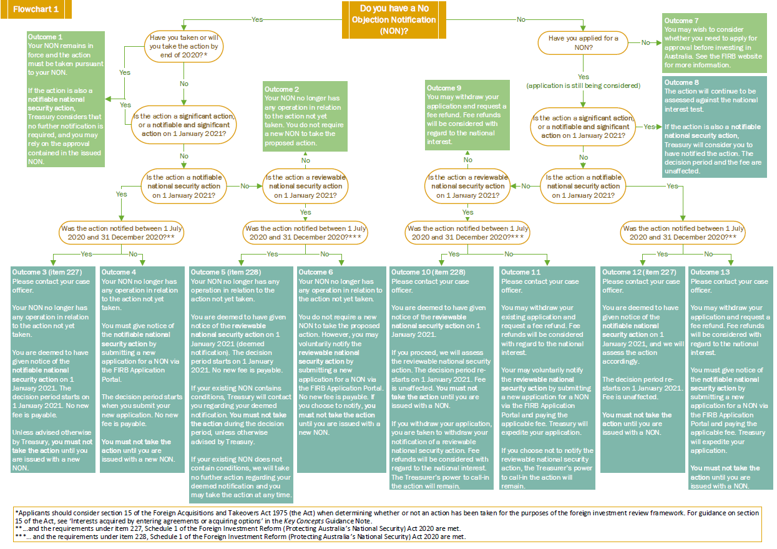

Exemption Certificate (EC)
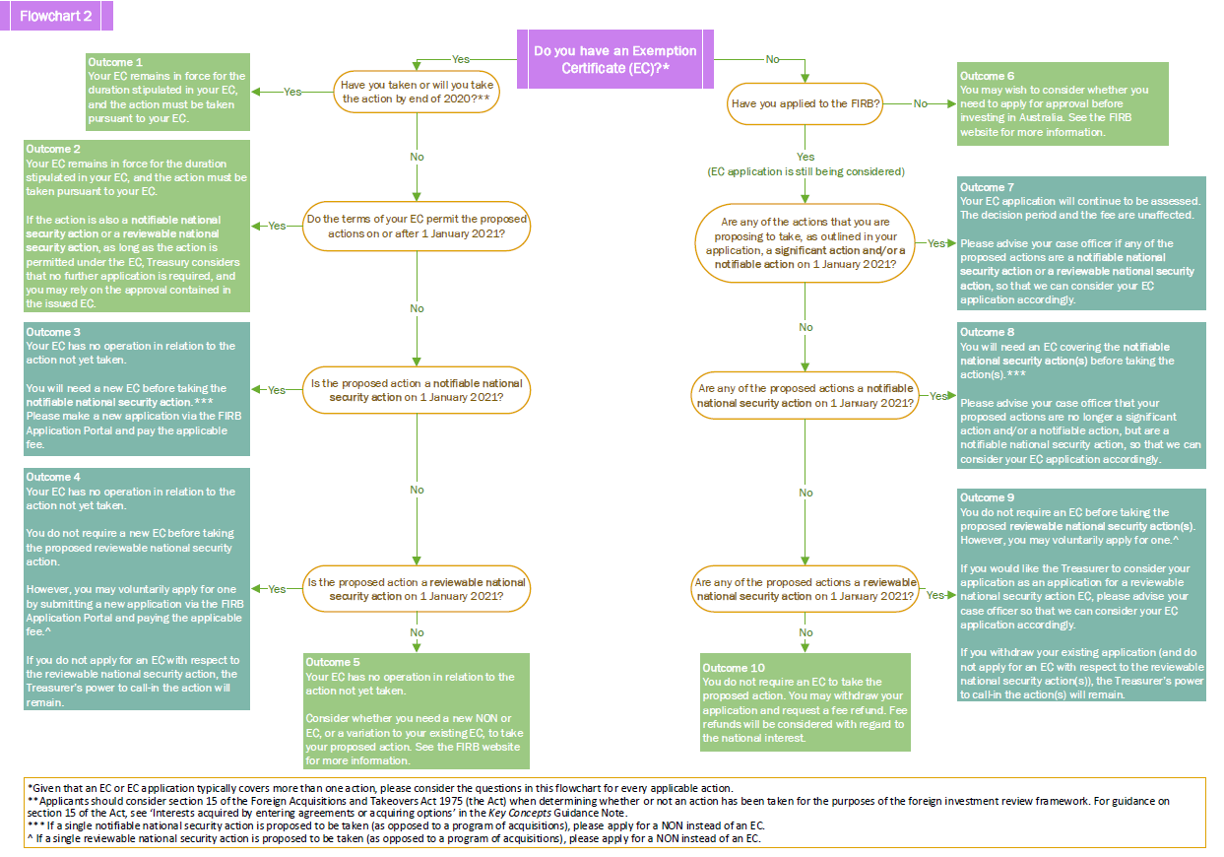

Notifiable action (but not significant action)

